When are the school events? Finish what the children say.
Parents’
Day?
Test Week?
1 | 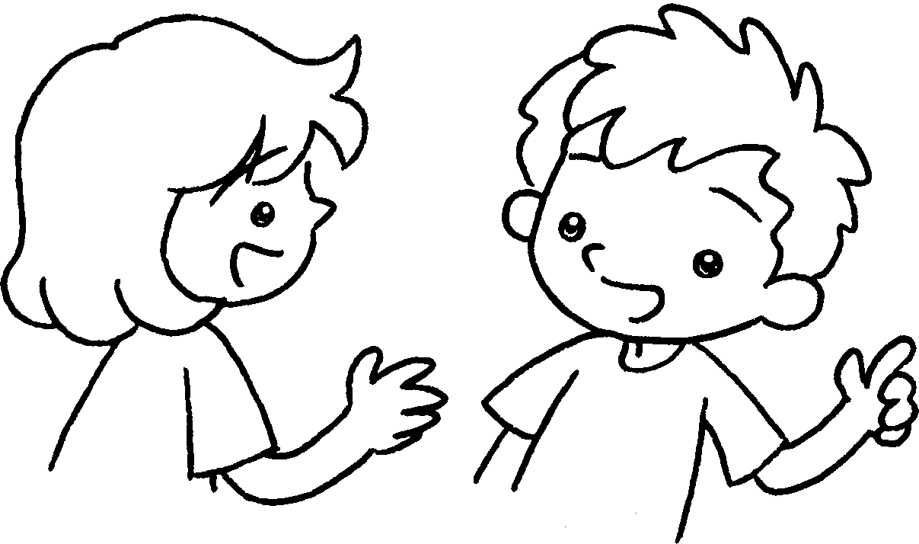 |  | When  A : ’s the school picnic?  B : It’s the twenty-fifth  of November.
2 |  |  | A : ’s English Camp?  B : It’s  April  April.
3 | 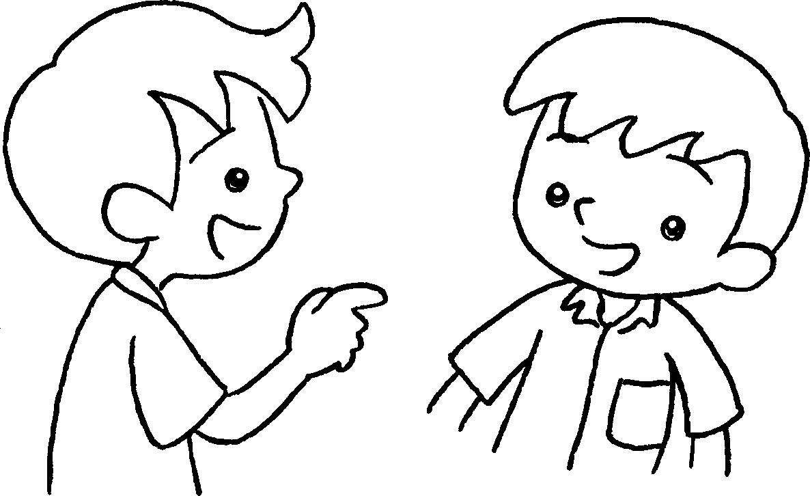 |  | A :  B : It’s  .
4 |  |  | A :  B :
25/11
13/4-17/4
10/2
3/6-7/6
A
B
A
B
A
B
A
B


Book 3A Chapter 5 Graded Worksheets
Worksheet 3⬇⬇⬇
- on
- When
from the thirteenth of to the seventeenth of
- When’s Parents’ Day?
on the tenth of February
- When’s Test Week?
It’s from the third of June to the seventh of June.

