School notices
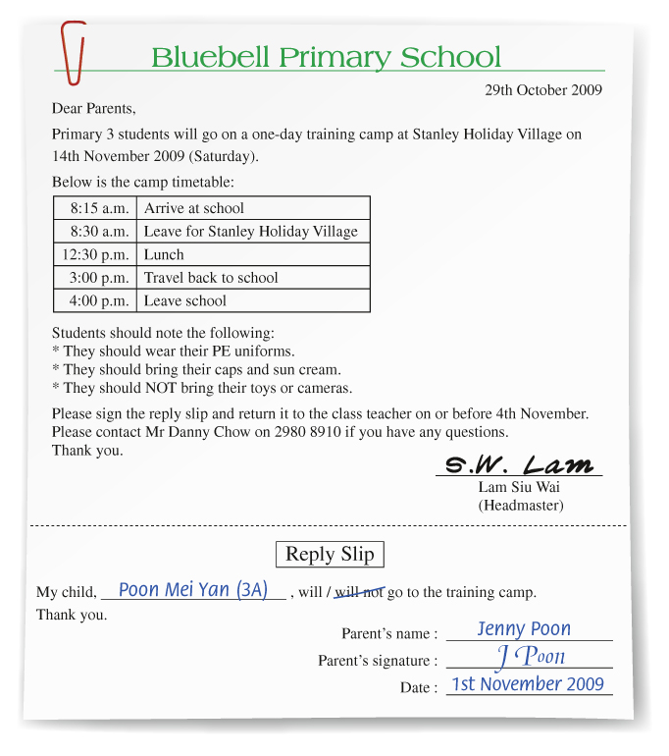

Write the answer and blacken  the circles.

1 Who wrote the school notice?

2 What is the school notice about?
 A. the training camp for Primary 3 students
 B. Stanley Holiday Village
 C. the timetable of the training camp
 D. Danny Chow

3 What CAN’T you find in the notice?
 A. the name of the school
 B. Poon Mei Yan’s signature
 C. the headmaster’s signature
 D. a reply slip

4 What should Poon Mei Yan do on 14th November 2009?
 A. She should arrive at school at 8:30 a.m.
 B. She should wear her PE uniform.
 C. She should bring her own lunch.
 D. She should return the reply slip to her class teacher.

Answers:
1 The headmaster / Lam Siu Wai / S.W. Lam. 2 A 3 B 4 B

