Choose and write.
badminton | basketball |  | football |  | table tennis
Chinese checkers |  |  | Chinese chess
the guitar |  | the piano |  | the violin

1 |  | 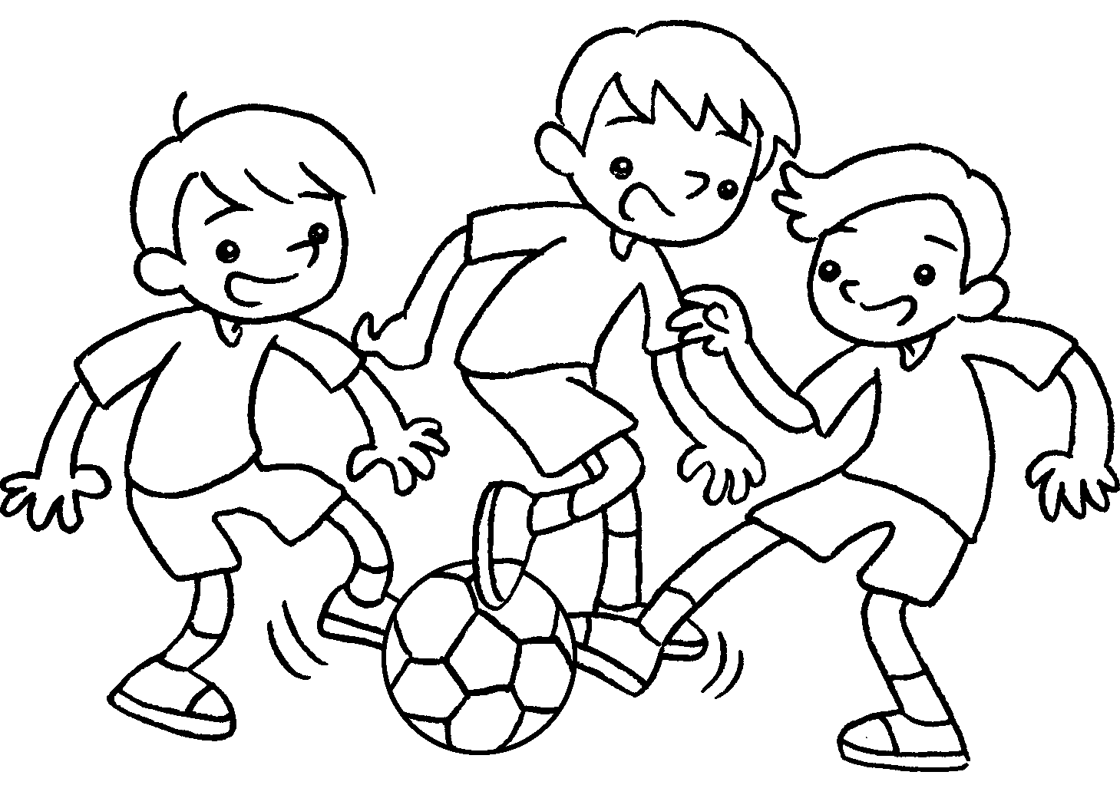 | 2 | 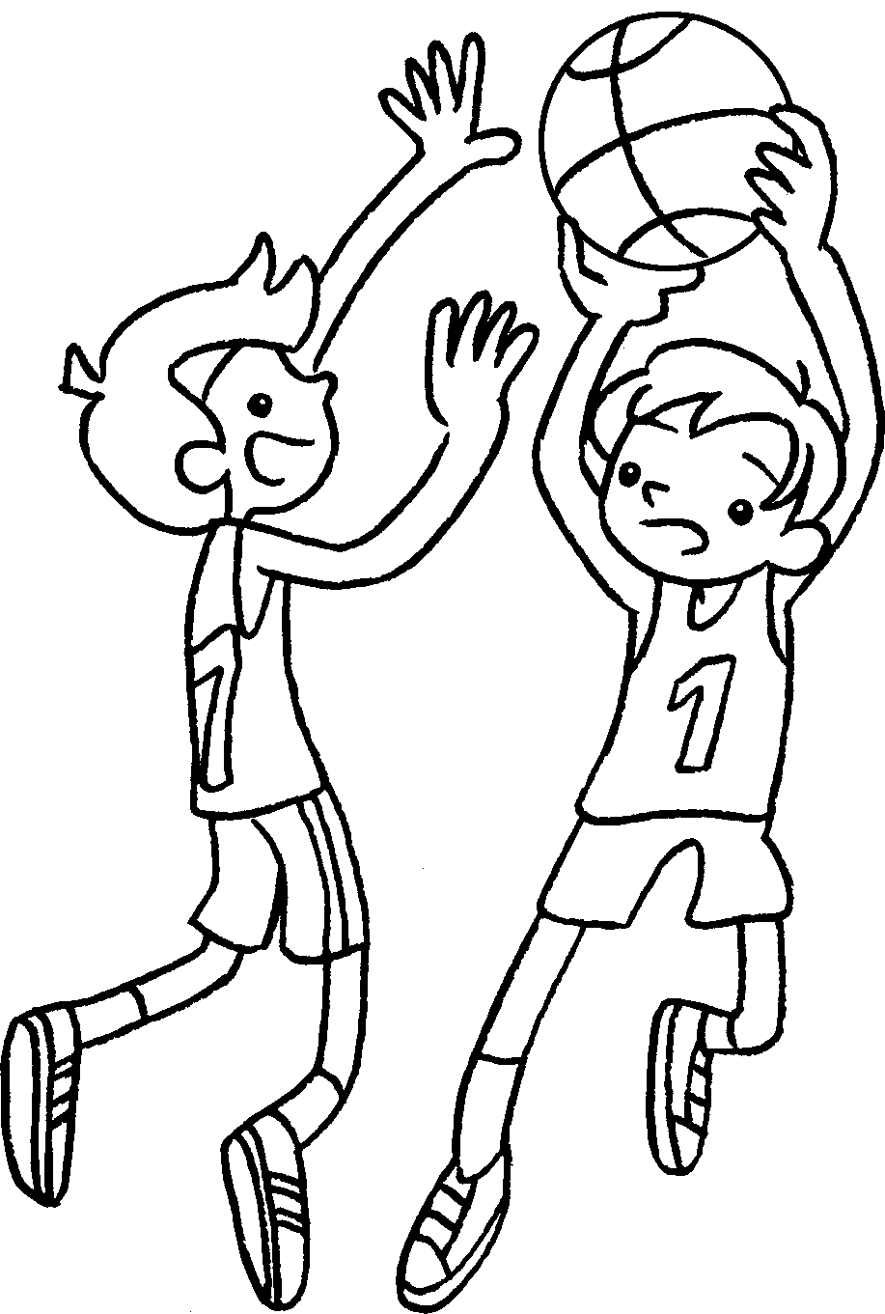 |  |  | 3 | 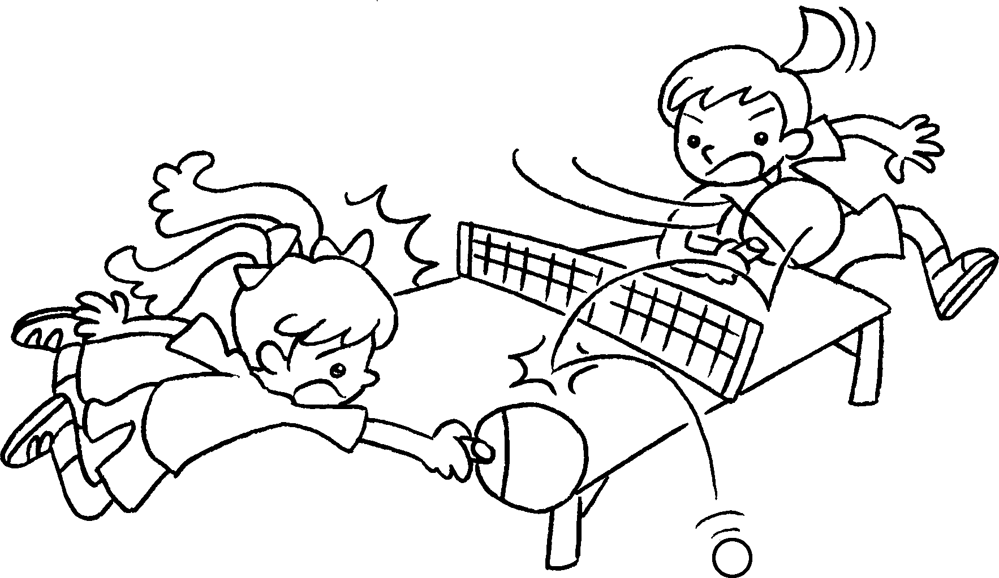 |  |  | 4 | 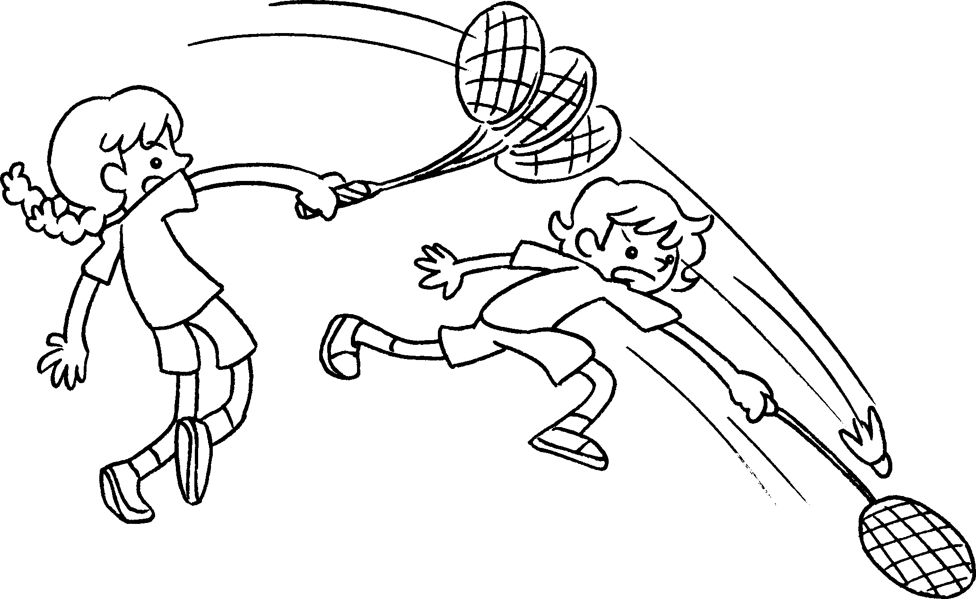
 |  | 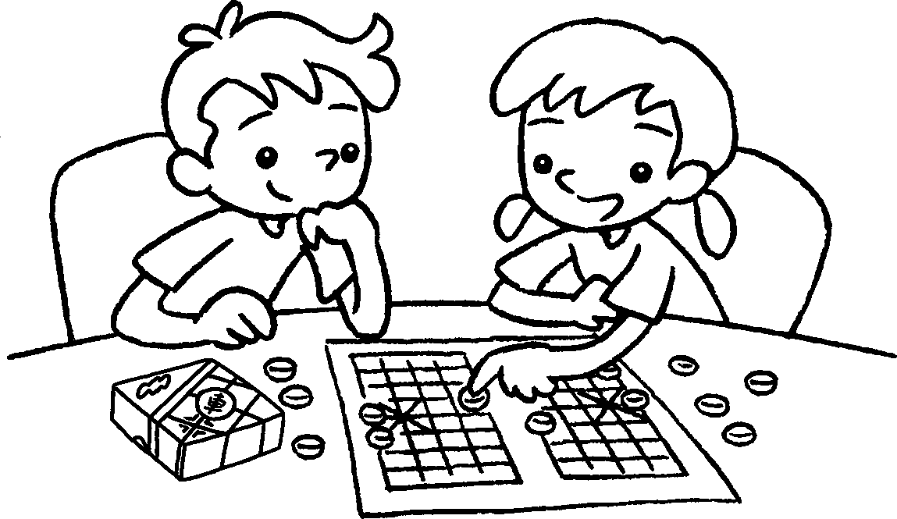  5 |  |  |  |  |  | 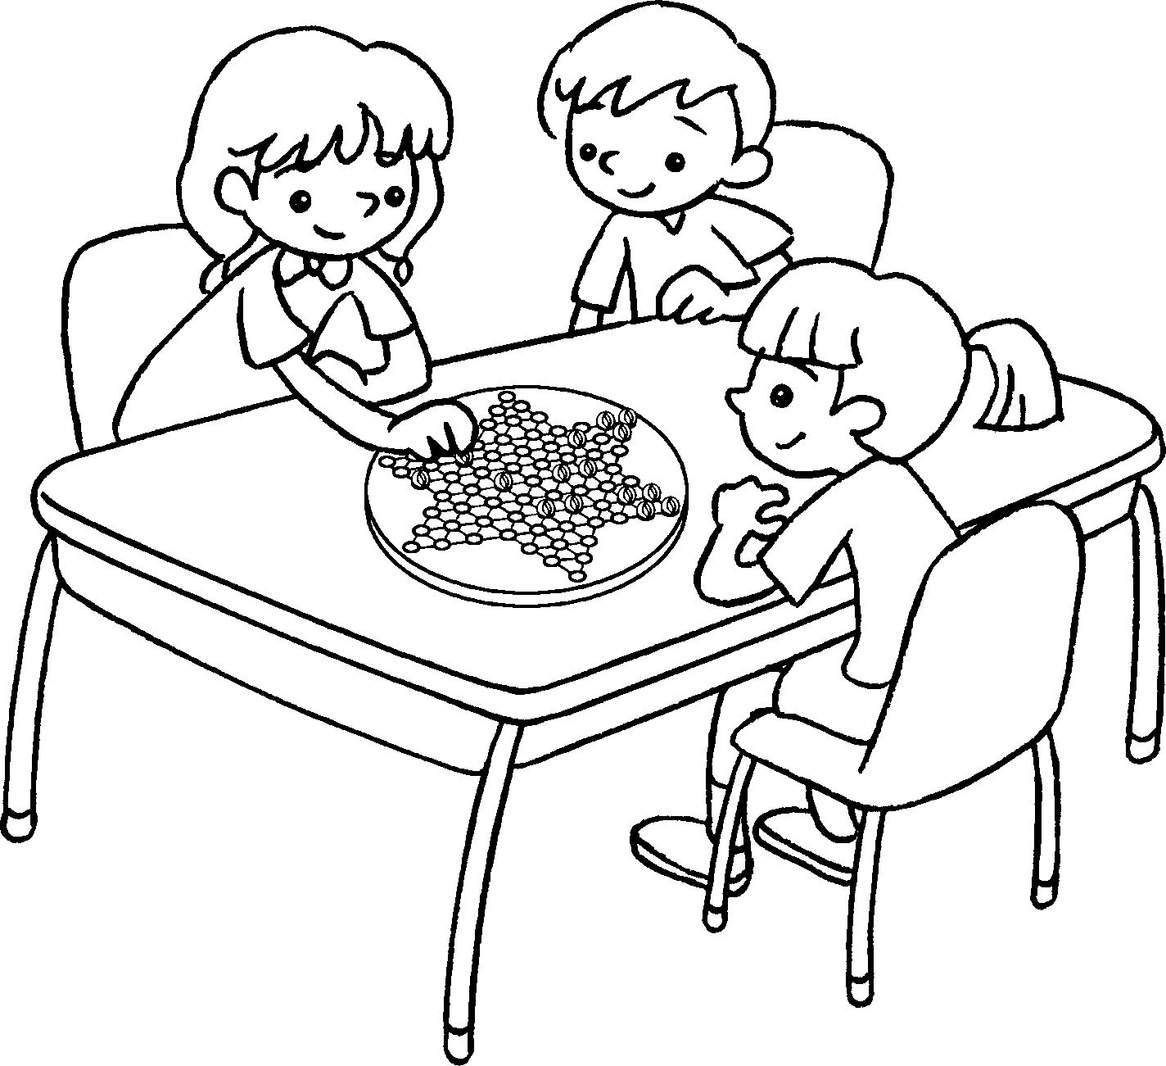  6
7 | 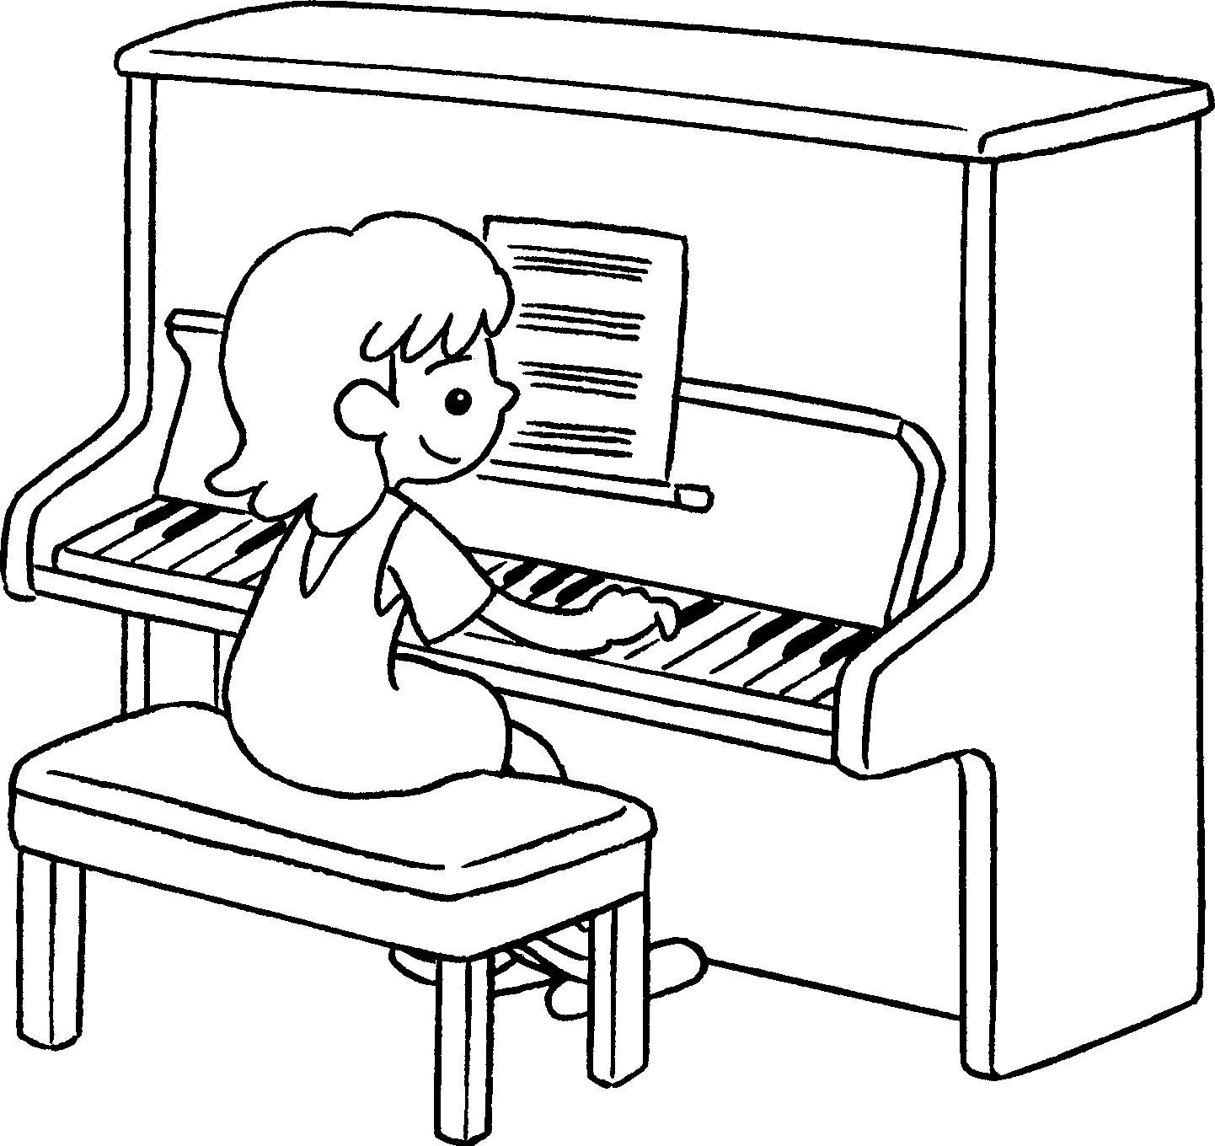 |  |  |  | 8 | 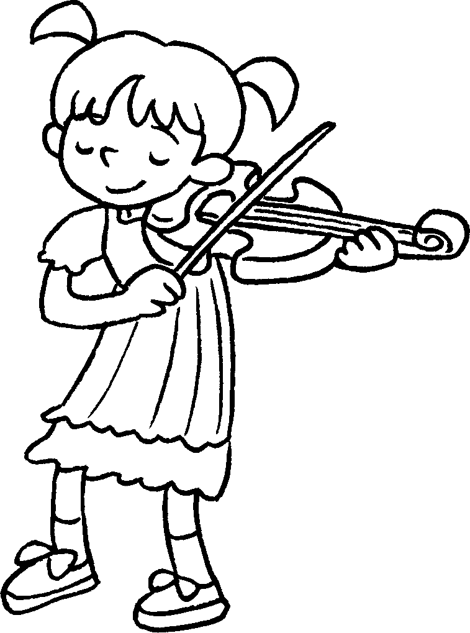 |  |  | 9 | 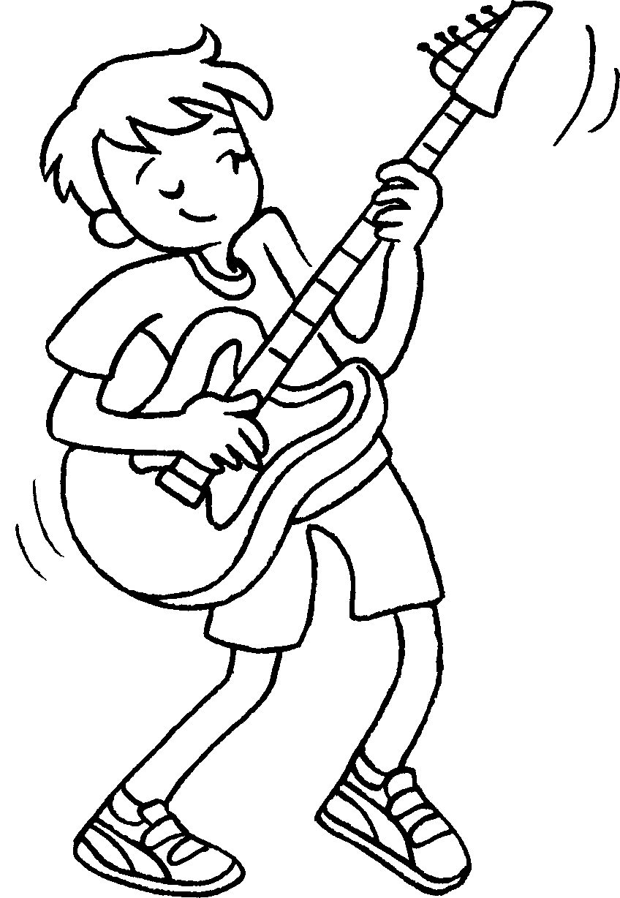

1 | play |  | 2 | play
3 | play |  | 4 | play
5 | play |  | 6 | play
7 | play |  | 8 | play
9 | play


Book 3A Chapter 6 Graded Worksheets
Worksheet 1⬇
1 football 2 basketball
3 table tennis 4 badminton
5 Chinese chess 6 Chinese checkers
7 the piano 8 the violin
9 the guitar

