What do the children do? Write.

1 |  | 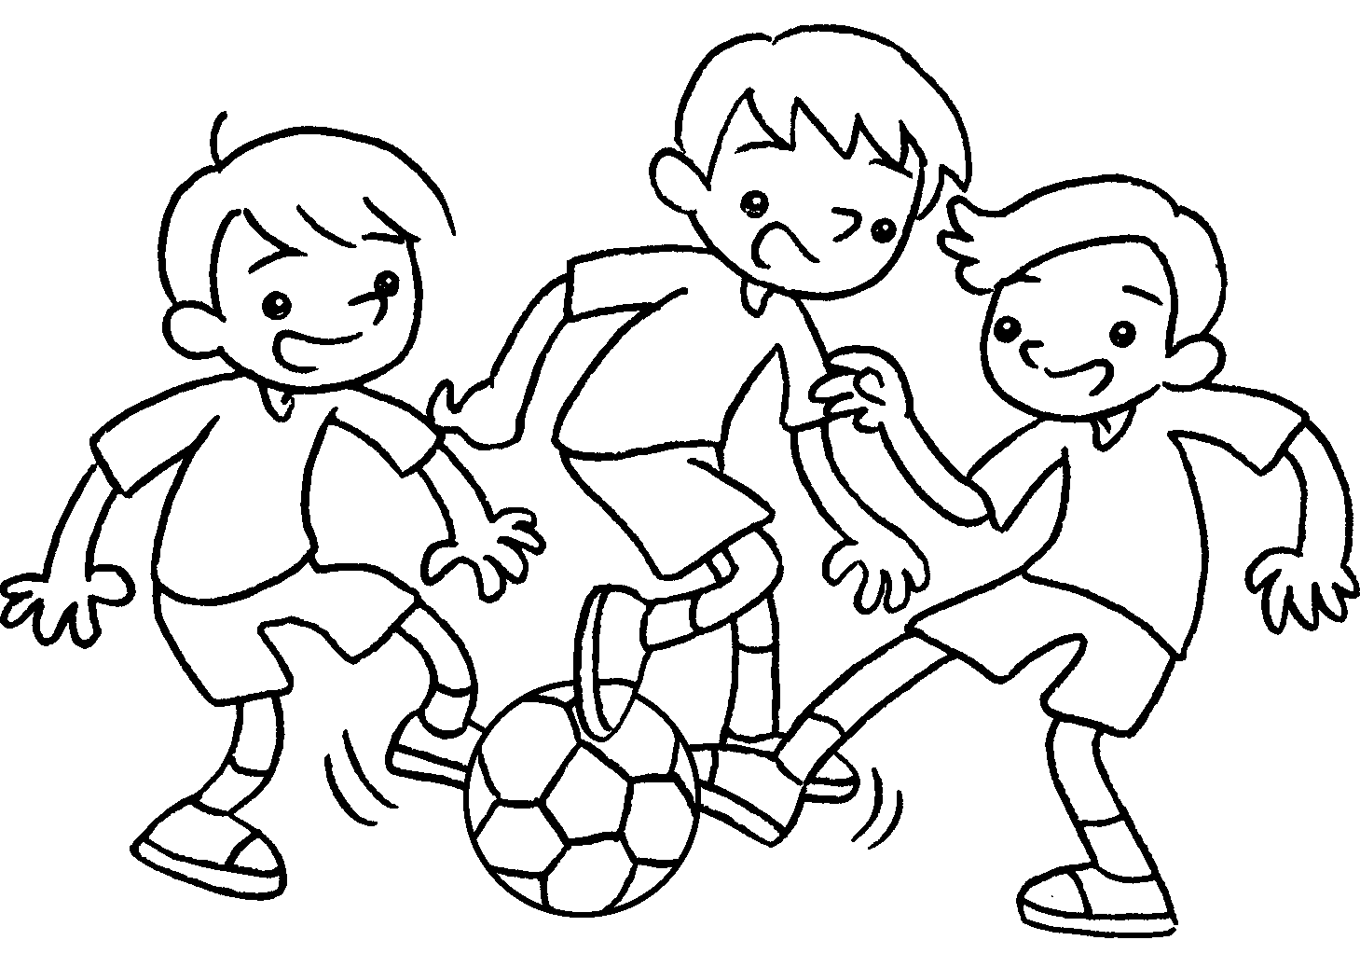 | 2 | 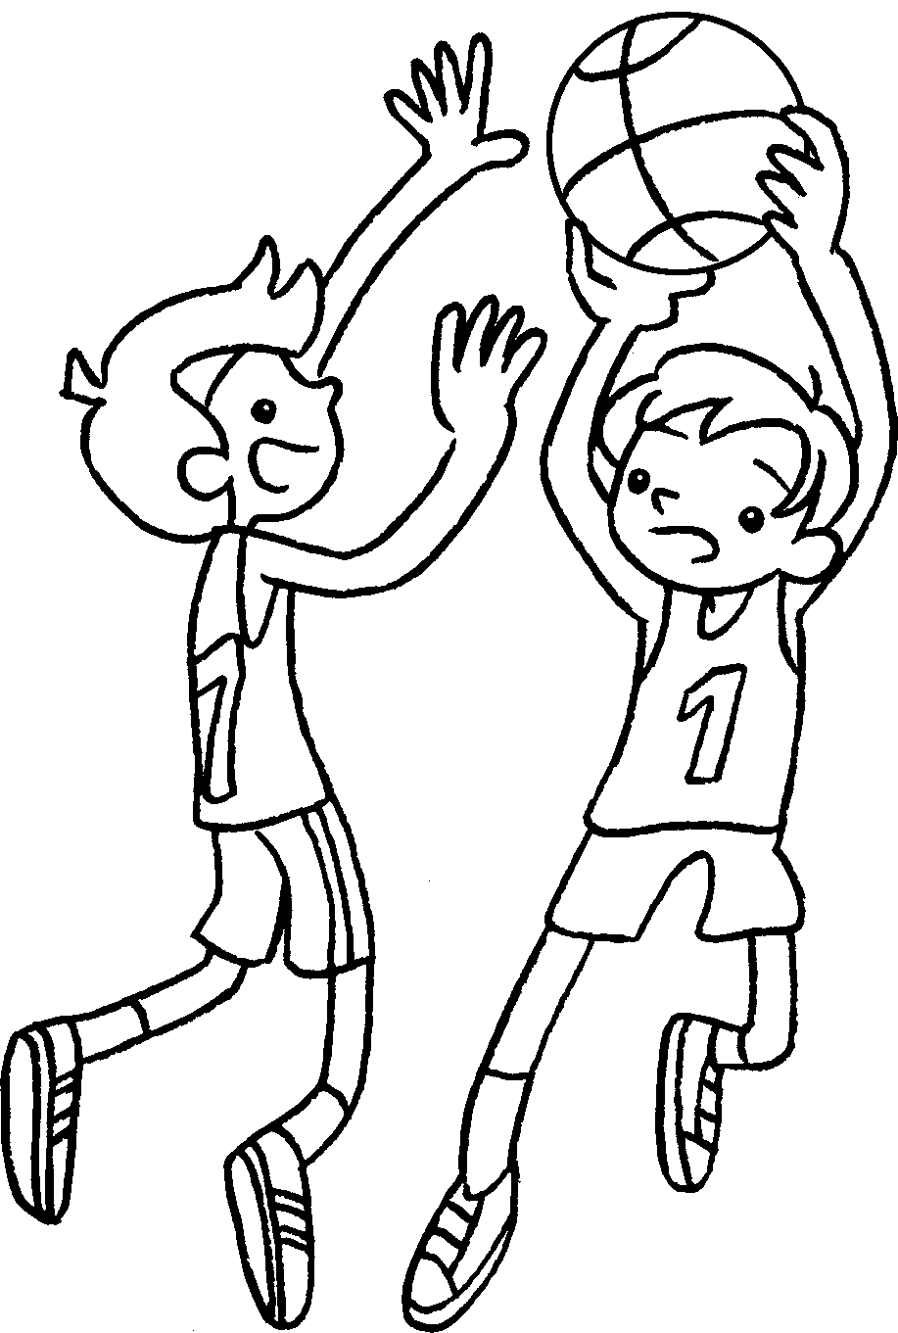 |  |  | 3 | 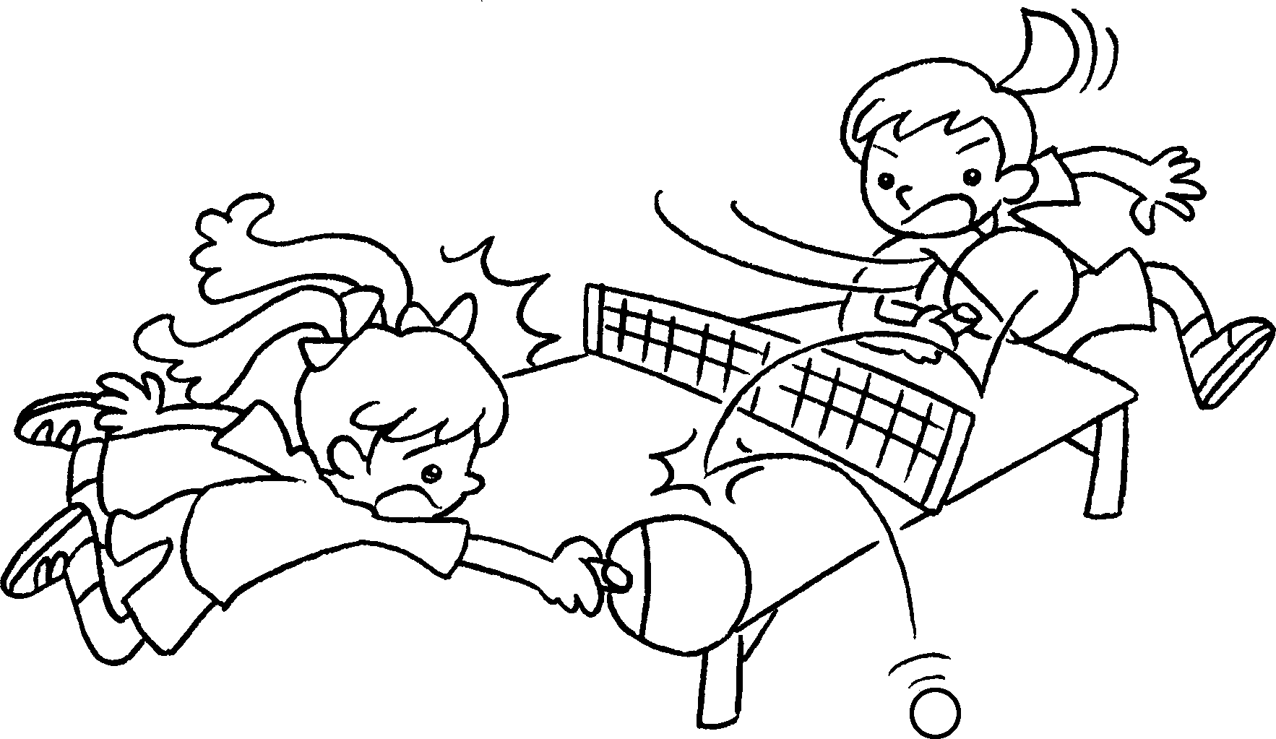 |  |  | 4 | 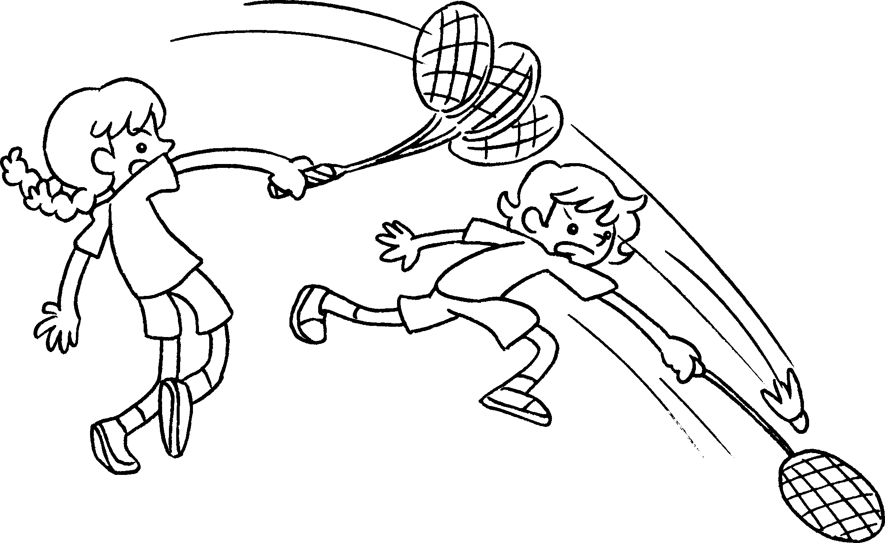
 |  | 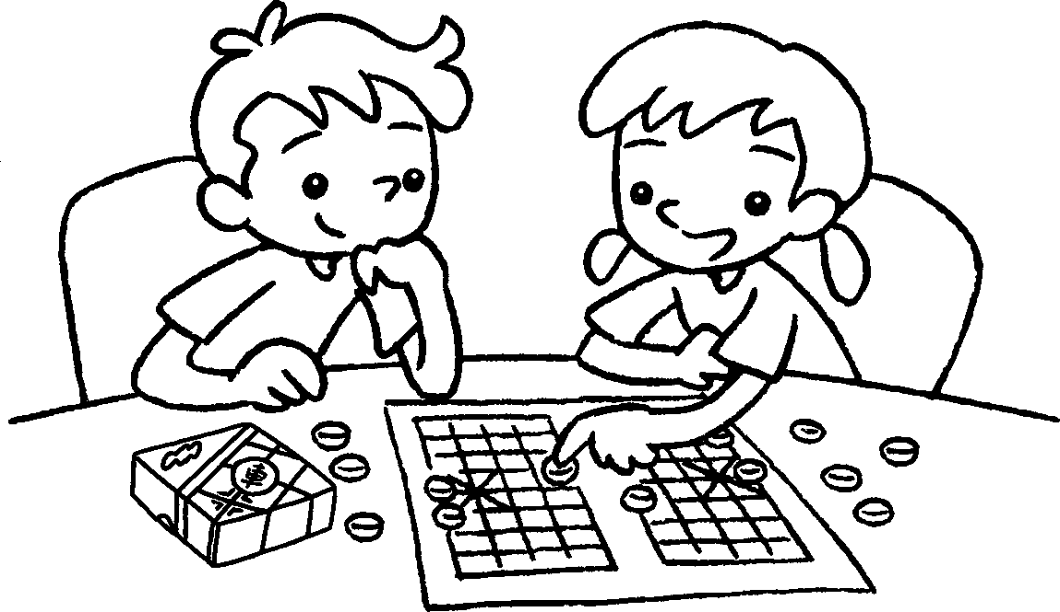  5 |  |  |  |  |  | 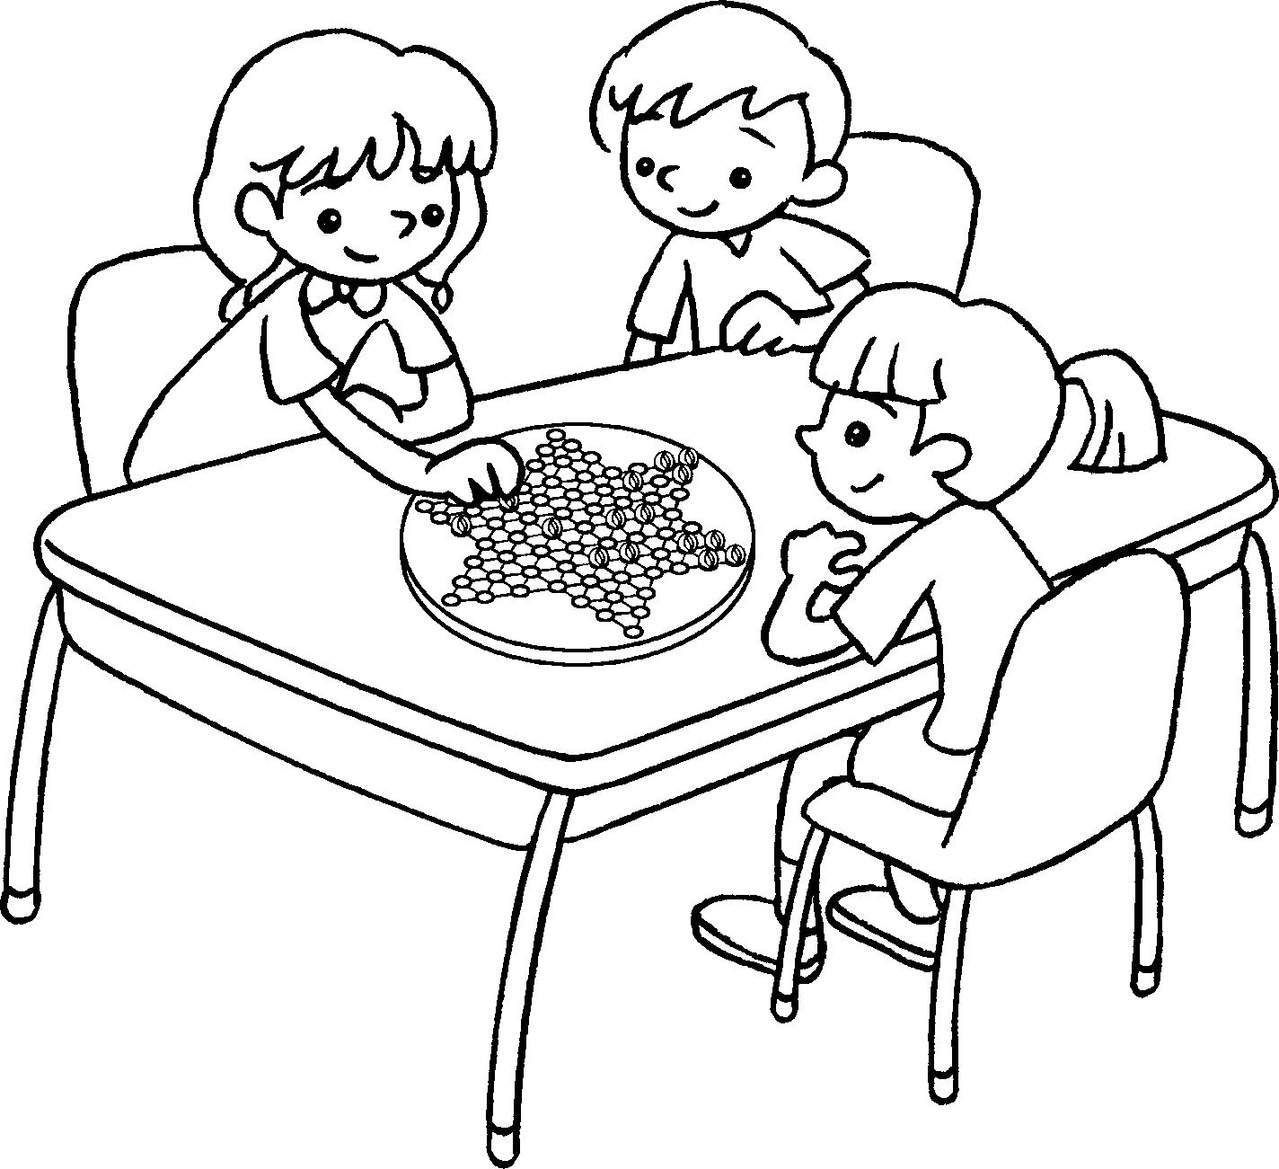  6
7 | 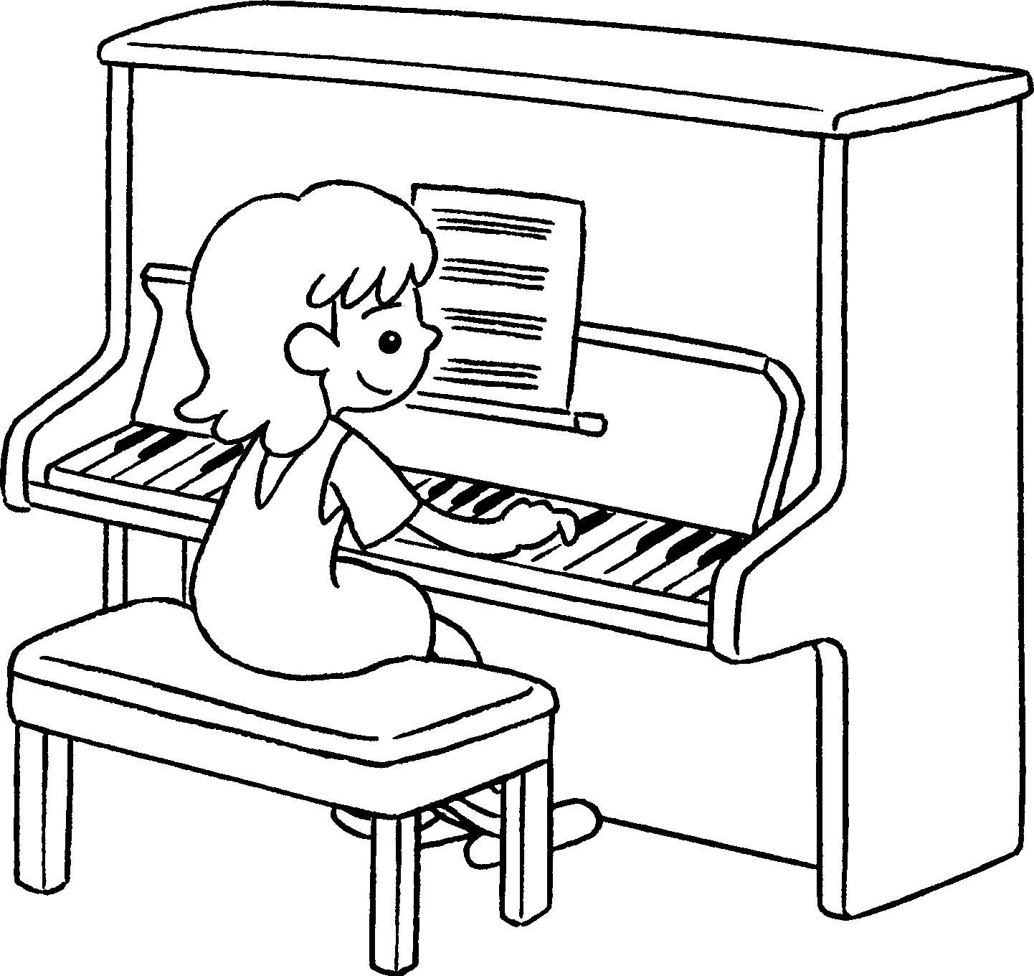 |  |  |  | 8 | 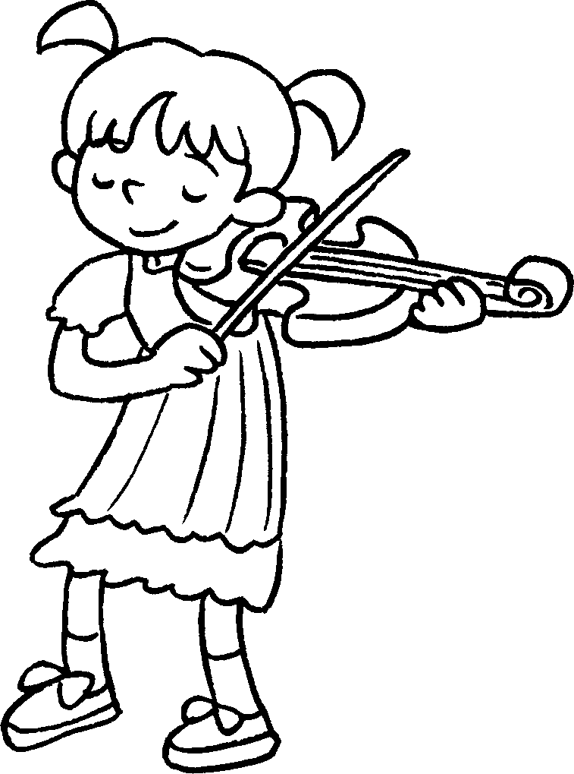 |  |  | 9 | 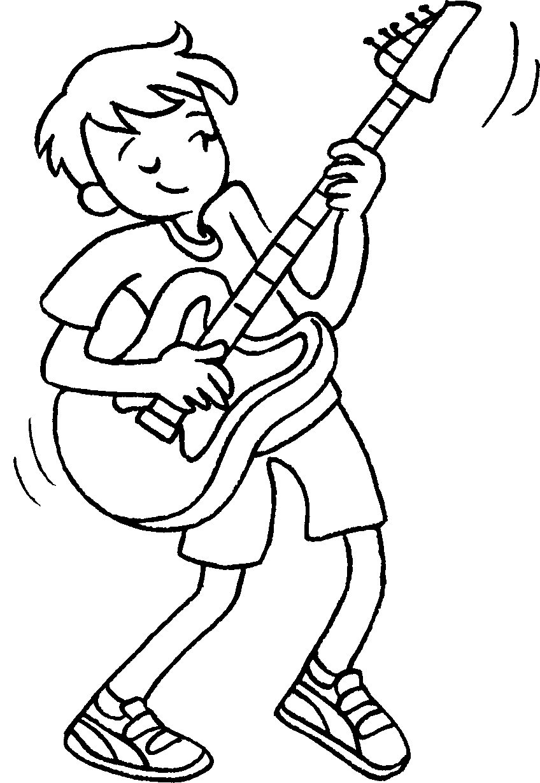

1 | play |  | 2 | play
3 | play |  | 4 | play
5 | play |  | 6 | play
7 | play the |  | 8 | play the
9 | play the


Book 3A Chapter 6 Graded Worksheets
Worksheet 1⬇⬇
1 f o o t b a l l 2 b a s k e t b a l l
3 t a b l e 4 b a d m i n t o n
5 C h i n e s e c h e s s 6 C h i n e s e c h e c k e r s
7 p i a n o 8 v i o l i n
9 g u i t a r

