What do the children do? Write.

1 |  | 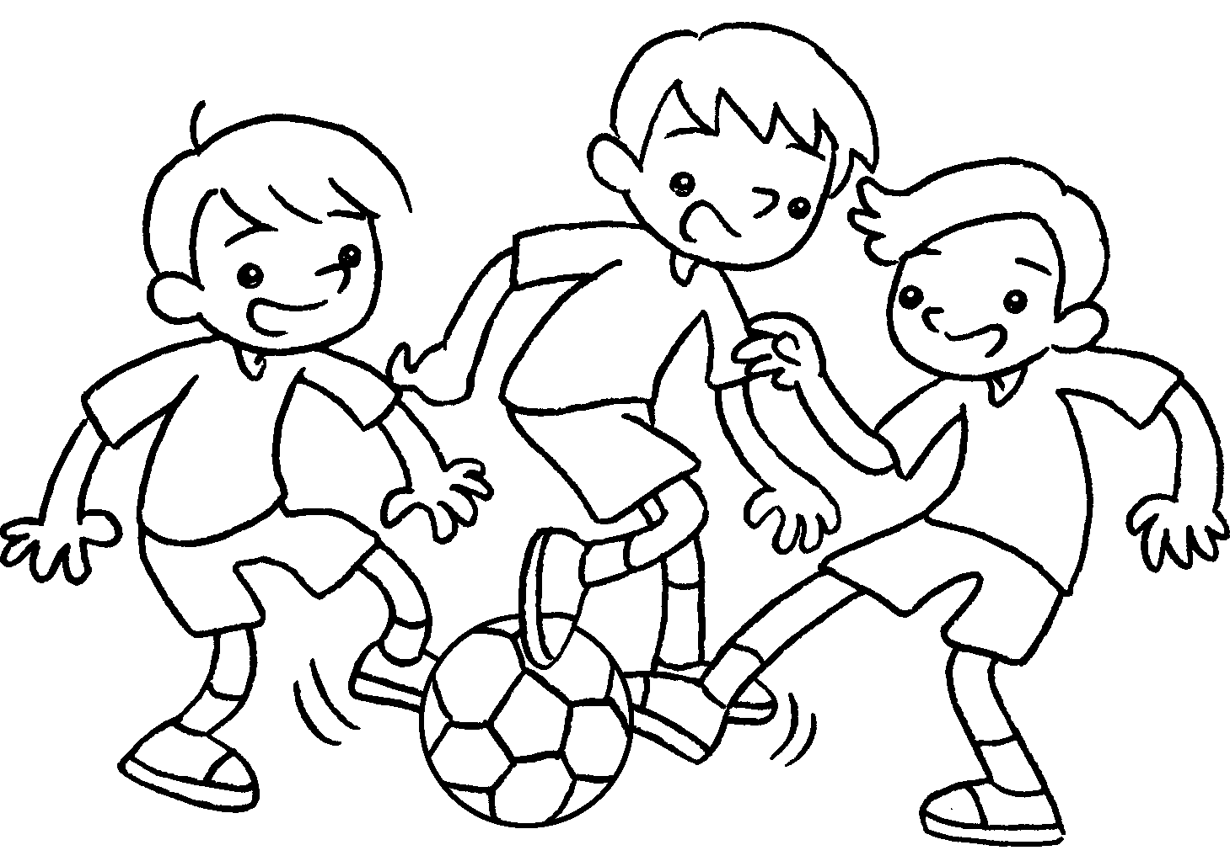 | 2 | 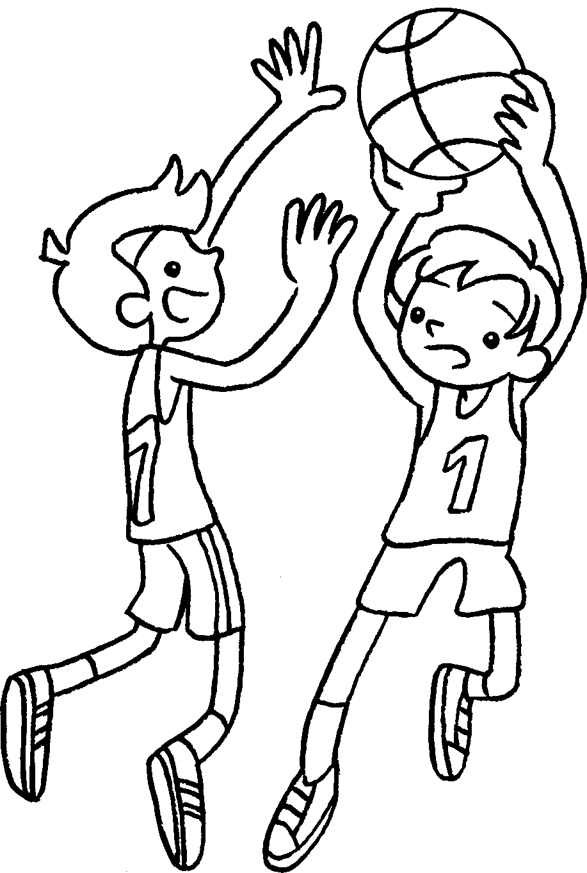 |  |  | 3 | 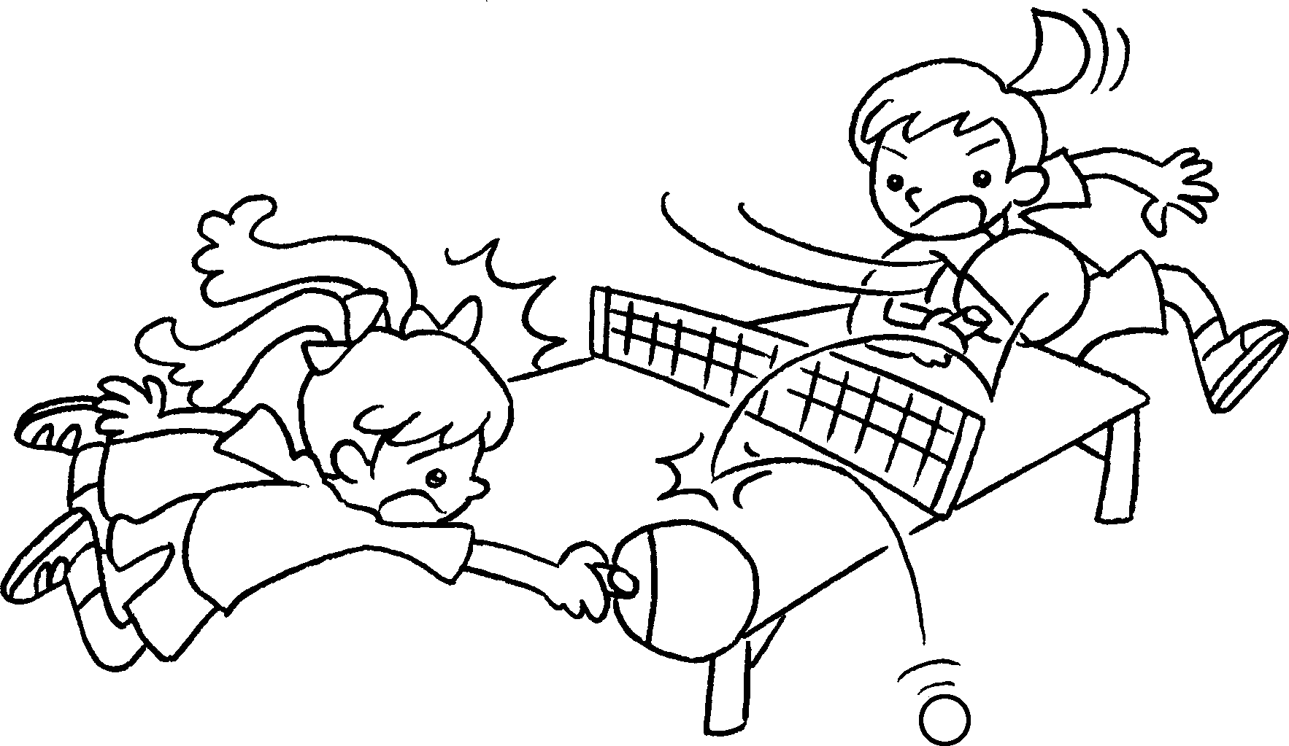 |  |  | 4 | 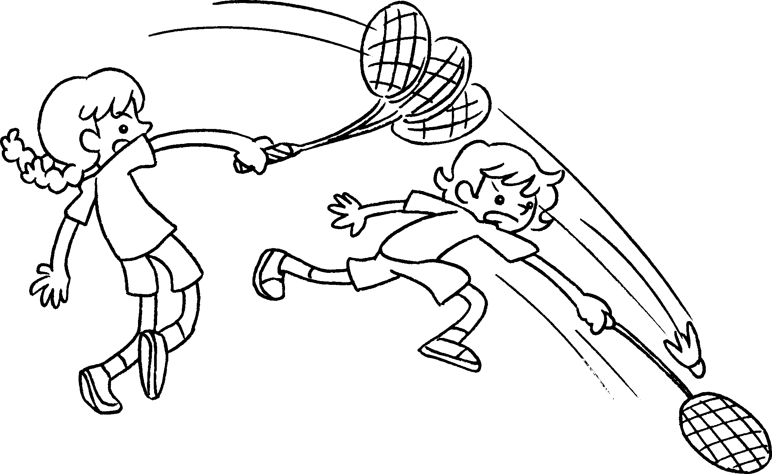
 |  | 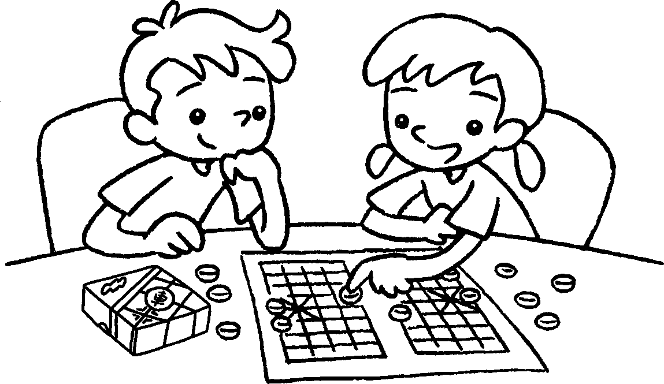  5 |  |  |  |  |  | 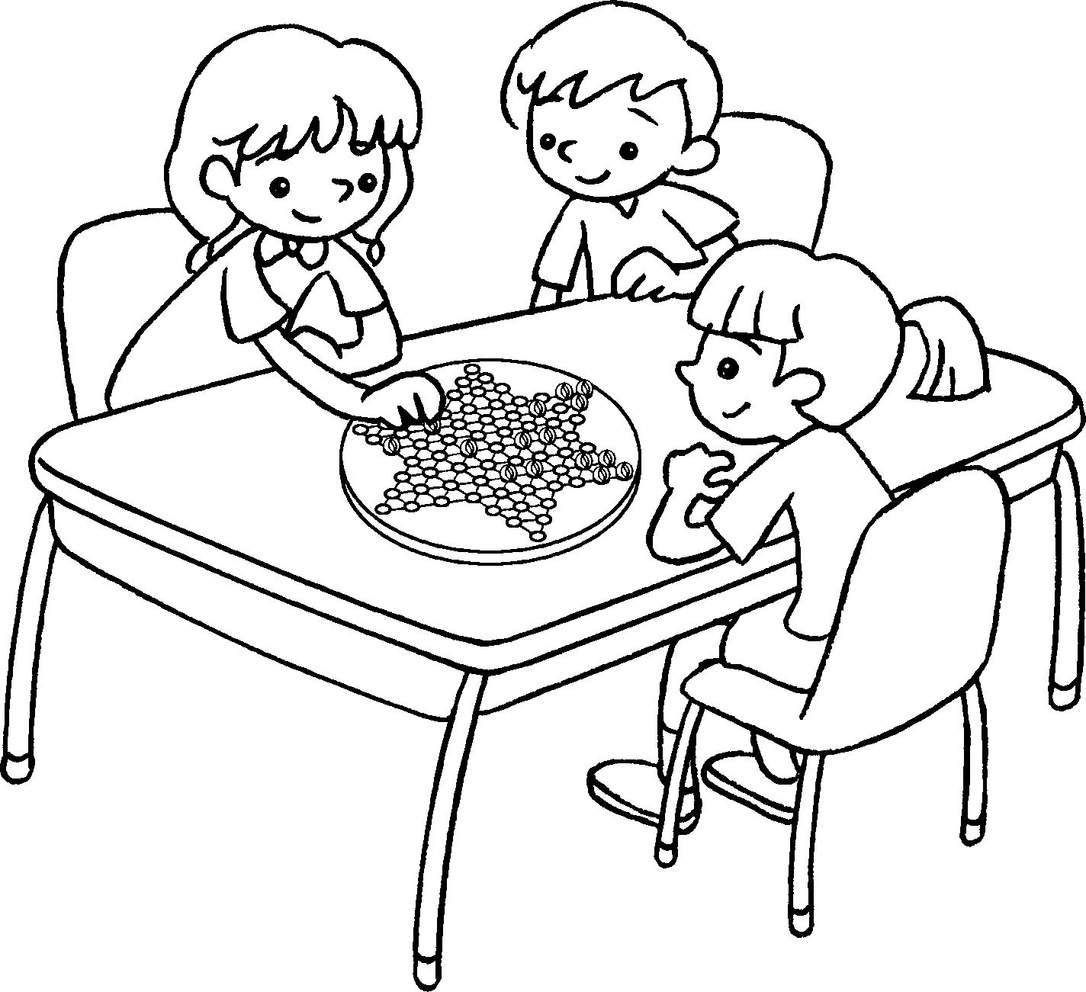  6
7 | 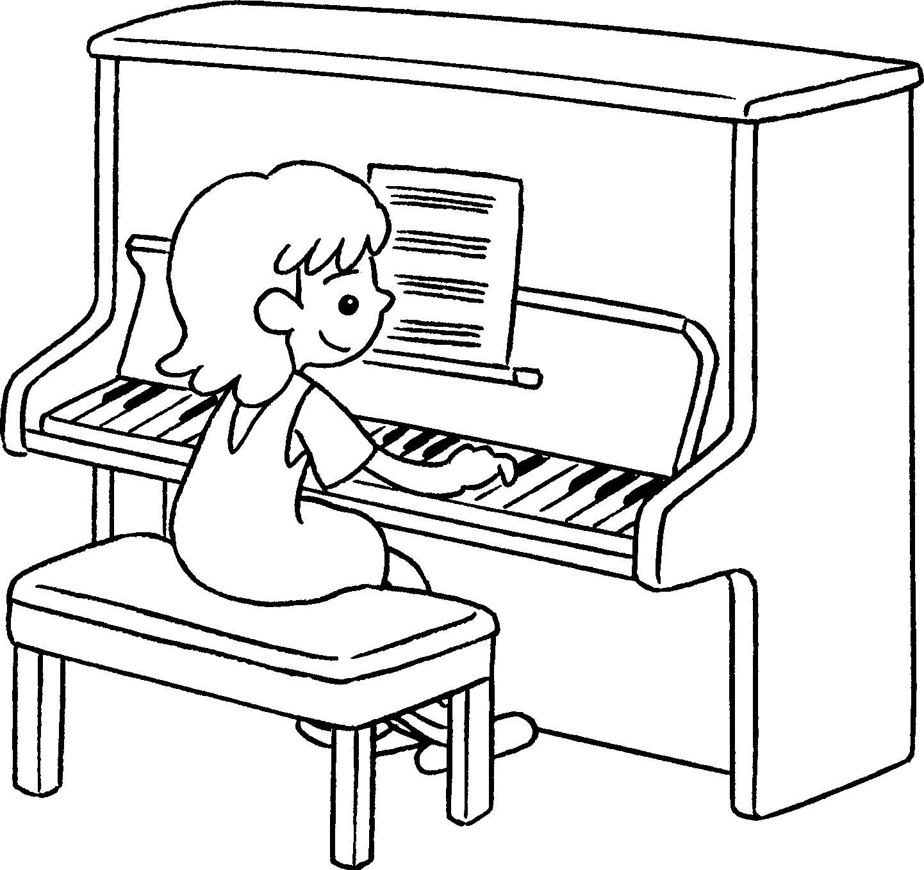 |  |  |  | 8 | 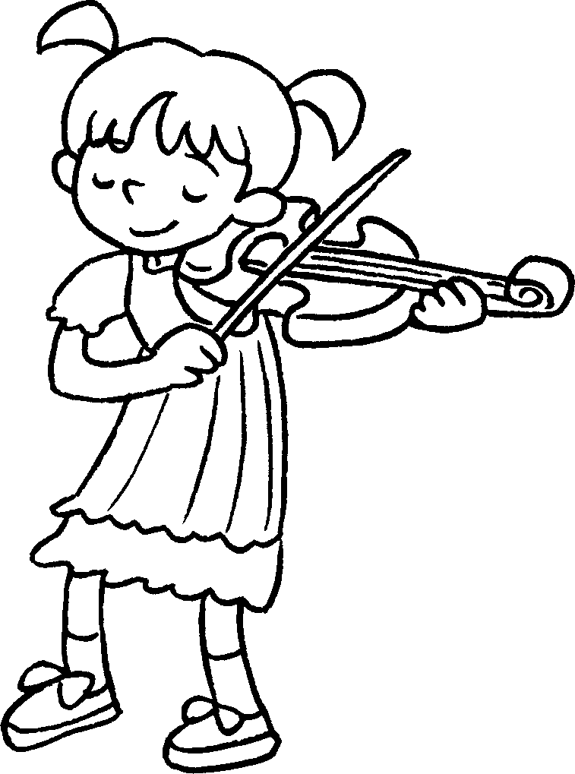 |  |  | 9 | 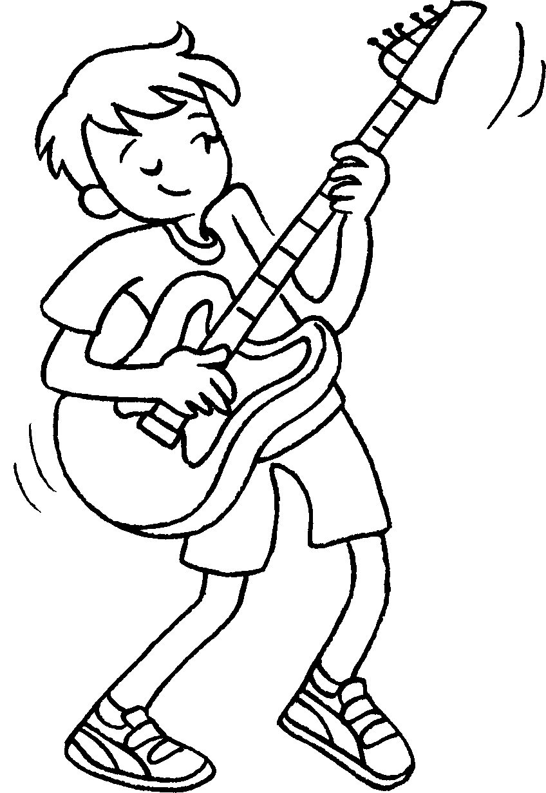

1 | play |  | 2 | play
3 | play |  | 4 | play
5 | play |  | 6 | play
7 | play the |  | 8 | play the
9 | play the


Book 3A Chapter 6 Graded Worksheets
Worksheet 1⬇⬇⬇
1 football 2 basketball
3 table tennis 4 badminton
5 Chinese chess 6 Chinese checkers
7 piano 8 violin
9 guitar

