Choose and write.
Can | Yes | can
 | No | can’t
✗
B
A
B
A
A
B
B
A
1 | 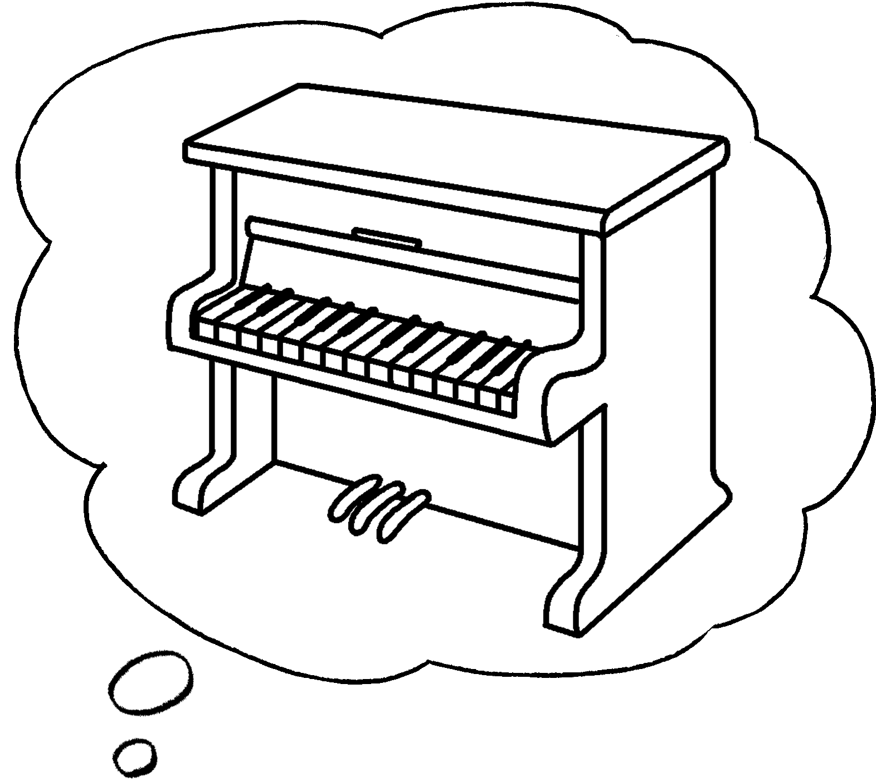  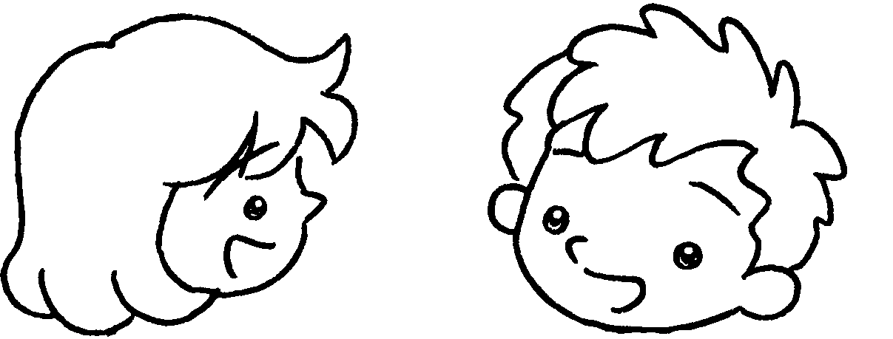 |  | A:  B : | Can you play the piano?  , I .
2 | 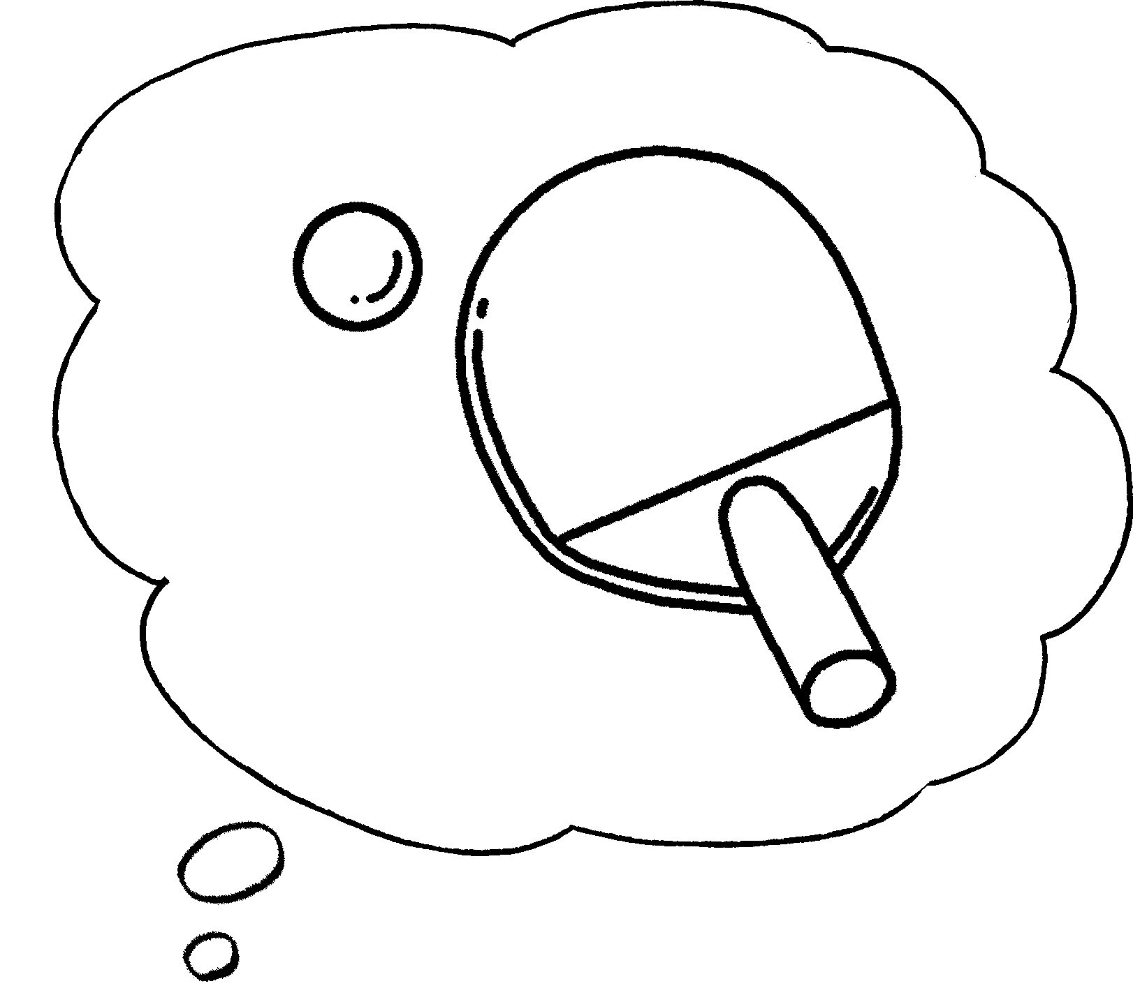  ✓  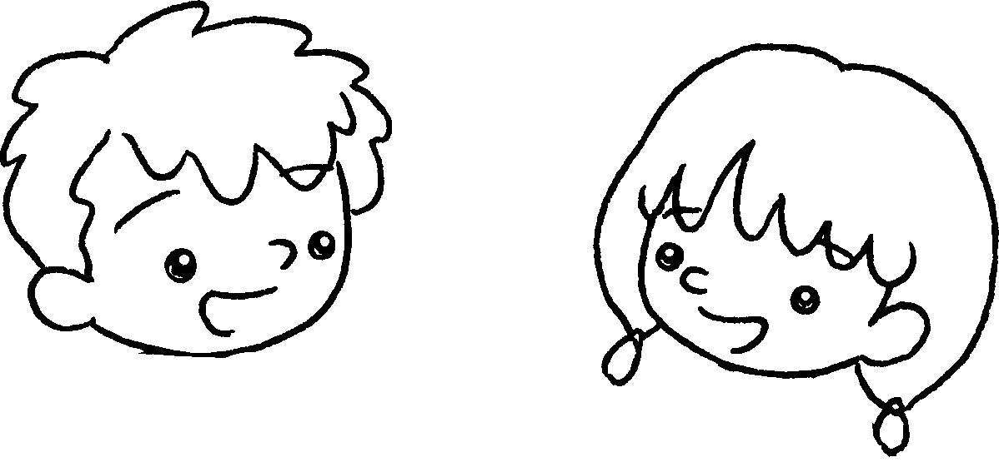 |  | A:  B : | Can you play table tennis?  , I .
3 | 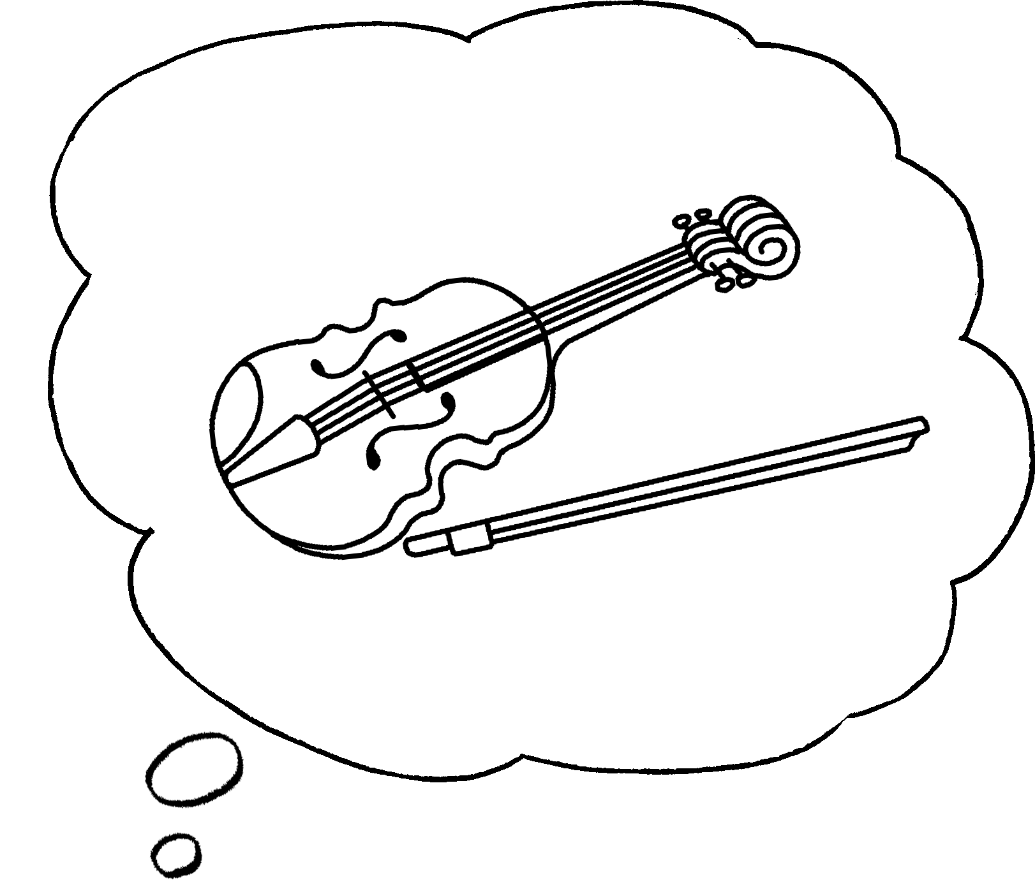  ✓  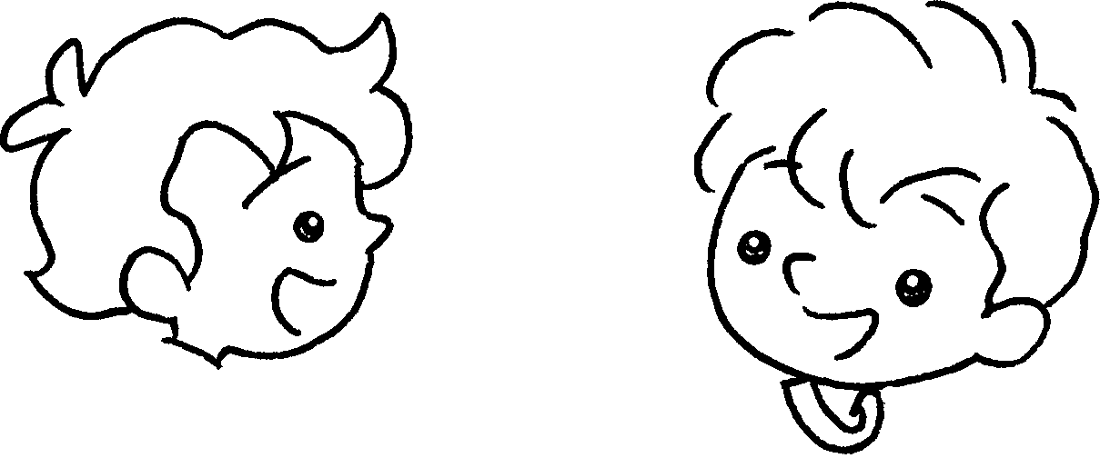 |  | A:  B : | you play the violin?  , I .
4 | 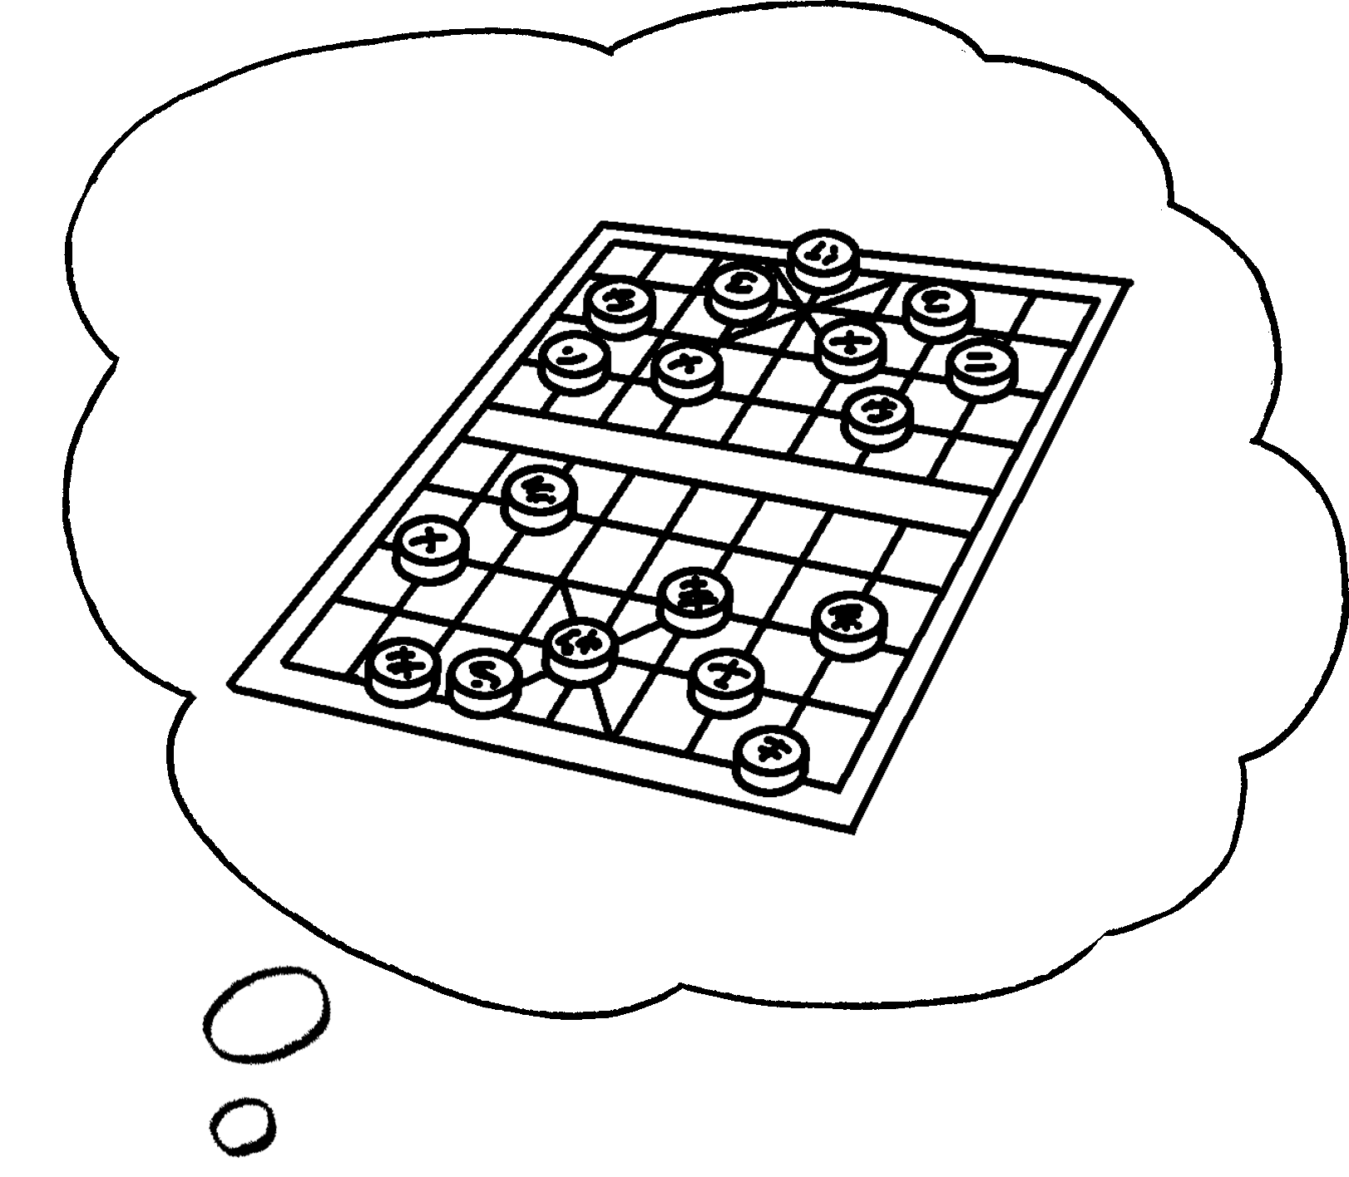  ✗  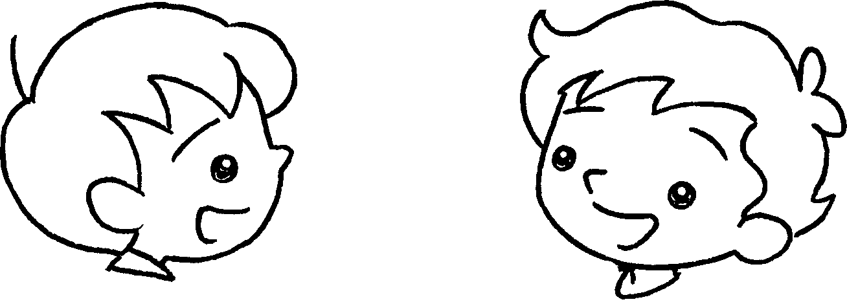 |  | A:  B : | you play Chinese chess?  , I .


Book 3A Chapter 6 Graded Worksheets
Worksheet 2⬇
1 No can’t
2 Yes can
3 Can
Yes can
- Can
No can’t

