Finish what the children say.
✗
B
A
B
A
A
B
B
A
1 | 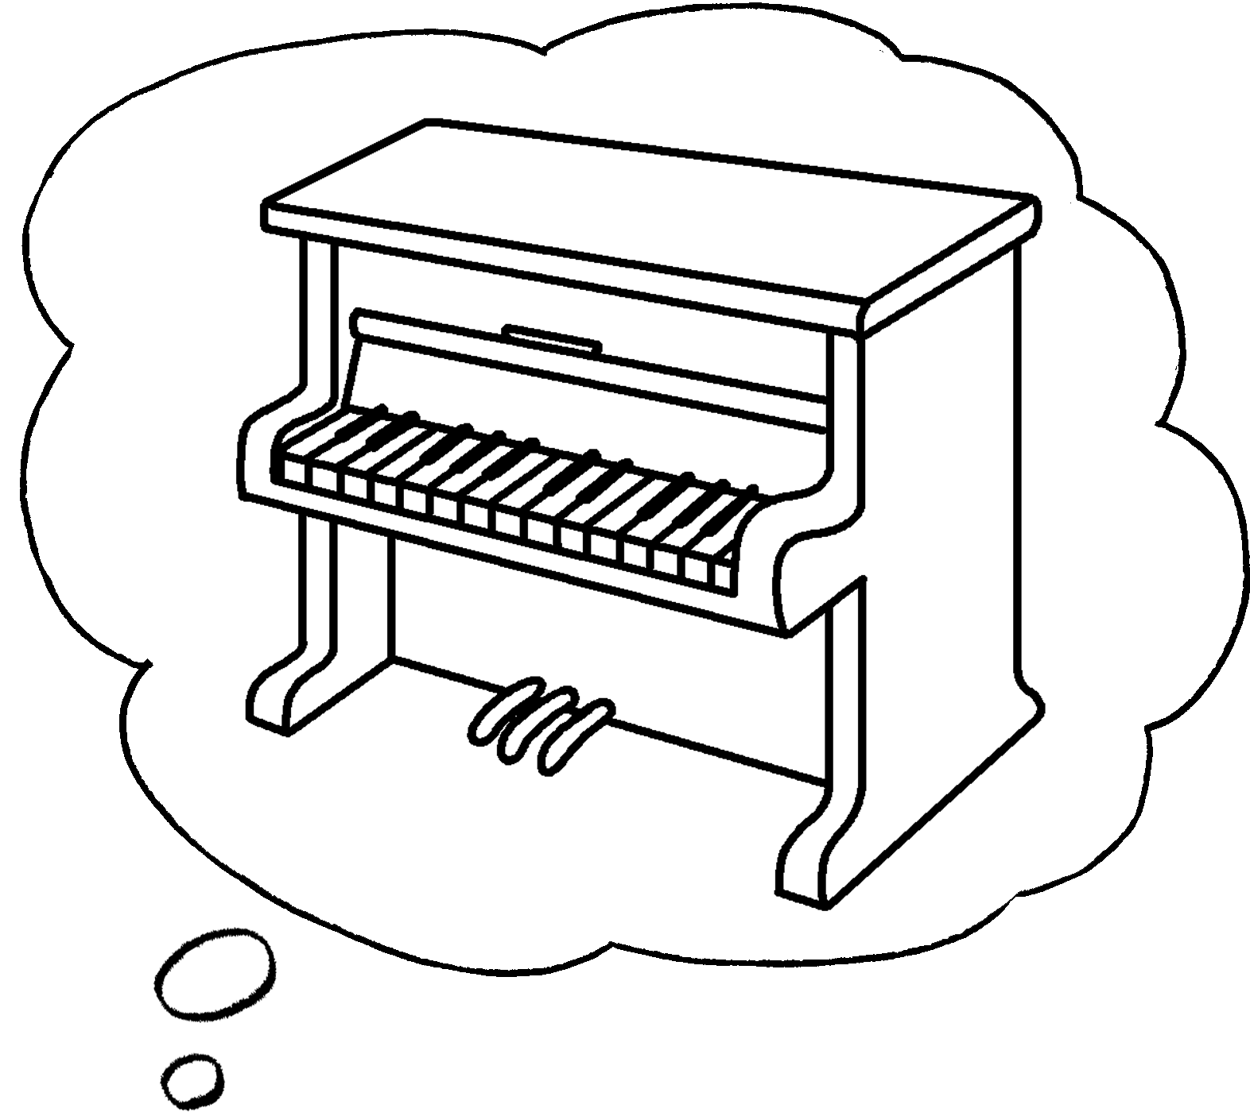  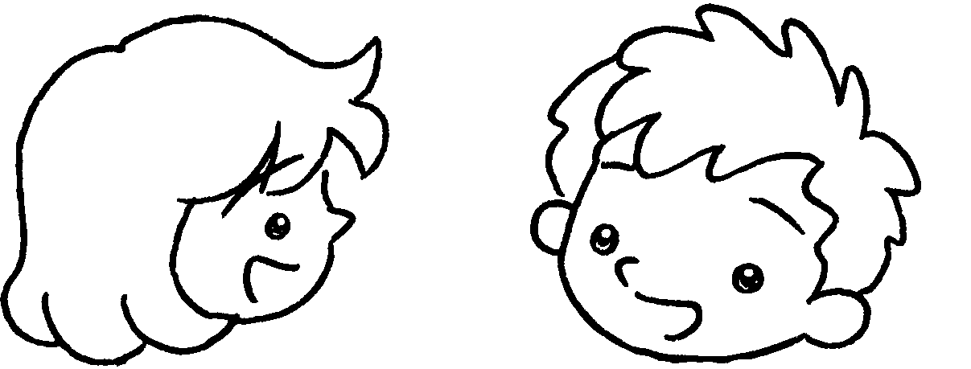 |  | A:  B : | Can you play the piano?  No, I .
2 | 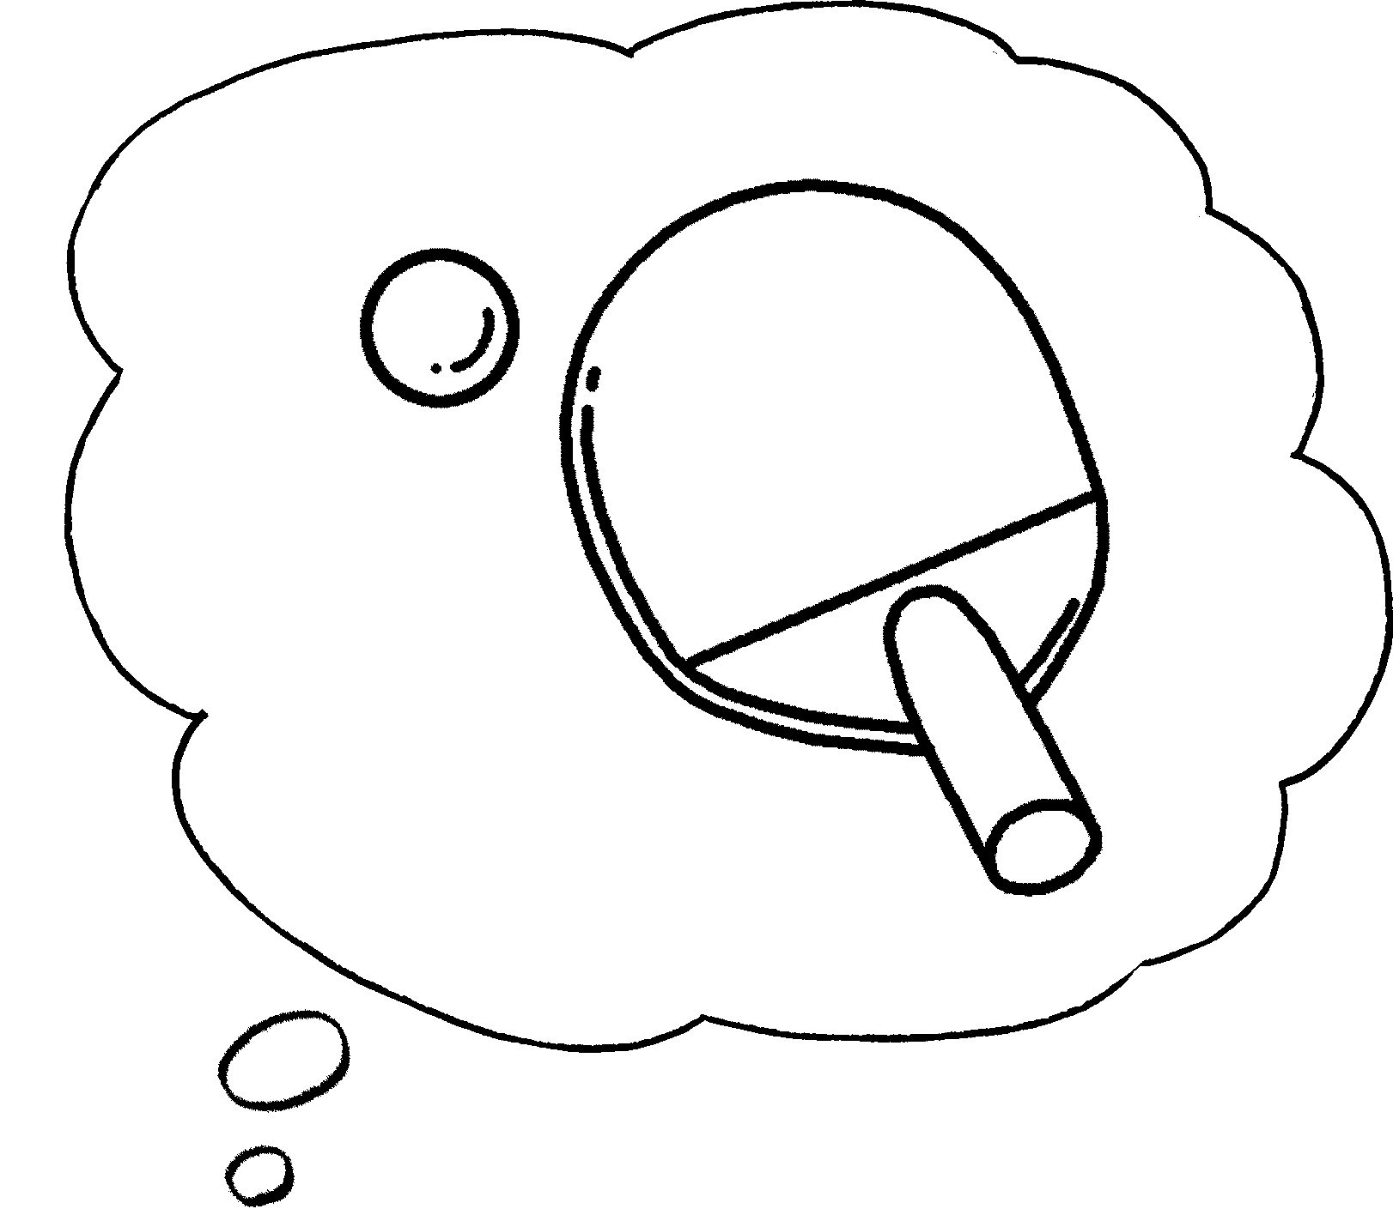  ✓  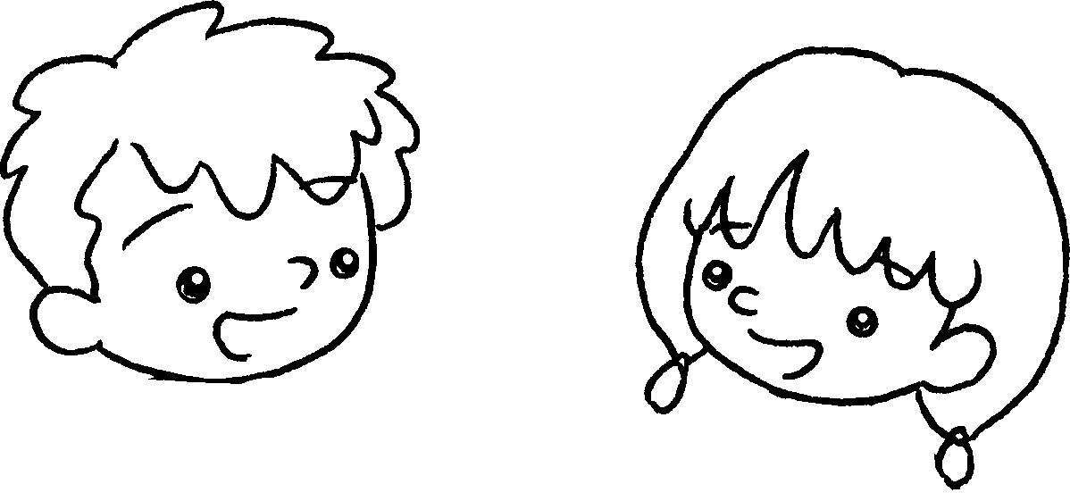 |  | A:  B : | Can you play ?  Yes, I .
3 | 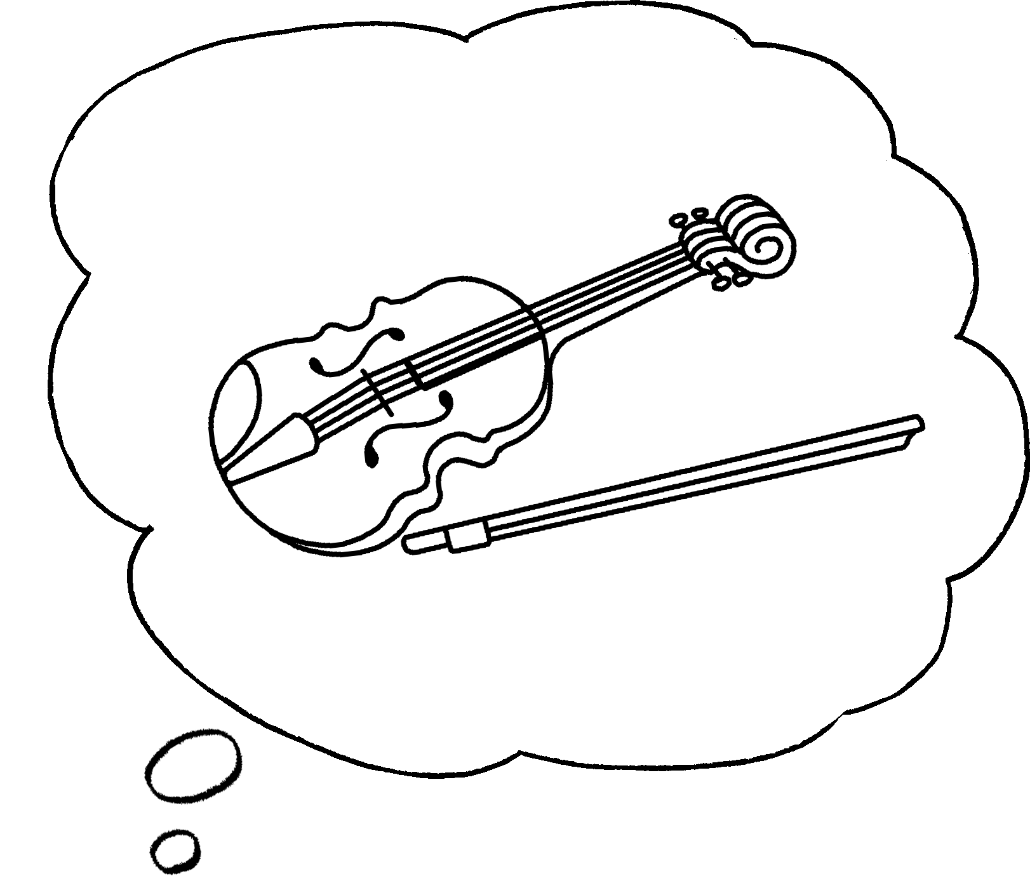  ✓  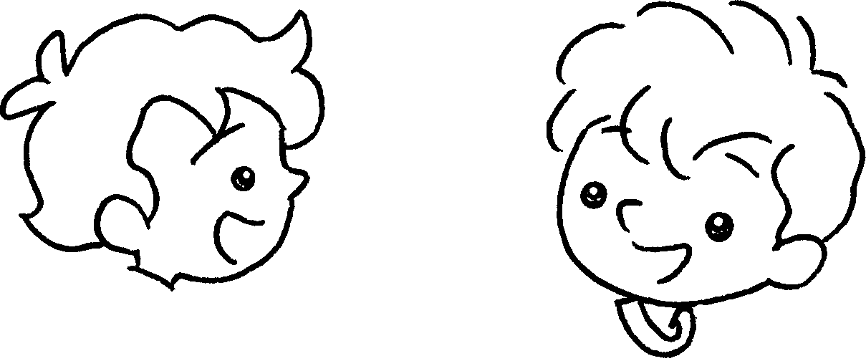 |  | A:  B : | you  ?
4 | 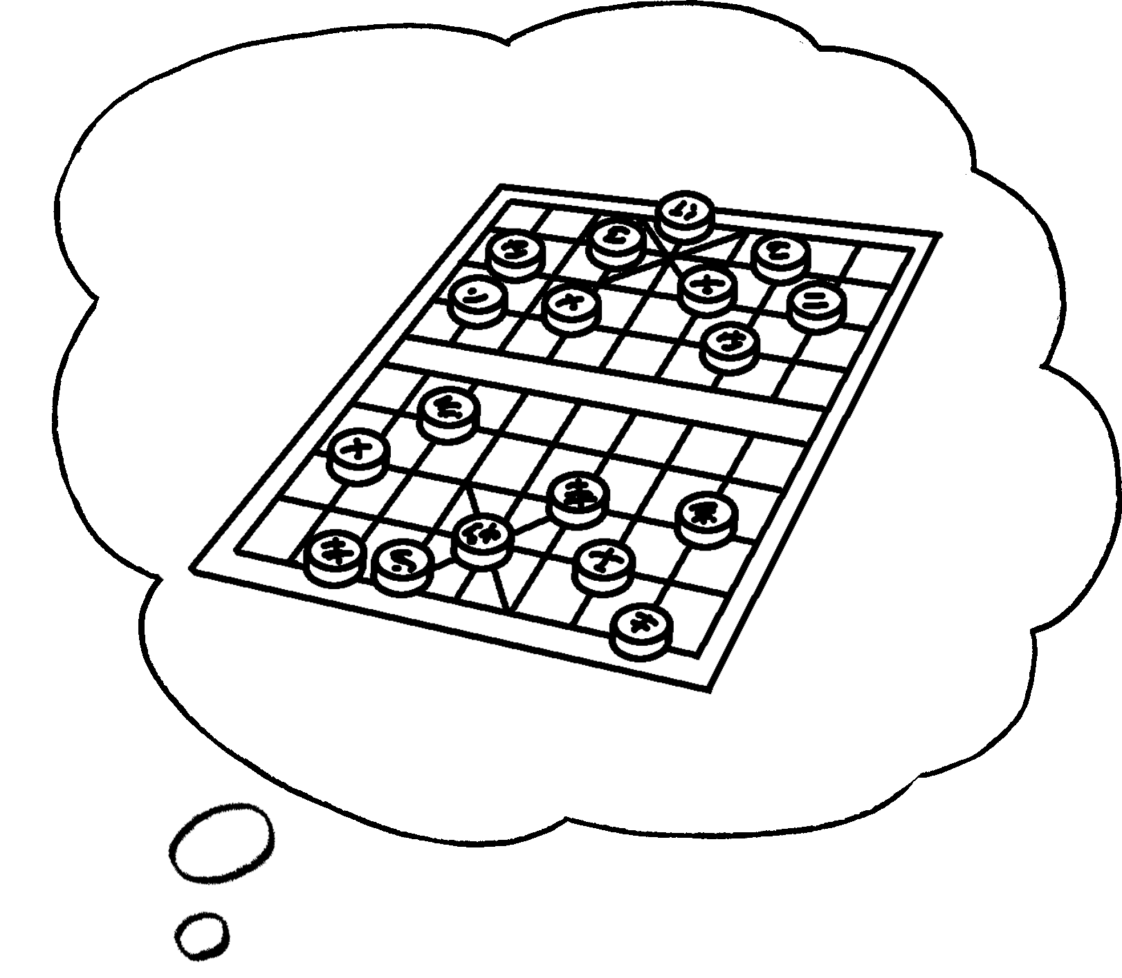  ✗  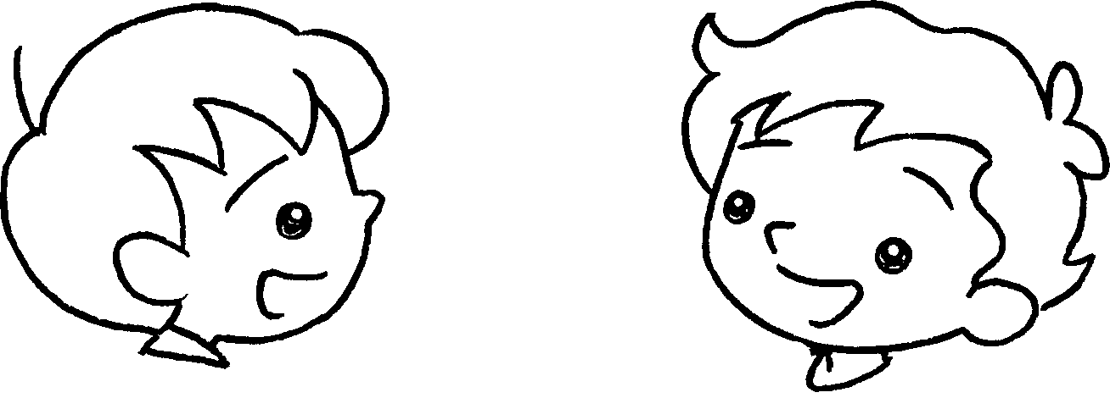 |  | A:  B :


Book 3A Chapter 6 Graded Worksheets
Worksheet 2⬇⬇⬇
- can’t
- table tennis
can
3 Can play the violin
Yes, I can.
4 Can you play Chinese chess?
No, I can’t.

