What can / can’t the children do? Write.

and | or | but

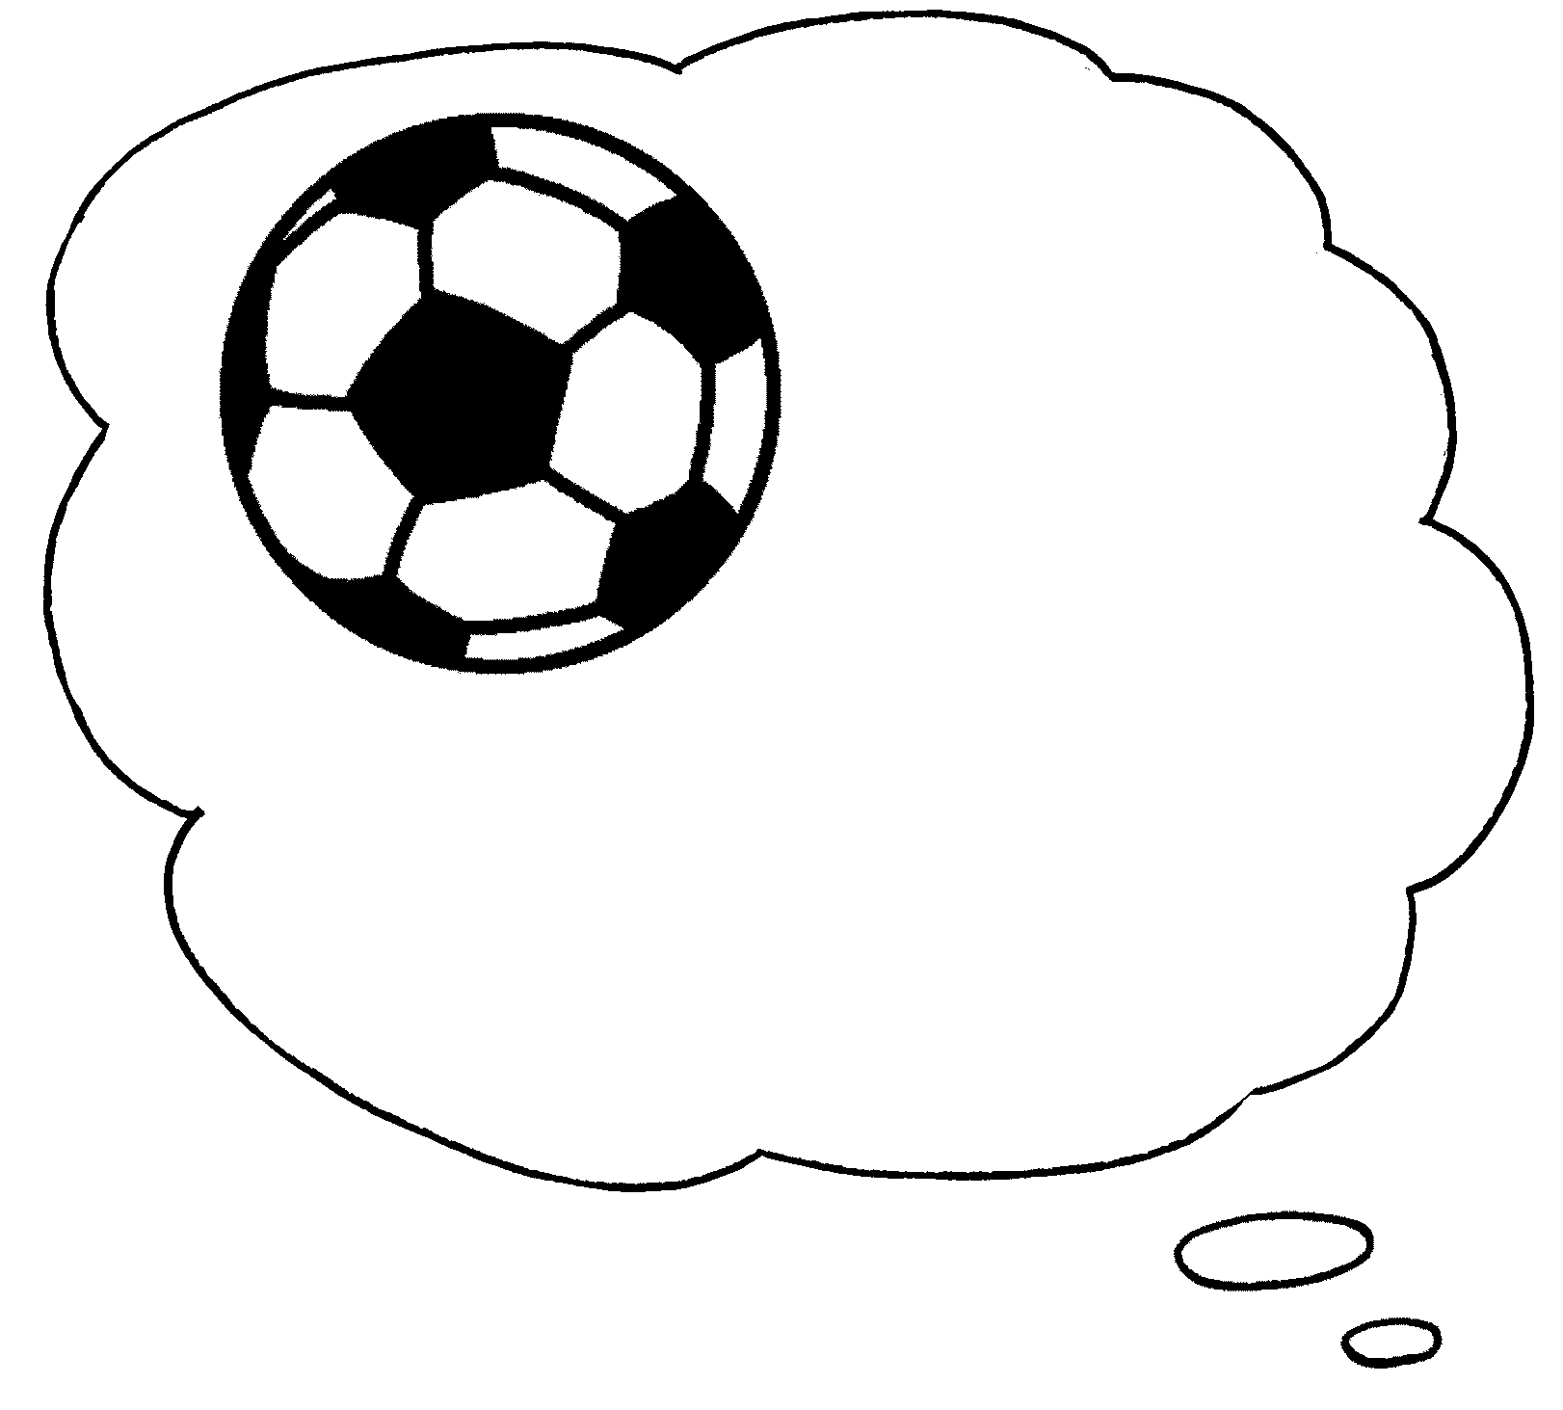  1 |   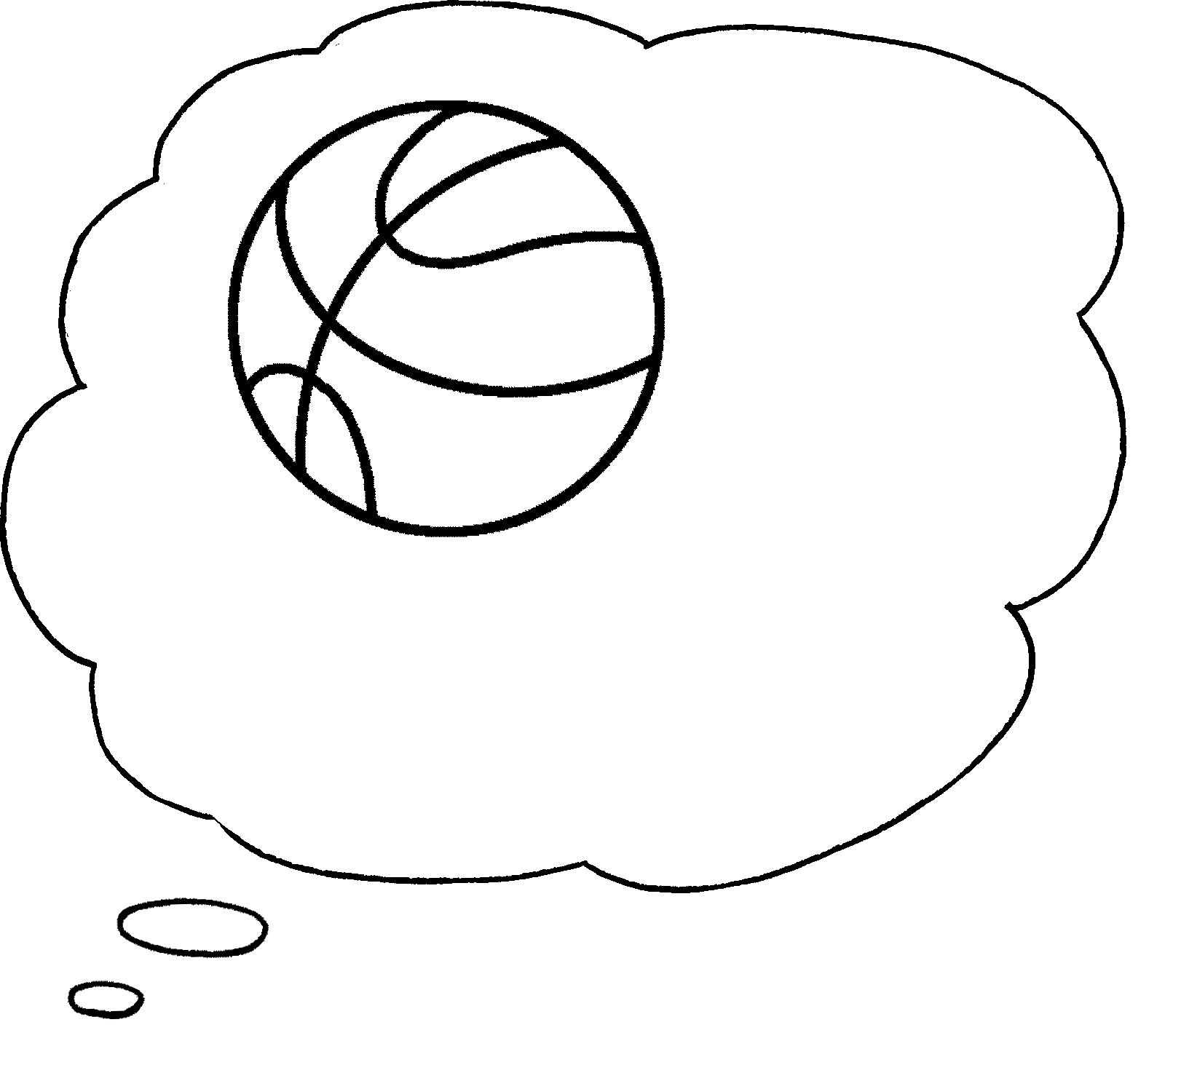  ✗  ✗ |  | I can’t play football ____________  _____________________ .
2 | 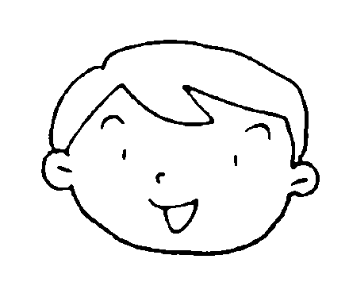  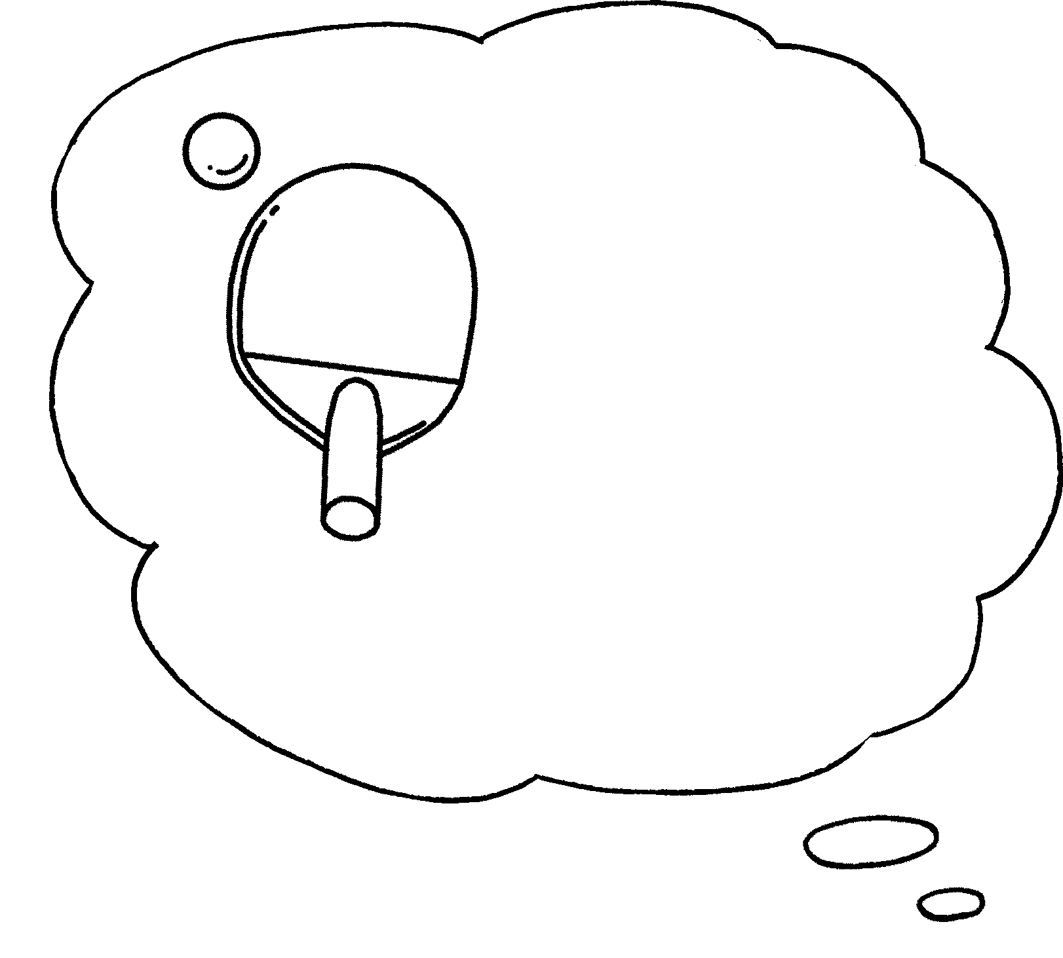  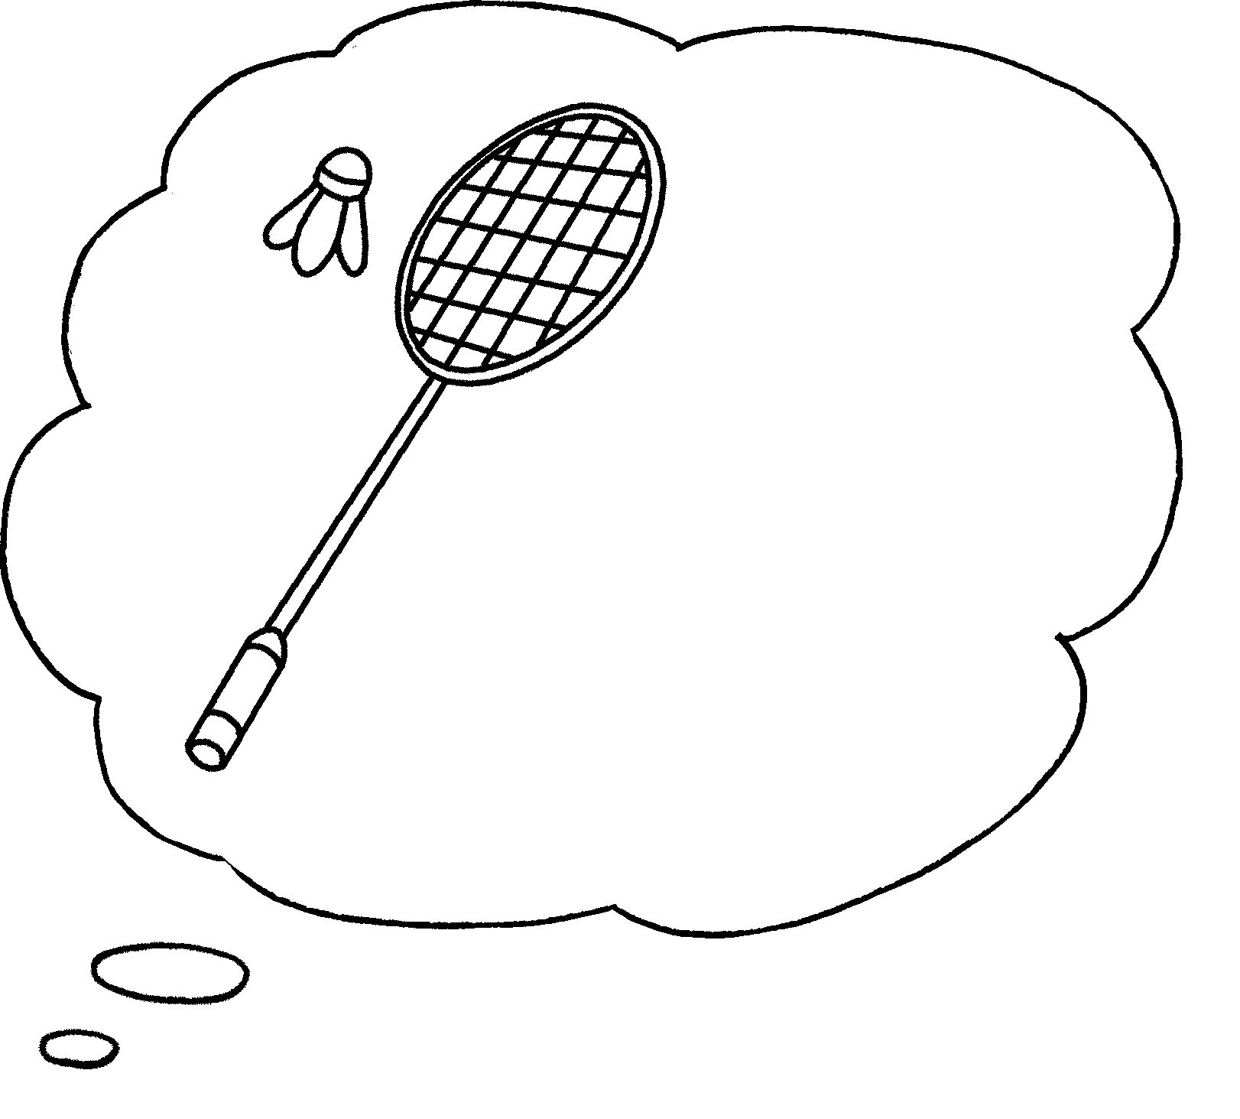  ✓  ✗ |  | I can play ______________________ I can’t ________________________ .
3 | 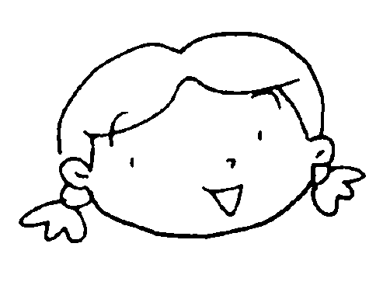  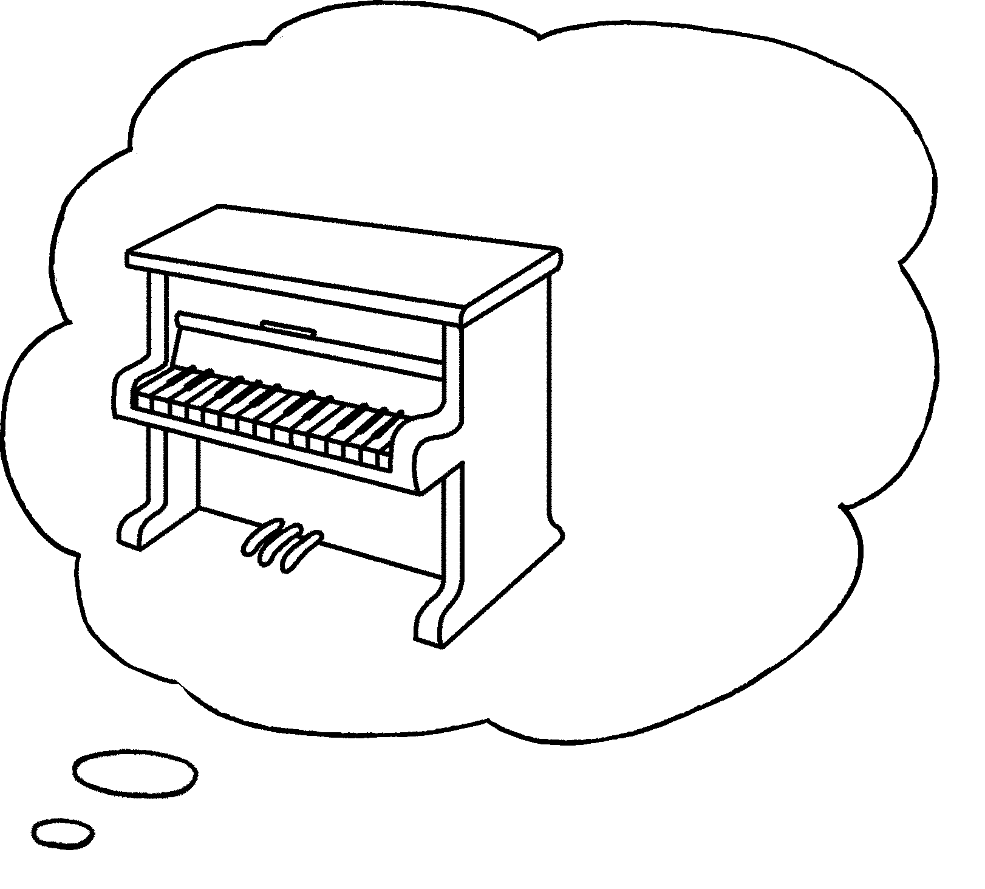  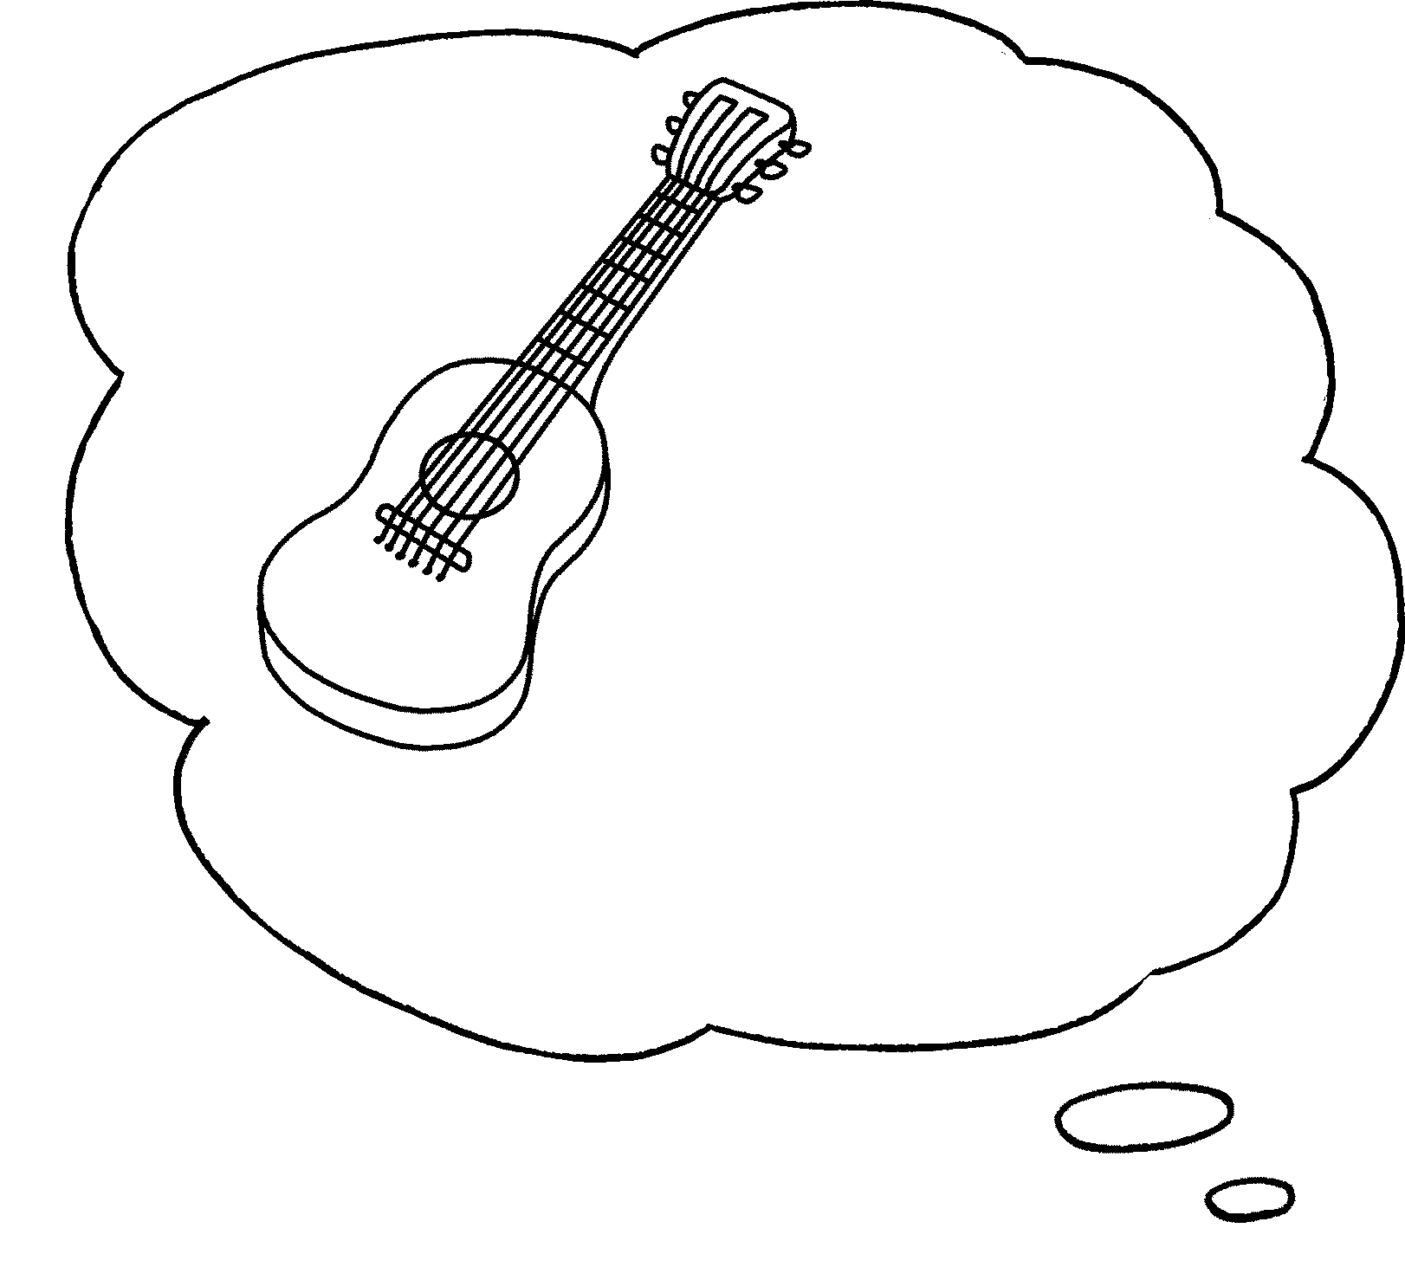  ✓  ✓ |  | I can __________________________  _______________________________ .
4 | 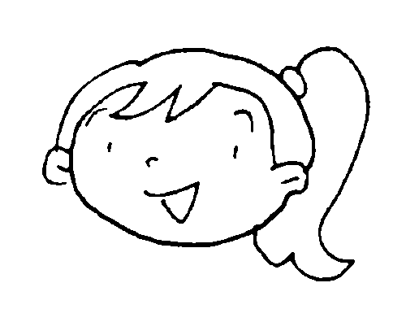  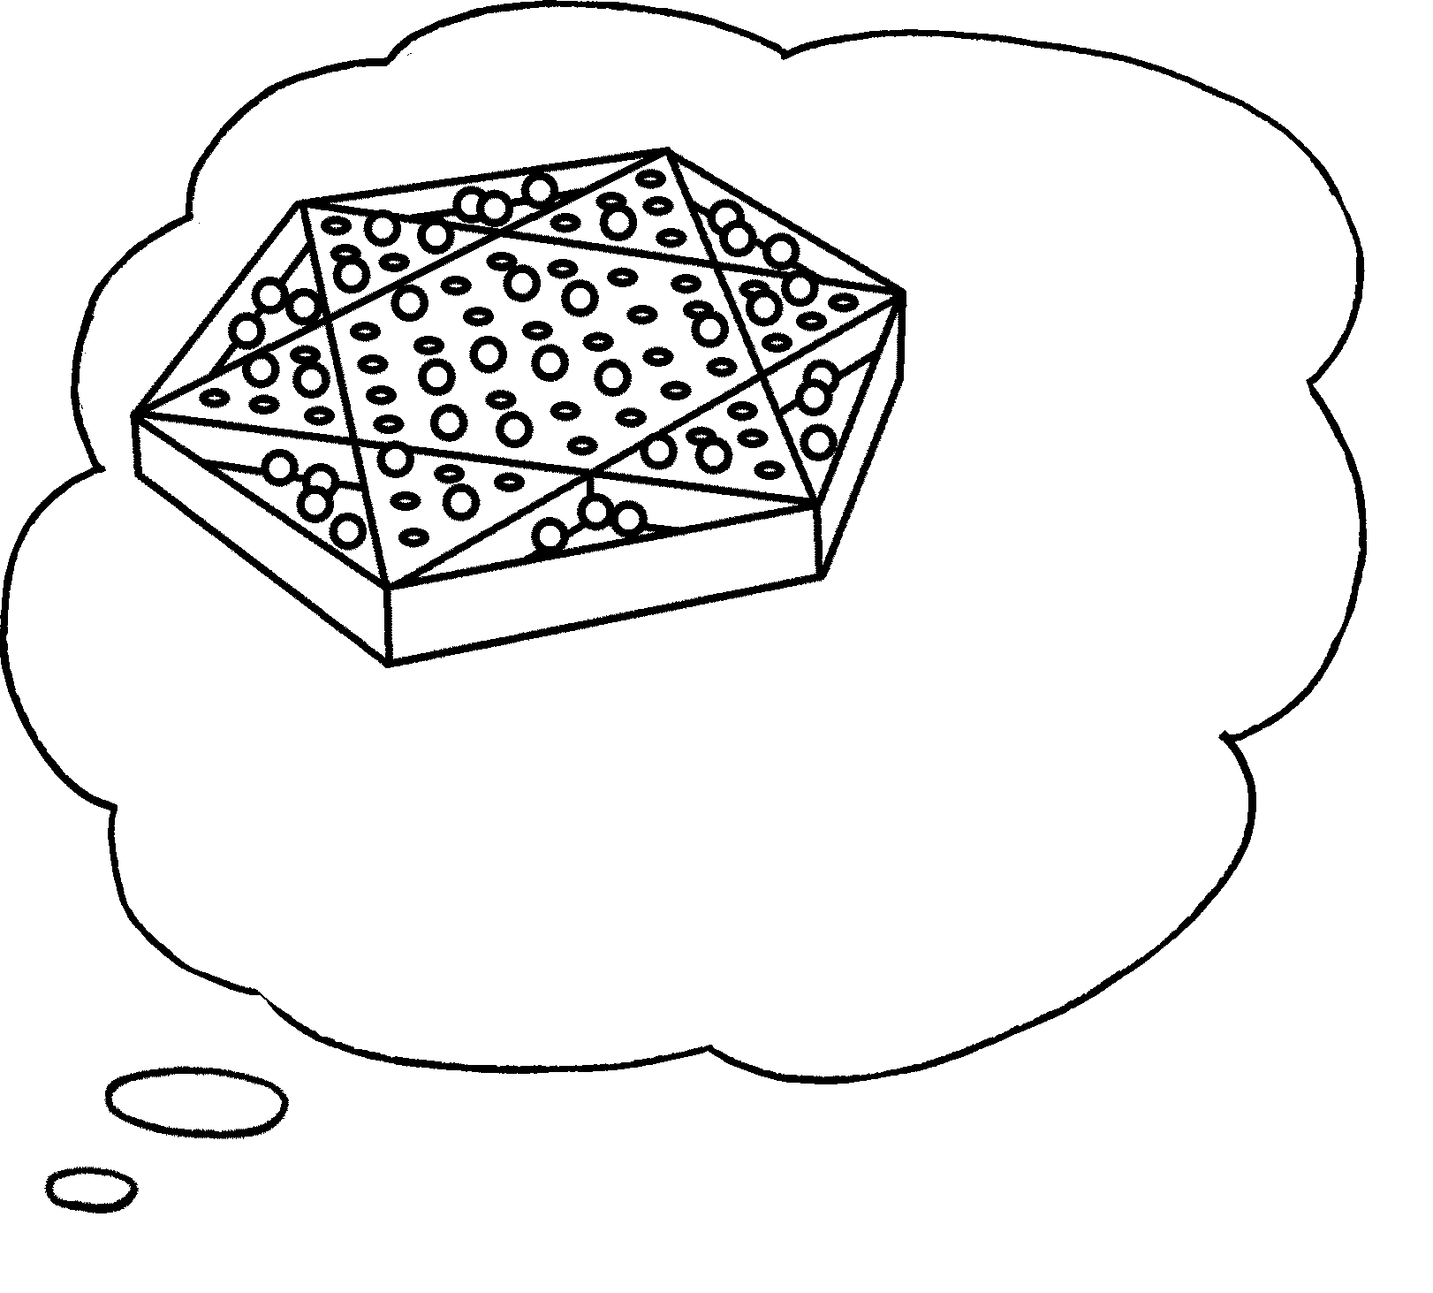  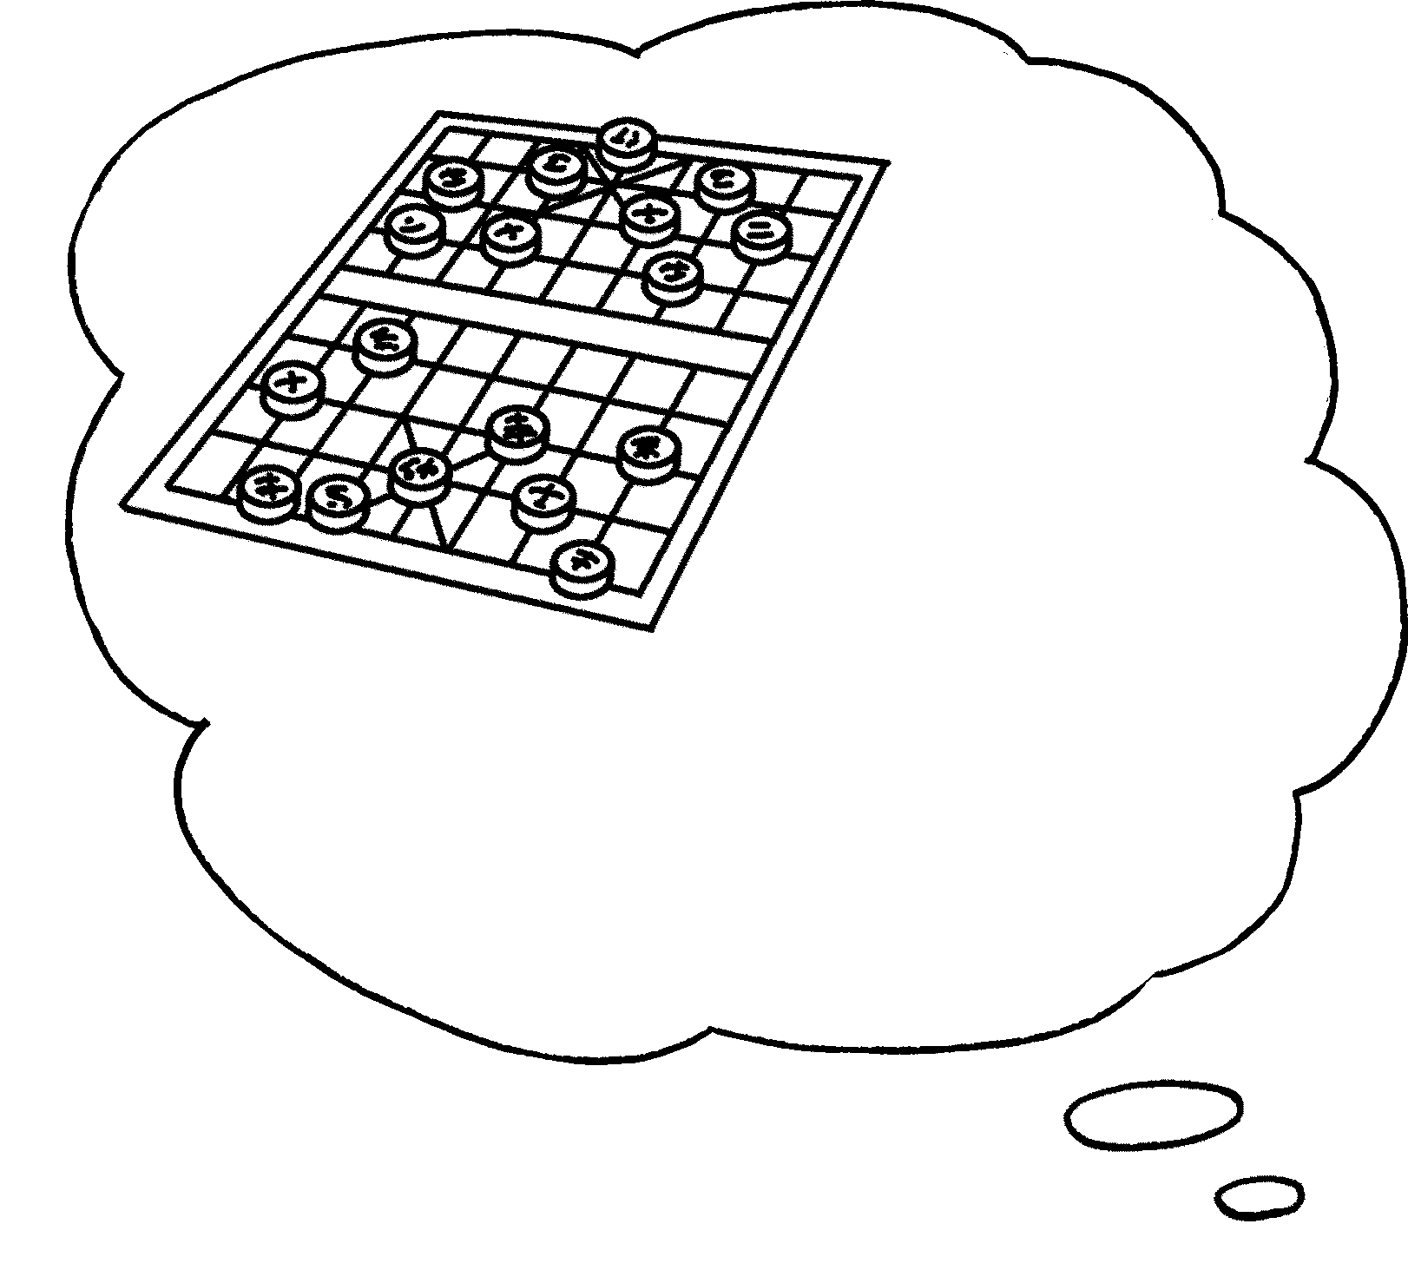  ✗  ✓ |  | I can’t _________________________  ________________________________  _______________________________ .


Book 3A Chapter 6 Graded Worksheets
Worksheet 3⬇⬇⬇
- or basketball
- table tennis but play badminton
- play the guitar and the piano
- play Chinese chess but I can play Chinese checkers

