6 What can we do?

Fun Fun Holiday Camp
Any plans for the holidays?
At our camps, we have many interesting activities!
Come and join us!
Sports Camp (Sai Kung)
You can play ball games, e.g. table tennis, basketball.
Chinese Chess Camp (Tai Po)
You can take Chinese chess classes and go to talks by winners of
the Hong Kong Chinese Chess Competition.
Music Camp (Sha Tin)
Music lovers can take music classes and play in a band.
Date: 26th−27th December
(Wednesday and Thursday)
For more information, please see Miss Leung at Rainbow Children’s Centre.
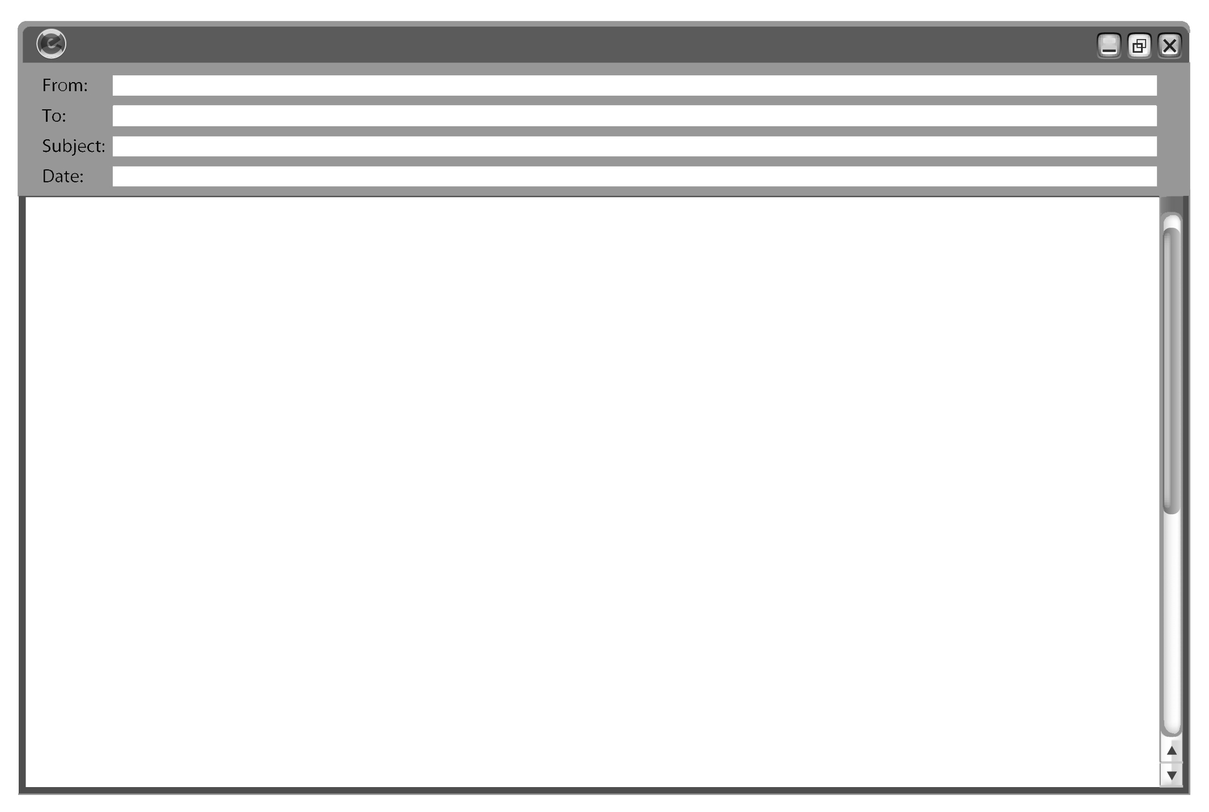
Eric
Jimmy
Fun Fun Holiday Camp
20/12/20XX
Hi Jimmy,
Are you free from 26th to 27th December? Do you want to go to Fun Fun Holiday Camp with me?
There are three camps for us to choose from ― Sports Camp, Chinese Chess Camp and Music Camp.
I don’t want to go to Music Camp because I’m not good at music. I can’t play the piano or the guitar. Can you play a musical instrument?
I want to go to Sports Camp because I’m good at sports. I can play basketball and table tennis. You are good at sports too. Do you want to go to Sports Camp? We can play ball games together.
Chinese Chess Camp also seems interesting. I can play Chinese chess but I’m not good at it. I can take classes at the camp. How about you? Which camp do you want to go to?
Please write soon!
From,
Eric


Write the answers and blacken  the circles.

1 How many camps are there to choose from?

2 Which camp(s) does Eric want to go to?

3 You cannot ___ at Sports Camp.
 A. play ball games
 B. play the piano
 C. play basketball
 D. play football

4 What is Eric good at? (You can choose more than one answer.)
 A. playing the guitar
 B. playing table tennis
 C. playing Chinese chess
 D. playing basketball

5 Why does Eric write the e-mail?
 A. He wants to go to a holiday camp with Jimmy.
 B. He wants to take music classes with Jimmy.
 C. He wants to play musical instruments with Jimmy.
 D. He wants to go to Fun Fun Holiday Camp on 20th
December.
Answers:
1 Three / 3. 2 Sports Camp and Chinese Chess Camp. 3 B 4 B, D 5 A

