- What can we do?
Eric wants to go on a camp during the school holidays. Which camp does he want to go to? Read the poster and the e-mail to find out.

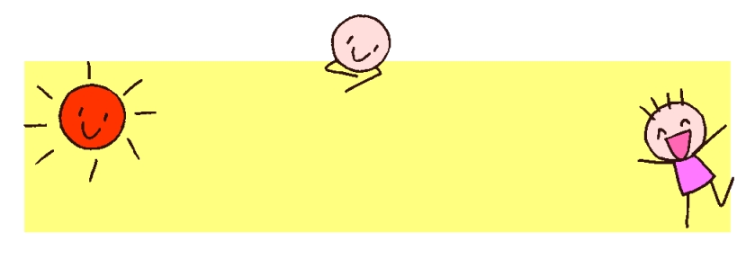
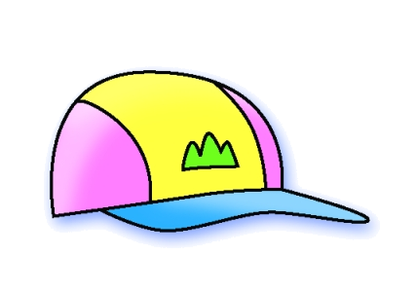
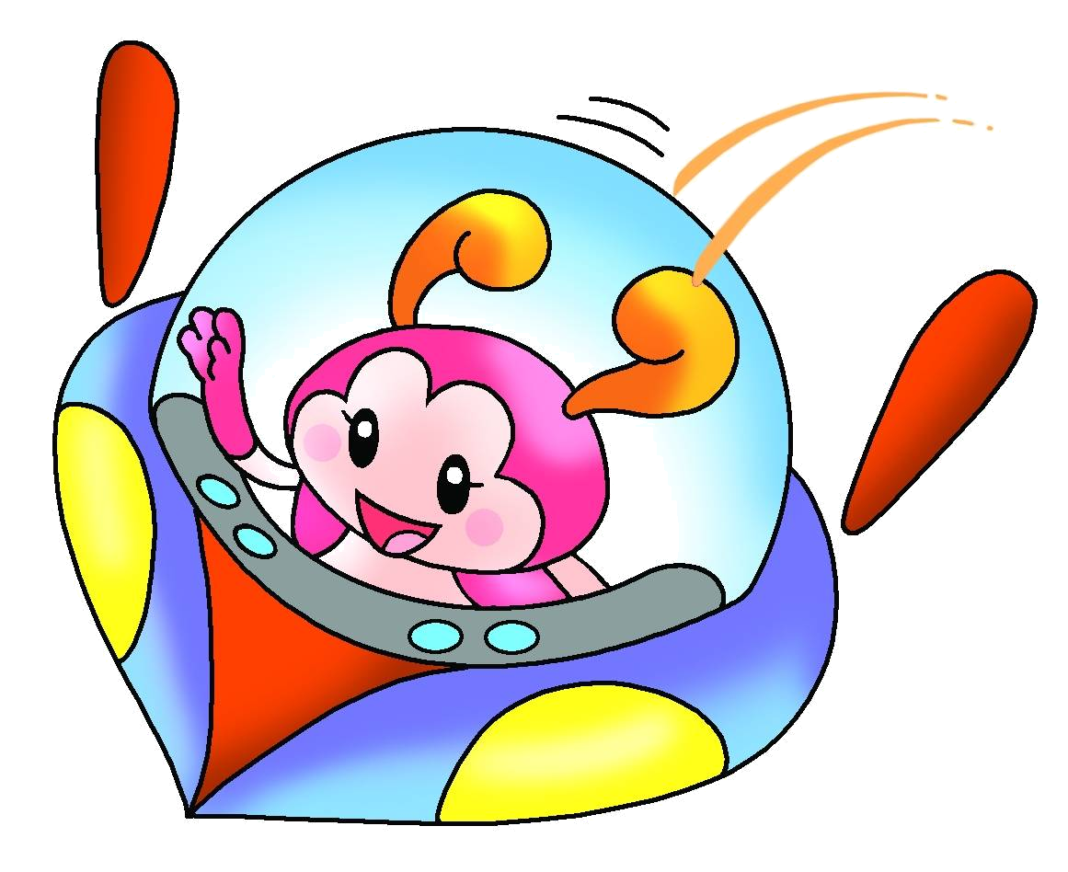
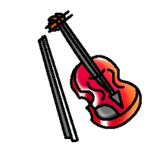
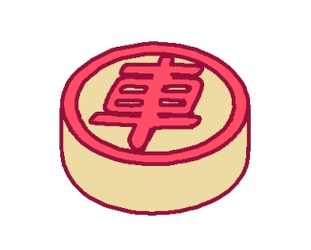

Fun Fun Holiday Camp
Sports Camp (Sai Kung)
You can play ball games, e.g. table tennis, basketball.
Chinese Chess Camp (Tai Po)
You can take Chinese chess classes and go to talks.
Music Camp (Sha Tin)
Music lovers can take music classes and play in a band.
Date: 26th−27th December
(Wednesday and Thursday)
For more information, please see Miss Leung at Rainbow Children’s Centre.

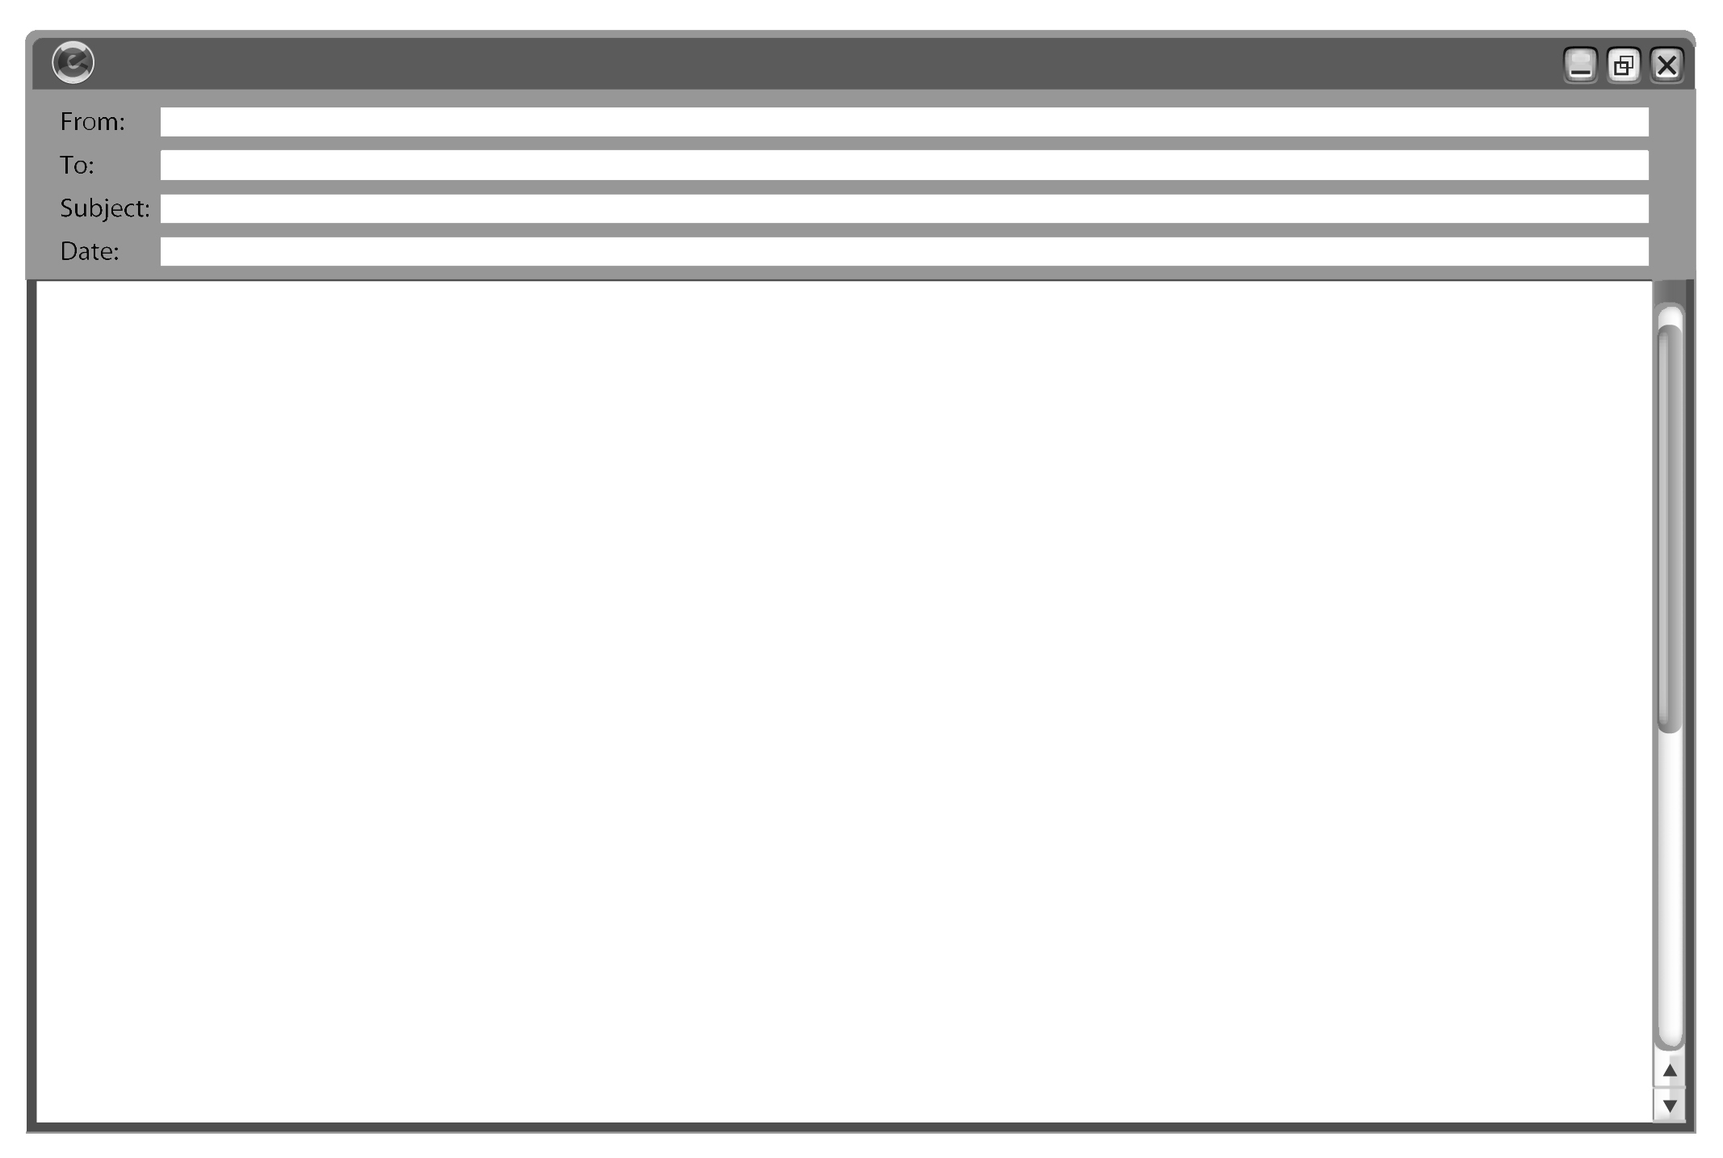
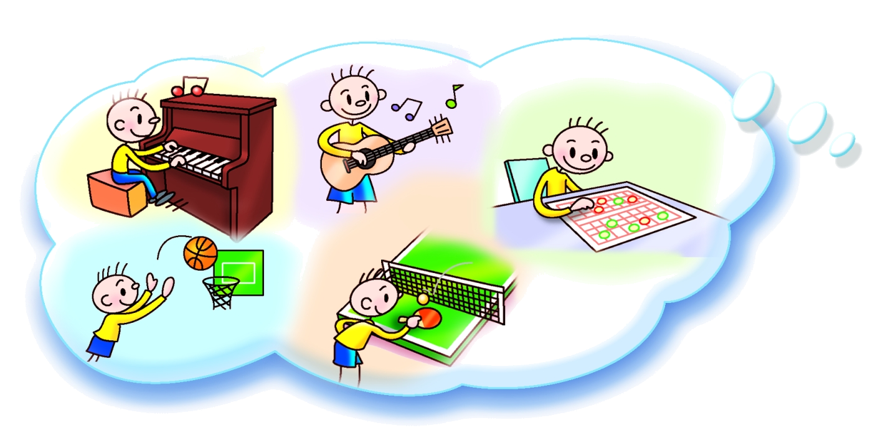

☒
☒
☑
☑
☑
Eric
Jimmy
Fun Fun Holiday Camp
20/12/20XX

Hi Jimmy,
Do you want to go to Fun Fun Holiday Camp?
There are three camps ― Sports Camp, Chinese Chess Camp and Music Camp.
I don’t want to go to Music Camp because I’m not good at music. I can’t play the piano or the guitar.
I want to go to Sports Camp because I’m good at sports. I can play basketball and table tennis. You are good at sports too. Do you want to go to Sports Camp together?
I can play Chinese chess but I’m not good at it. I can take classes at Chinese Chess Camp. How about you? Which camp do you want to go to?
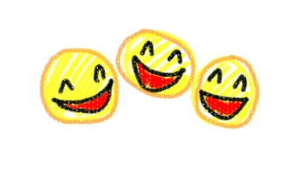
Write soon!
From,
Eric

