Task — Writing an e-mail to a friend about a camp

1 Answer these questions.
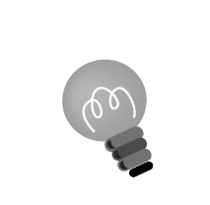
Hint: Don’t write complete sentences. Just write some notes or draw pictures.
- Which classes do you want to take? Why?

- Are you good at music or sports? Do you want to enter the contests?

- What do you want to do on 24/12? Why?
2 Now write an e-mail to your friend about the camp. Use your notes.
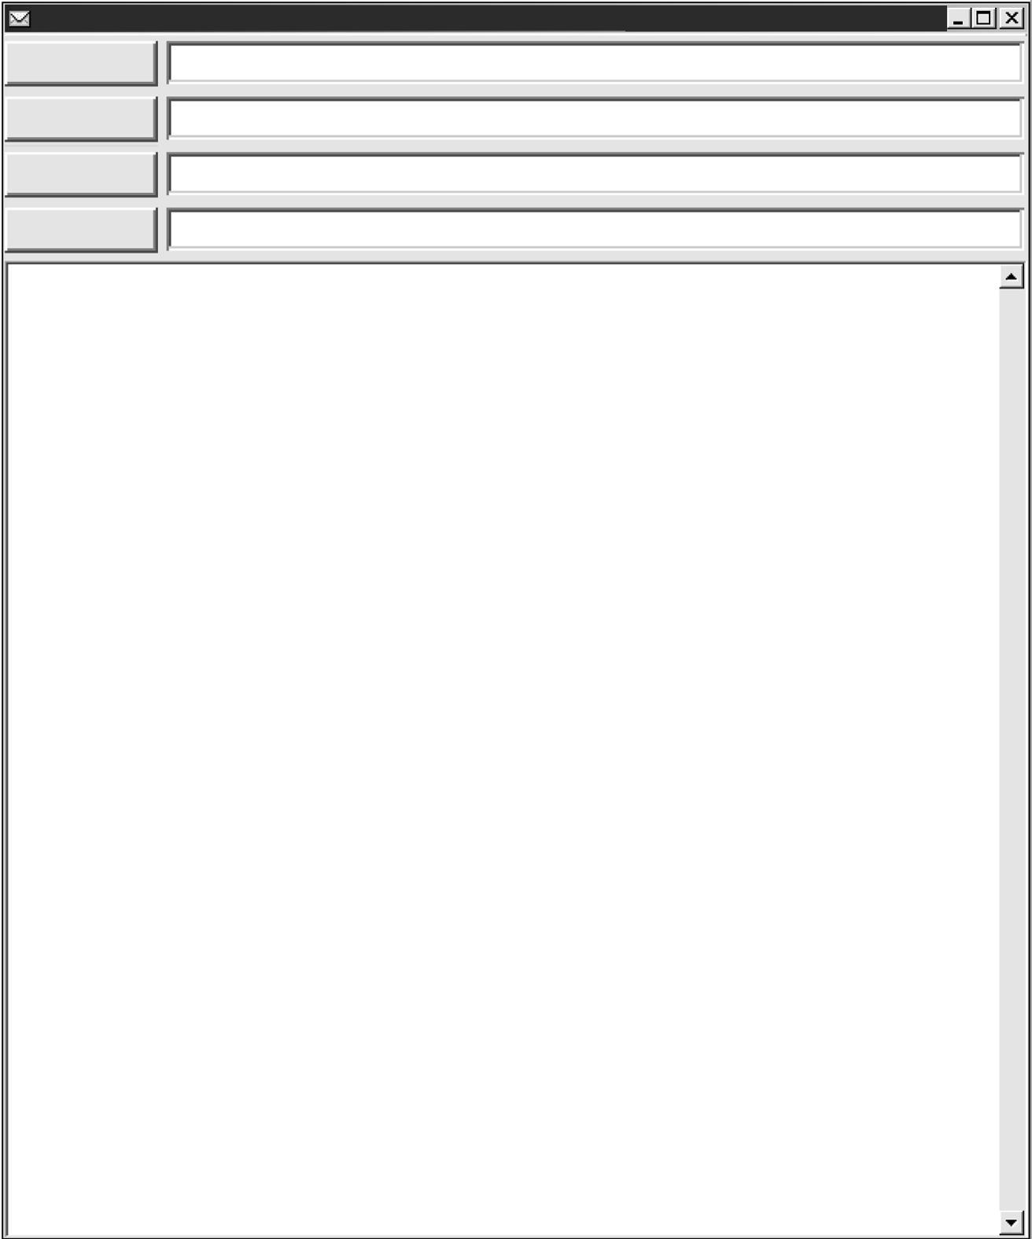
From:
Date:
To:
Subject:
Say Hi / Hello in an e-mail to friends.
___________________,

I want to go to Joyful Christmas Camp with you. The
camp is from _______________________________.
Are you free at that time?

At the camp, we can take classes. I want to take the __________________________________________
__________________________________________
__________________________________________
We can enter contests too. I’m _________________
__________________________________________
__________________________________________
There are other activities to do at the camp. We can
__________________________________________
__________________________________________
Do you want to go to the camp? Let’s go together!

Write soon.

From,
___________________
Write your name here.
- Try to link the sentences with and, but, or.
- Try to give reasons with because.

Checklist for Ch 6 Task

Check your writing and tick (✓ ).

Checking for myself | ☺ ☺ | ☺ | ☹
- I can write an e-mail using the guiding questions.
- I can use my own words to write ideas.
- I can spell all the words (check spellings using the textbook).
- I can write the correct dates and months (e.g. 23rd December, 25th December).
- I can use connectives (e.g. and, but, or, because) to link ideas.
- I can use capital letters to begin names of festivals and months (e.g. Christmas, December).

Now ask your partner to check your writing and tick (✓ ).

Checking by ( _________________ ) | ☺ ☺ | ☺ | ☹
- Do I understand my partner’s e-mail?
- Does my partner spell all the words correctly?
- Does my partner write the correct dates and months?
- Does my partner use connectives correctly to link ideas?
- Does my partner use capital letters to begin names of festivals and months?

Remember to make changes to your writing before you hand it in.

