What subjects are they? Fill in the missing letters.

1 | 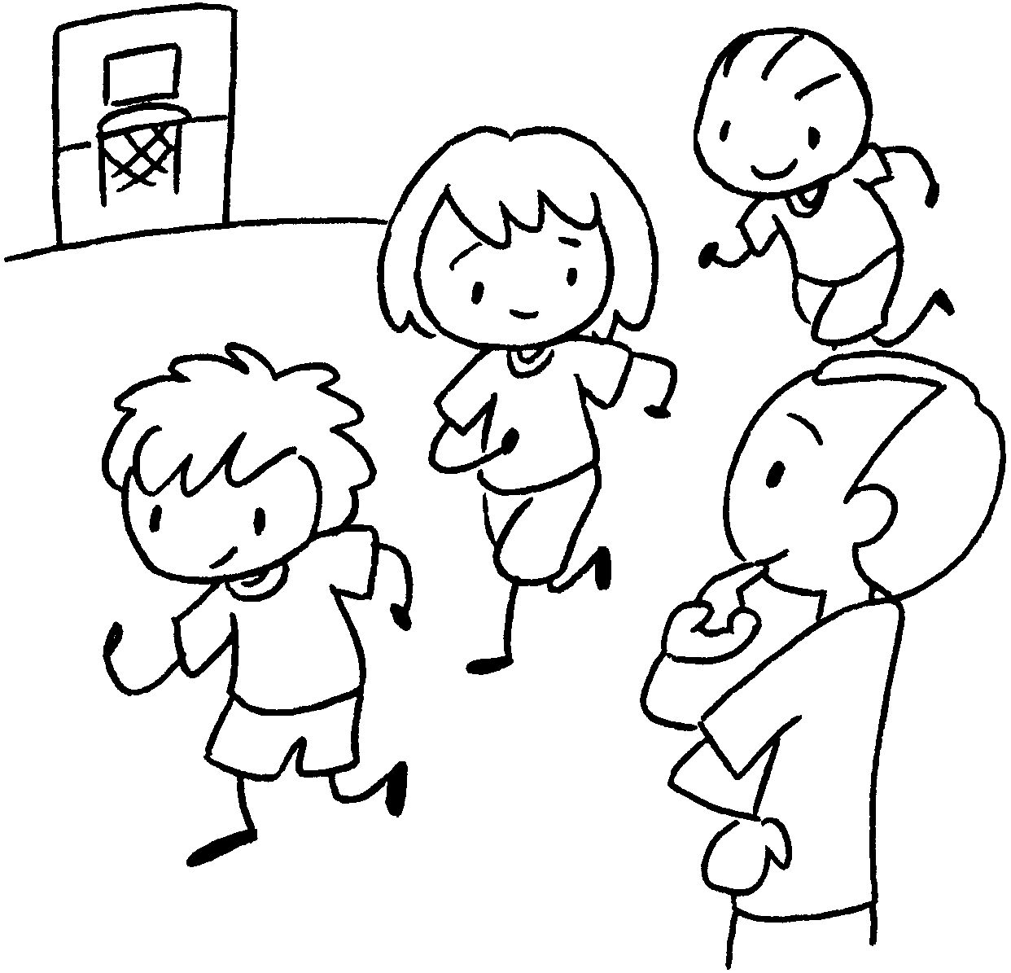 | 2 |  | 3 | 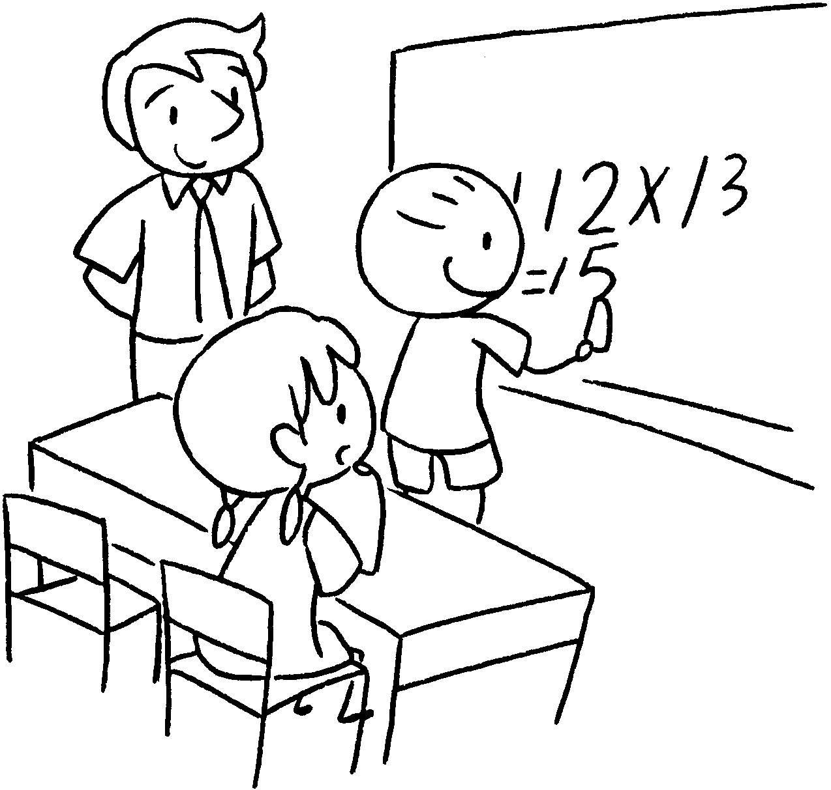
4 | 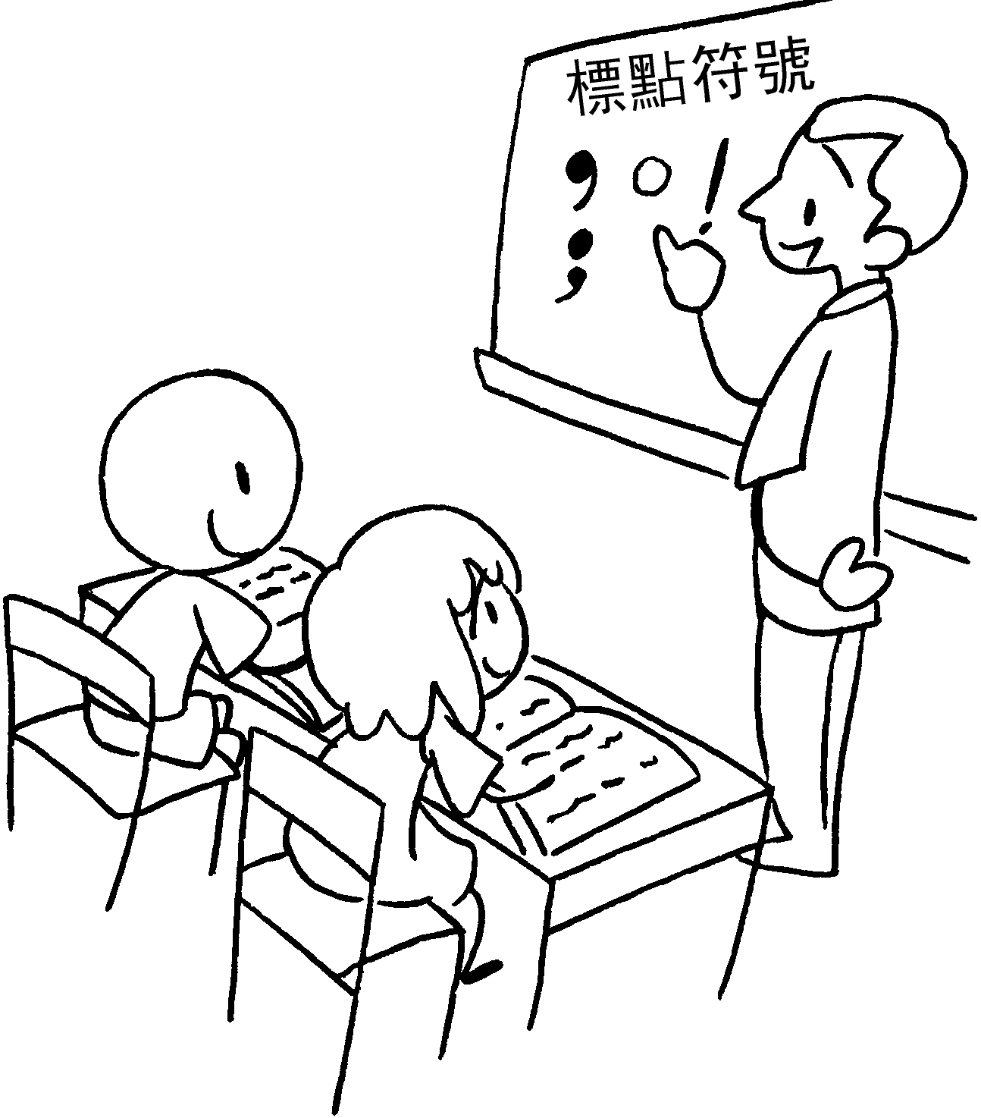 | 5 | 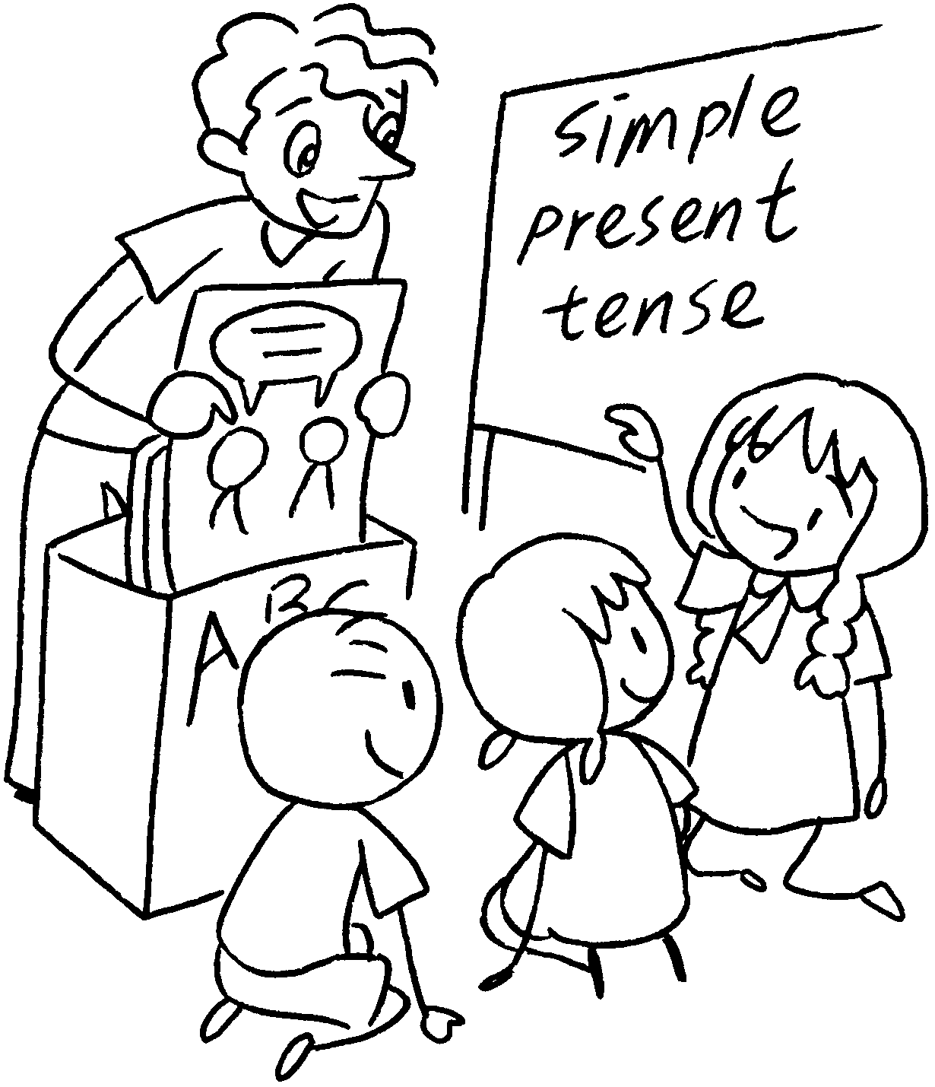 | 6 | 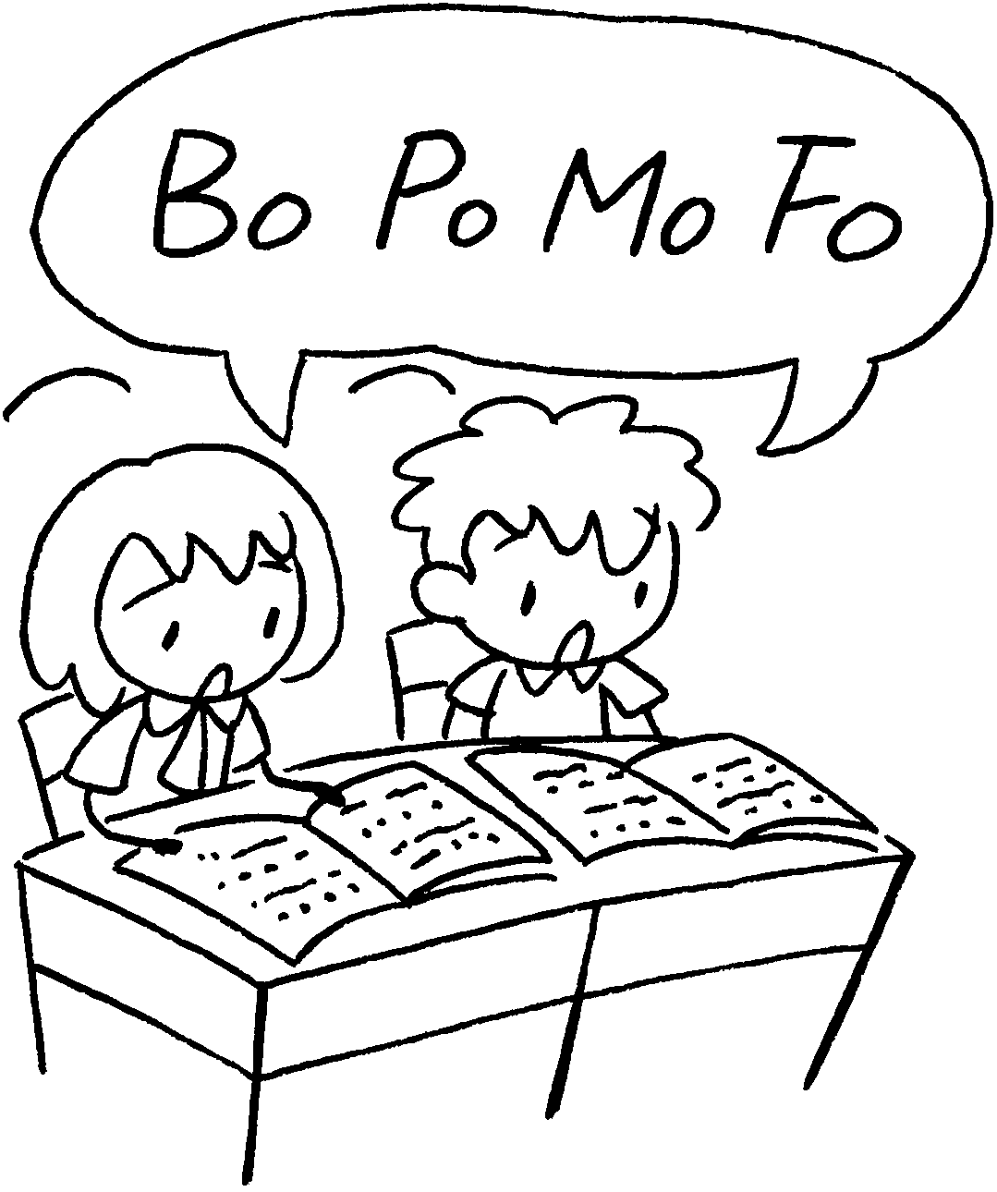
7 |  | 8 | 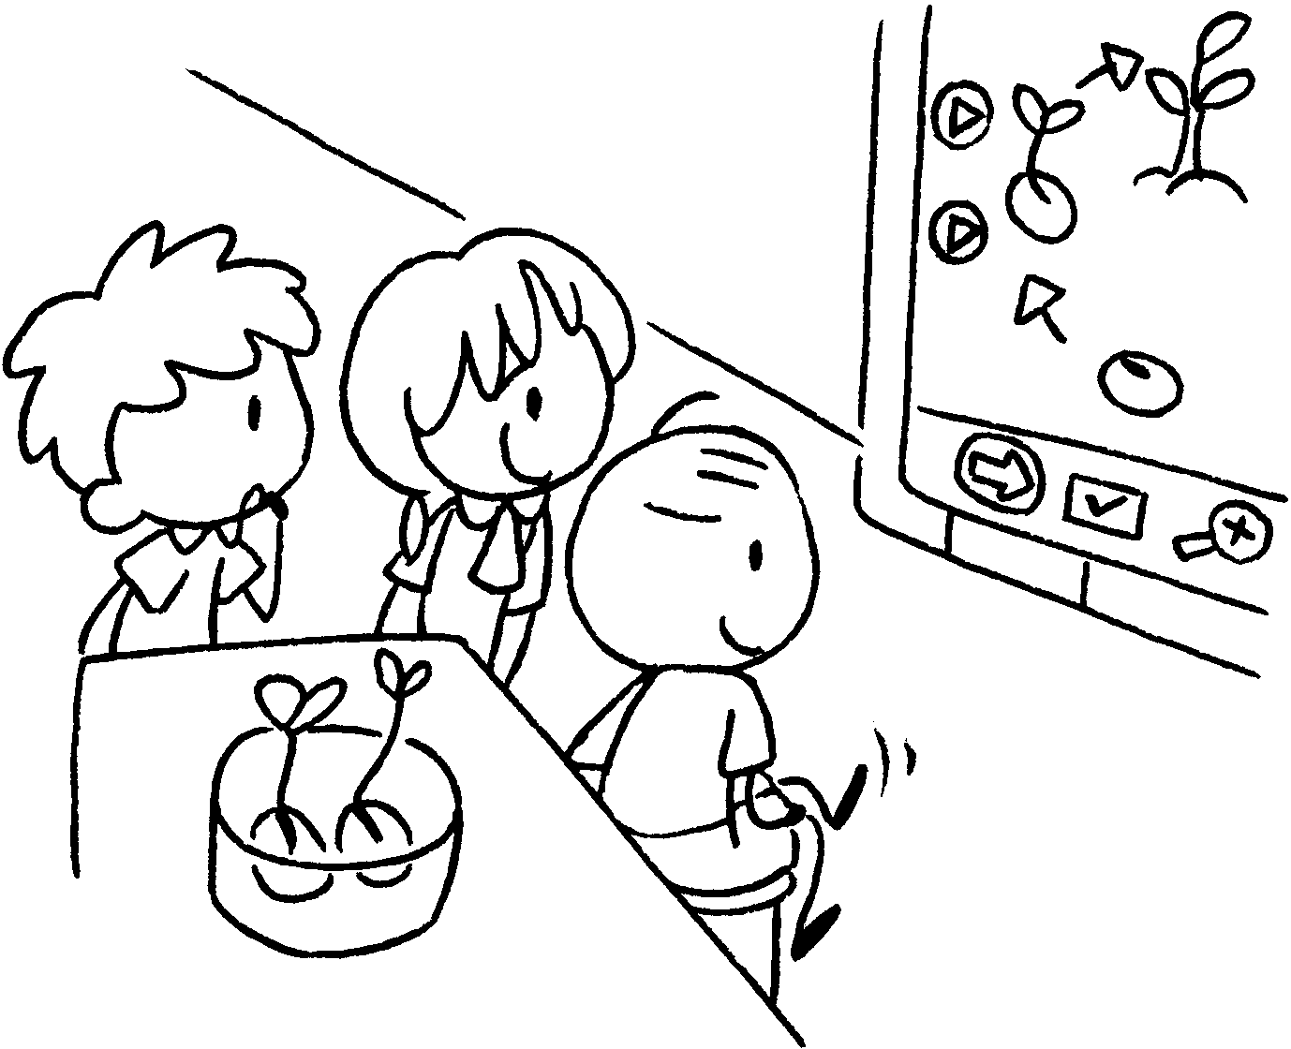 | 9 | 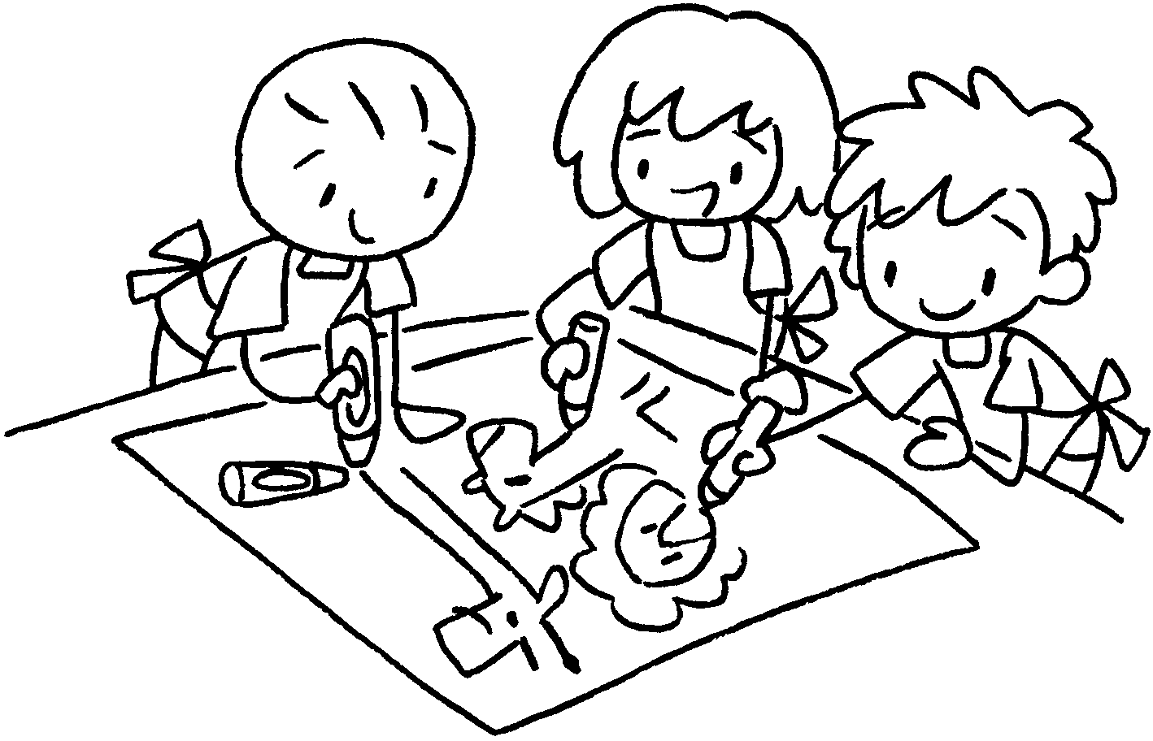

1 | P __ | 2 | M __ __ __ __
3 | M __ __ __ __ | 4 | C __ __ __ __ __ __
5 | E __ __ __ __ __ __ | 6 | P __ __ __ __ __ __ __ __
7 | C __ __ __ __ __ __ __  S __ __ __ __ __ __ | 8 | G __ __ __ __ __ __  S __ __ __ __ __ __
9 | V __ __ __ __ __ A __ __ __


Book 3B Chapter 1 Graded Worksheets
Worksheet 1⬇⬇
1 P E 2 M u s i c
3 M a t h s 4 C h i n e s e
5 E n g l i s h 6 P u t o n g h u a
7 C o m p u t e r S t u d i e s 8 G e n e r a l S t u d i e s
9 V i s u a l A r t s

