What subjects are they? Write.

1 | 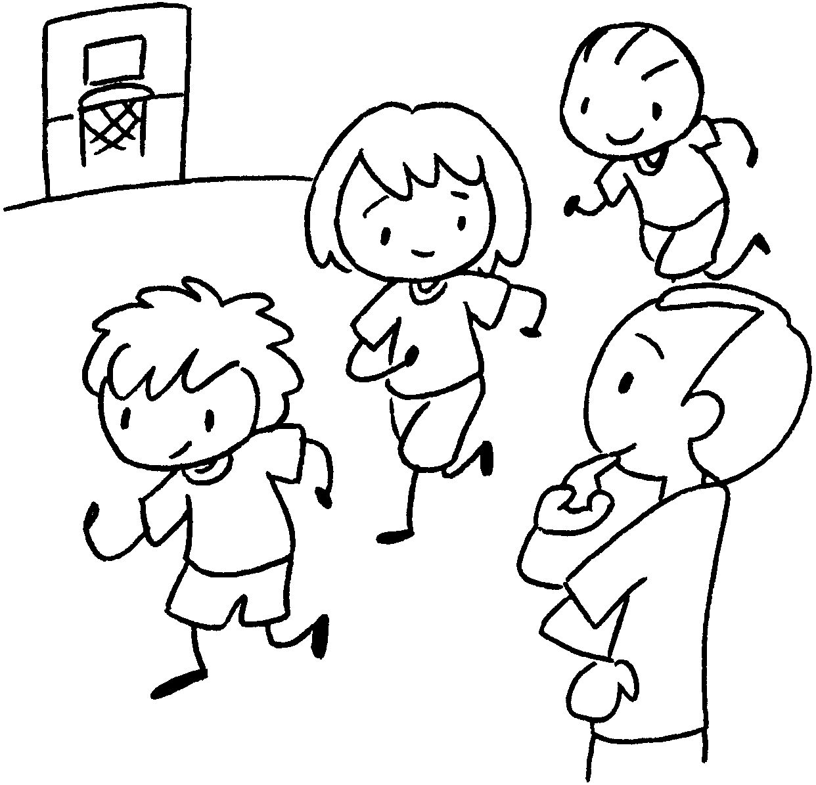 | 2 | 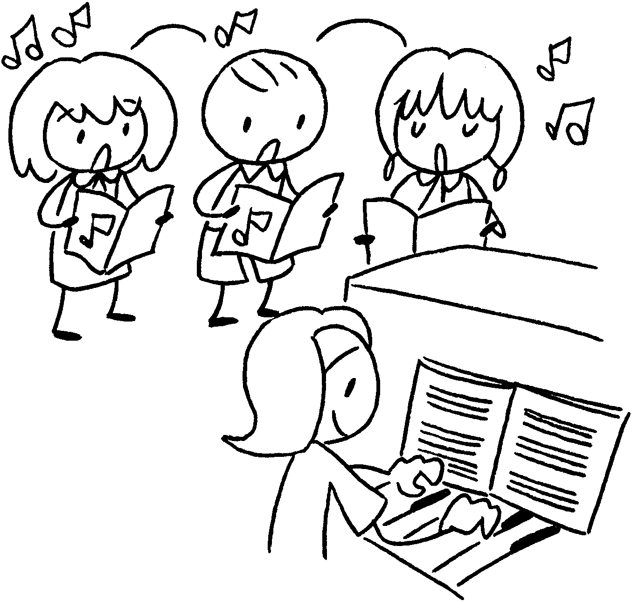 | 3 | 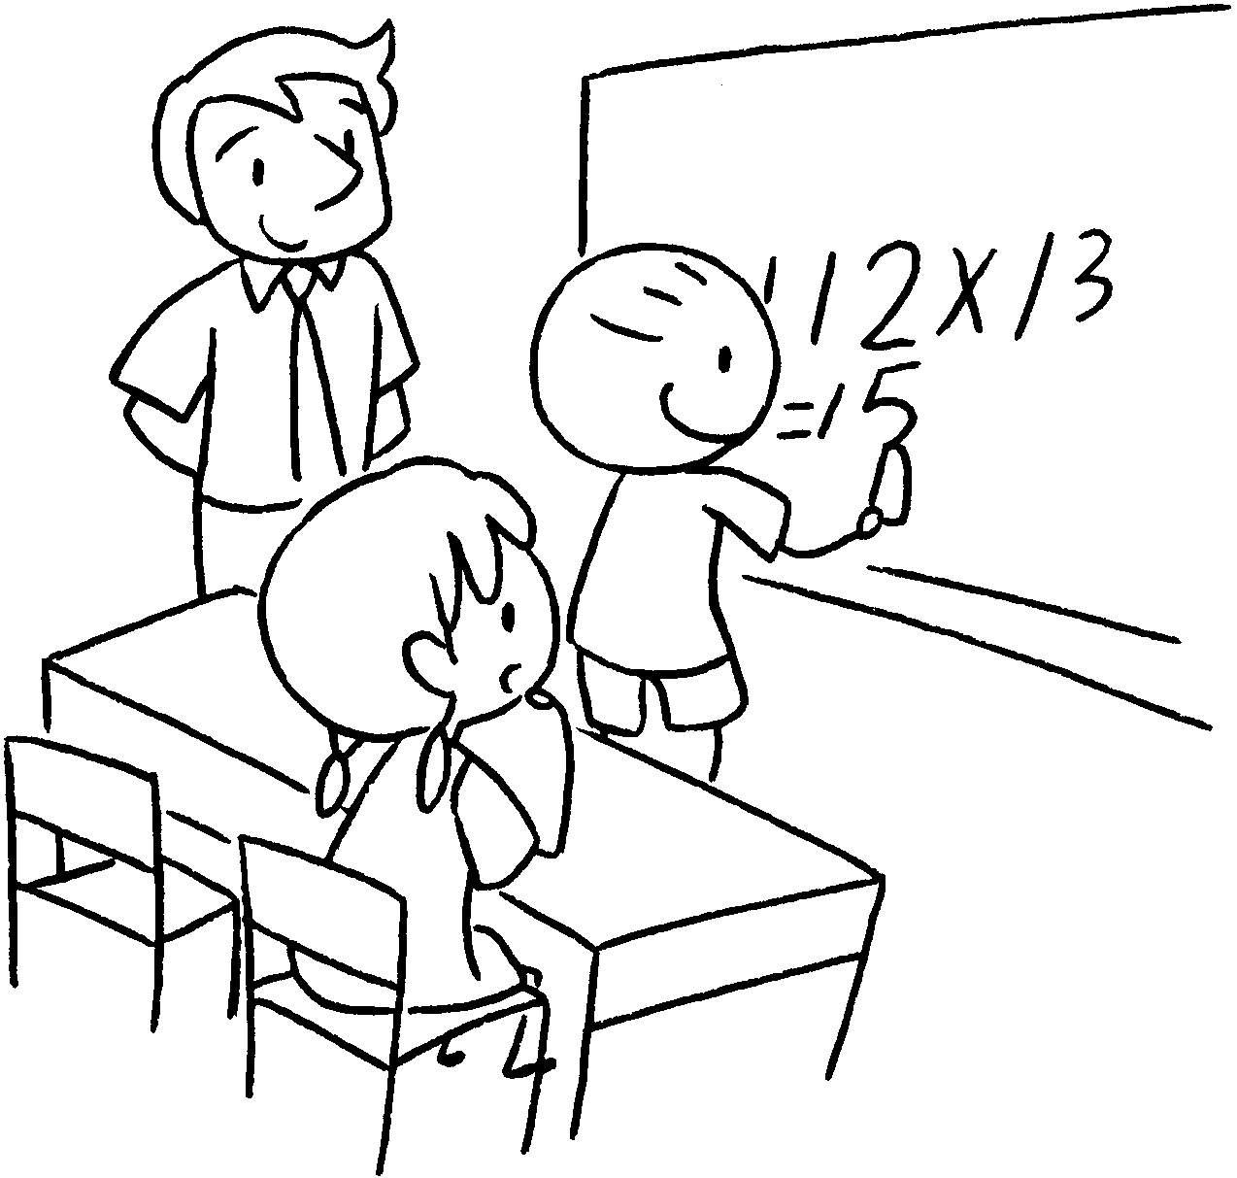
4 | 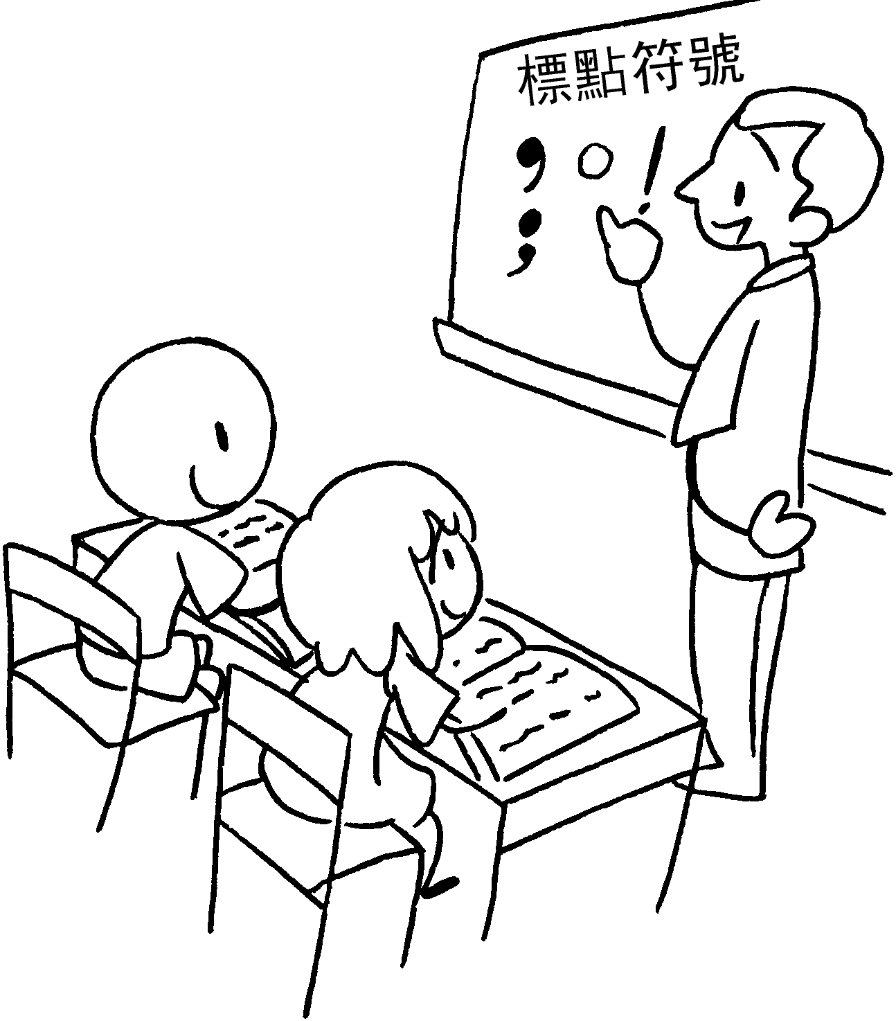 | 5 | 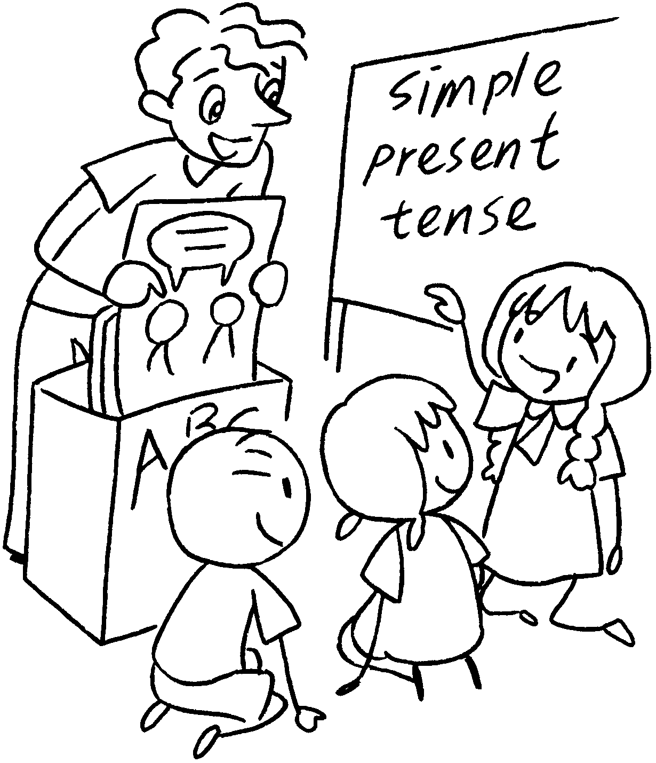 | 6 | 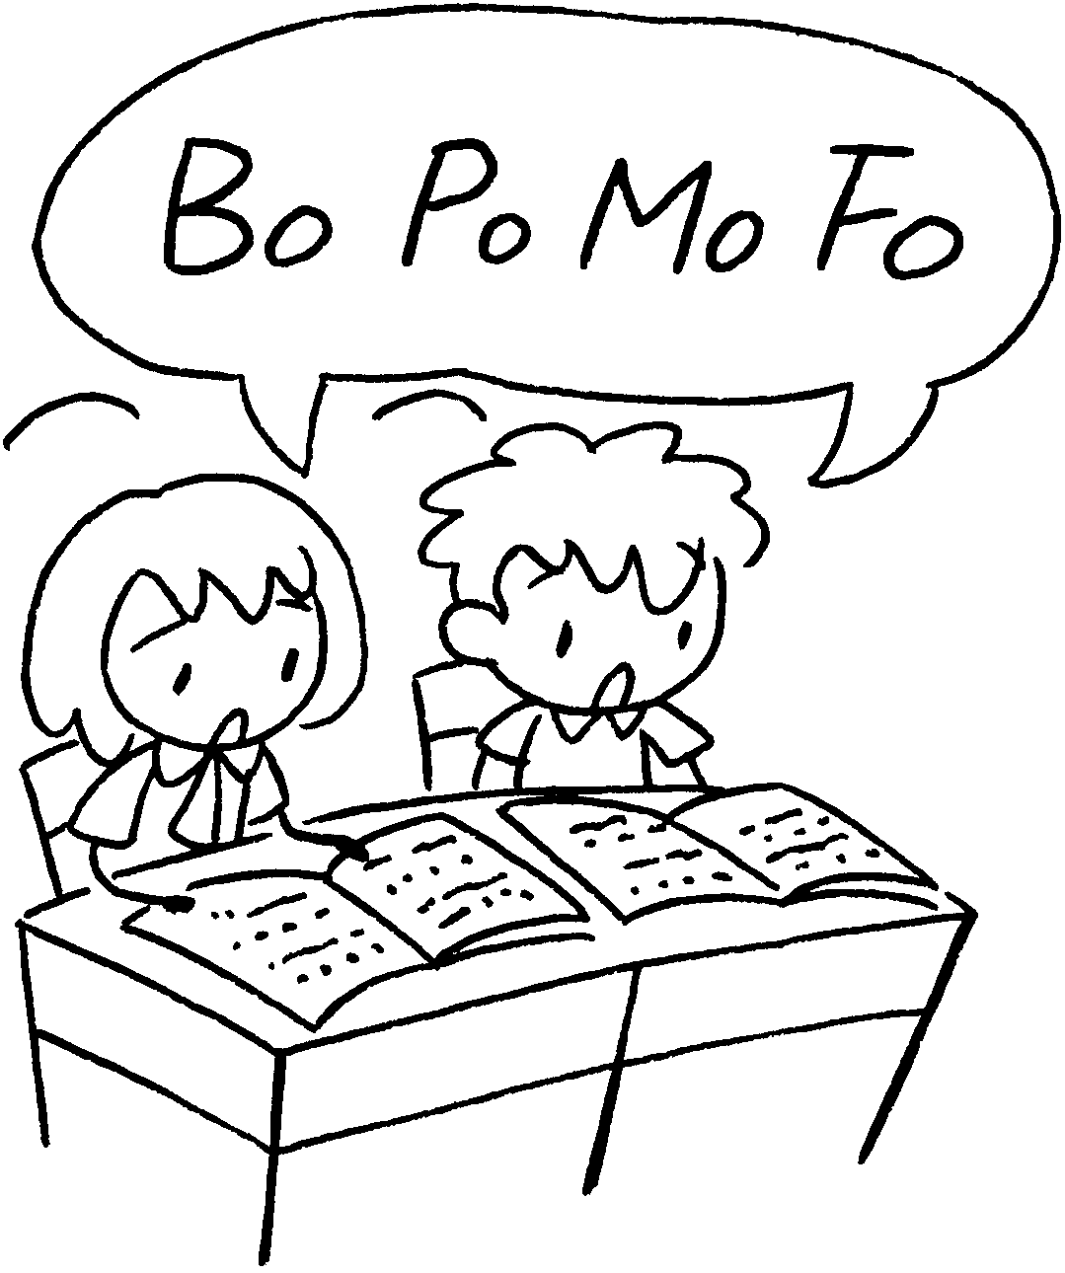
7 | 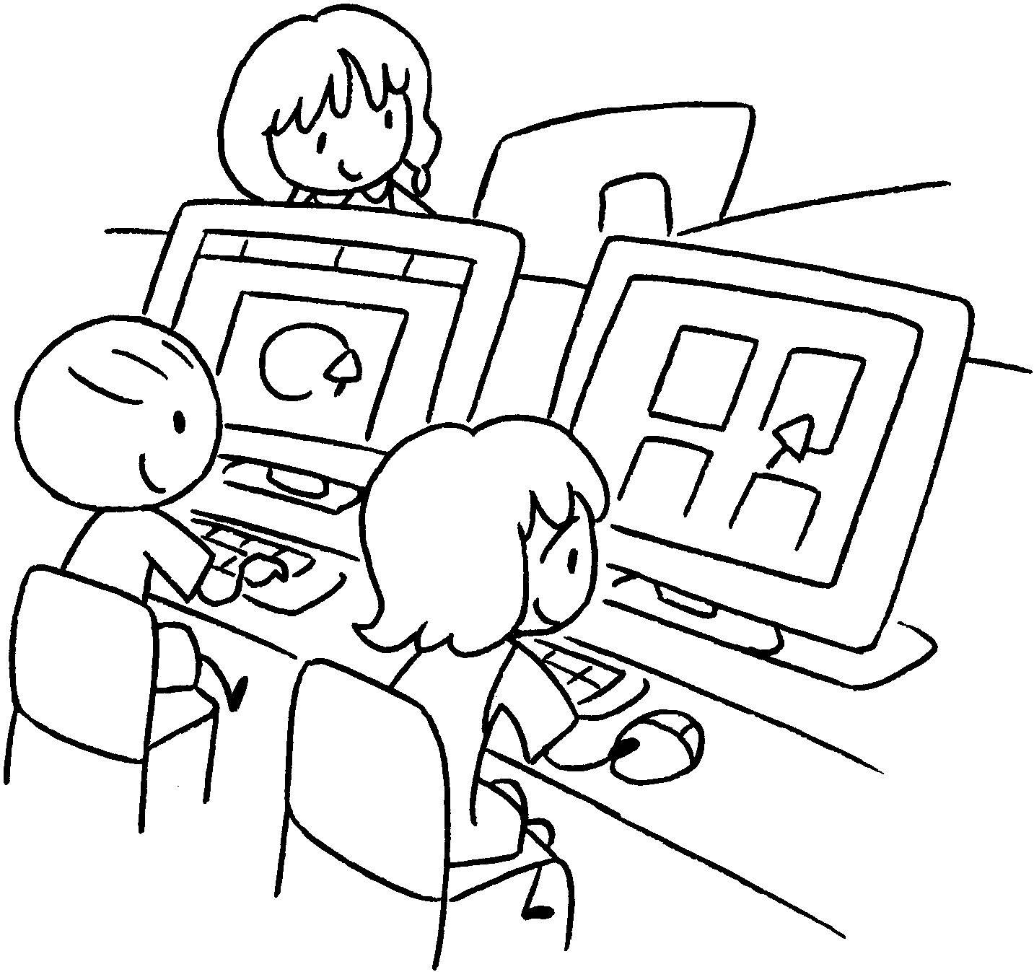 | 8 | 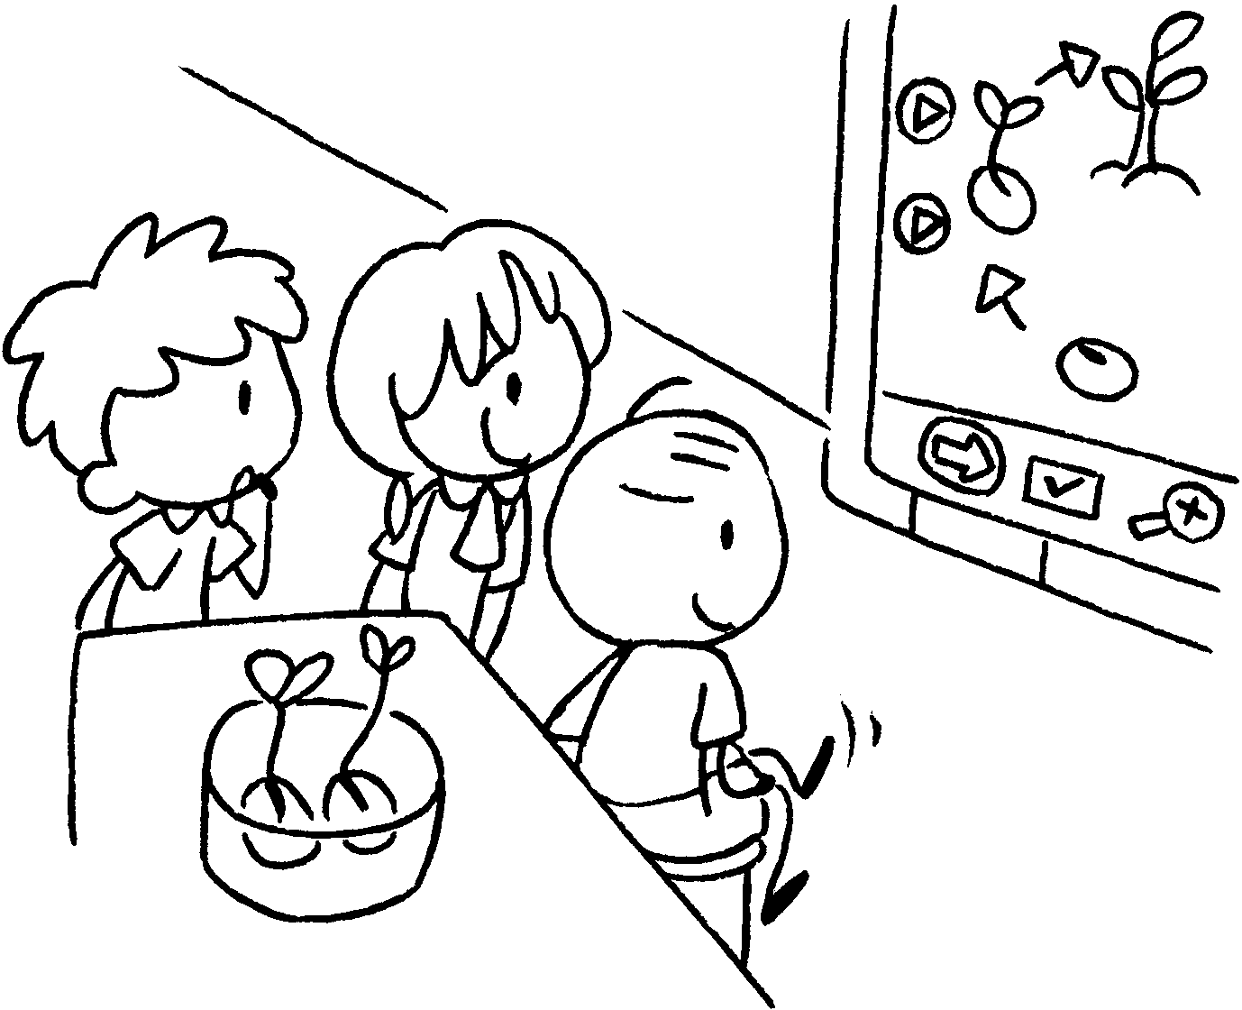 | 9 | 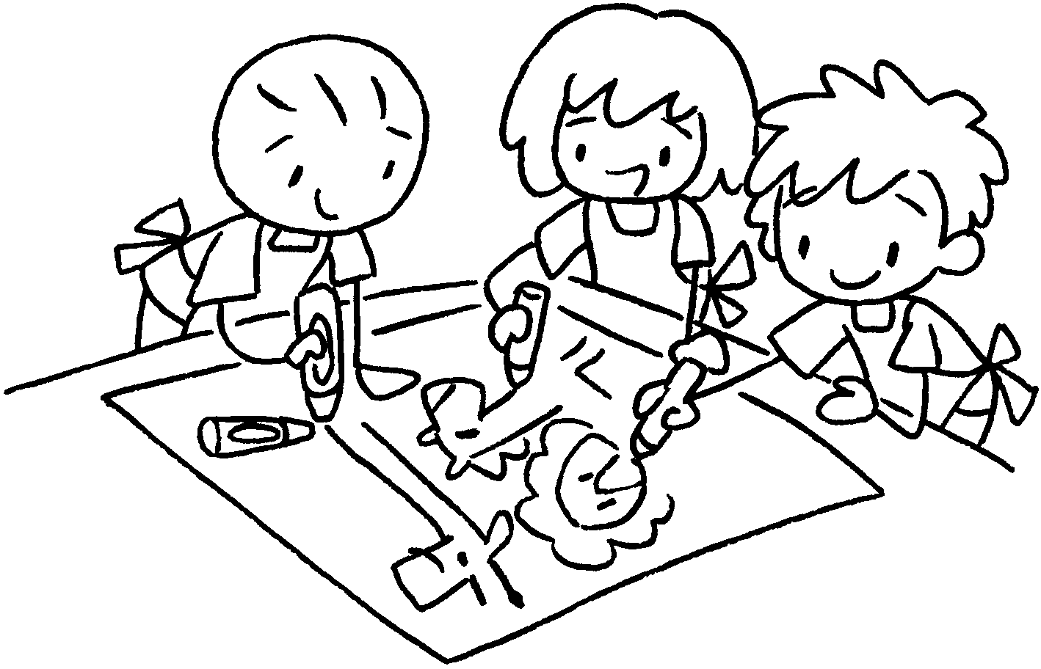

1 |  | 2
3 |  | 4
5 |  | 6
7 |  | 8
9


Book 3B Chapter 1 Graded Worksheets
Worksheet 1⬇⬇⬇
1 PE 2 Music
3 Maths 4 Chinese
5 English 6 Putonghua
7 Computer Studies 8 General Studies
9 Visual Arts

