Circle the correct answers.
1 | 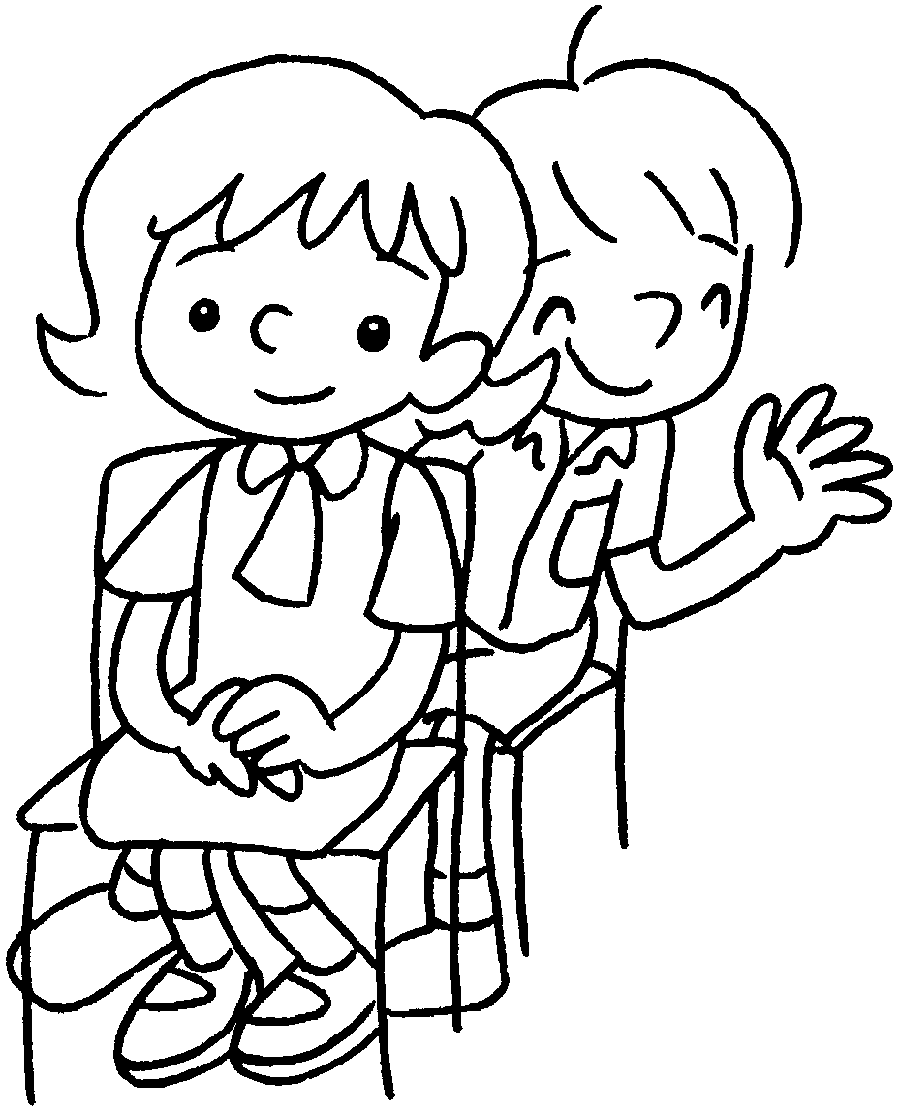  Fiona  Ken | Fiona sits ( in front of / next to ) Ken.
2  …  Daisy | 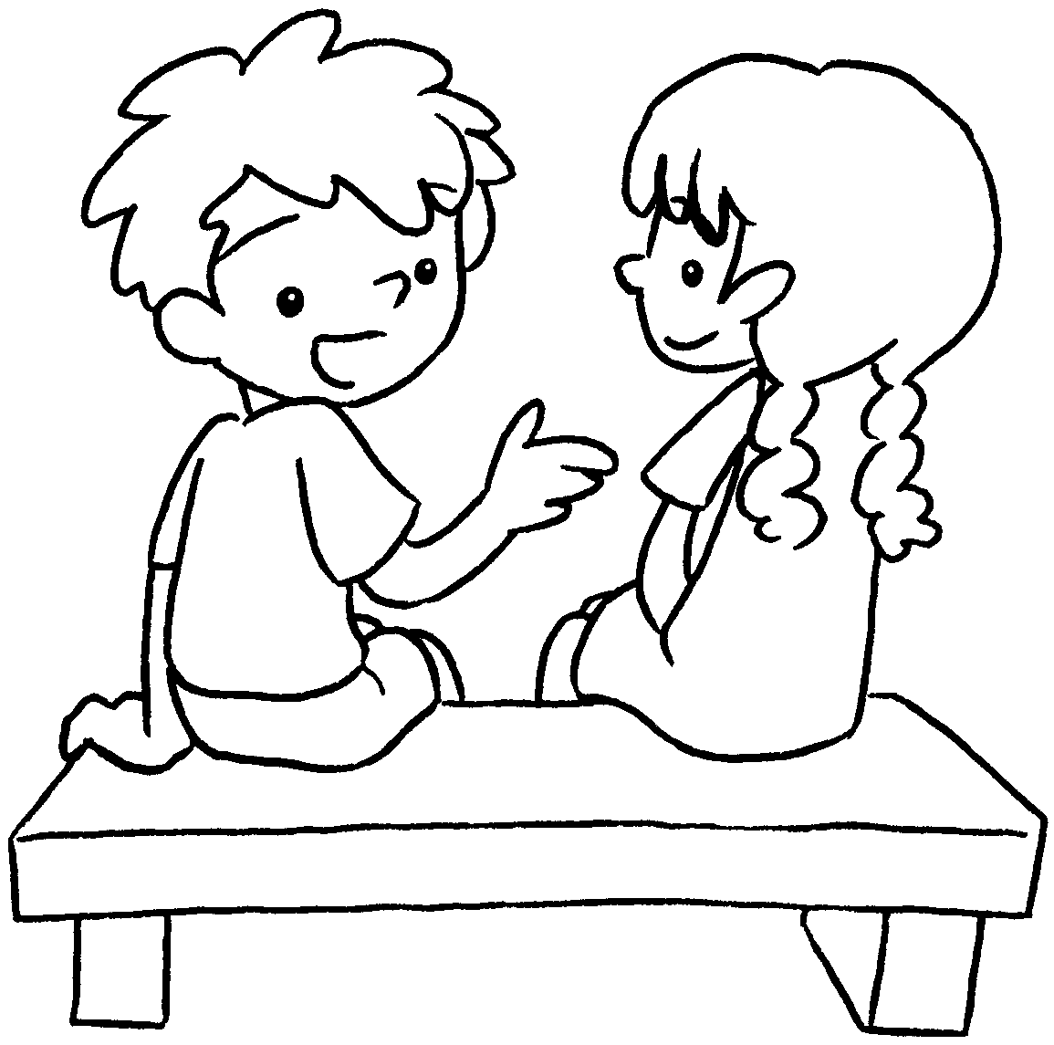 | Daisy sits ( on my left / on my right ).
3 | 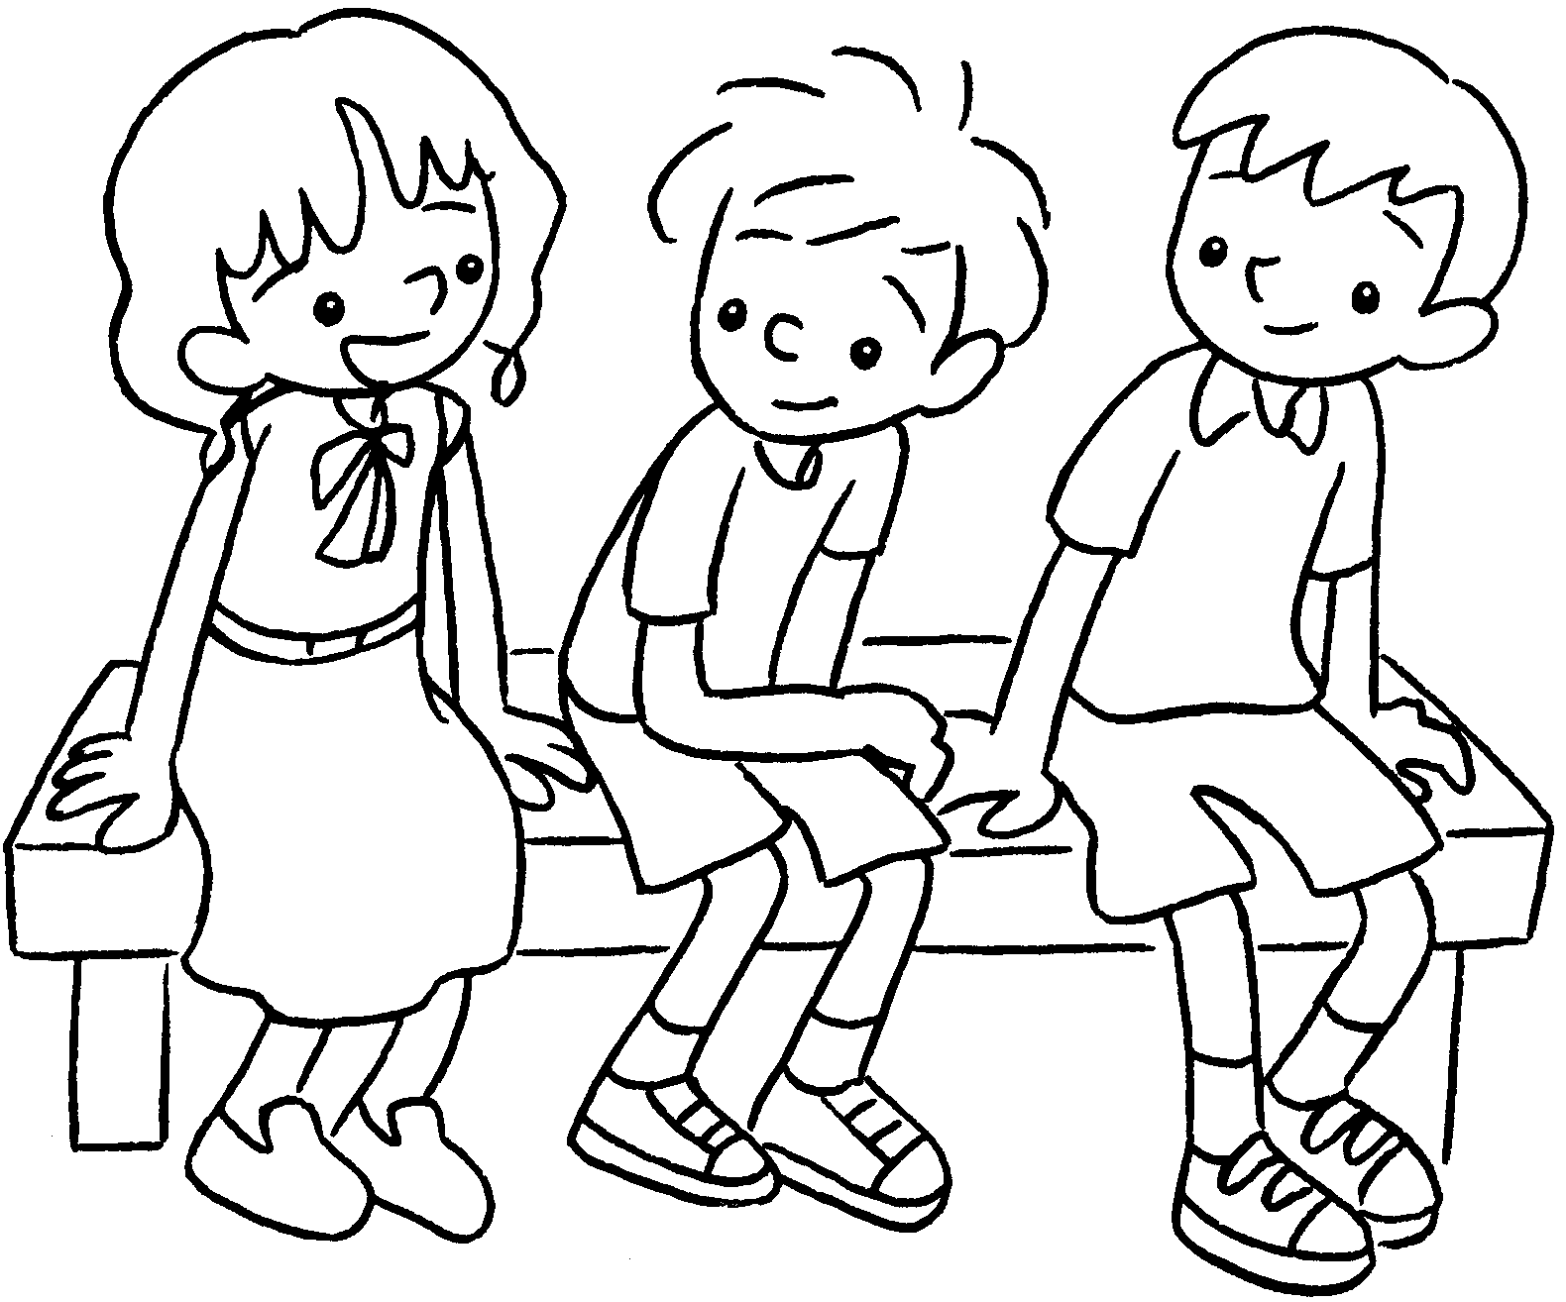  Helen  Billy  Sam | Billy sits ( next to / between ) Sam  and Helen.
4  Kitty  Jerry | 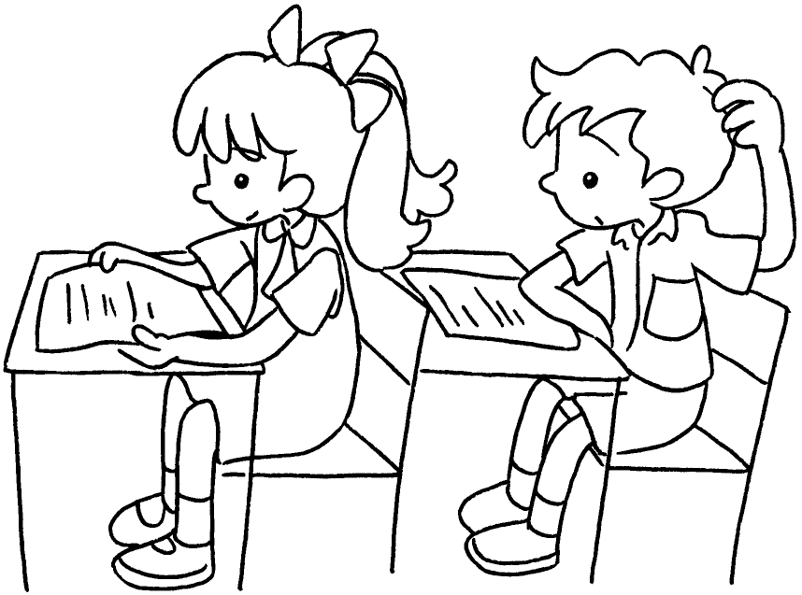 | Jerry sits ( behind / in front of ) Kitty.
5 | 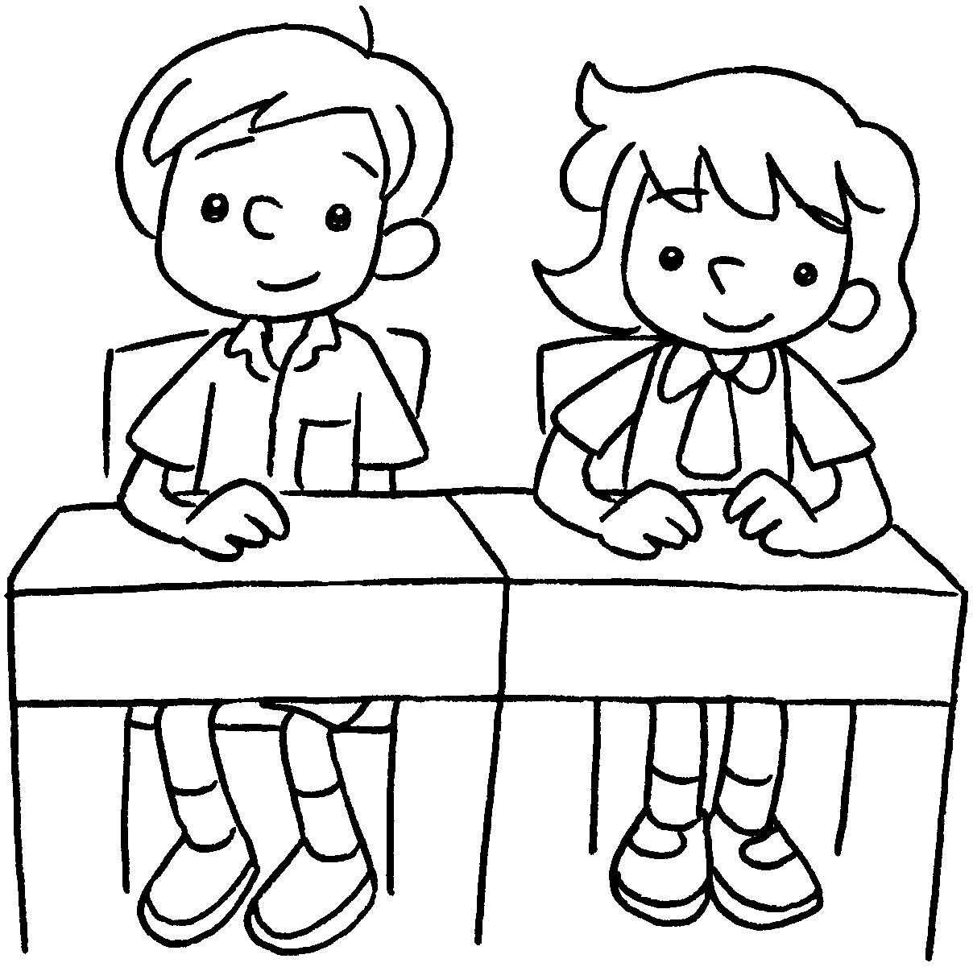  Ricky  Tina | Ricky sits ( next to / behind ) Tina.


Book 3B Chapter 1 Graded Worksheets
Worksheet 2⬇
- ( in front of / next to )
- ( on my left / on my right )
- ( next to / between )
- ( behind / in front of )
- ( next to / behind )

