Where do the children sit? Fill in the blanks.
1 | 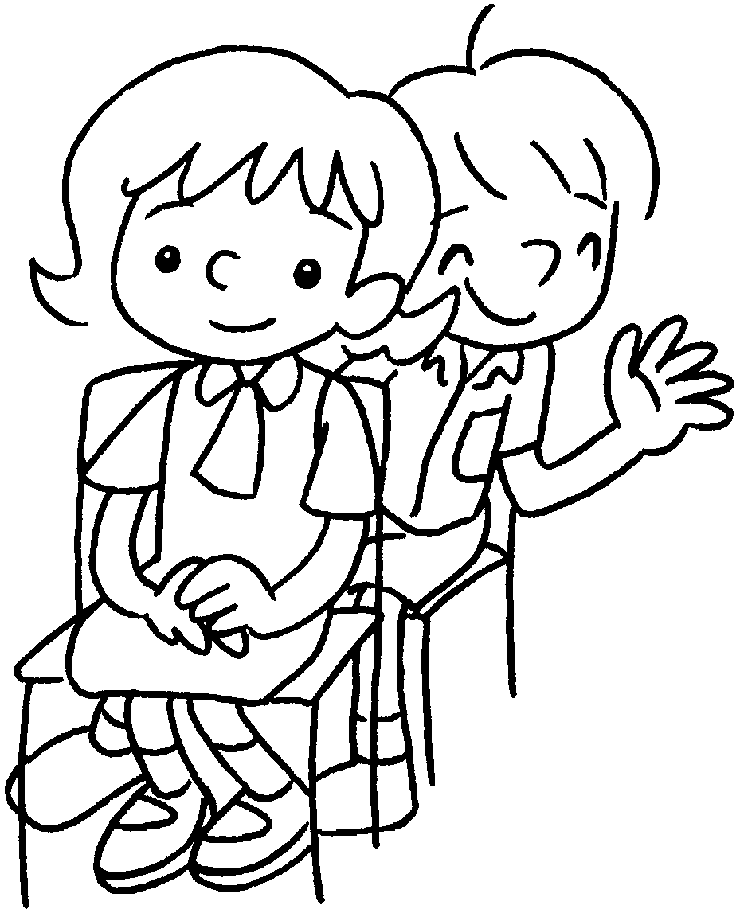  Fiona  Ken | Fiona sits Ken.
2  …  Daisy | 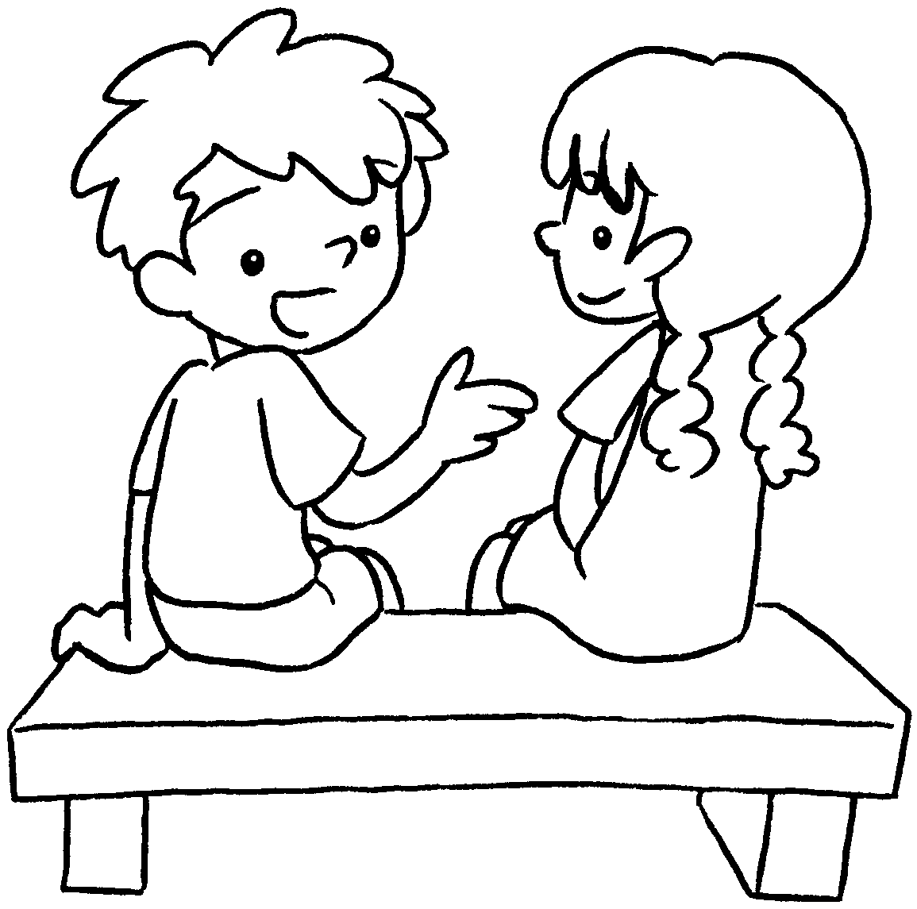 | Daisy sits .
3 | 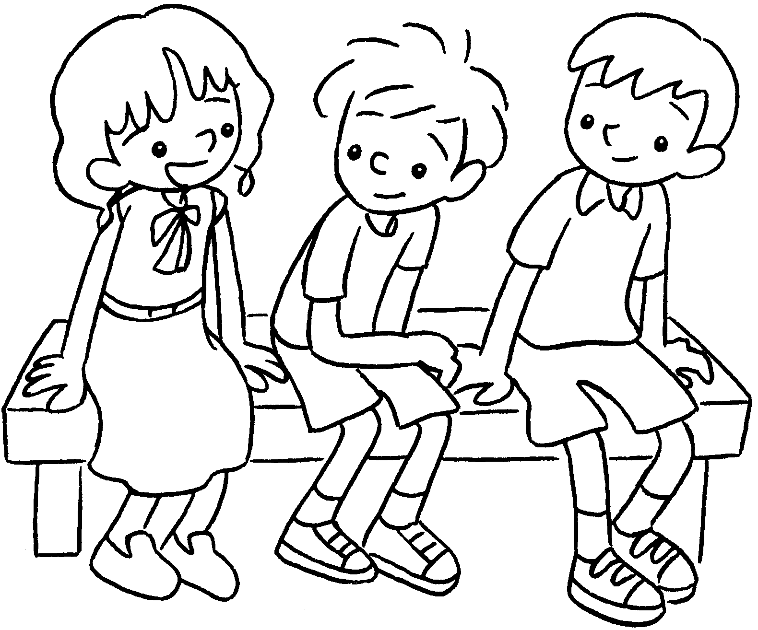  Helen  Billy  Sam | Billy sits Sam and Helen.
4  Kitty  Jerry | 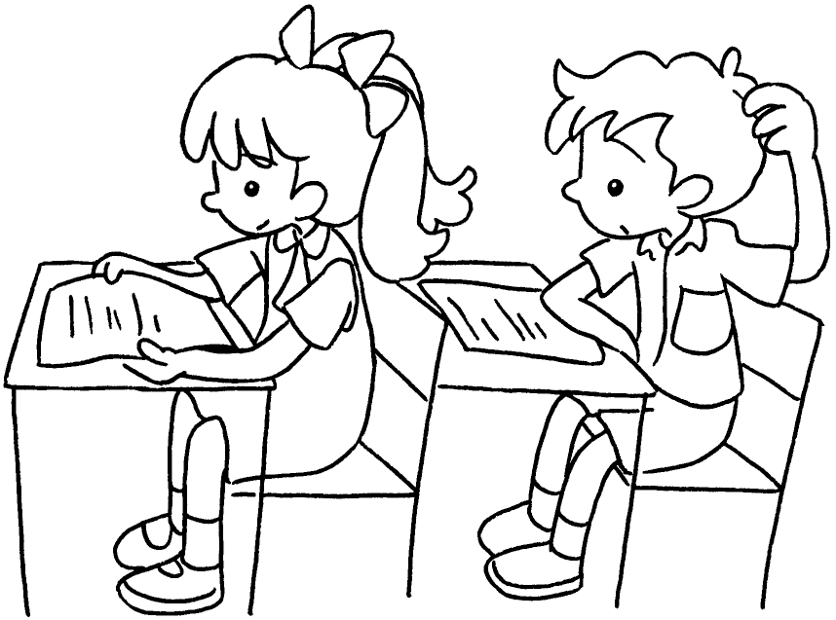 | Jerry sits Kitty.
5 | 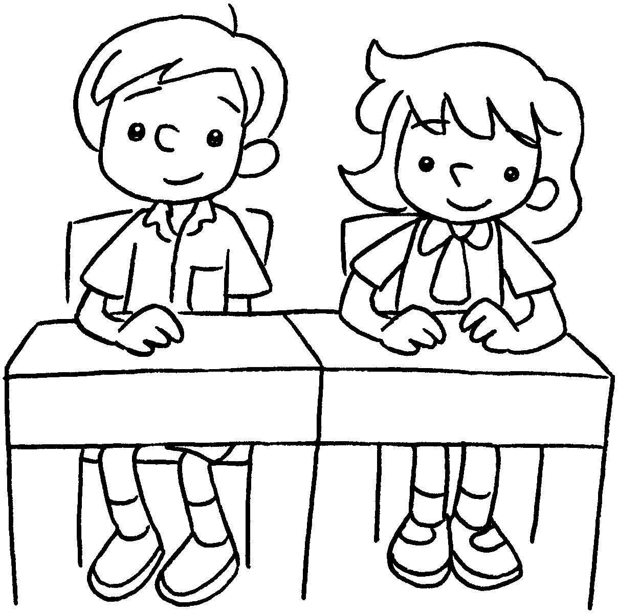  Ricky  Tina | Ricky sits Tina.


Book 3B Chapter 1 Graded Worksheets
Worksheet 2⬇⬇⬇
- in front of
- on my right
- between
- behind
- next to

