Finish the sentences.
 | good at | ... ing

1 | 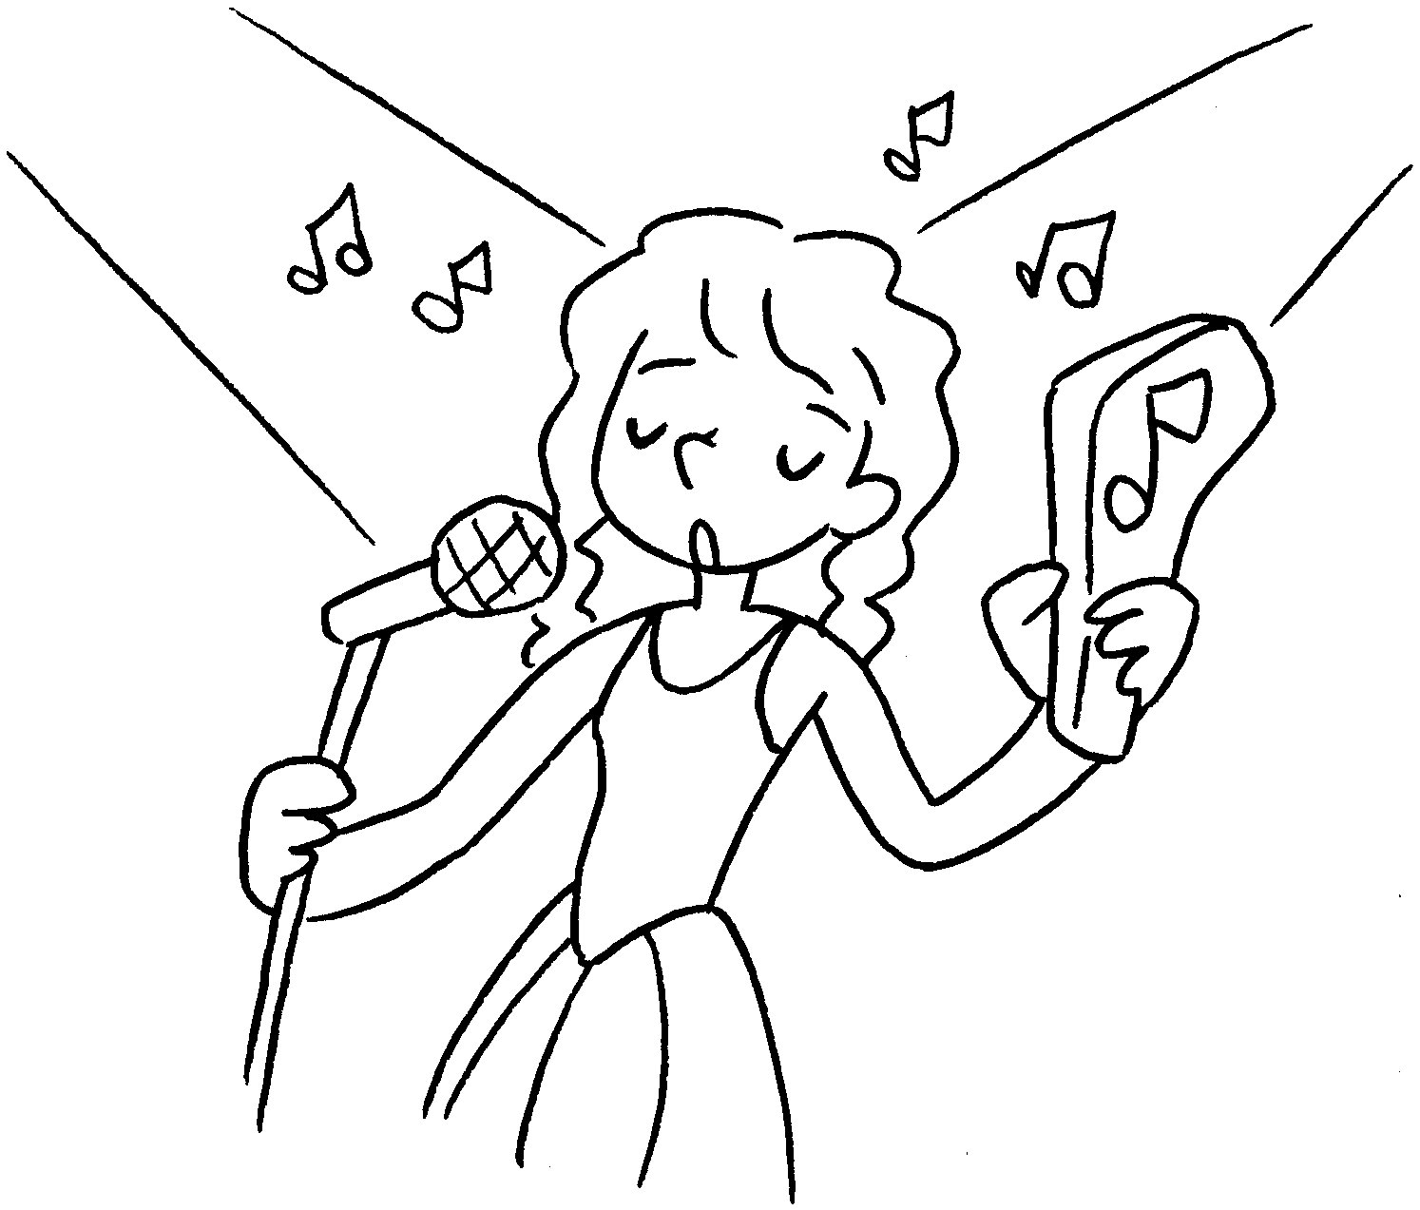 | Coco is singing.
2 | 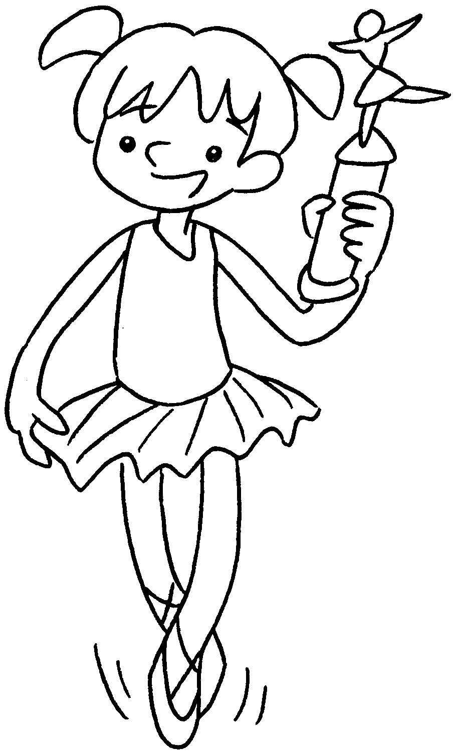 | Kelly is good at  ( dance ).
3 | 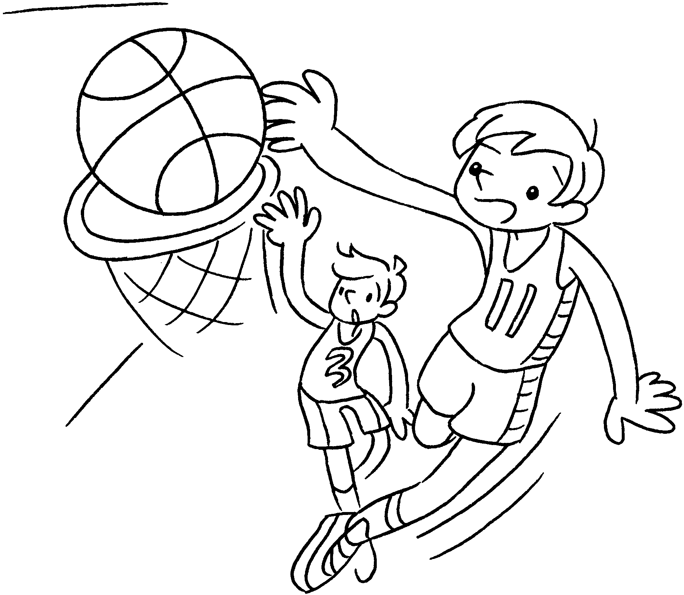 | Tom is good at  ( play ) basketball.
4 |  | Carol is  ( paint ) pictures.
5 | 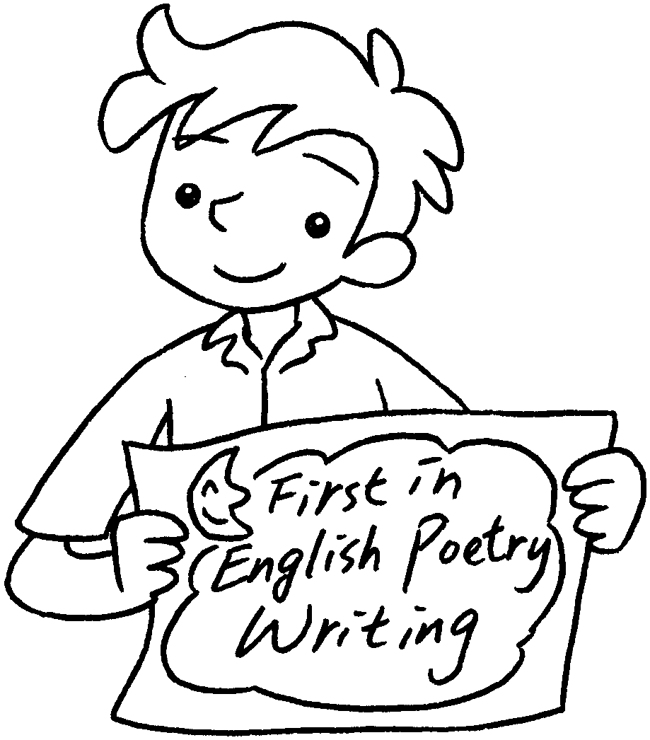 | Sam’s favourite subject is English.  He is  ( write ) English  poems.


Book 3B Chapter 1 Graded Worksheets
Worksheet 3⬇
- good at
- dancing
- playing
- good at painting
- good at writing

