What are the people good at? Finish the sentences.
play paint sing write

1 | 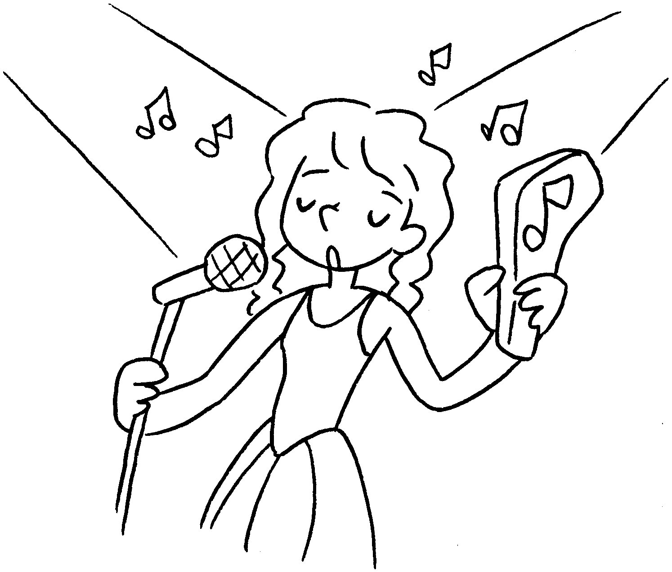 | Coco is good at .
2 | 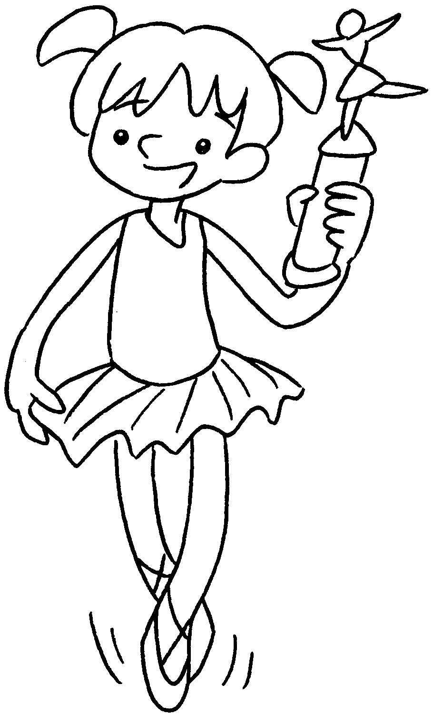 | Kelly is  dancing.
3 | 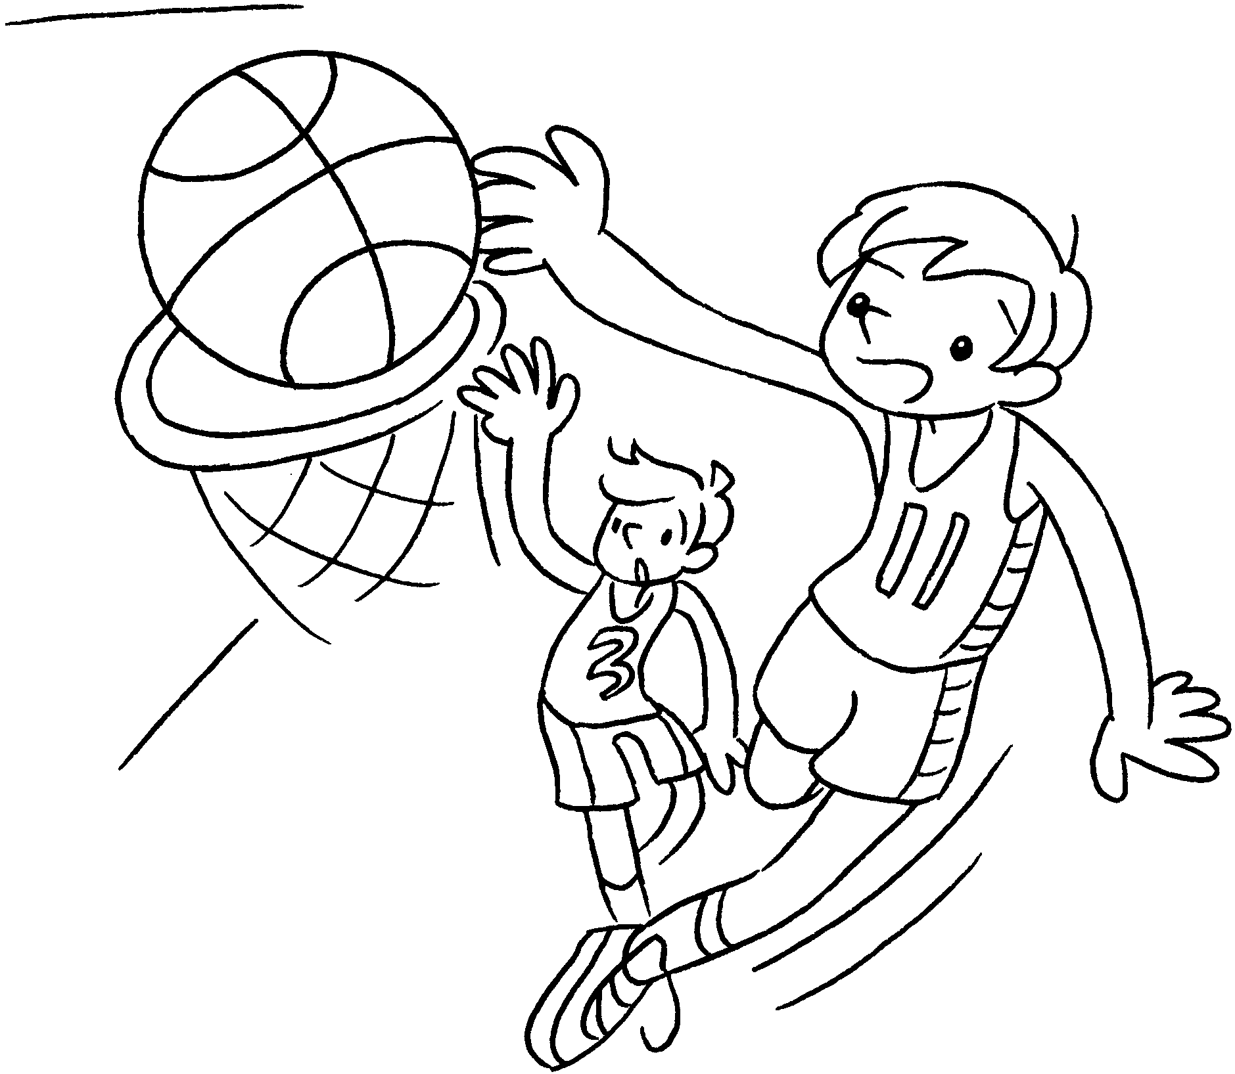 | Tom is  basketball.
4 | 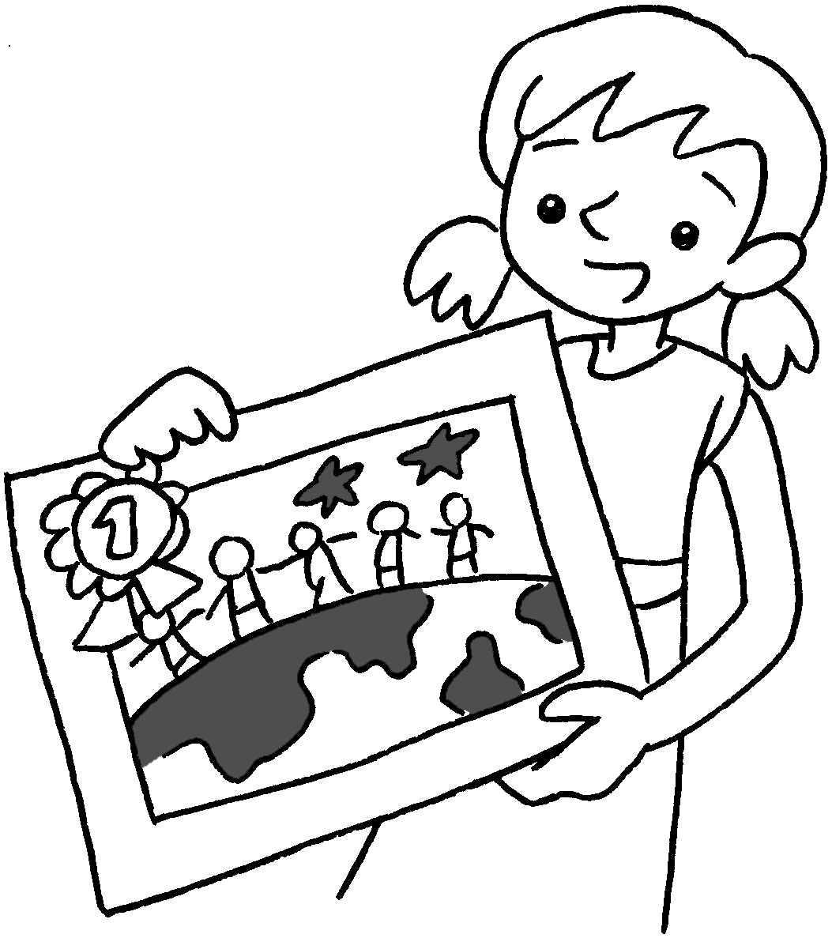 | Carol is  pictures.
5 | 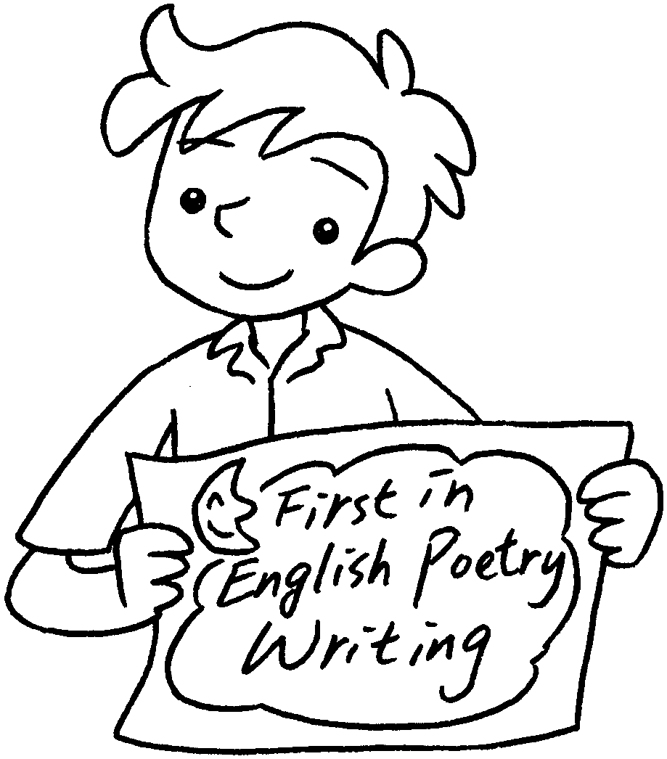 | Sam’s favourite subject is English.  He is  English poems.


Book 3B Chapter 1 Graded Worksheets
Worksheet 3⬇⬇
- singing
- good at
- good at playing
- good at painting
- good at writing

