Timetables
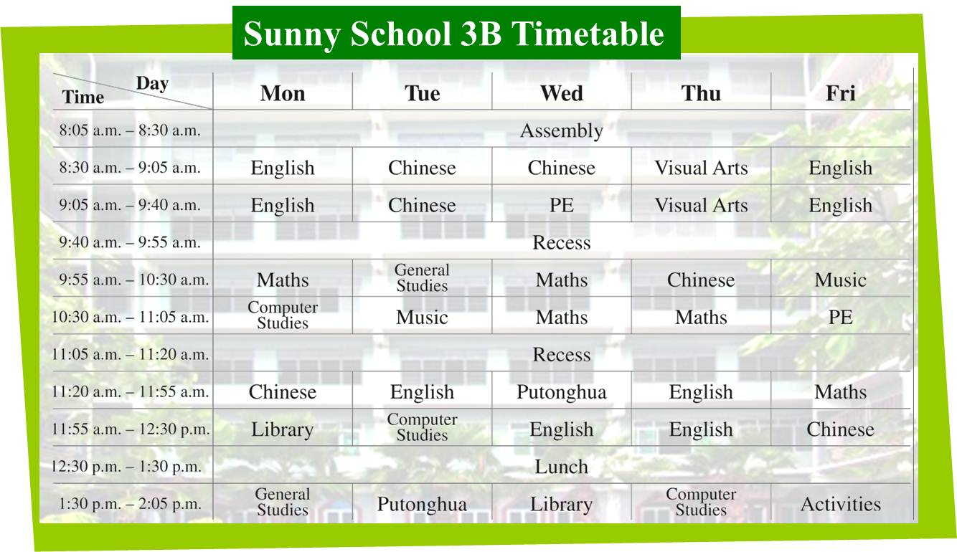

Write the answer and blacken  the circles.

1 On which day(s) do 3B pupils have PE lessons?

2 What time do 3B pupils start their first lesson?
 A. 8:05 a.m.
 B. 8:30 a.m.
 C. 9:05 a.m.
 D. 9:55 a.m.

3 It is 2:00 p.m. on Thursday. 3B pupils are ___ .
 A. in the library
 B. in the playground
 C. in the computer room
 D. in the music room

4 3B pupils have a(n) ___ lesson after lunch on Tuesdays.
 A. Putonghua
 B. English
 C. Music
 D. Chinese

Answers:
1 Wednesday(s) and Friday(s). 2 B 3 C 4 A

