Choose and write.

fight | laugh | listen | look
play | play | shout | talk

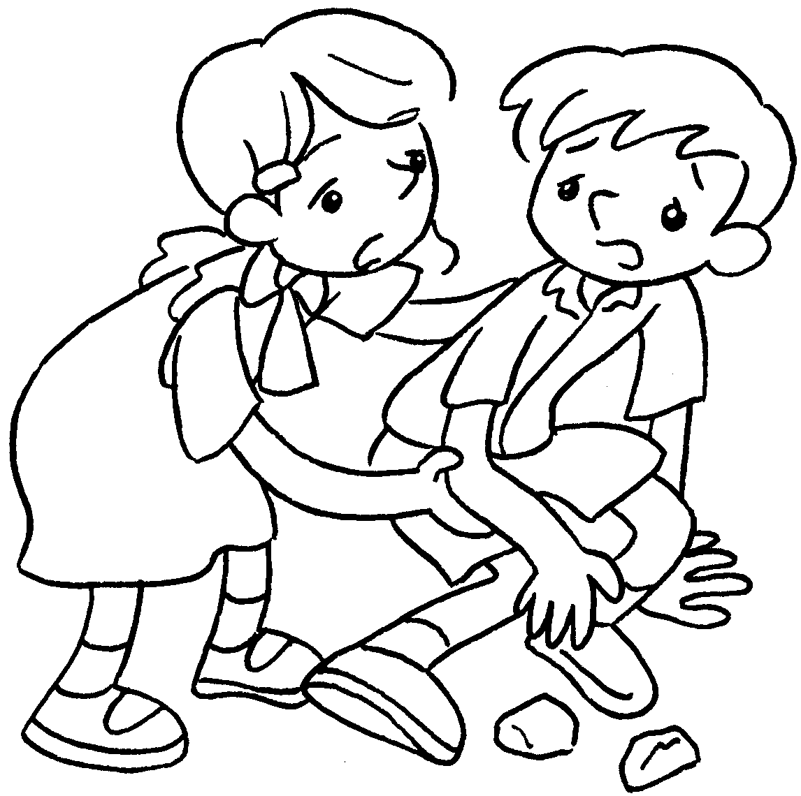  1 | 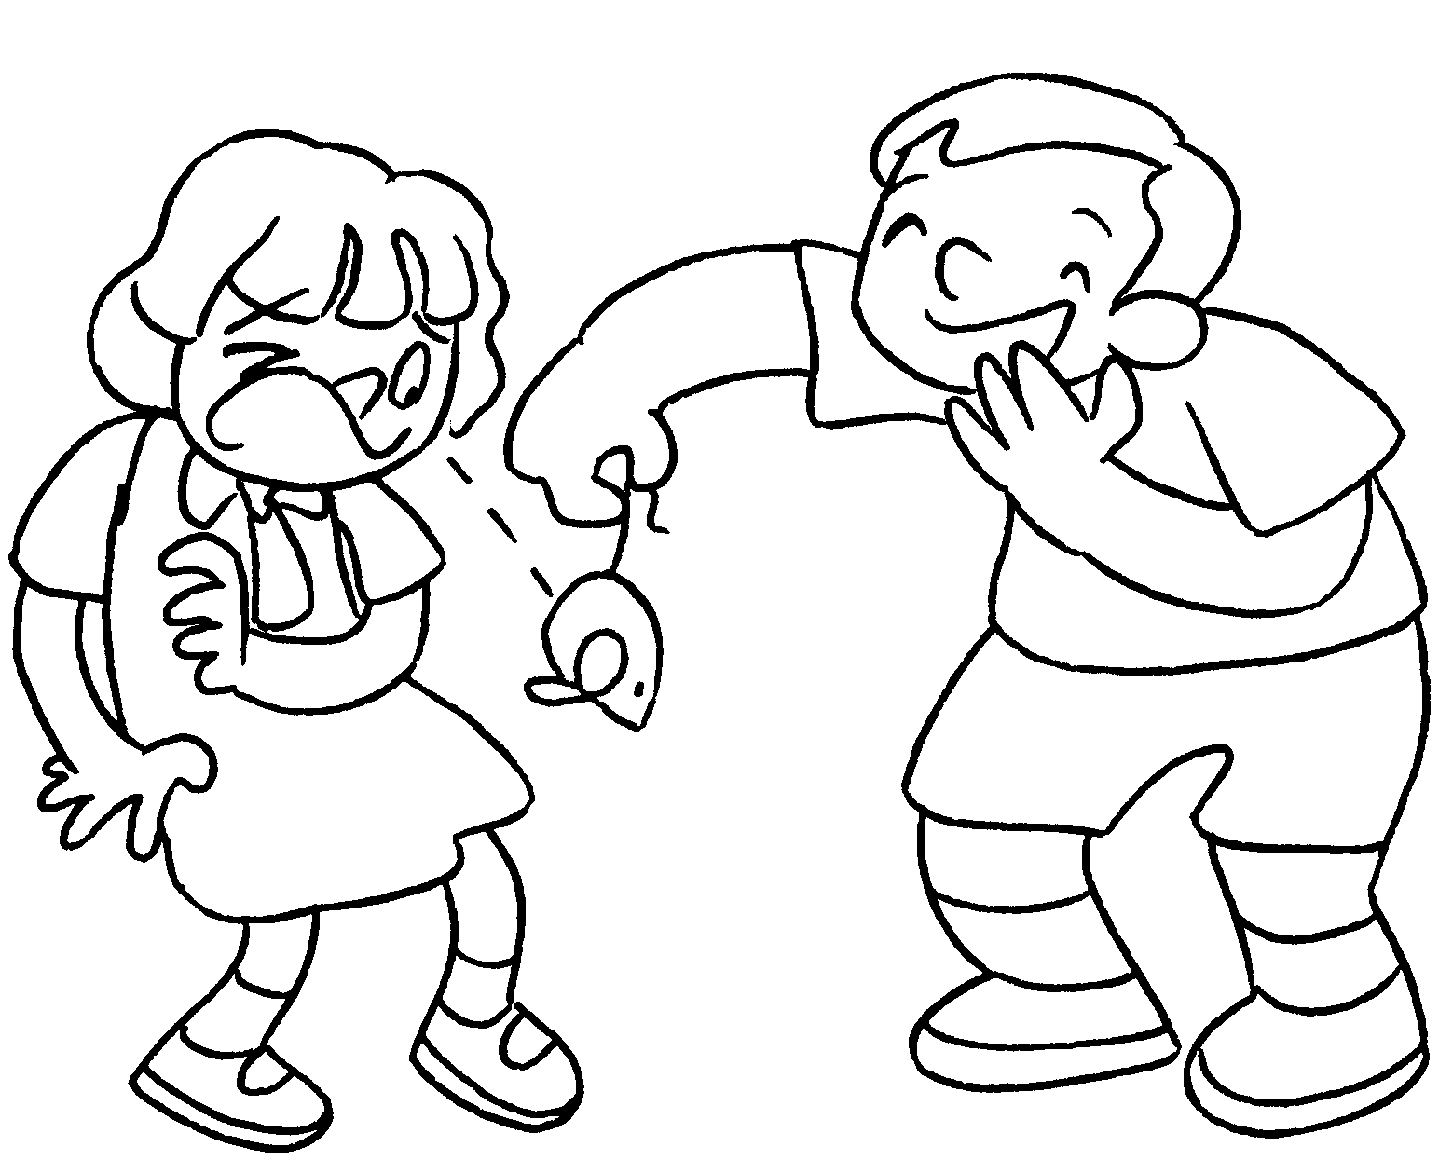  2 |  | 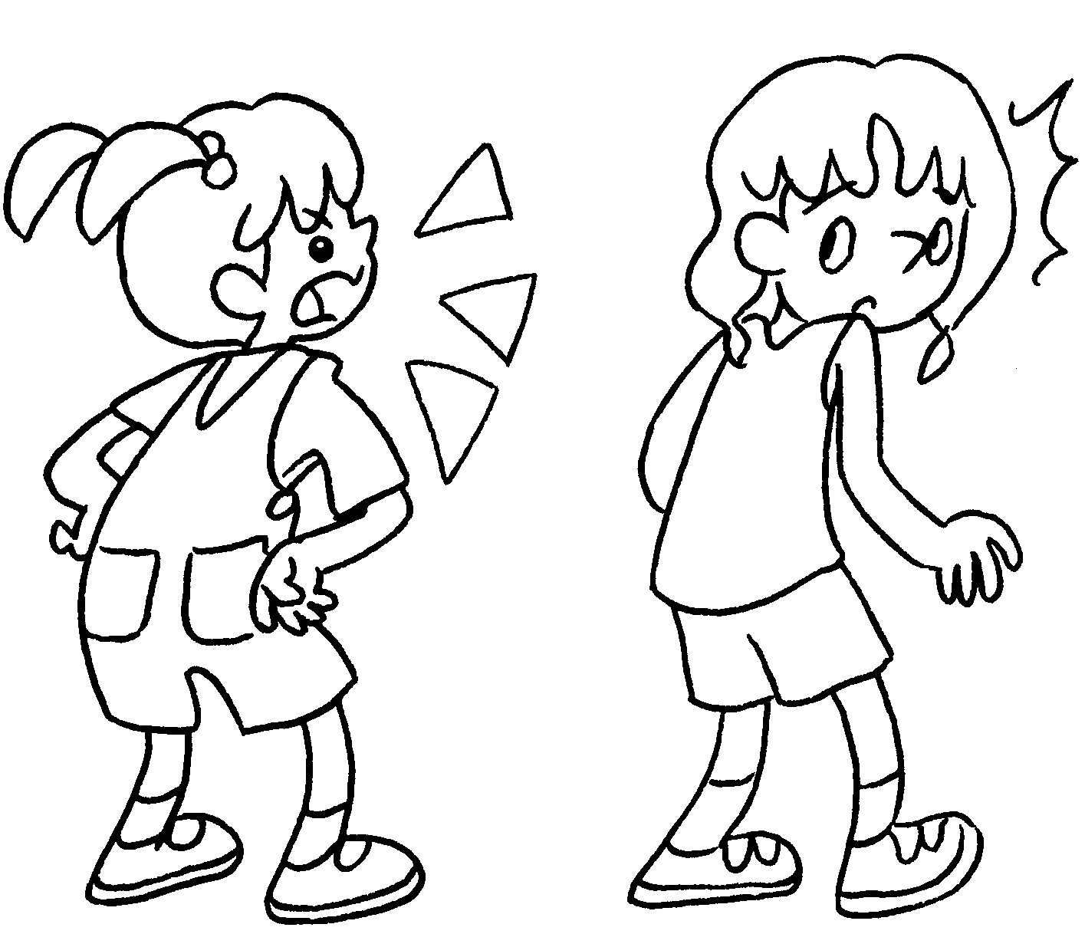  3
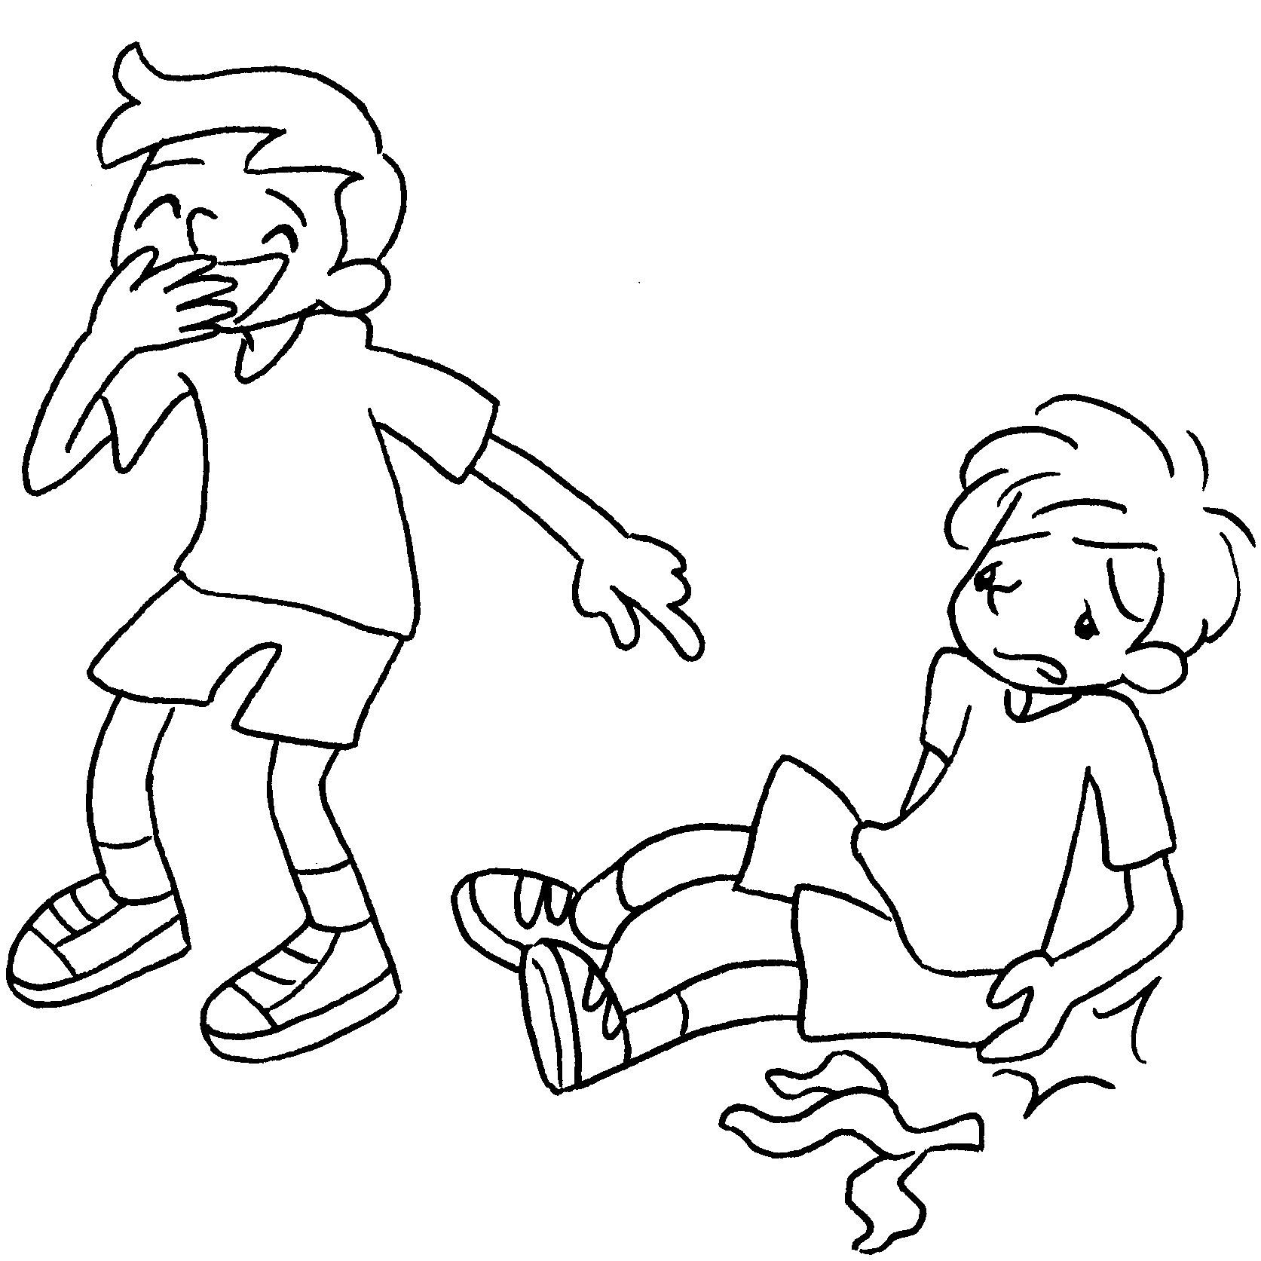  4 | 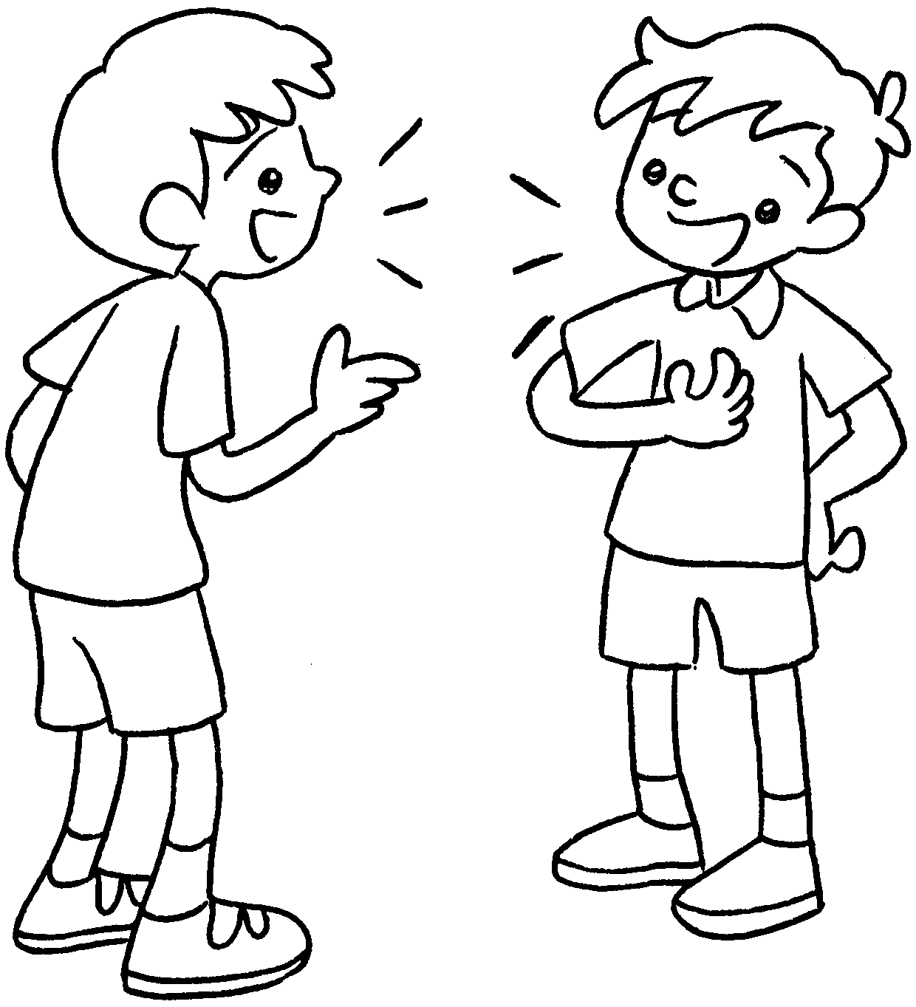  5 |  | 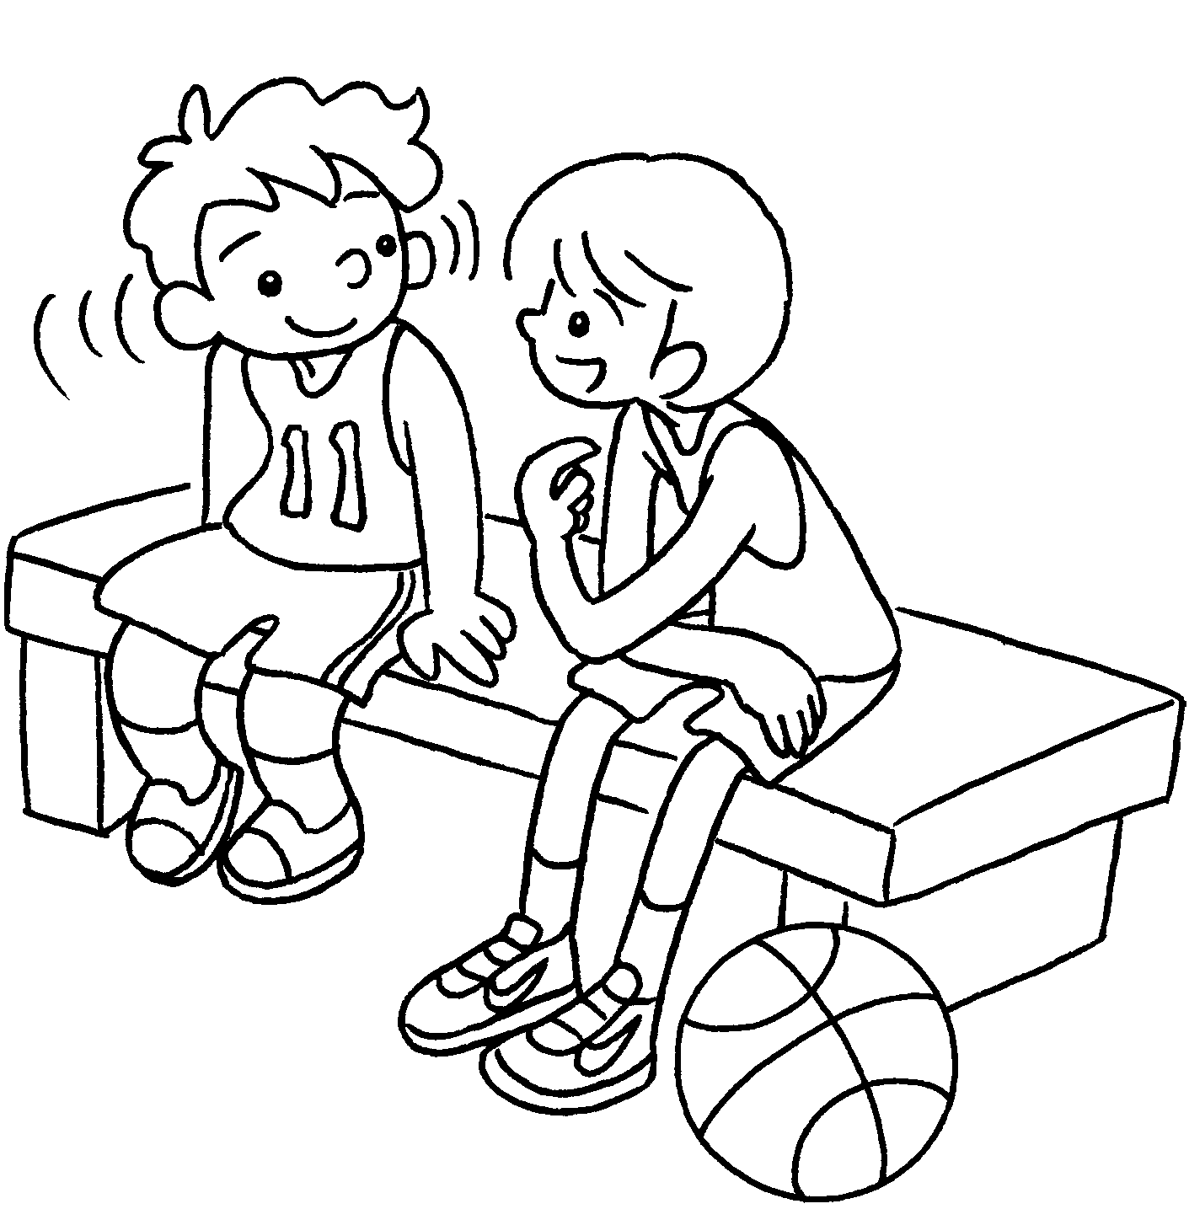  6
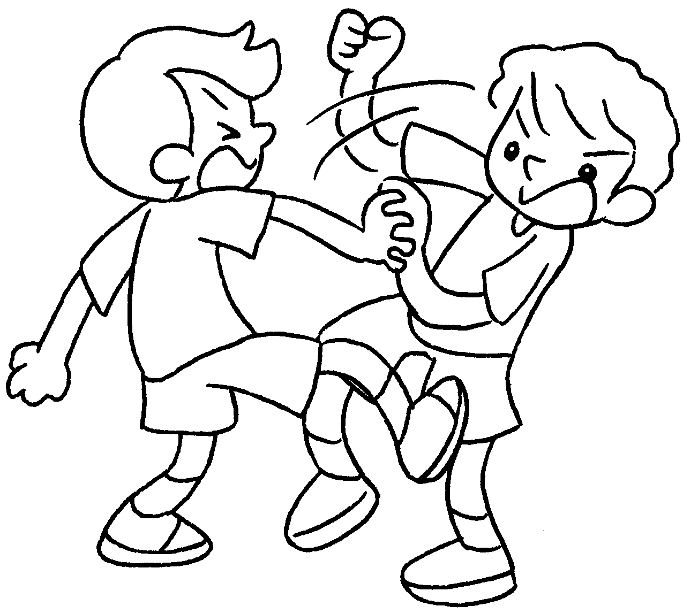  7 |  | 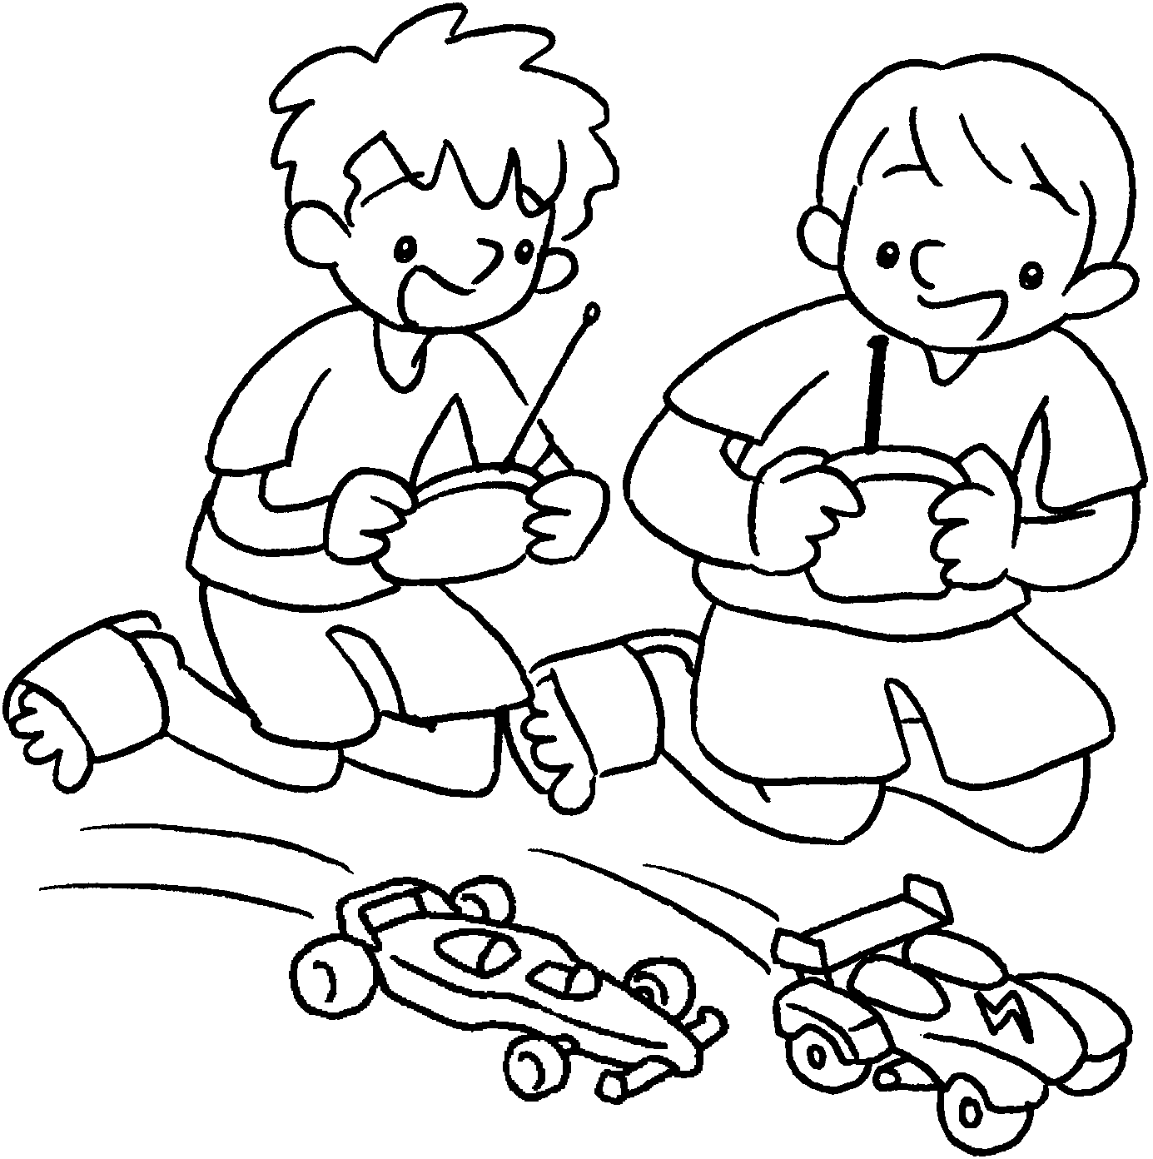  8

1 | after | 2 | tricks on
3 | at | 4 | at
5 | to | 6 | to
7 | with | 8 | with


Book 3B Chapter 2 Graded Worksheets
Worksheet 1⬇
1 look 2 play
3 shout 4 laugh
5 talk 6 listen
7 fight 8 play

