Look at the pictures and fill in the missing letters.

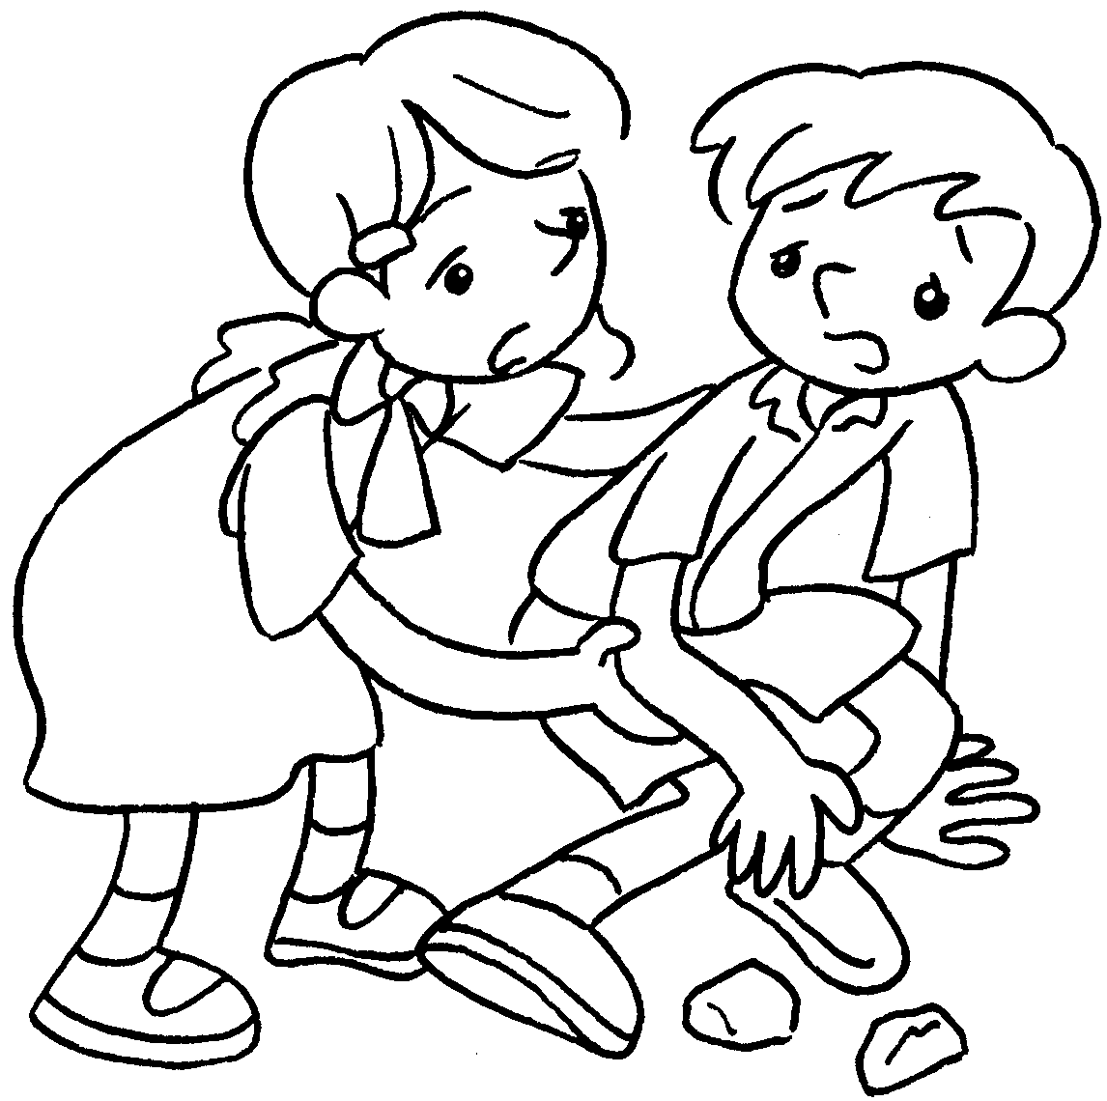  1 | 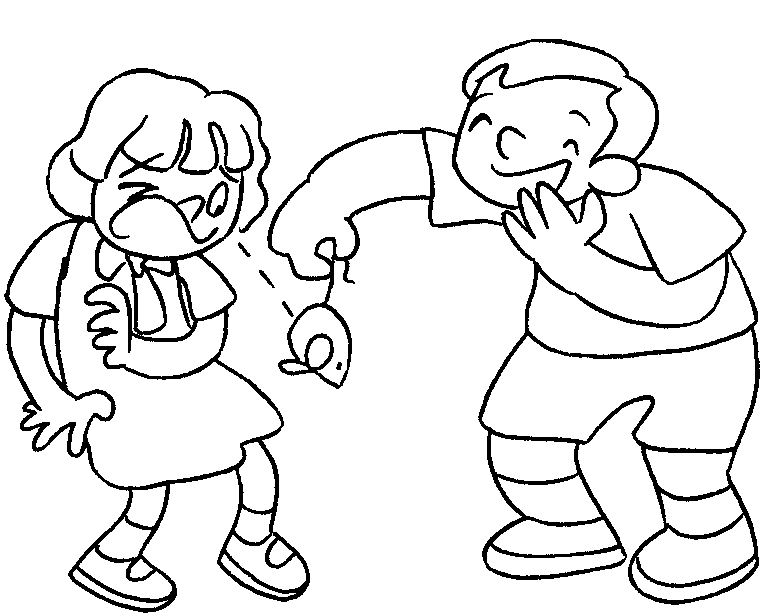  2 |  | 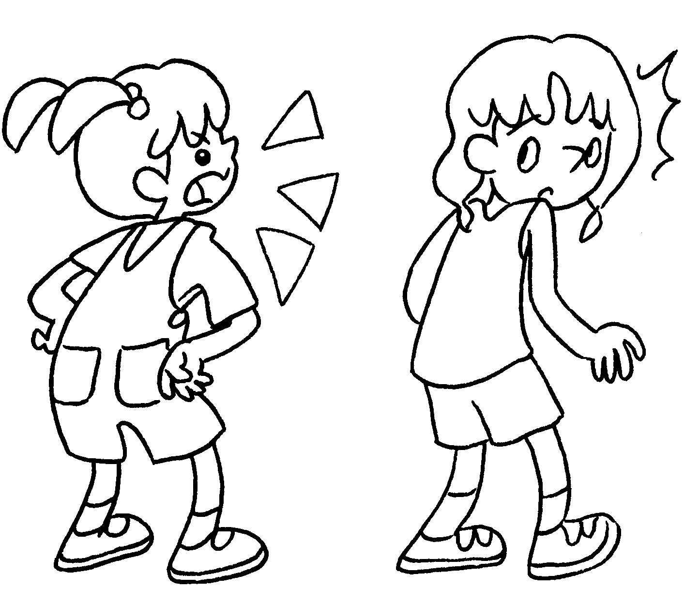  3
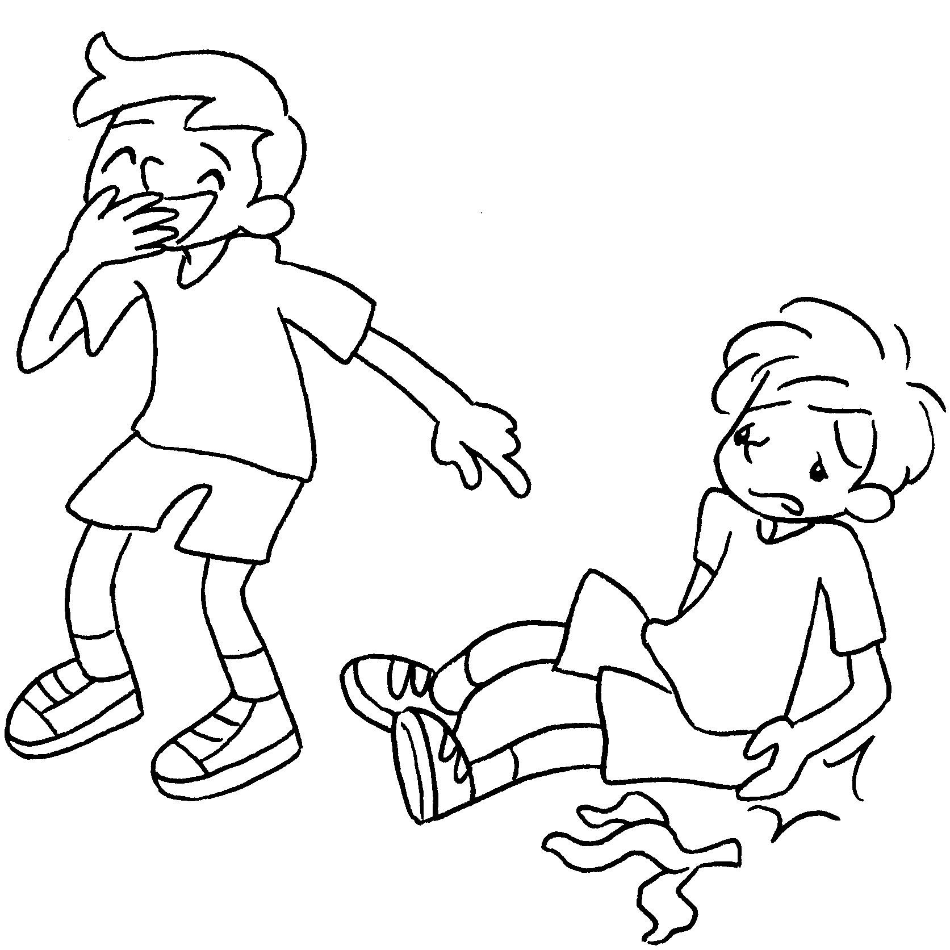  4 | 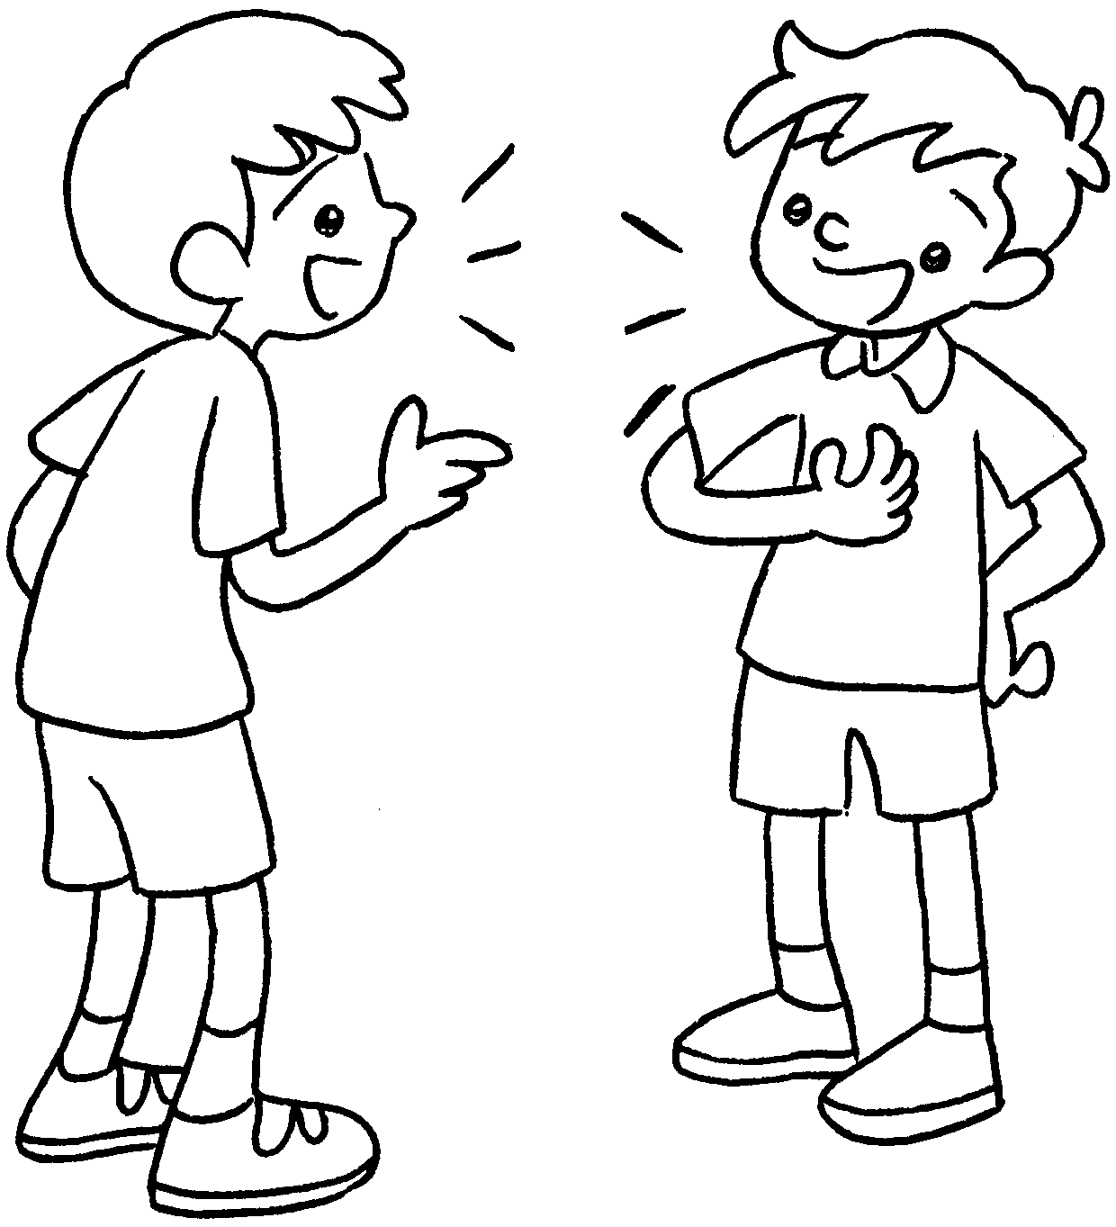  5 |  | 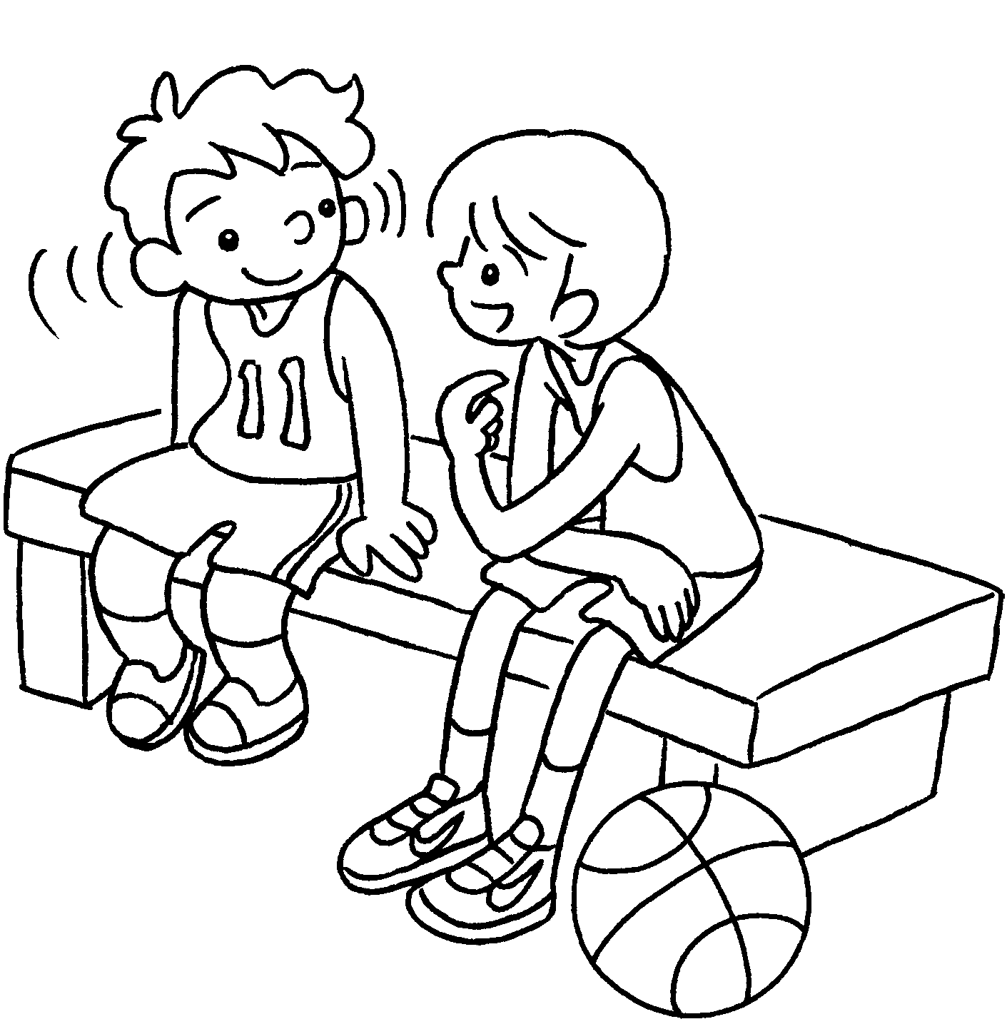  6
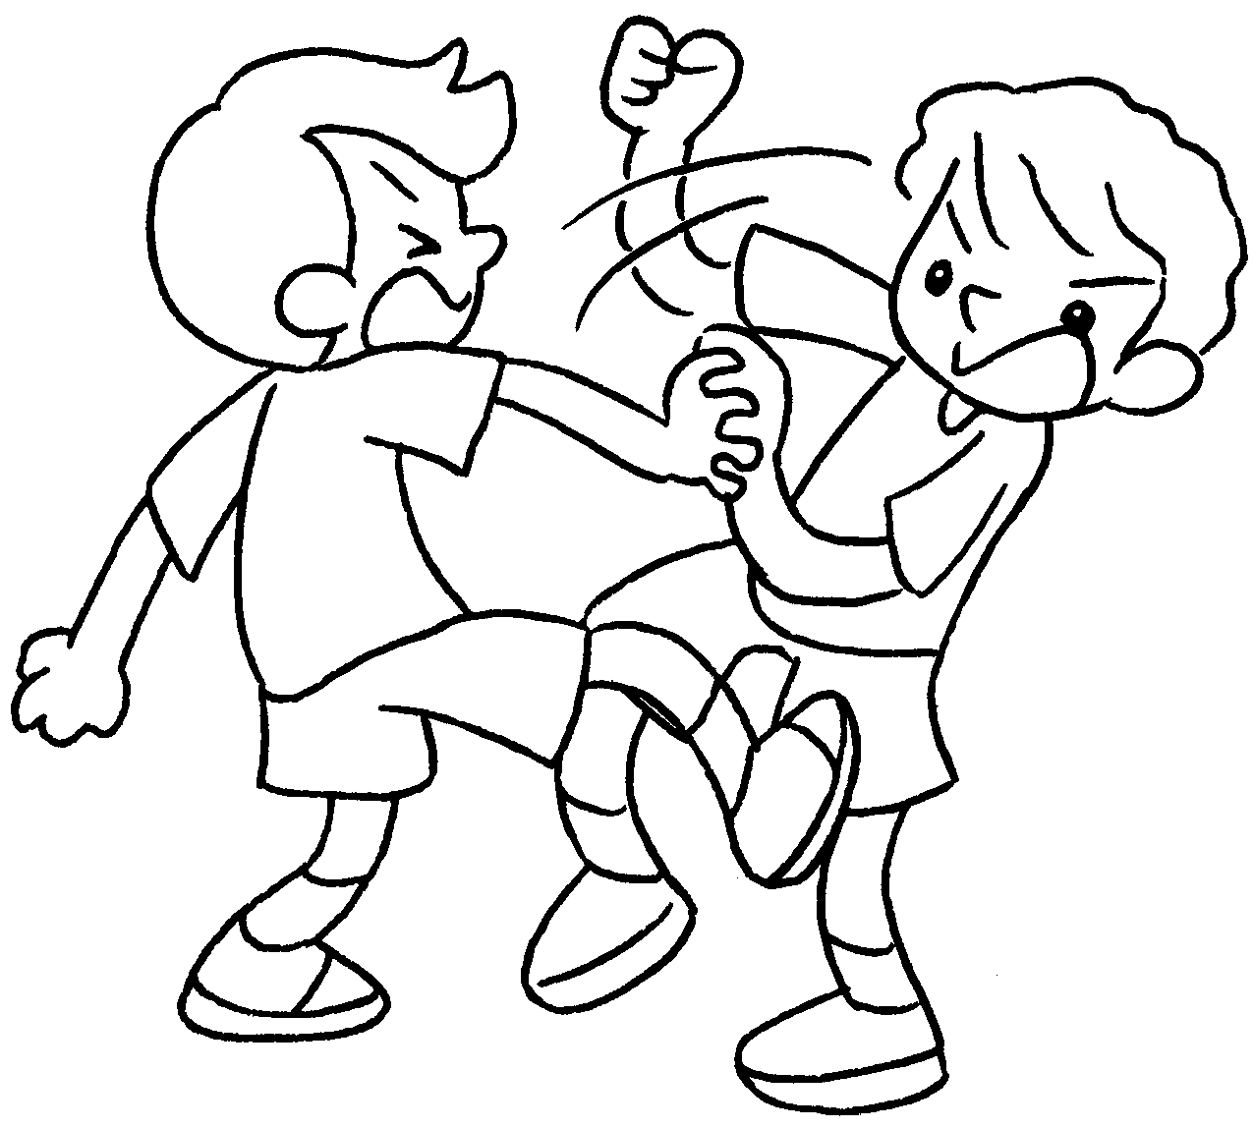  7 |  | 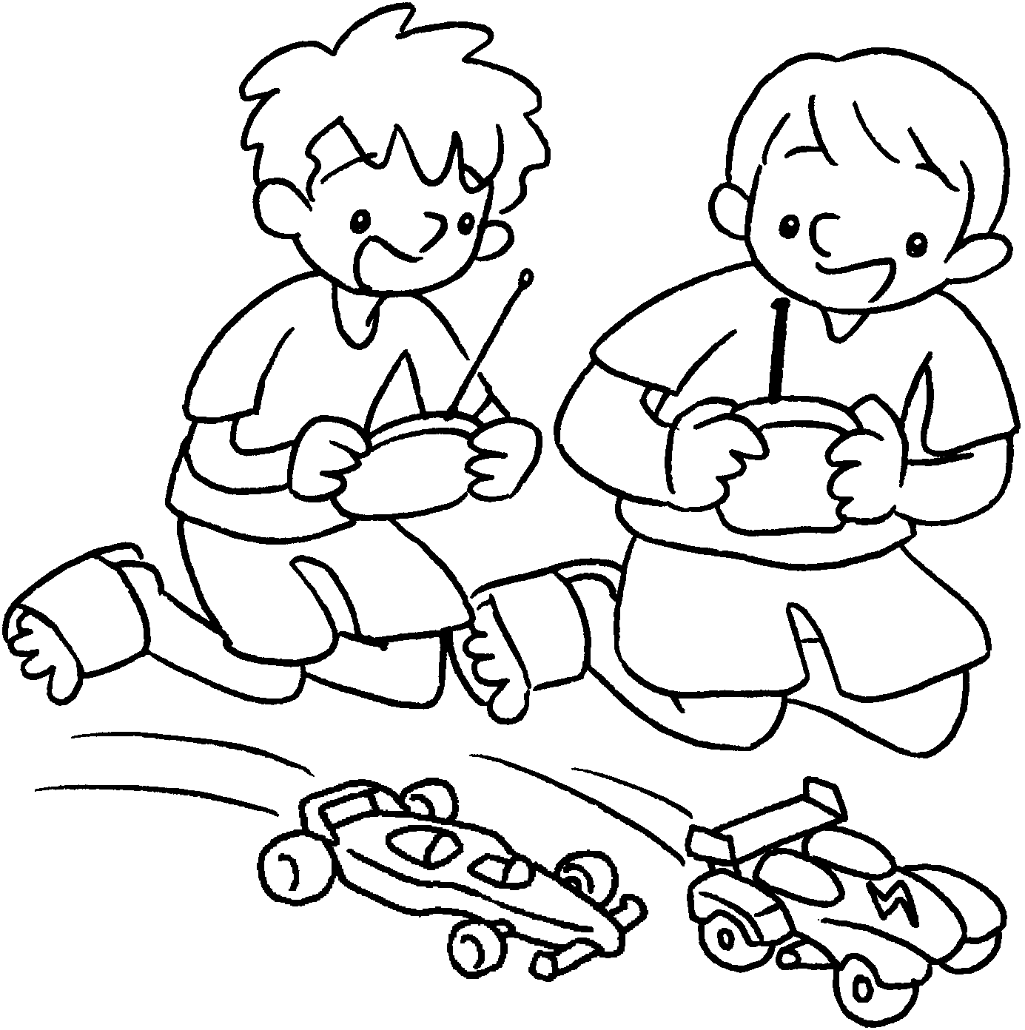  8

1 | l __ __ __ after | 2 | p __ __ __ tricks on

3 | s __ __ __ __ at | 4 | l __ __ __ __ at

5 | t __ __ __ to | 6 | l __ __ __ __ __ to

7 | f __ __ __ __ with | 8 | p __ __ __ with


Book 3B Chapter 2 Graded Worksheets
Worksheet 1⬇⬇
1 l o o k 2 p l a y
3 s h o u t 4 l a u g h
5 t a l k 6 l i s t e n
7 f i g h t 8 p l a y

