Look at the pictures and fill in the blanks.

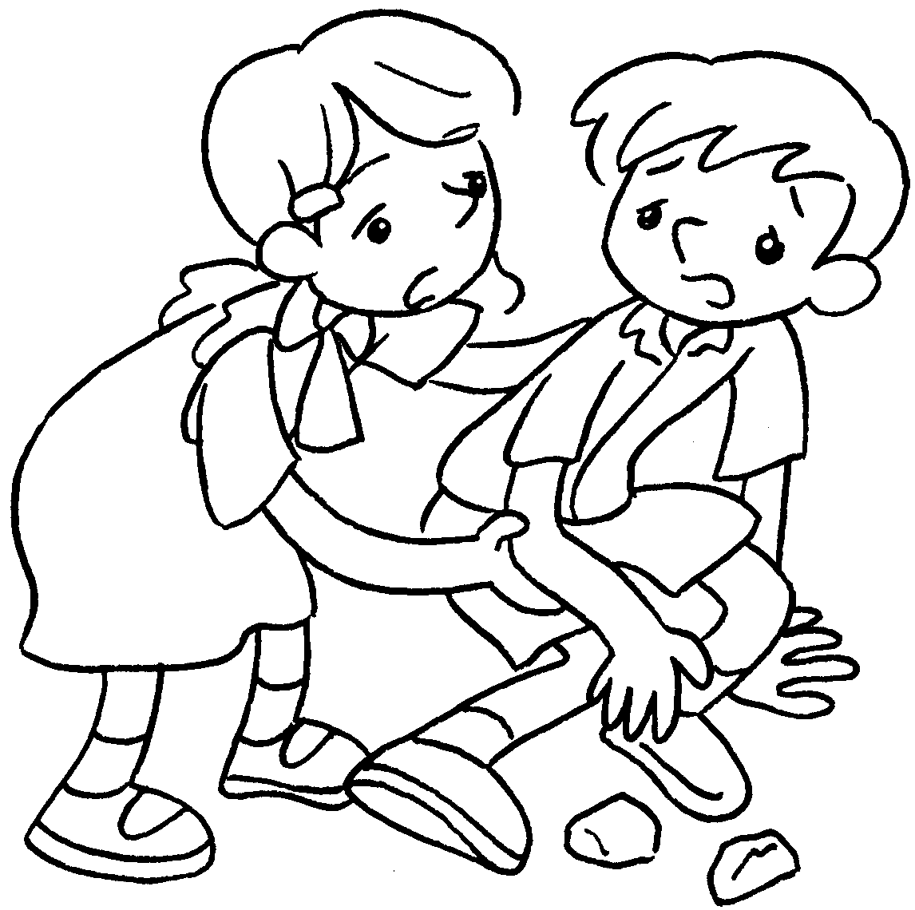  1 | 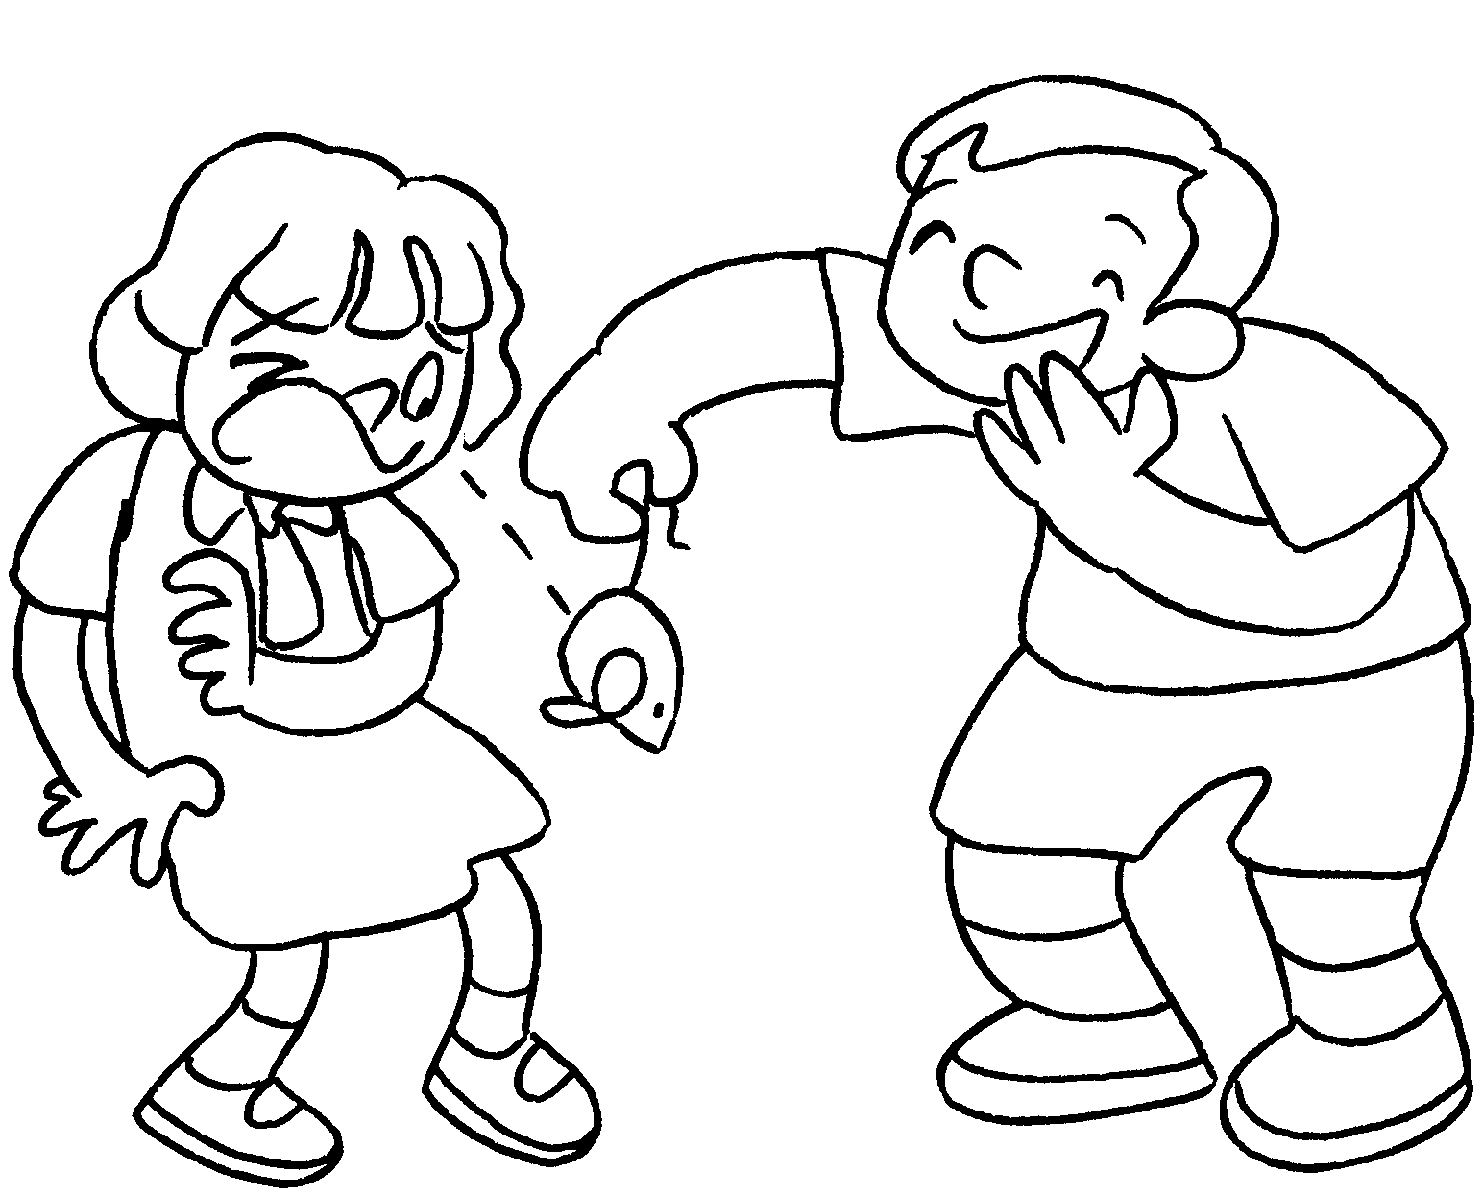  2 |  | 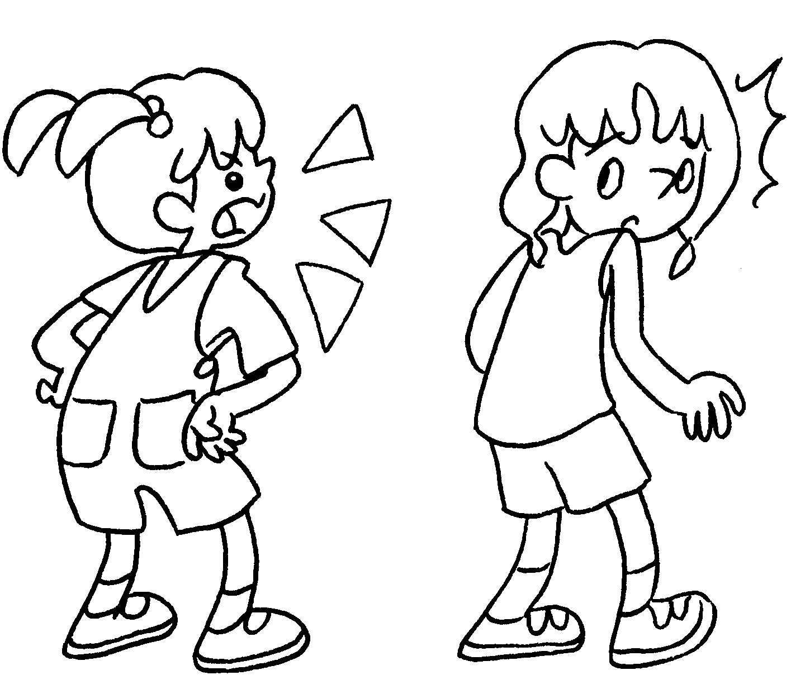  3
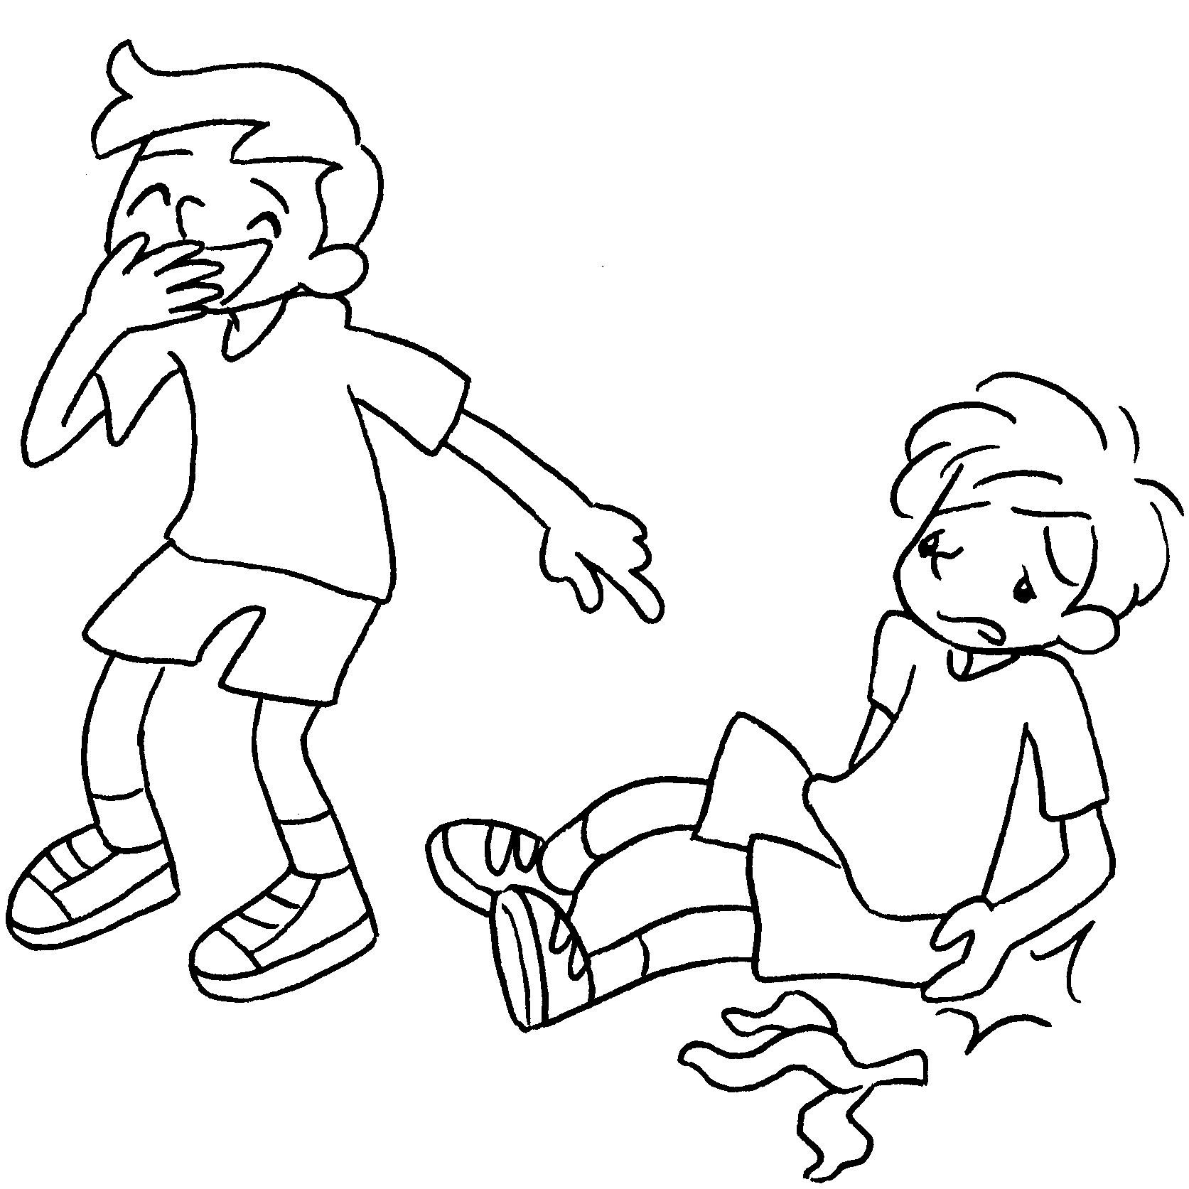  4 | 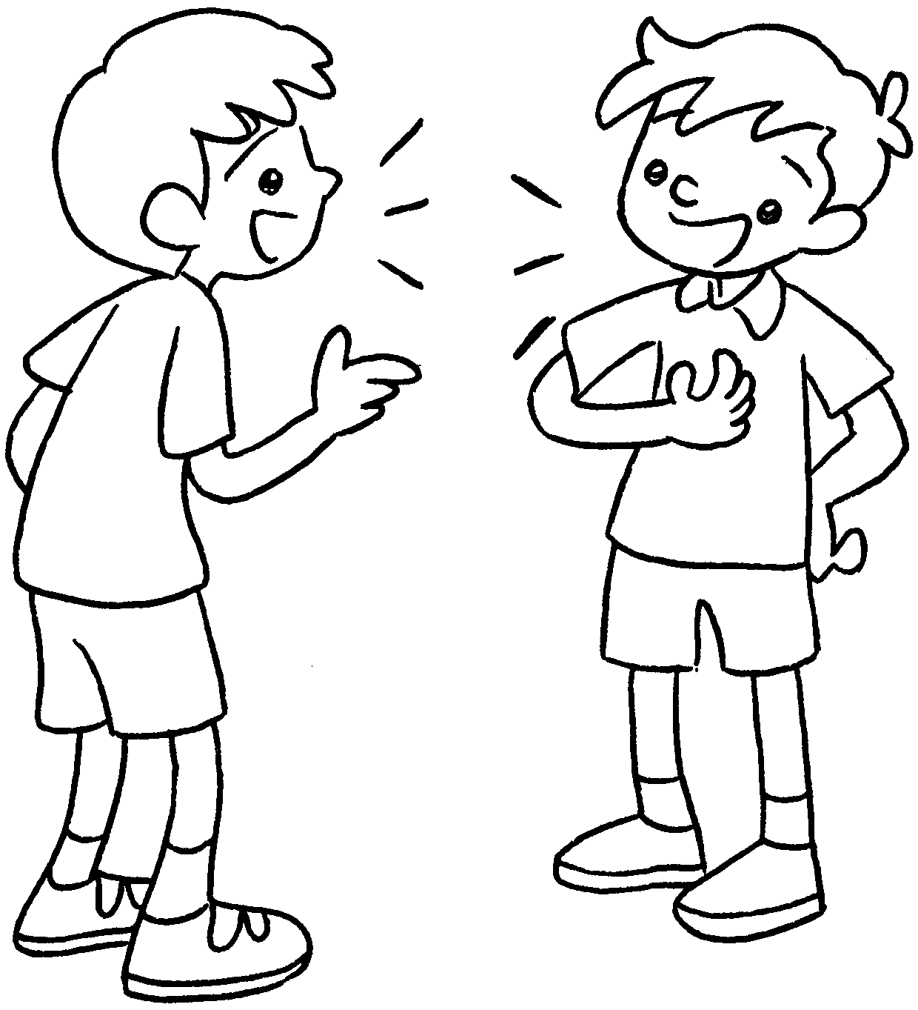  5 |  | 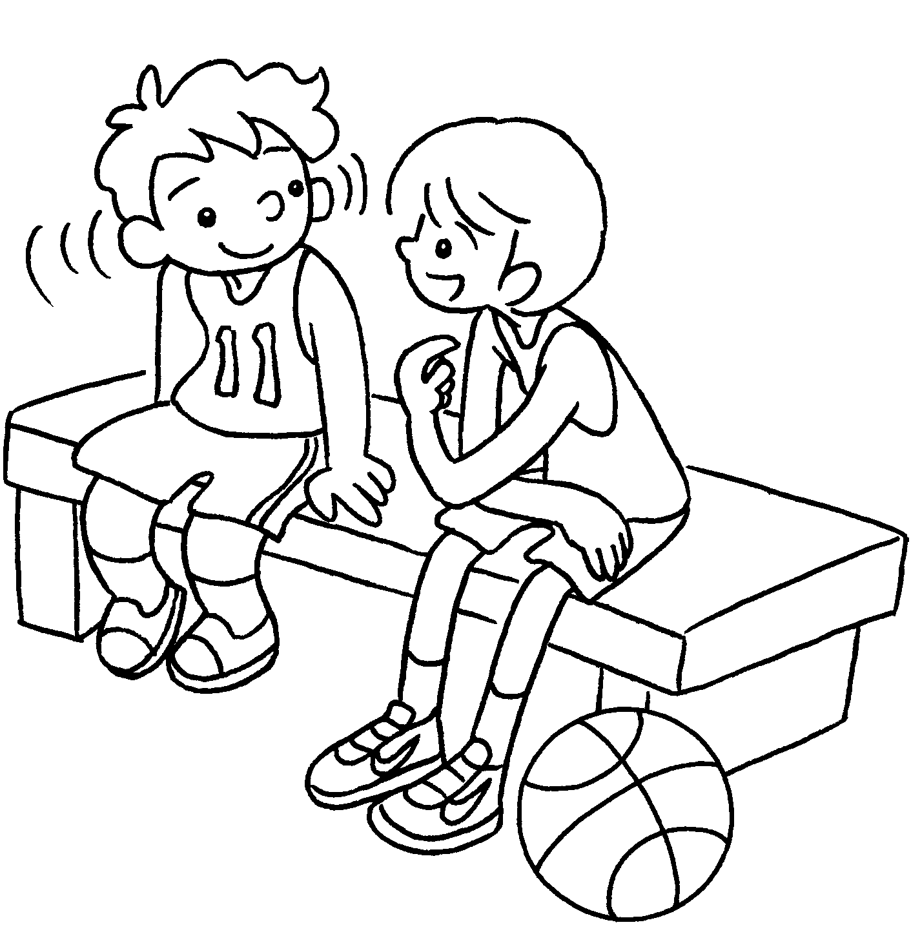  6
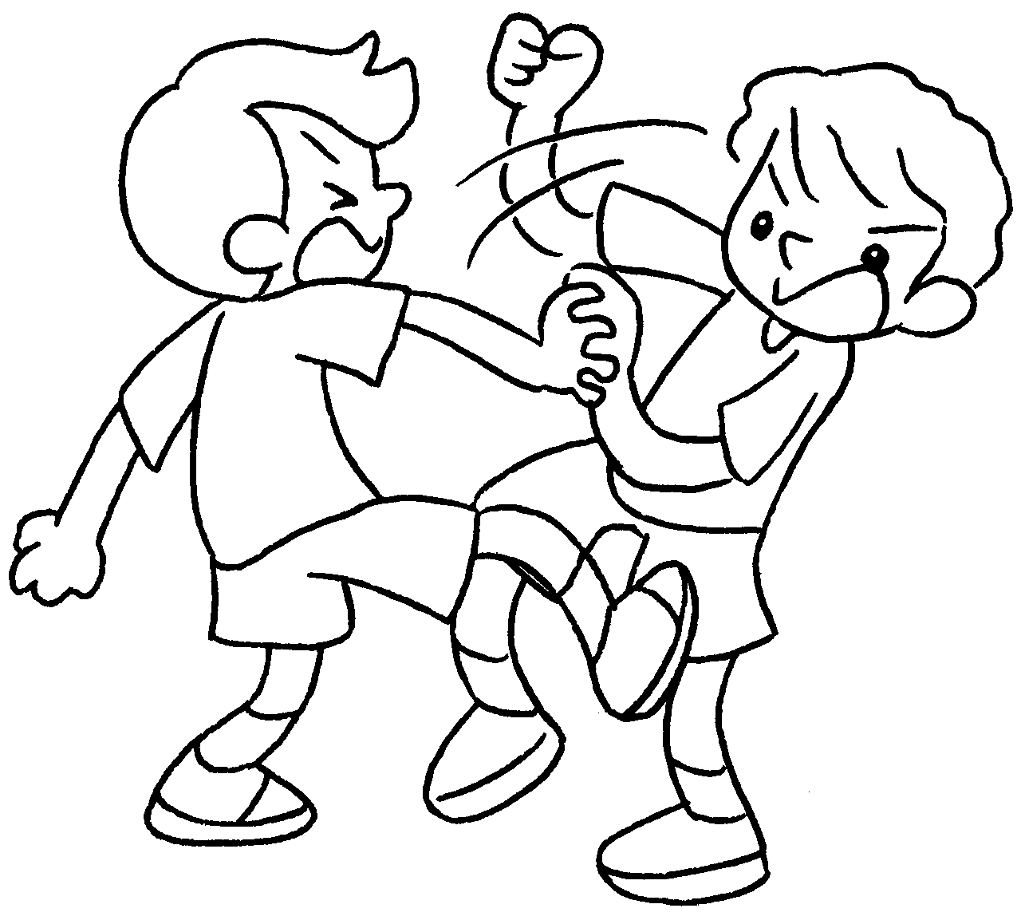  7 |  | 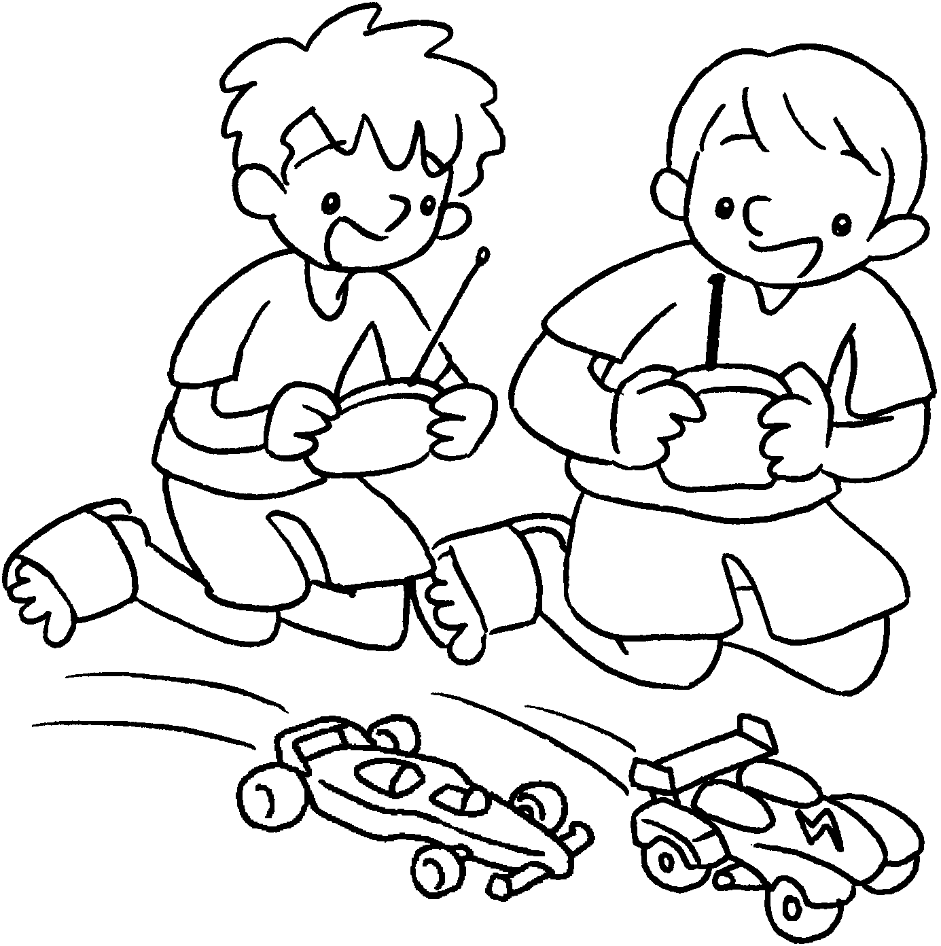  8

1 | l after | 2 | p tricks on
3 | s at | 4 | l at
5 | t to | 6 | l to
7 | f with | 8 | p with


Book 3B Chapter 2 Graded Worksheets
Worksheet 1⬇⬇⬇
1 look 2 play
3 shout 4 laugh
5 talk 6 listen
7 fight 8 play

