Circle the correct answers.

1 | 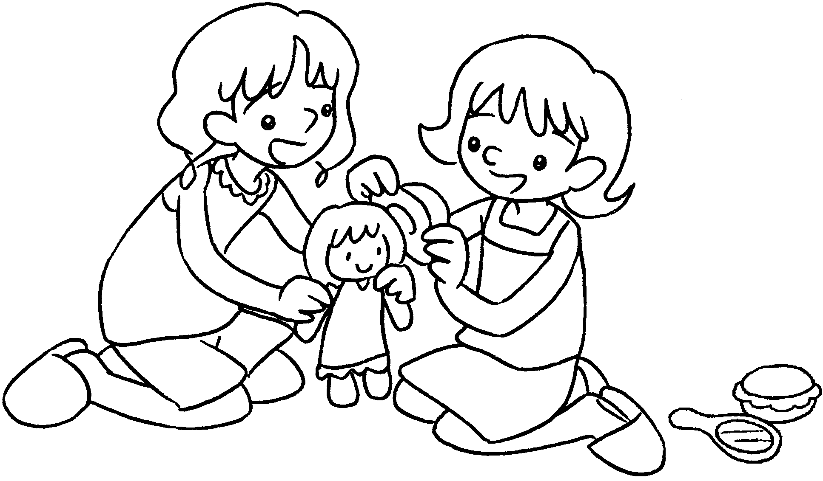  Penny plays ( at / with )  Mary. |  | 2 | 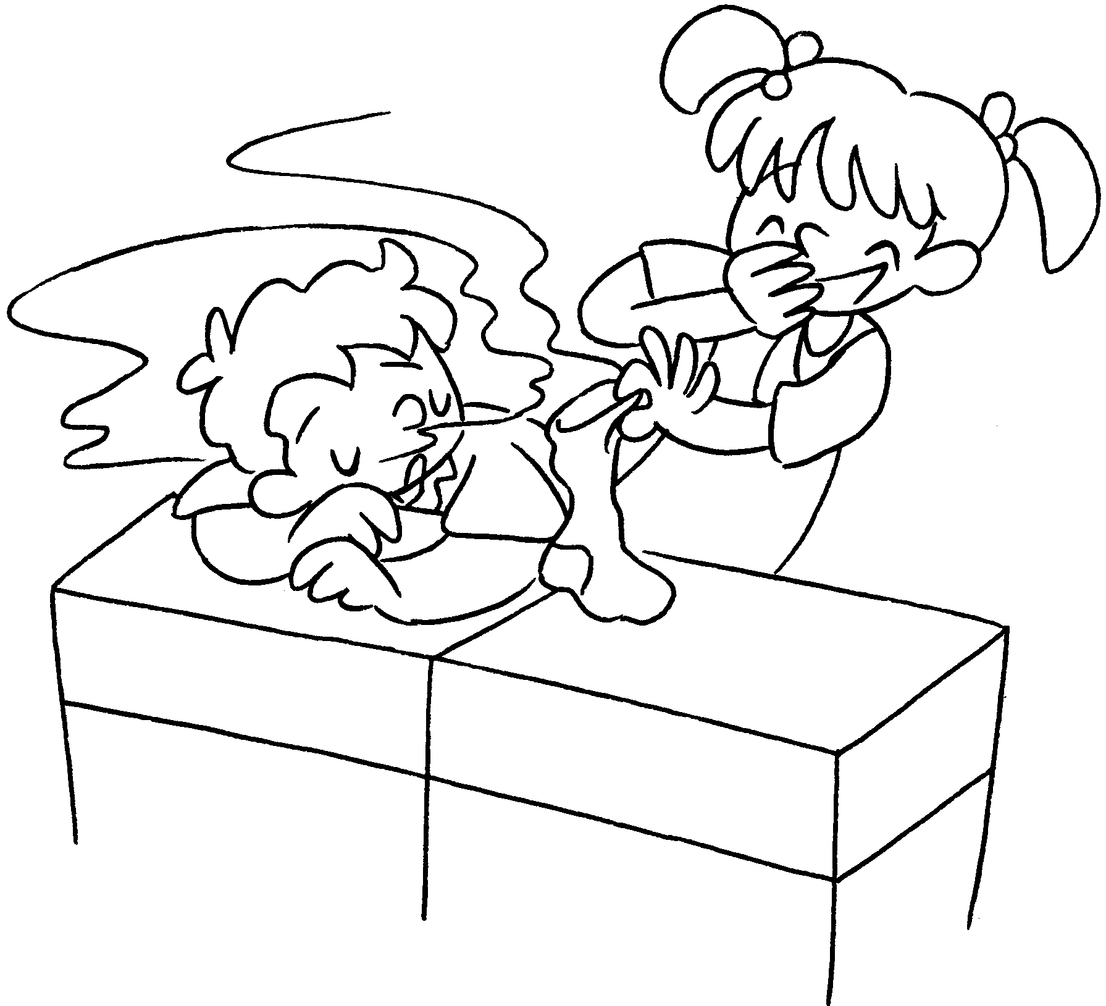  Linda plays tricks ( on / to )  Tommy.
3 | 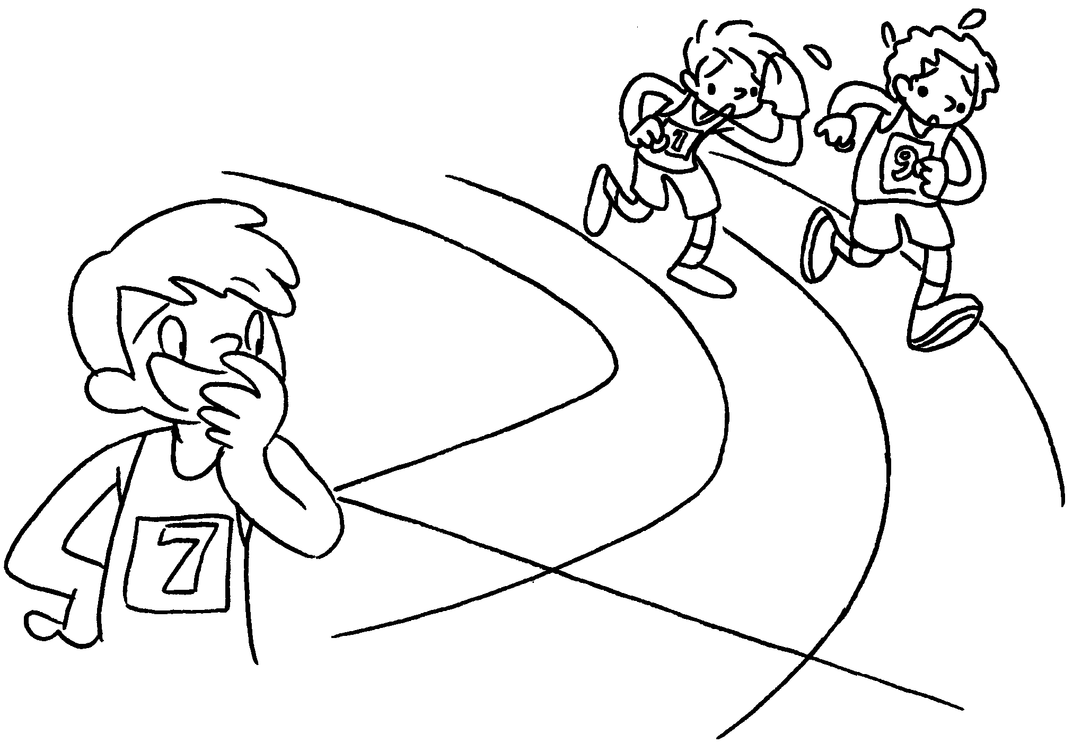  Peter laughs ( with / at )  Paul and Ben. |  | 4 | 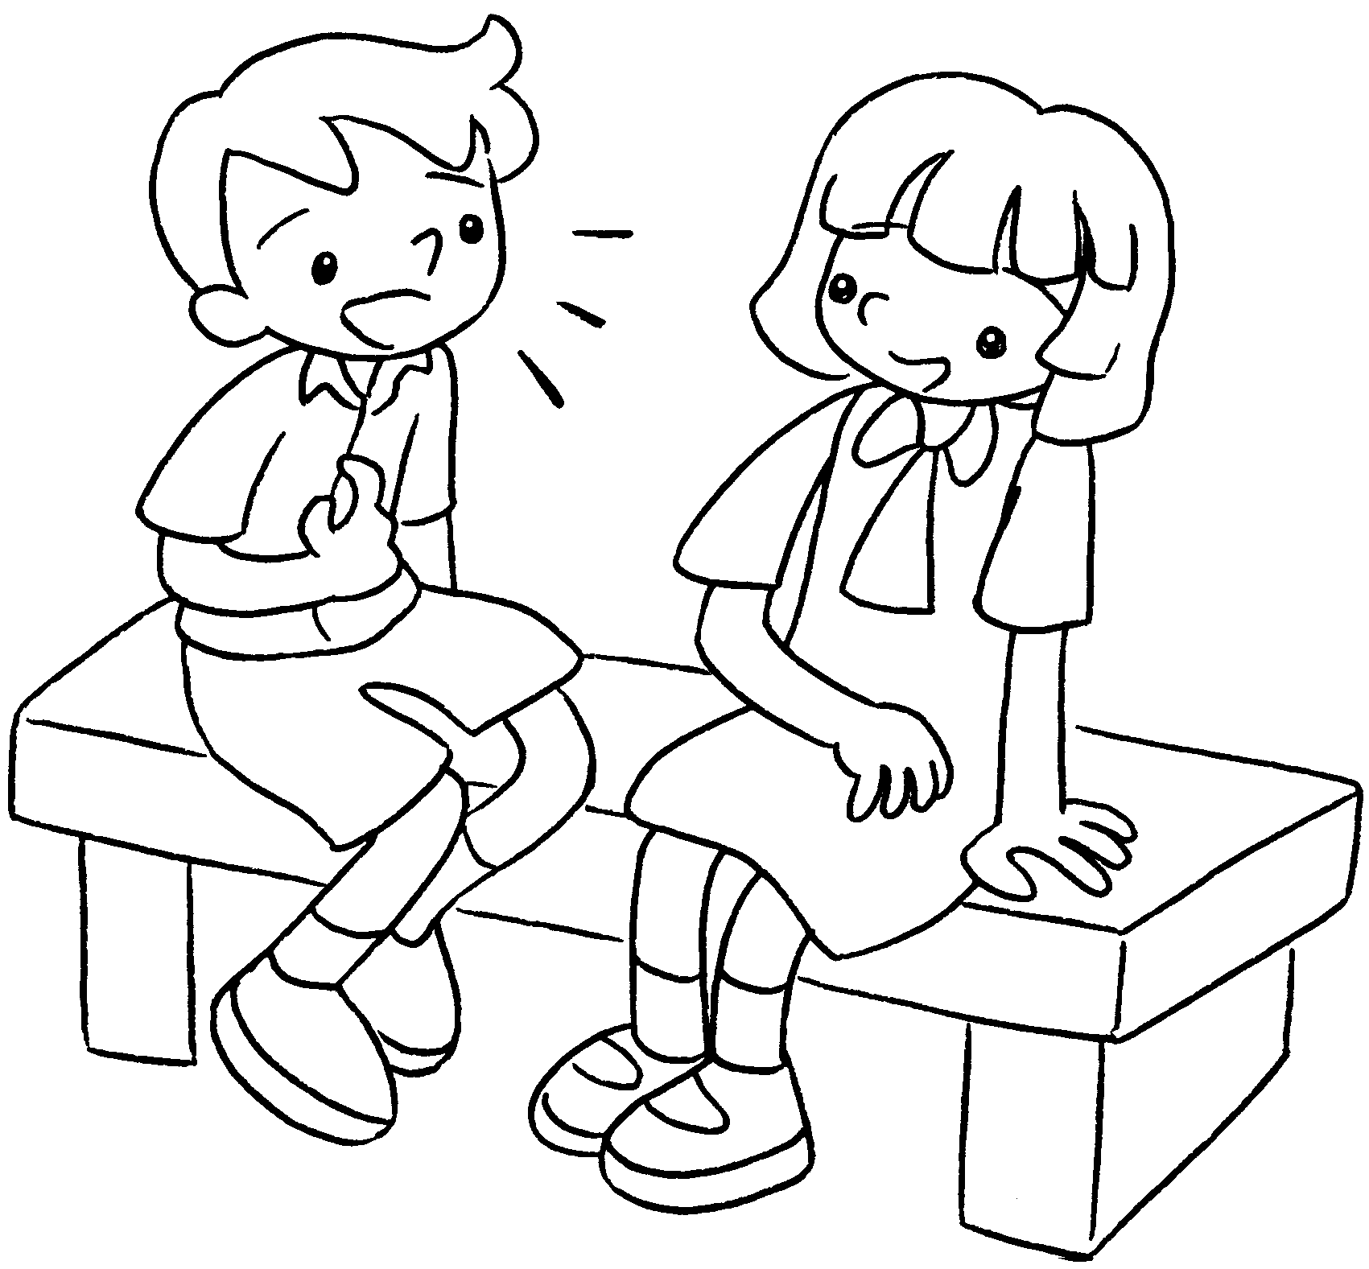  David talks ( after / to / at )  Amy.
5 | 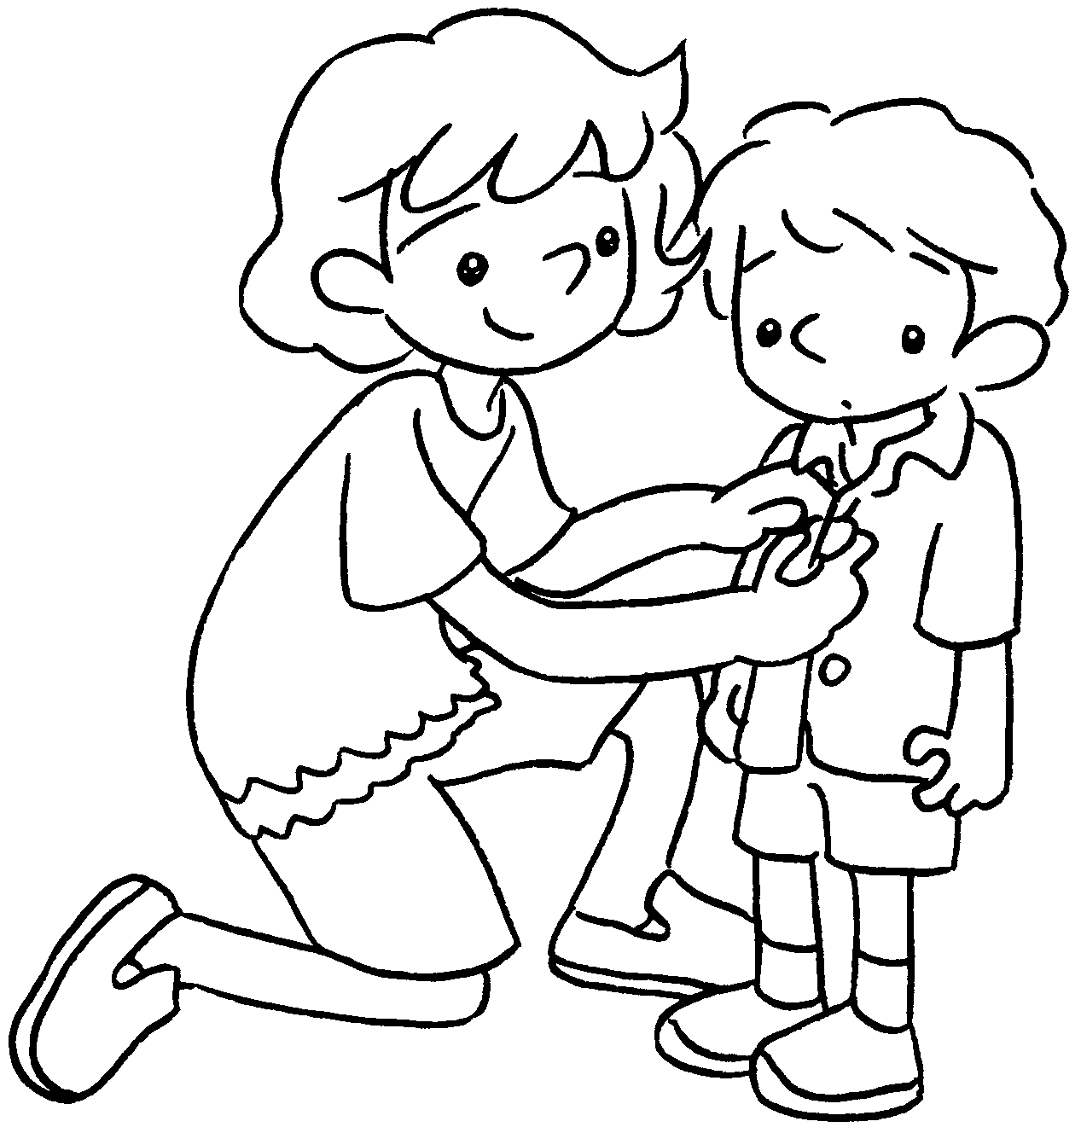  Kate looks ( on / to / after )  her brother. |  | 6 | 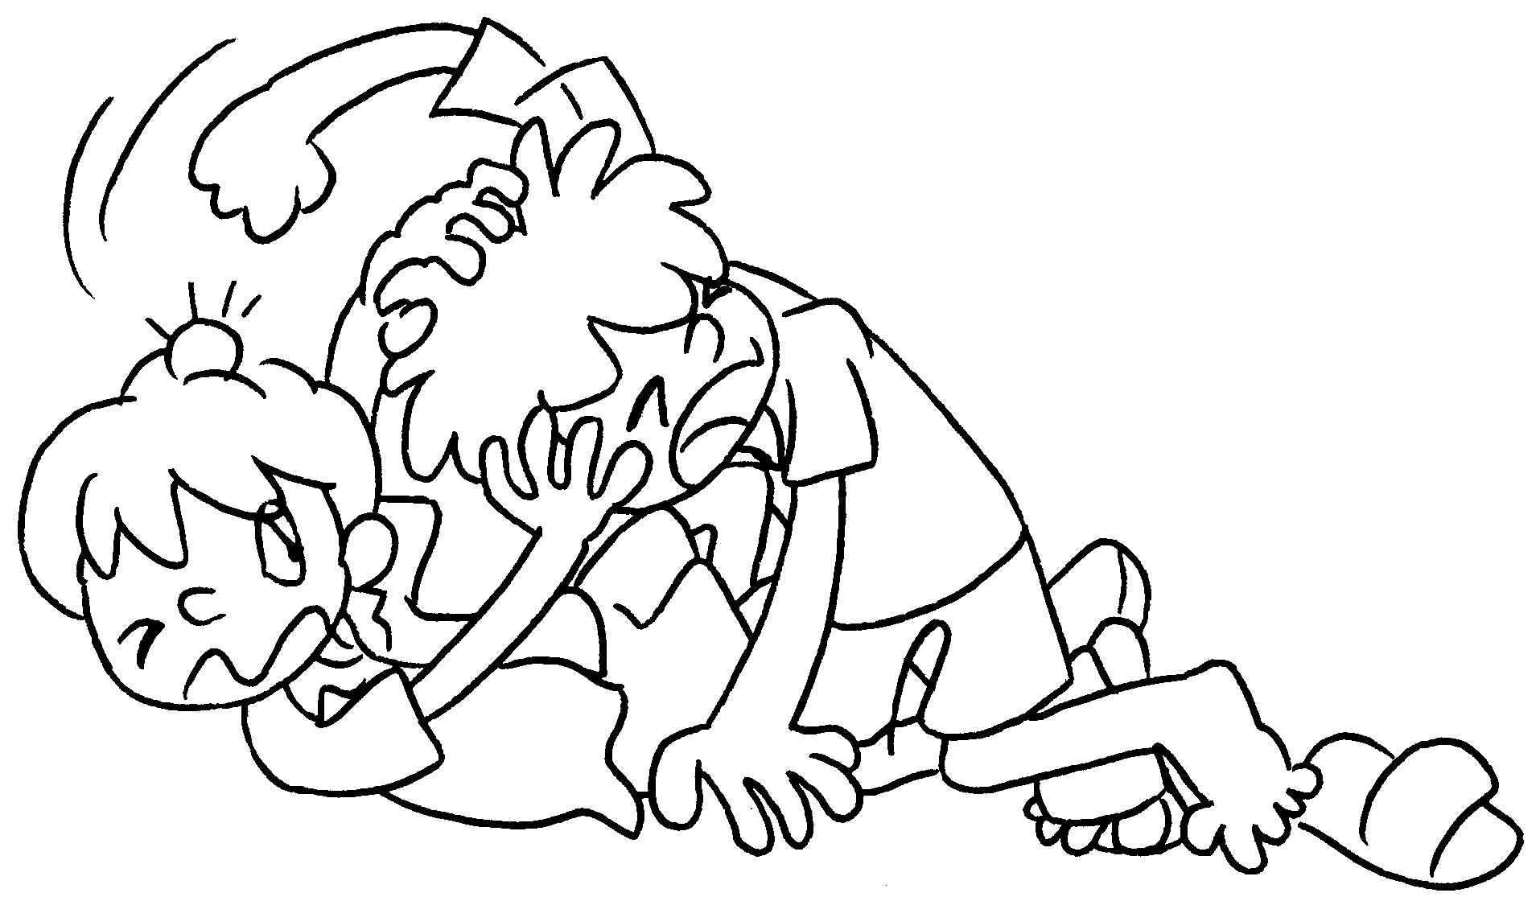  Andy fights ( with / at / on )  Bobby.


Book 3B Chapter 2 Graded Worksheets
Worksheet 2⬇
- ( at / with )
- ( on / to )
- ( with / at )
- ( after / to / at )
- ( on / to / after )
- ( with / at / on )

