Fill in the blanks with the correct prepositions.

1 | 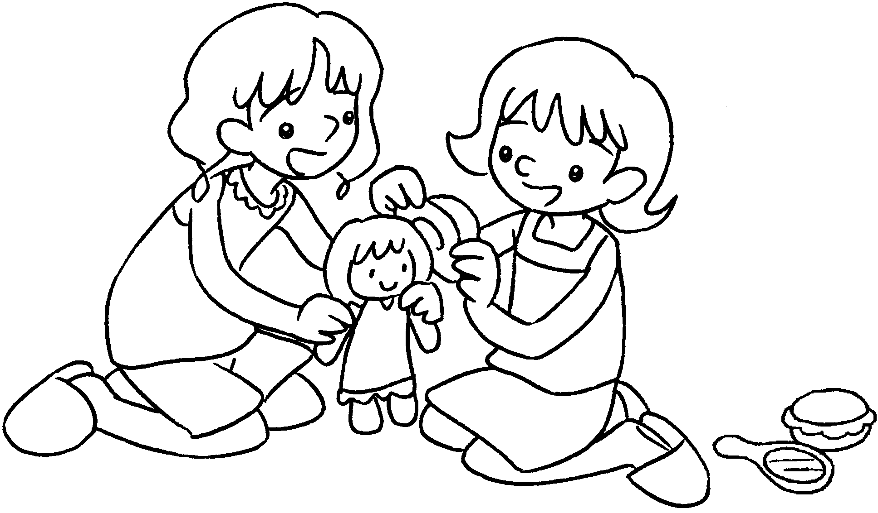  Penny plays  Mary. |  | 2 | 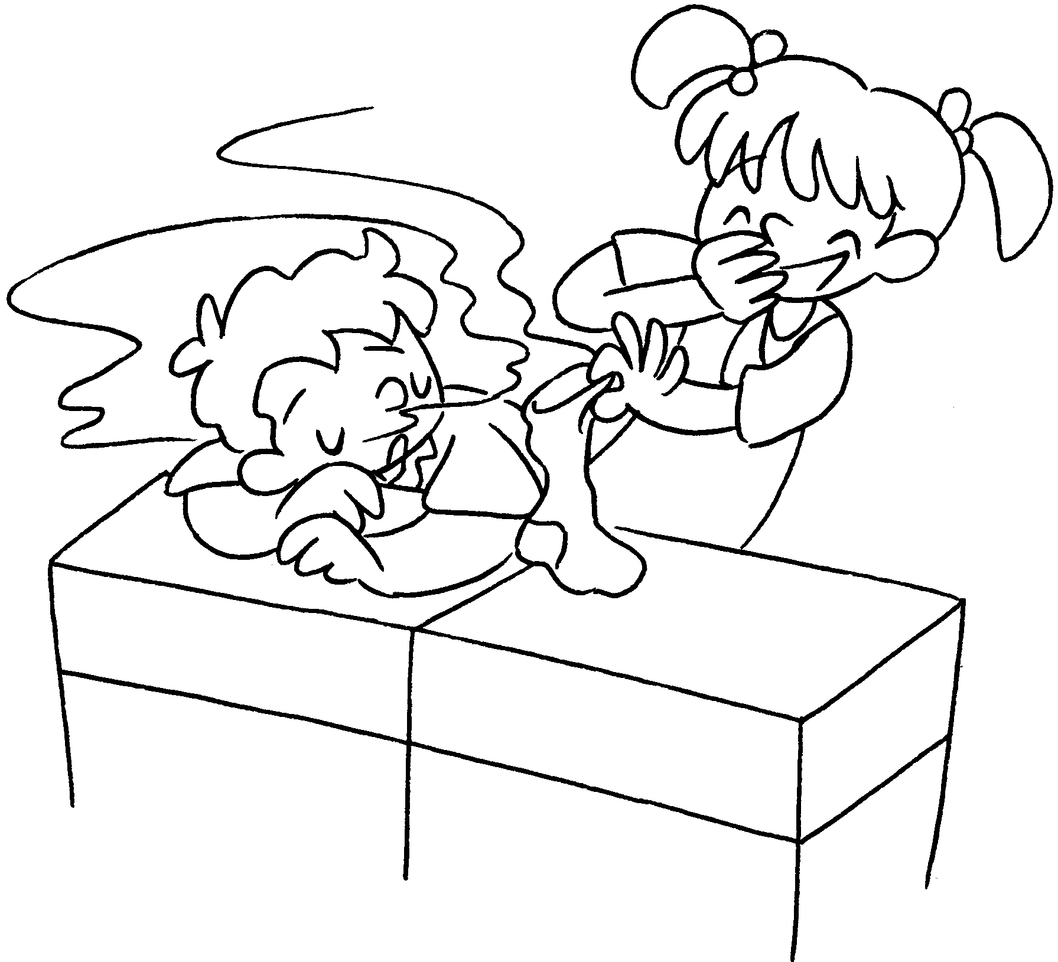  Linda plays tricks  Tommy.
3 | 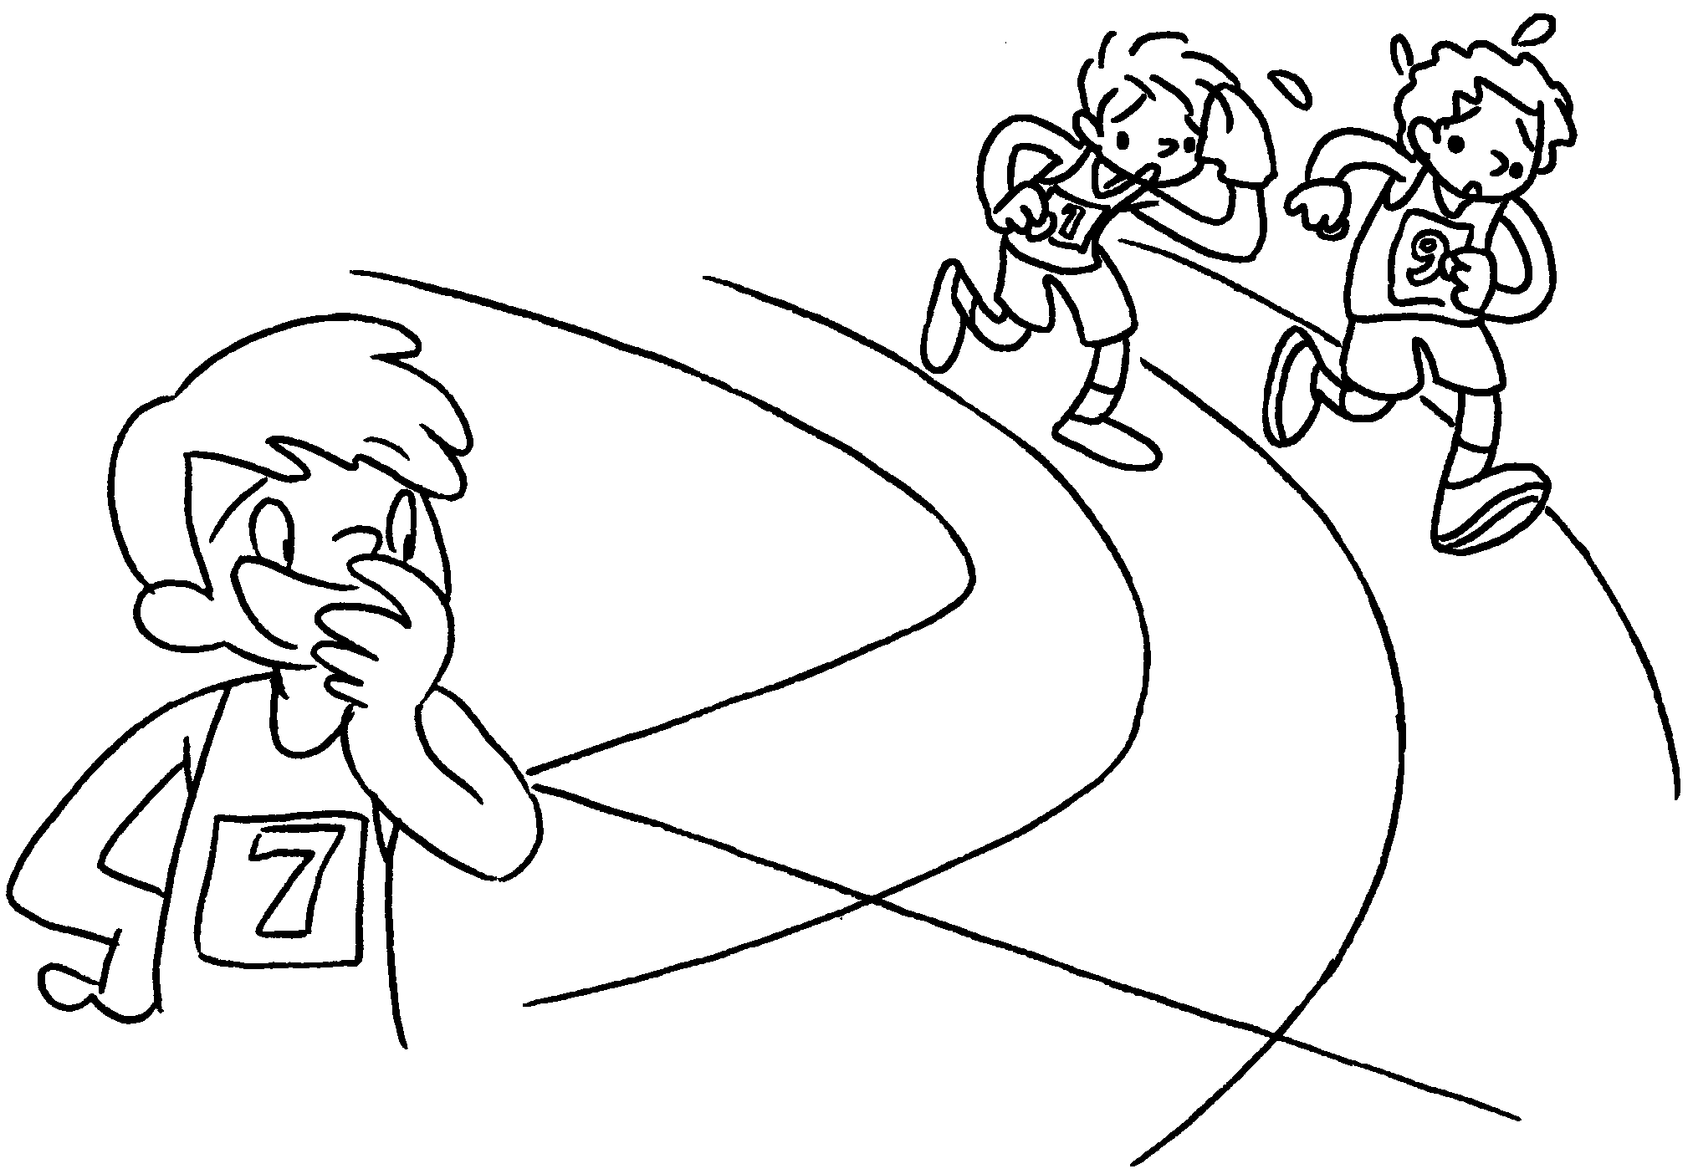  Peter laughs  Paul and Ben. |  | 4 | 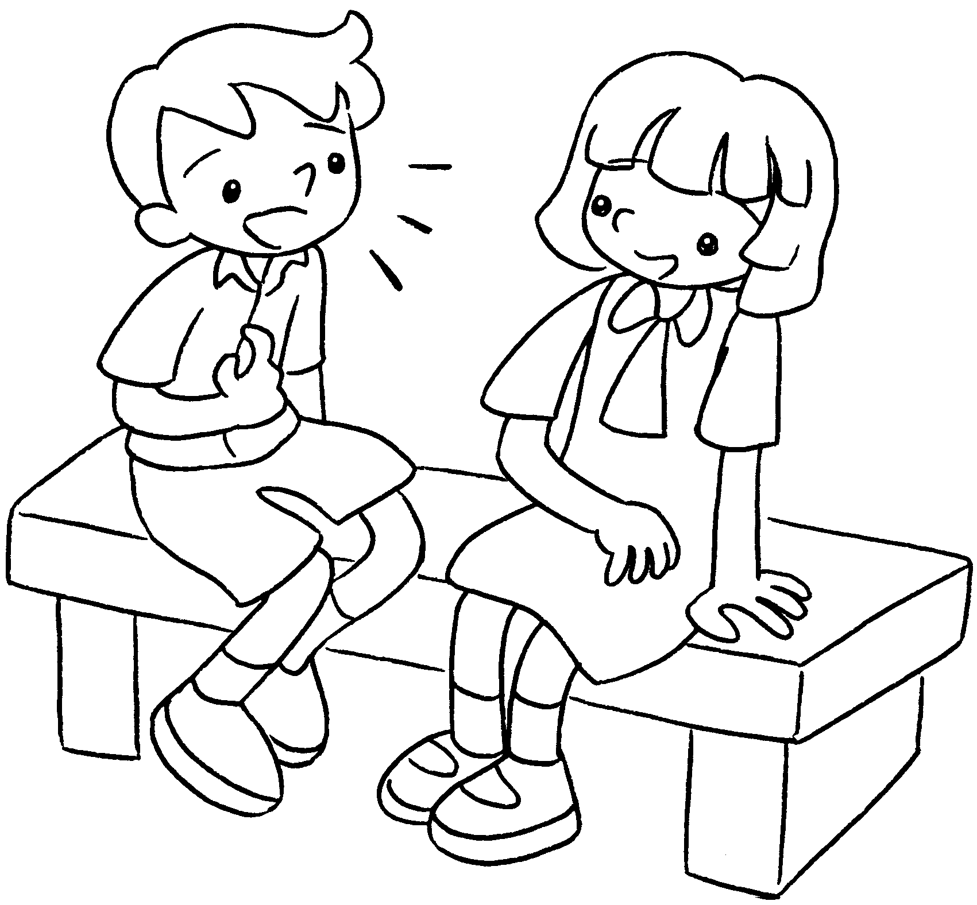  David talks Amy.
5 | 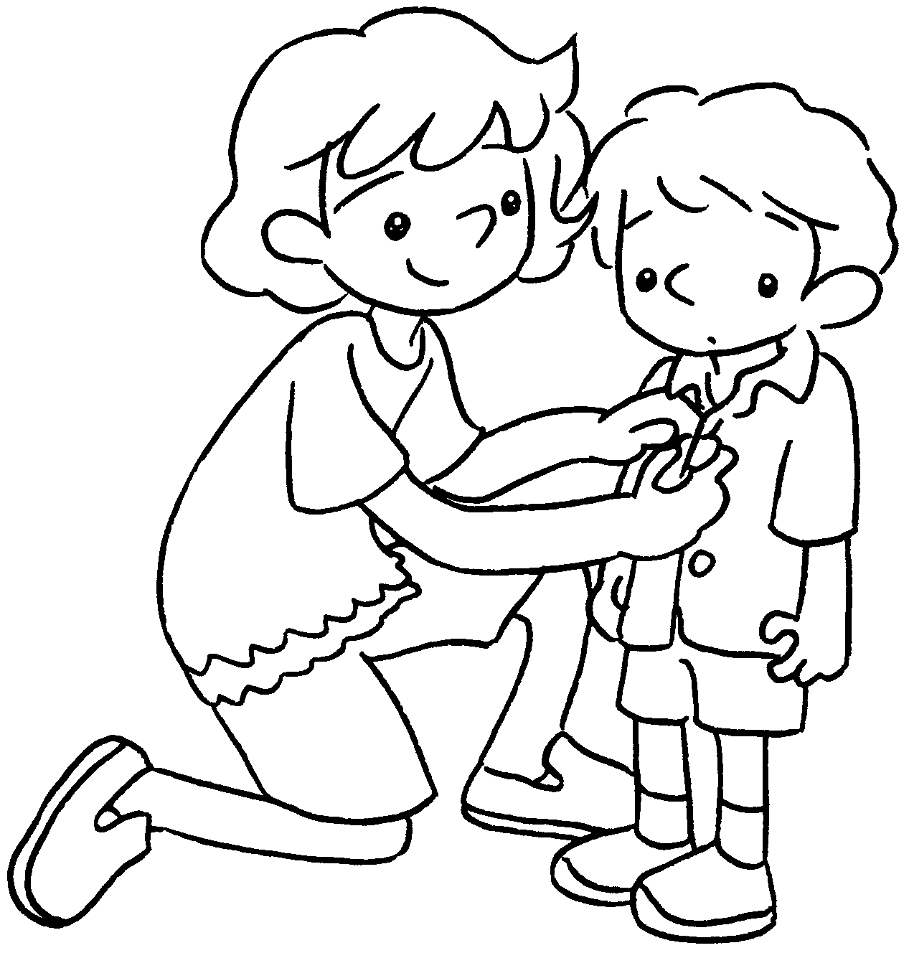  Kate looks  her brother. |  | 6 | 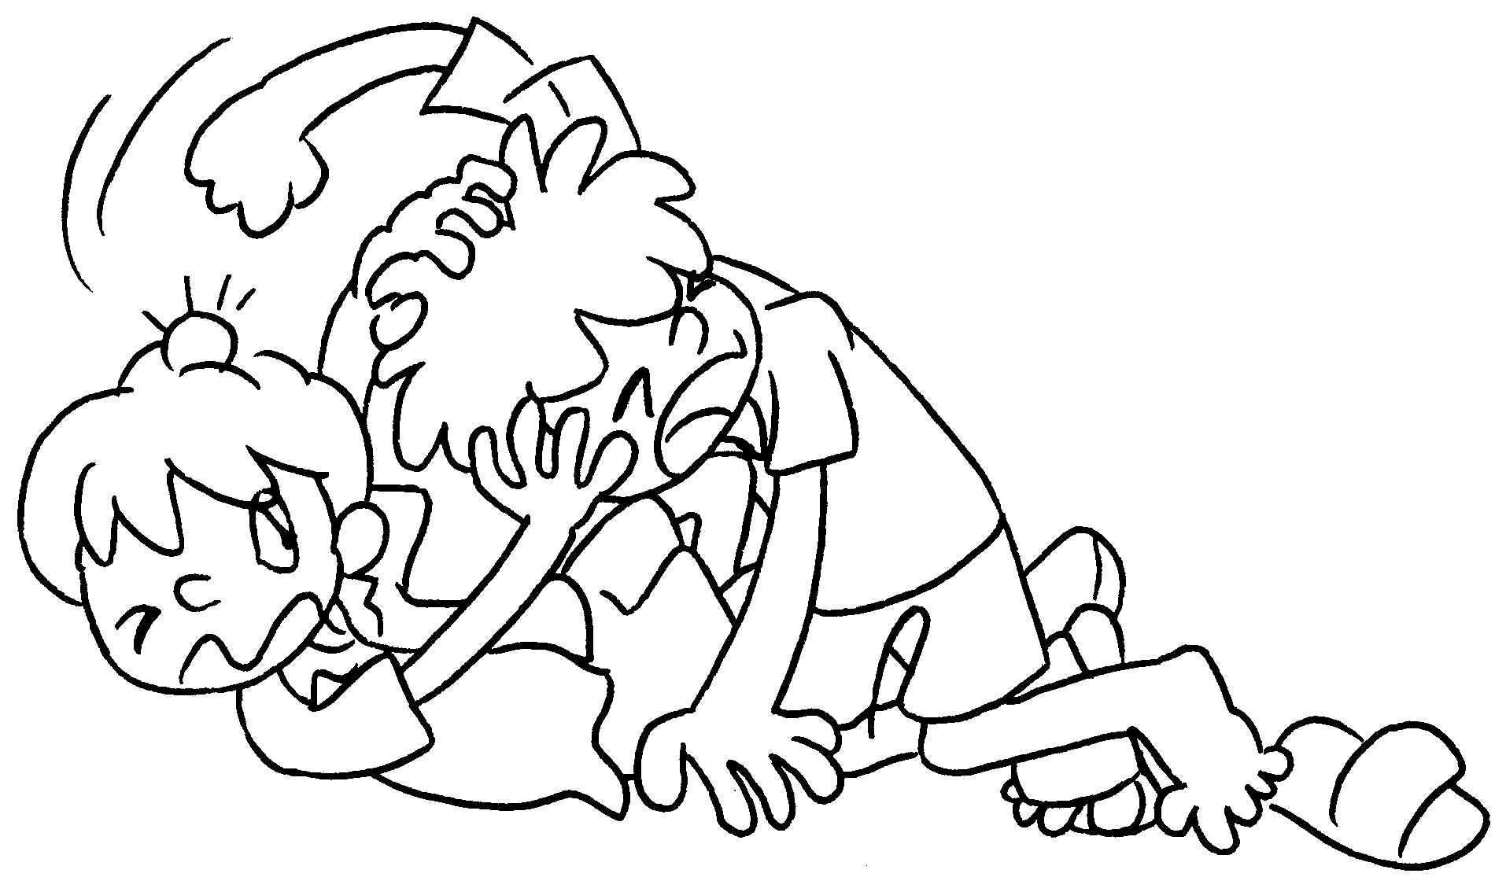  Andy fights  Bobby.


Book 3B Chapter 2 Graded Worksheets
Worksheet 2⬇⬇⬇
- with
- on
- at
- to
- after
- with

