Circle the correct answers.
1 | 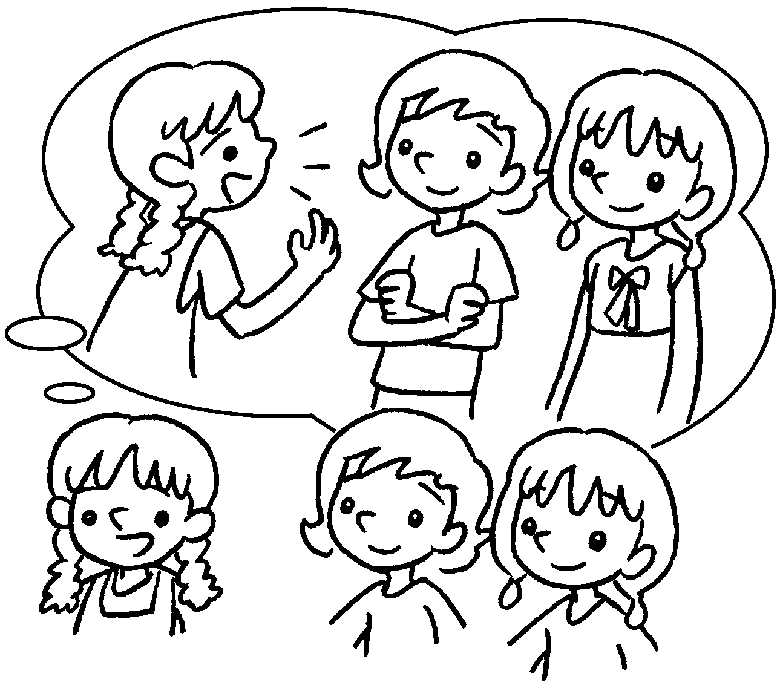 | They are Ann and Lisa.  I like talking to ( her / them / him ).
2 | 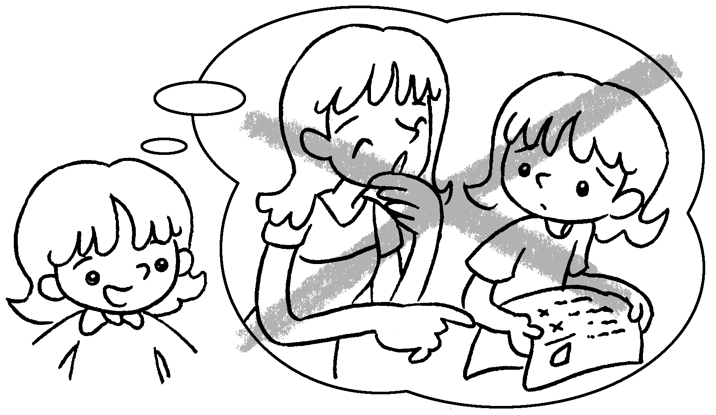 | My sister is good to me. She  doesn’t laugh at ( you / him / me ).
3 | 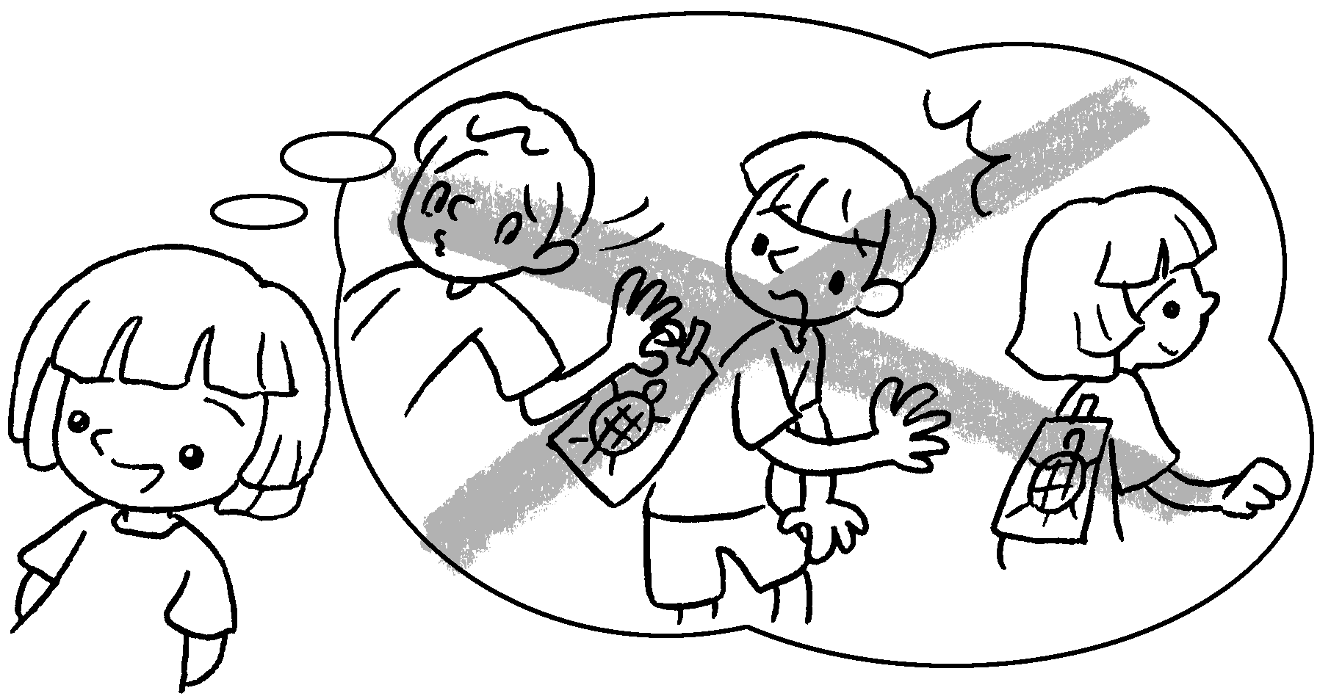 | Tommy is good to me and my  brother. He doesn’t play tricks on  ( you / us / them ).
4 | 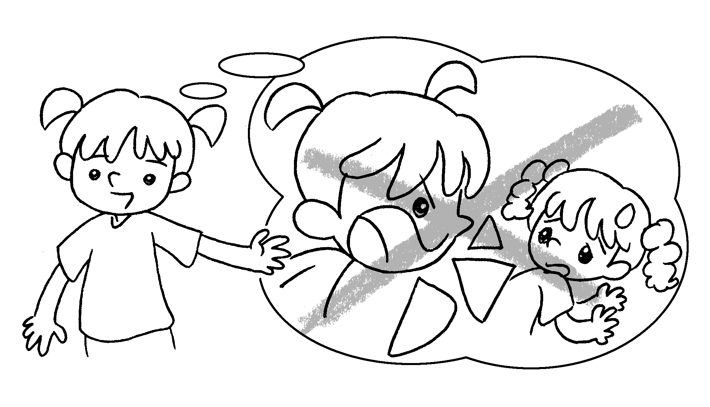 | I love my sister Mimi. I don’t shout  at ( us / her / them ).
5 | 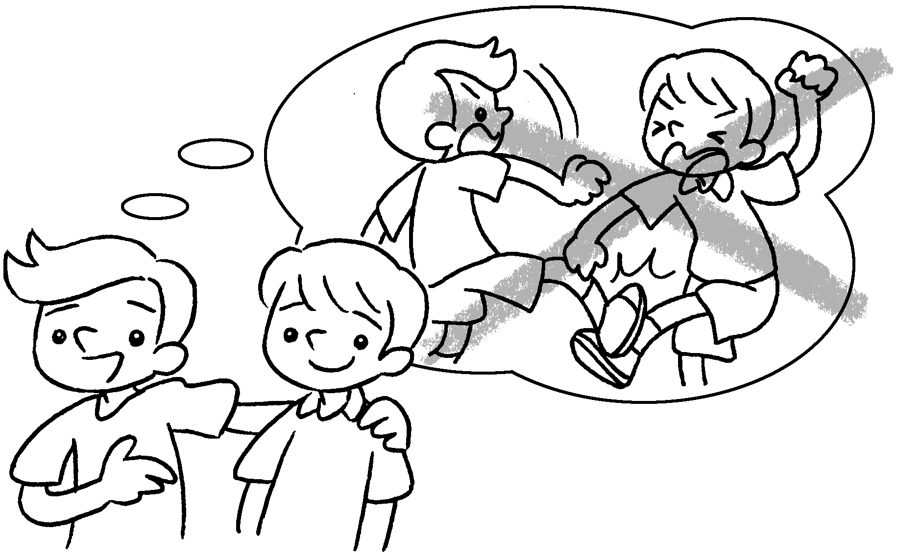 | Paul is my friend. I don’t fight with  ( us / her / him ).
6  … | 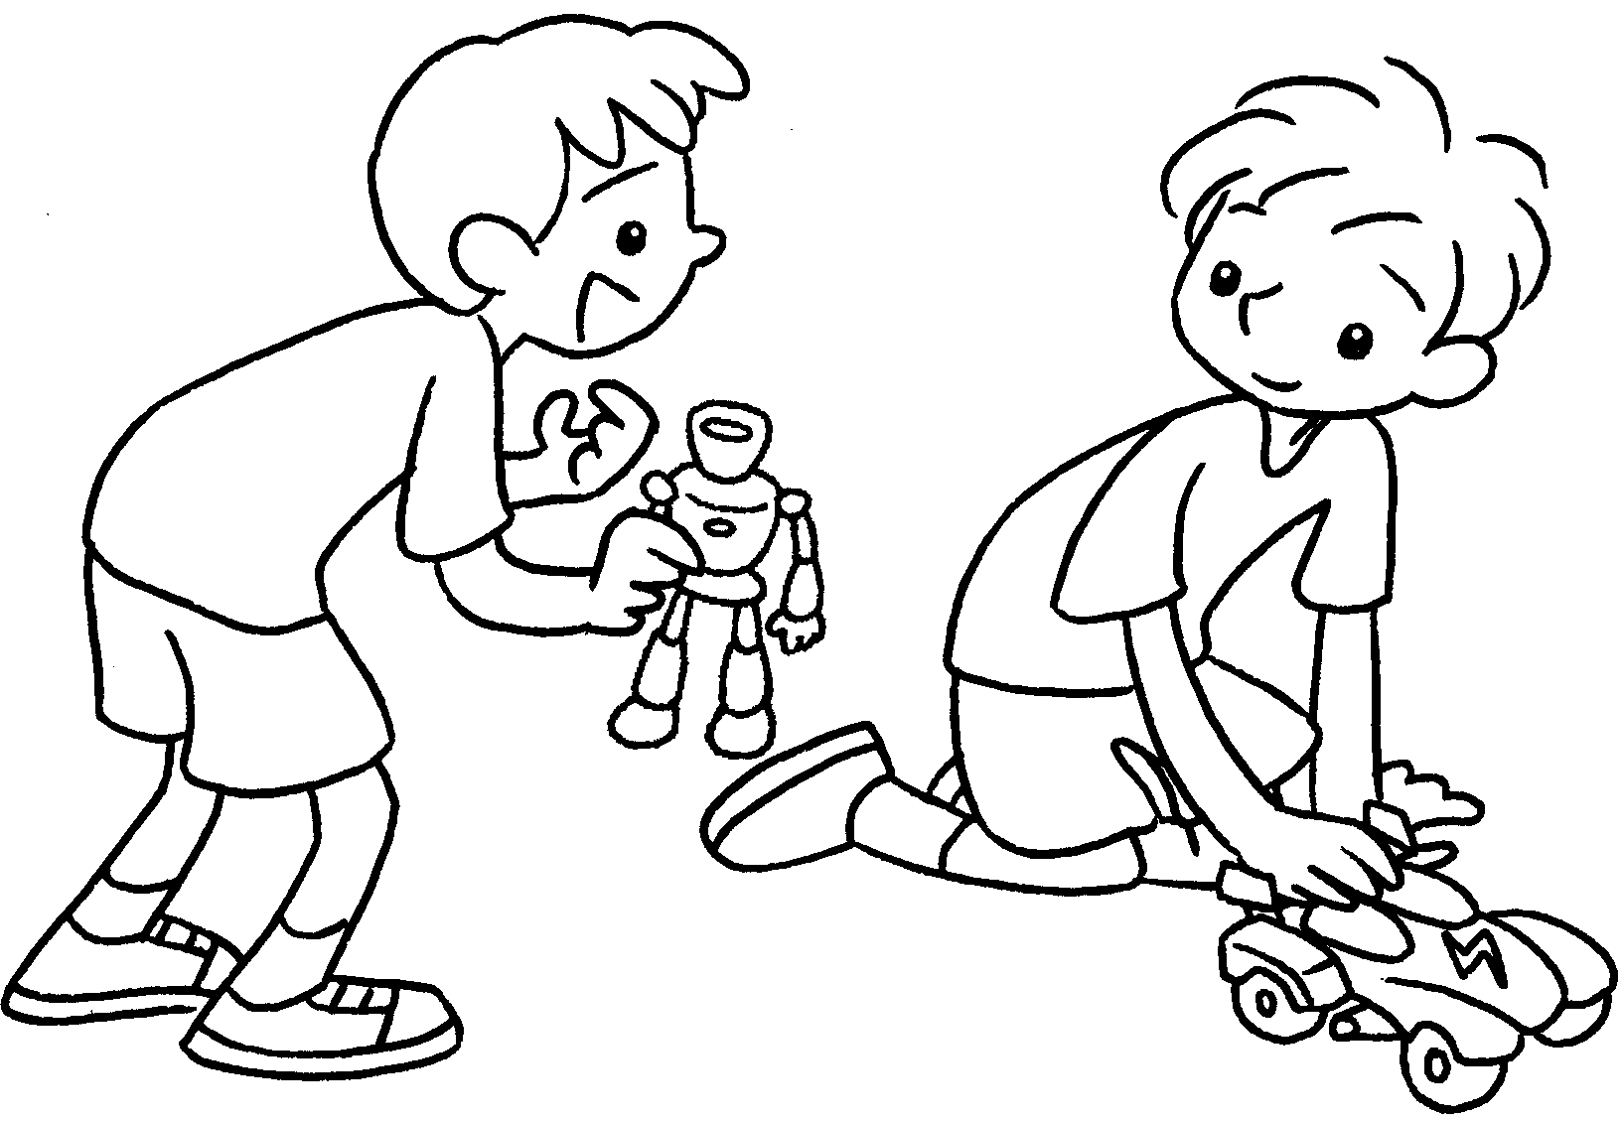 | Alex, can I play with ( me / her /  you )?


Book 3B Chapter 2 Graded Worksheets
Worksheet 3⬇
- ( her / them / him )
- ( you / him / me )
- ( you / us / them )
- ( us / her / them )
- ( us / her / him )
- ( me / her / you )

