Choose and write.

me you him her us them

1 | 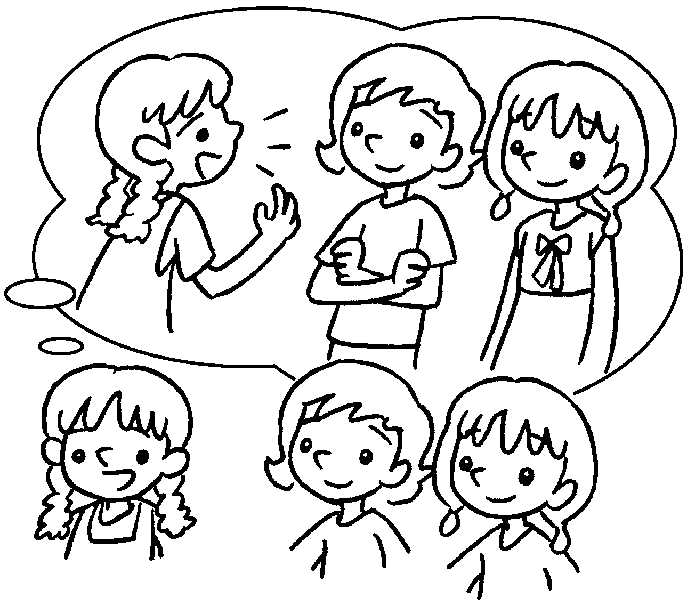 | They are Ann and Lisa.  I like talking to .
2 | 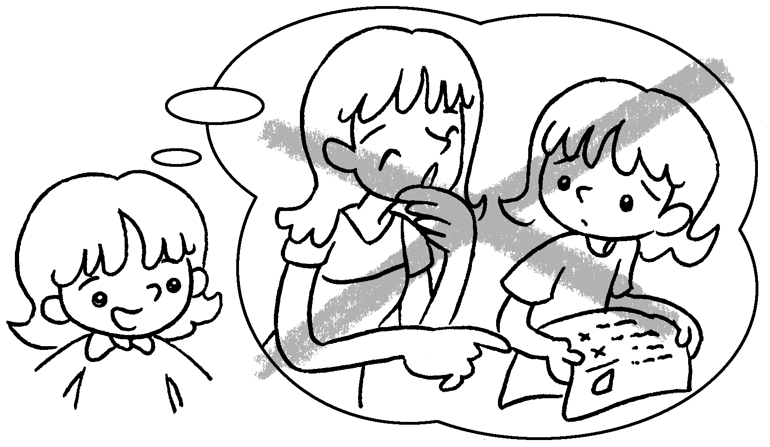 | My sister is good to me. She  doesn’t laugh at .
3 | 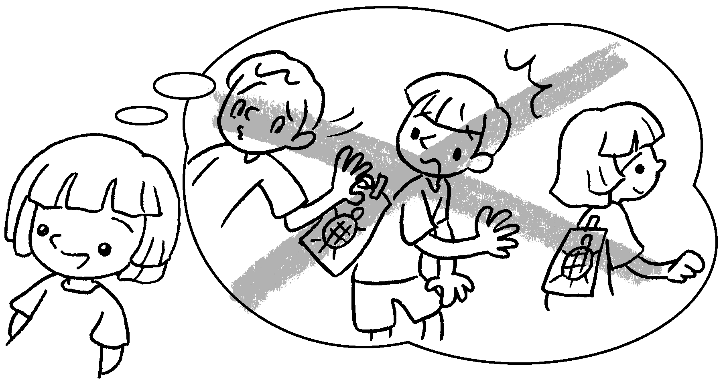 | Tommy is good to me and my  brother. He doesn’t play tricks on  .
4 | 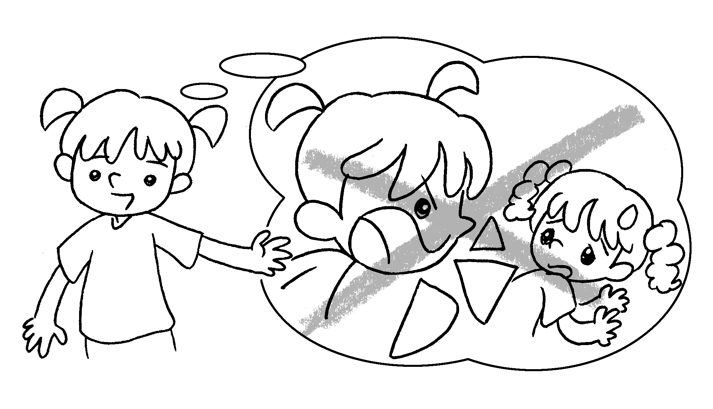 | I love my sister Mimi. I don’t shout  at .
5 | 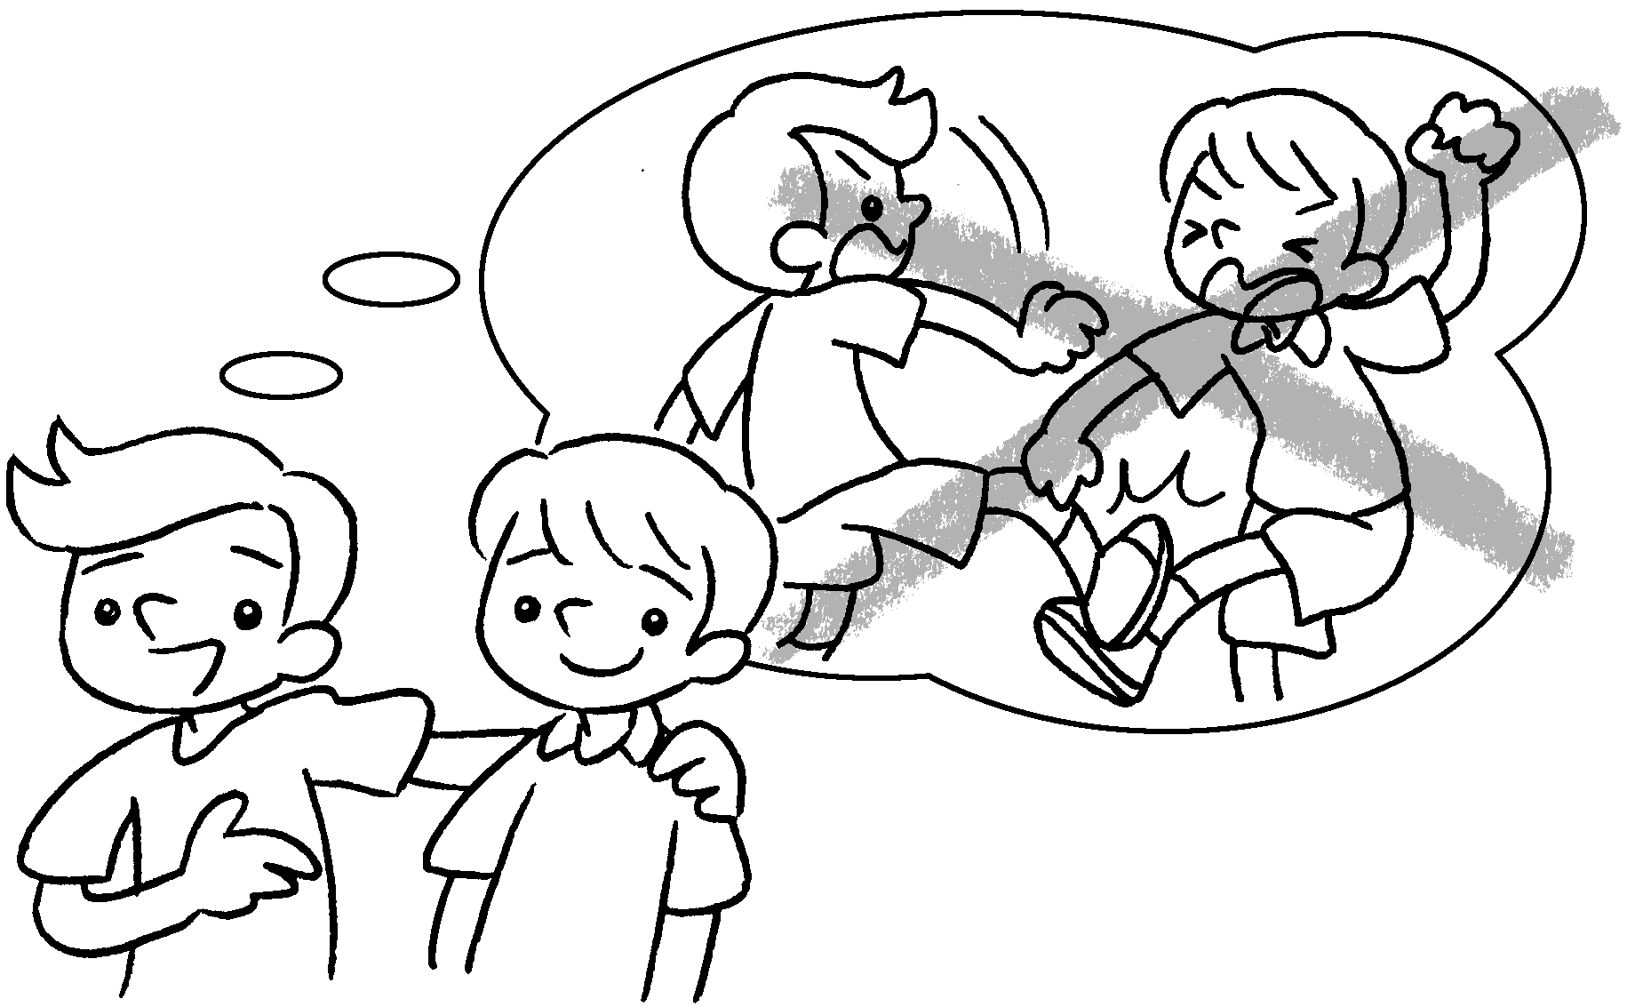 | Paul is my friend. I don’t fight with  .
6  … | 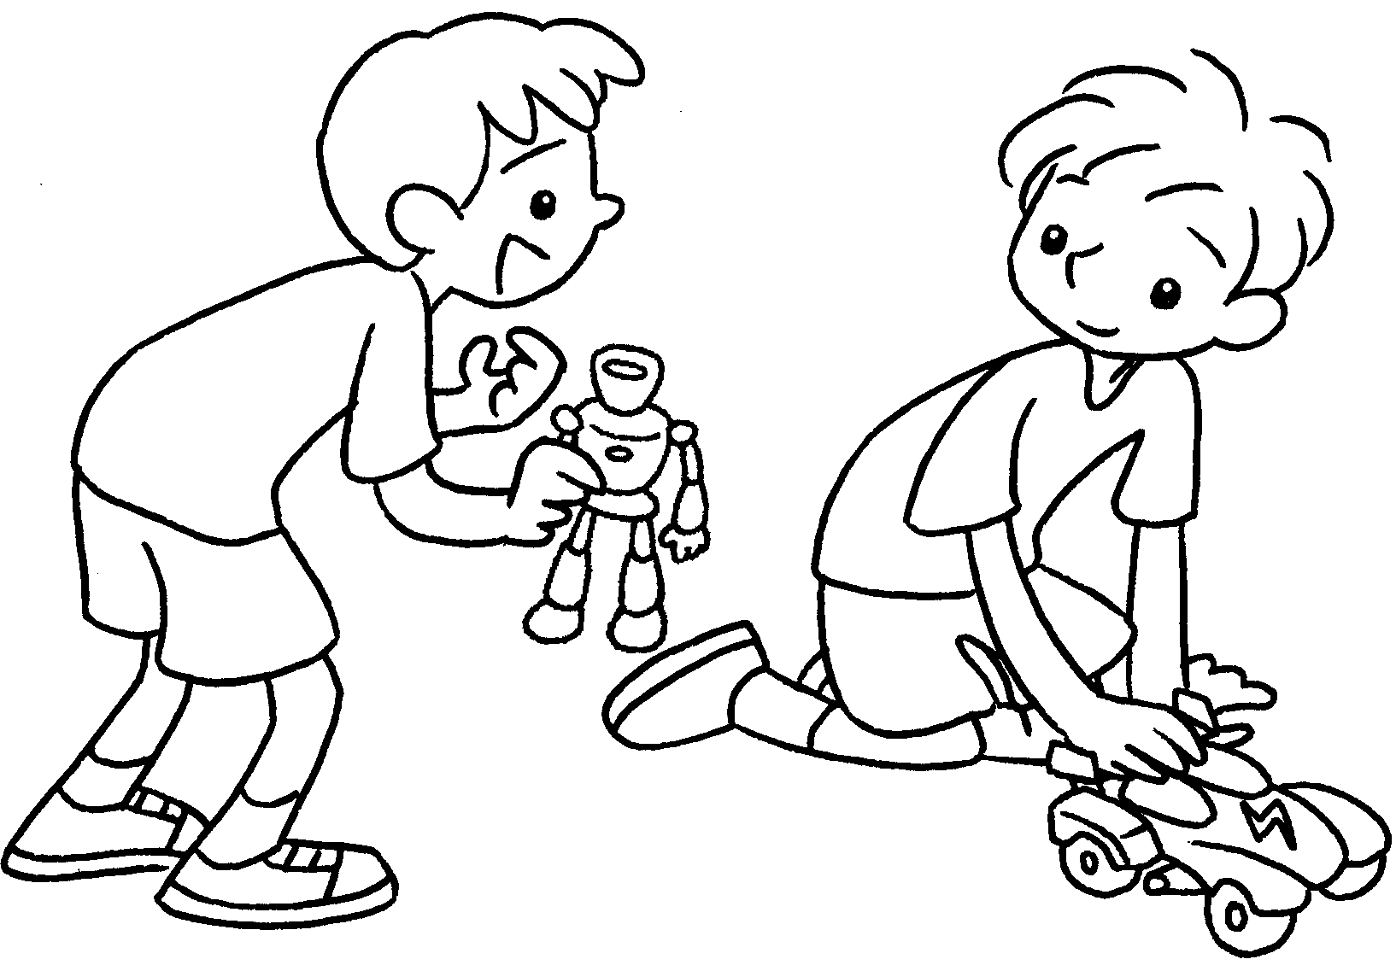 | Alex, can I play with ?


Book 3B Chapter 2 Graded Worksheets
Worksheet 3⬇⬇
- them
- me
- us
- her
- him
- you

