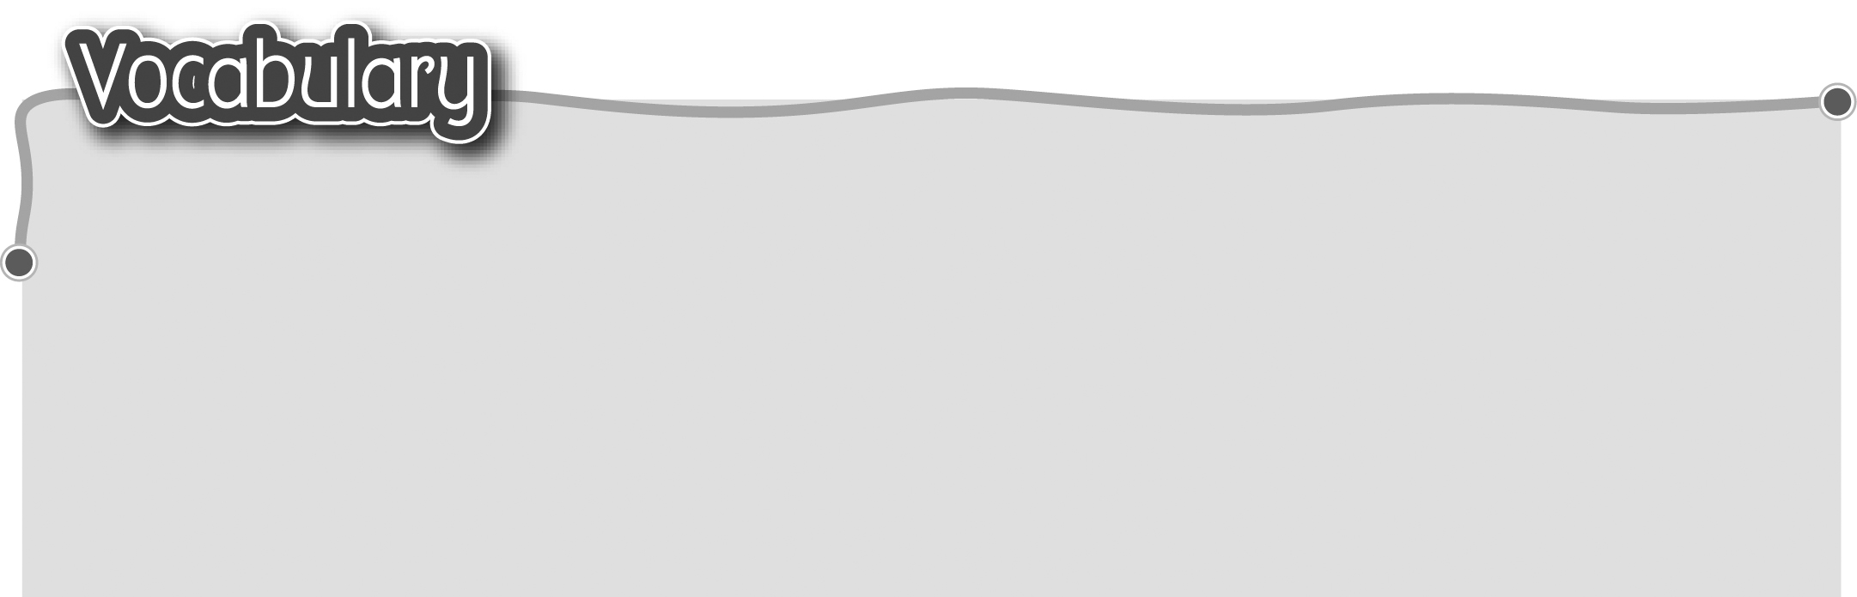
1 listen to 聆聽 5 laugh at 取笑
The words marked with * have different meanings in other contexts. You can look up those meanings in a dictionary.

2 talk to 交談 6 shout at 對……大聲喊叫
3 look after 照顧 7 fight with 與……打架
4 play tricks on 作弄 8 play with* 與……一起玩耍

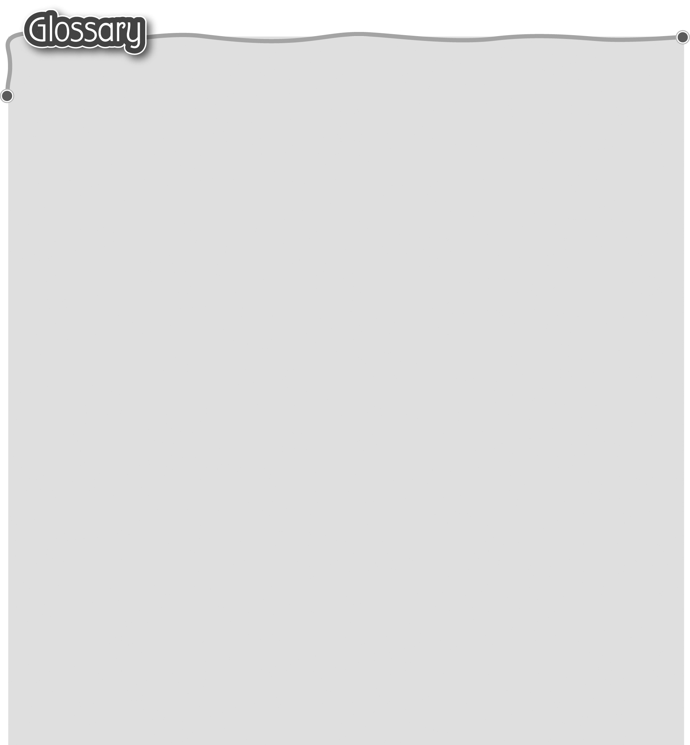
1 forest (p.10) 森林 15 hurt* (p.10) 傷害（動詞）
2 mice (mouse) (p.10) 老鼠 16 brave (p.10) 勇敢
3 nearby (p.10) 在附近 17 tiny (p.11) 細小
4 noise* (p.10) 嘈雜聲 18 funny* (p.11, p.15) 有趣/風趣
5 wake* (p.10) 吵醒 19 net* (p.11) 網
6 him (p.10) 他 20 get out* (p.11) 逃出
7 us (p.11) 我們 21 bite* (p.11) 咬（動詞）
8 them (p.11) 牠/他們 22 hole* (p.11) 洞
9 me (p.11) 我 23 free* (p.11) 自由（形容詞）
10 her* (p.13) 她 24 sometimes (p.15) 有時
11 angry (p.10) 生氣 25 naughty (p.15) 頑皮
12 roar* (p.10) 吼叫聲（名詞） 26 still* (p.15) 仍然（副詞）
13 afraid (p.10) 害怕 27 cheerful (p.15) 開朗
14 hide* (p.10) 躲藏 28 glad (p.17) 高興

