Choose and write.
good
naughty
friendly
shy
strong
weak
careful
careless
1 | 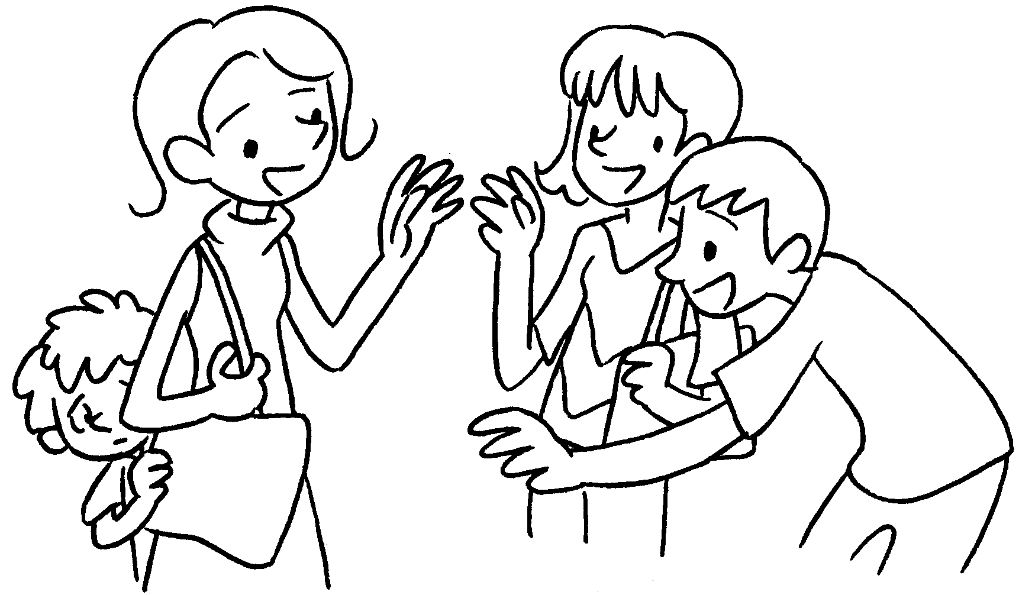 |  | 2 | 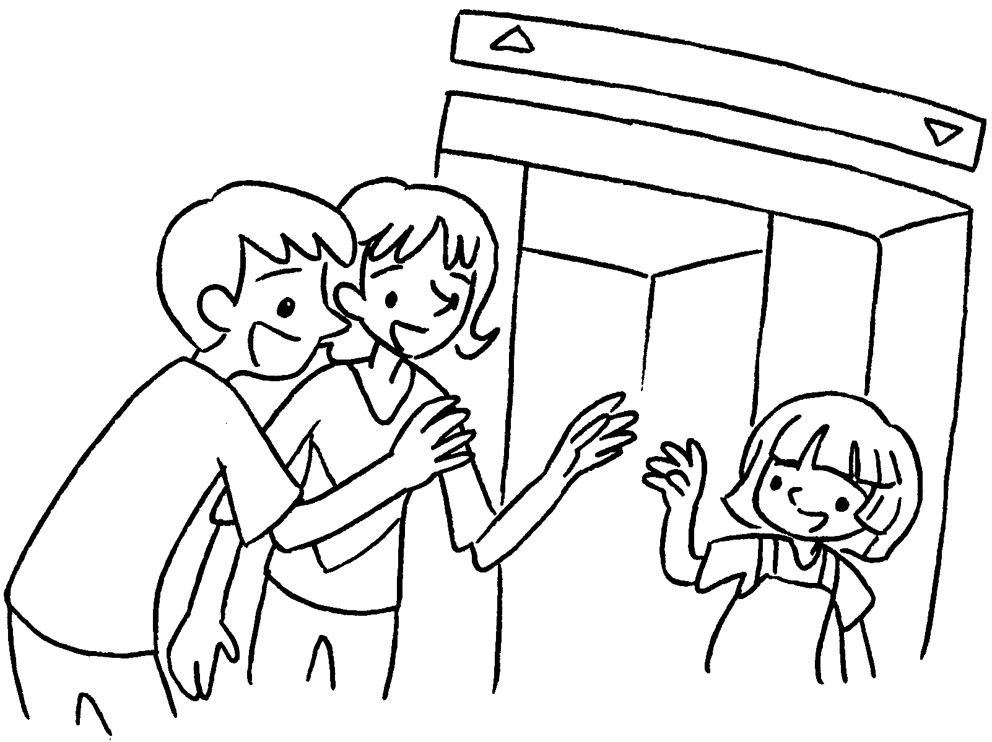
3 |  |  | 4 | 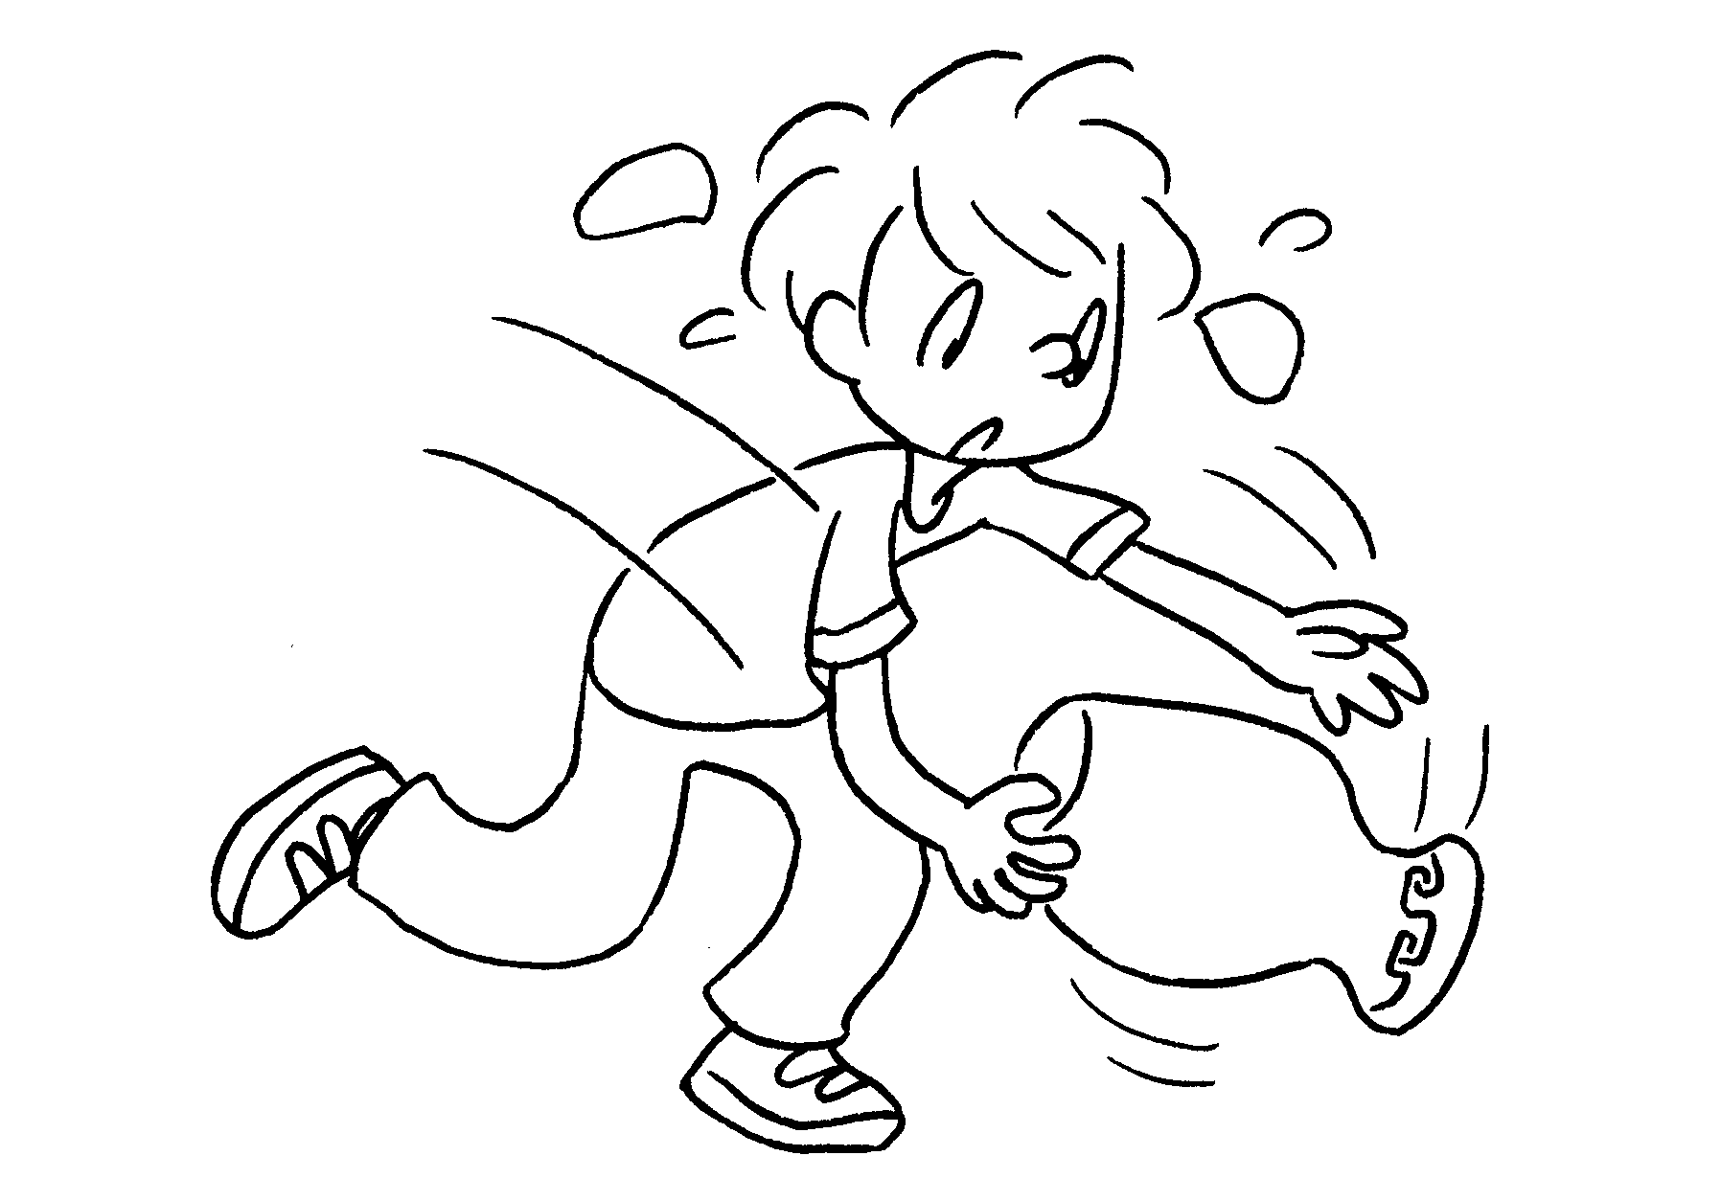
5 | 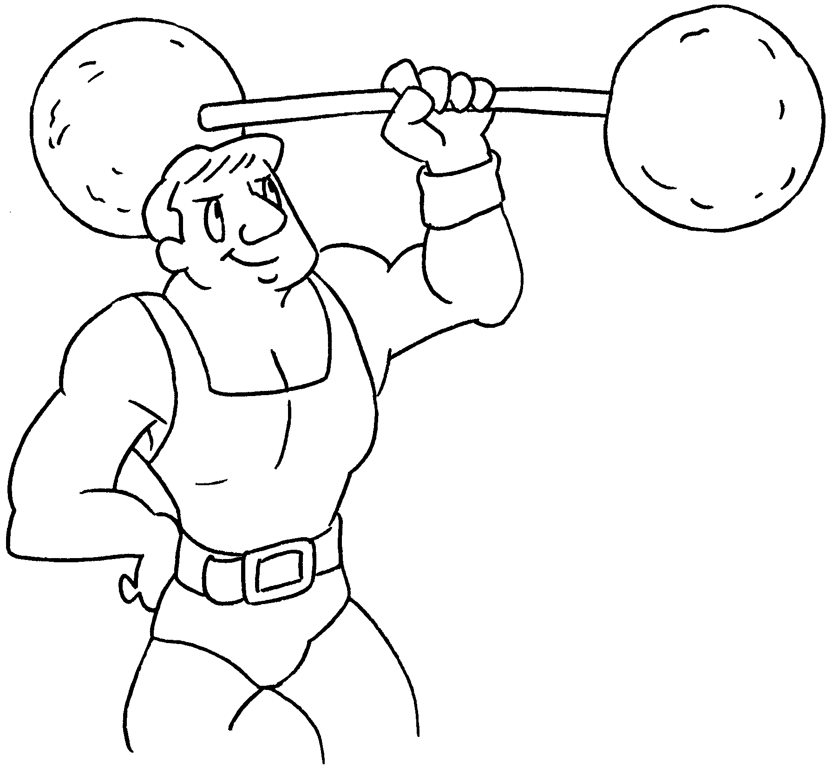 |  | 6 | 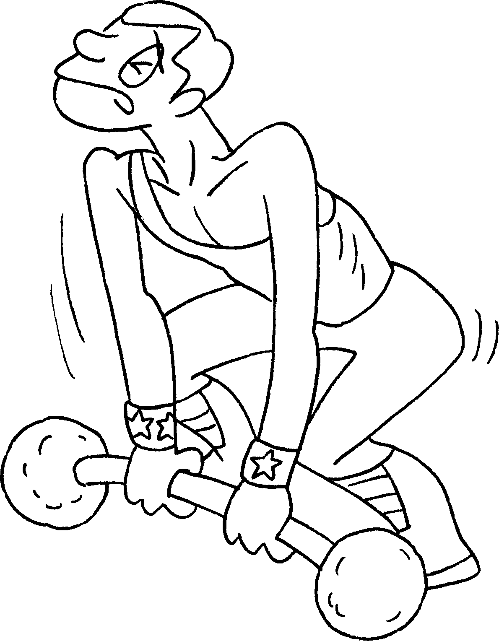
7 | 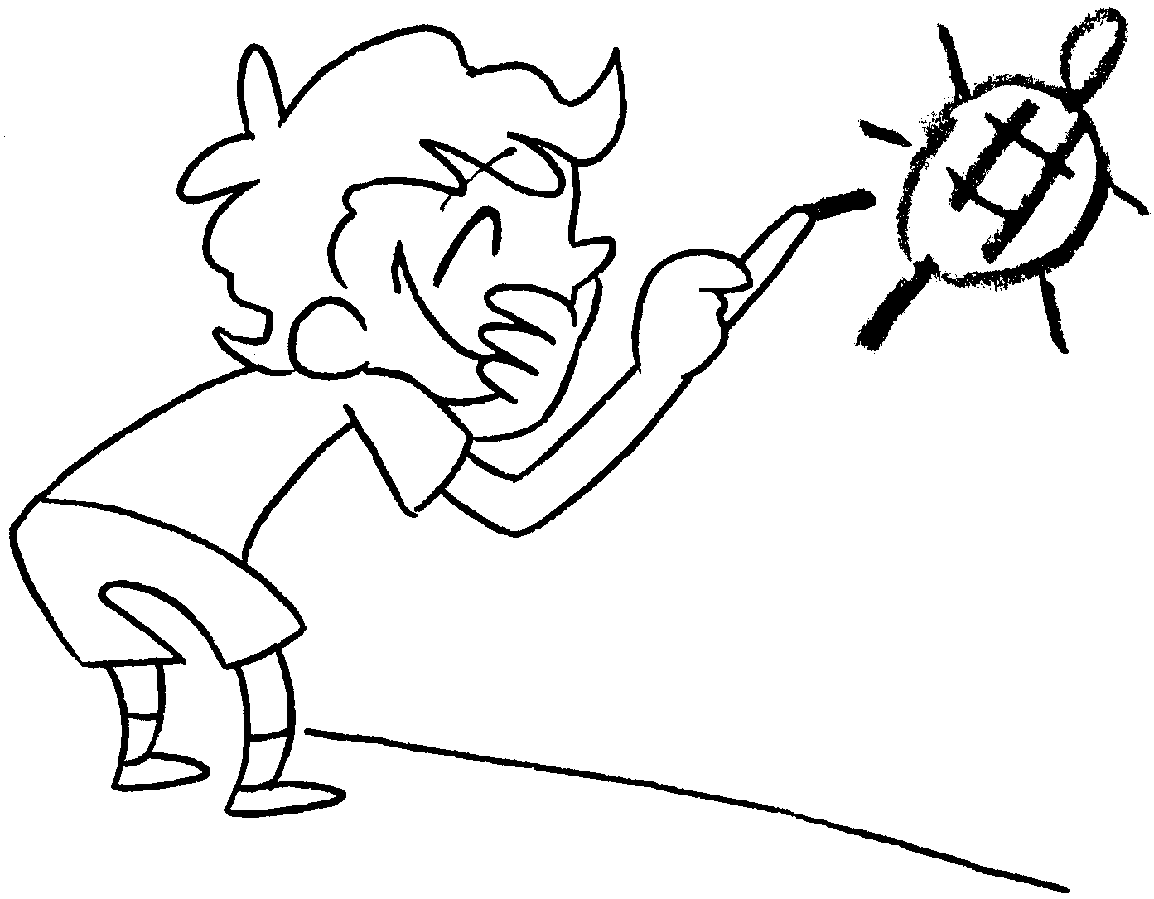 |  | 8 | 


Book 3B Chapter 3 Graded Worksheets
Worksheet 1⬇
- shy 2 friendly
3 careful 4 careless
5 strong 6 weak
7 naughty 8 good

