How can you describe the people? Fill in the missing letters.

1 | 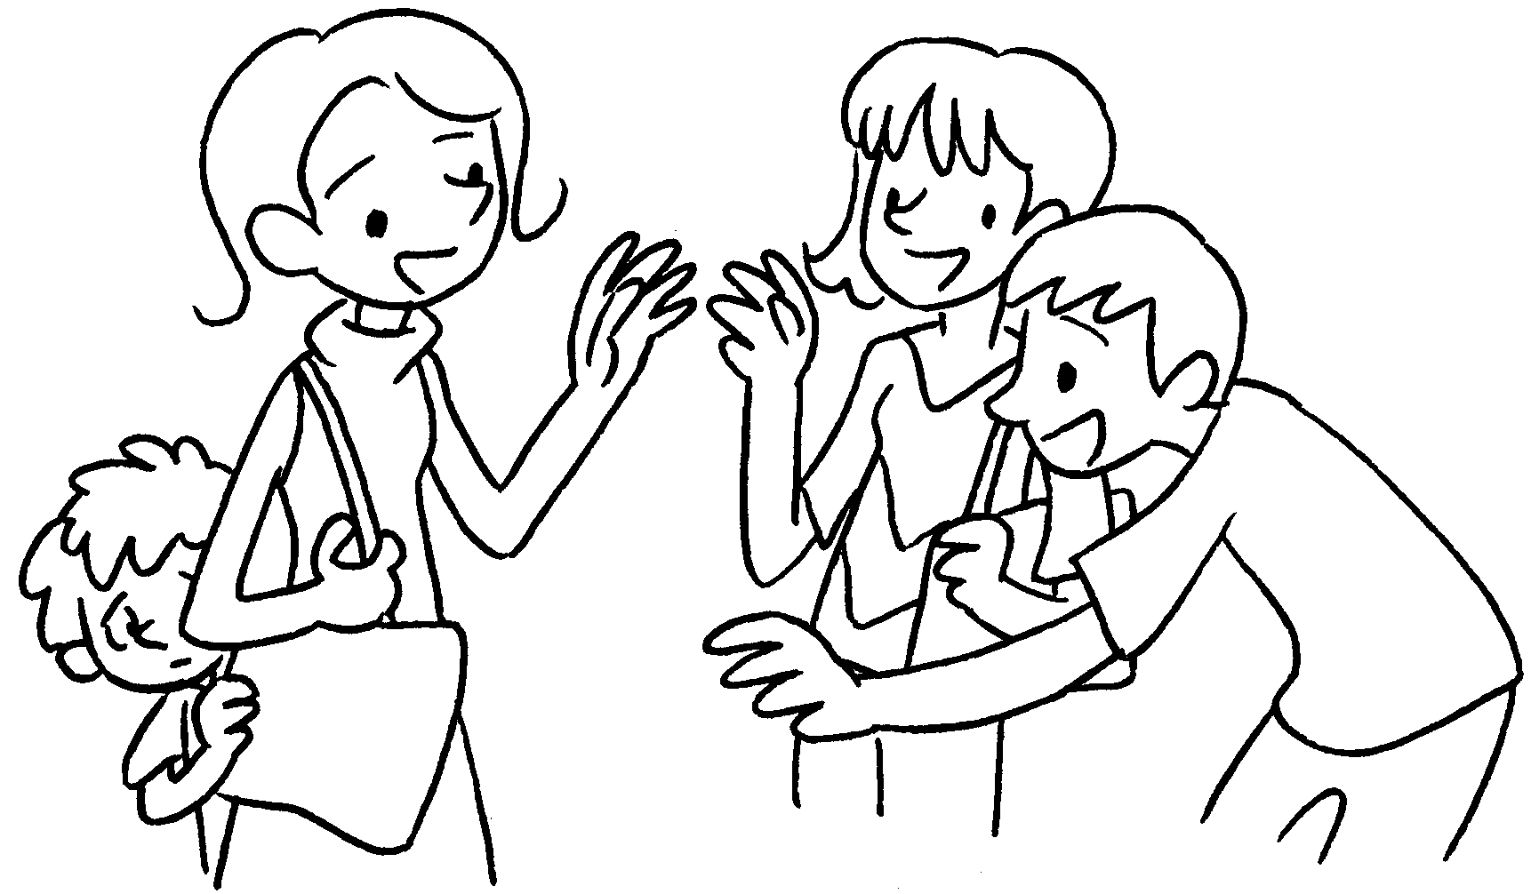  s __ __ |  | 2 | 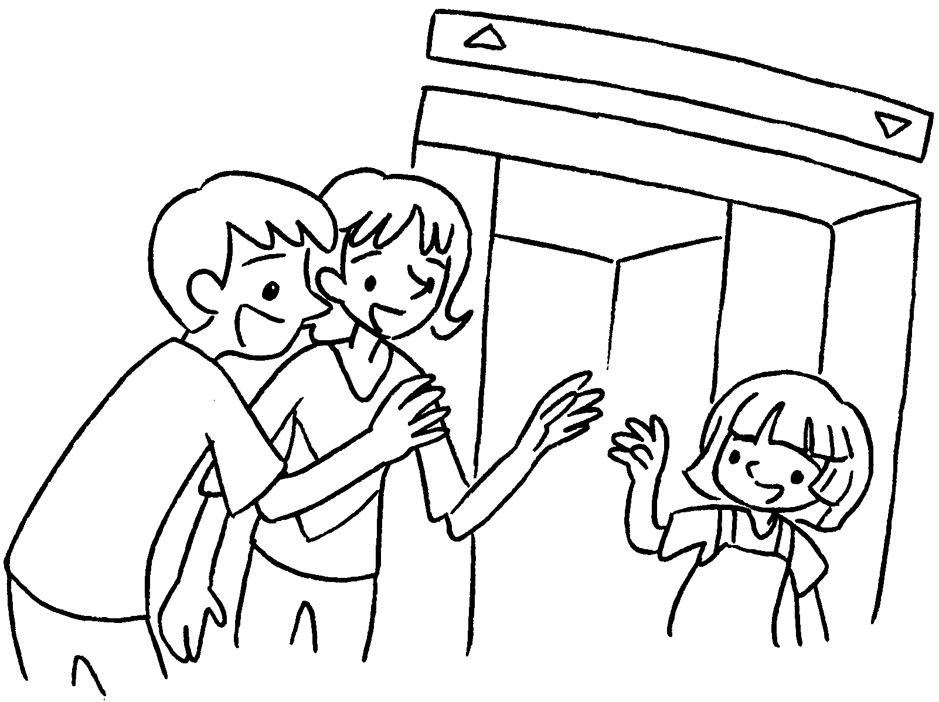  f __ __ __ __ __ __ __
3 | 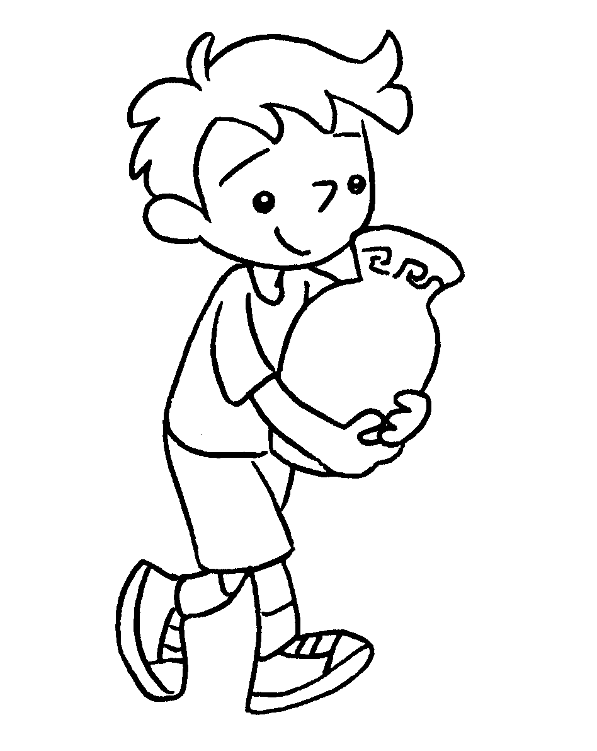  c __ __ __ __ __ __ |  | 4 | 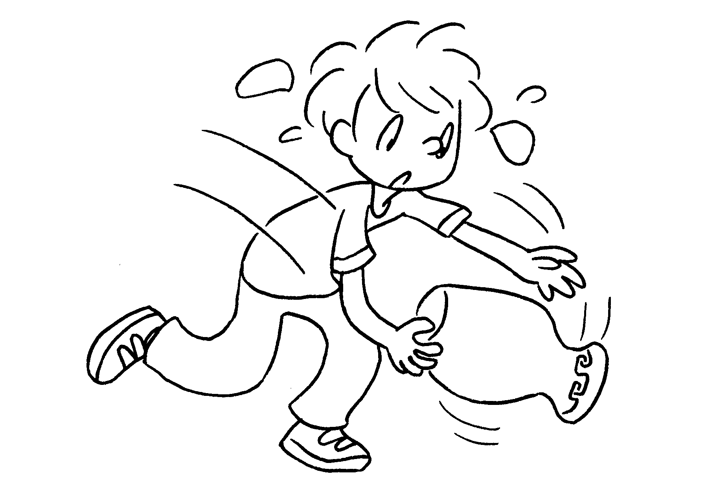  c __ __ __ __ __ __ __
5 | 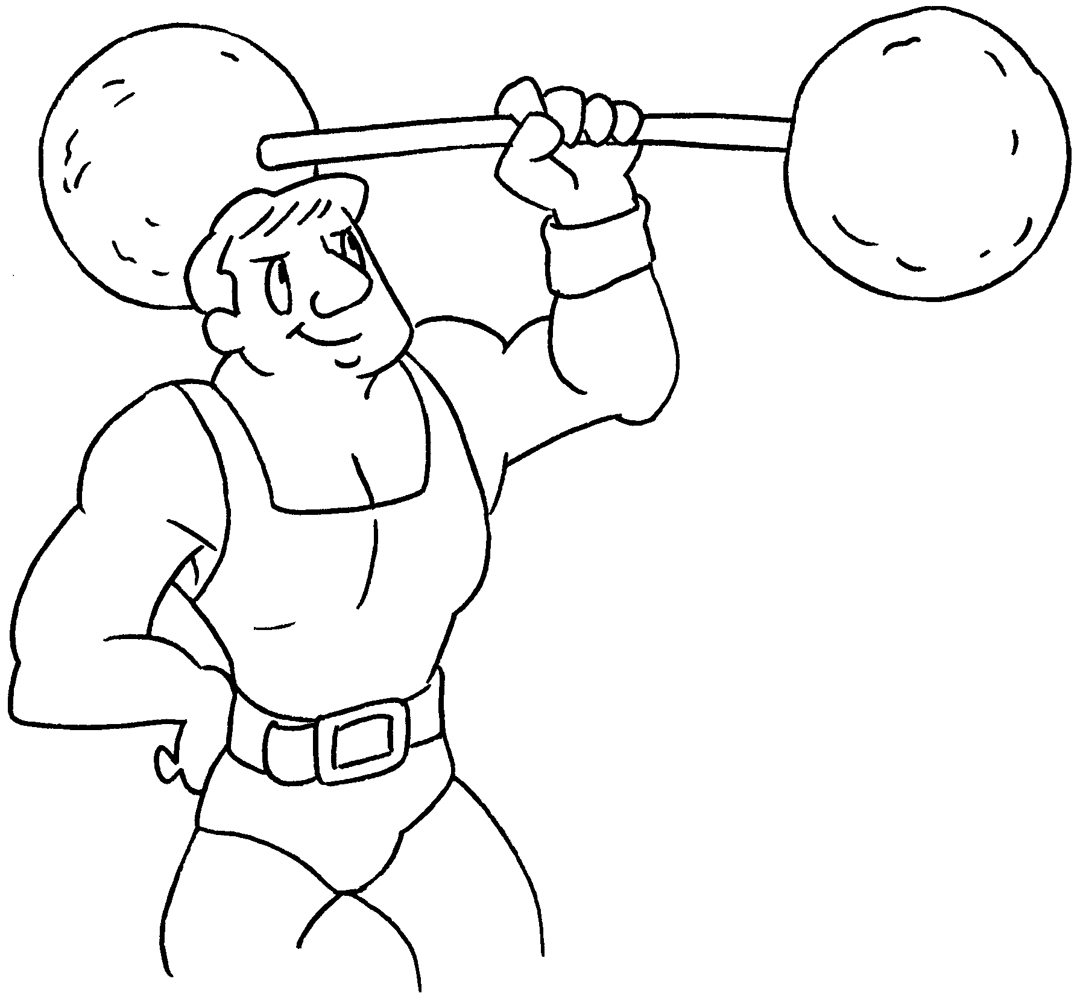  s __ __ __ __ __ |  | 6 | 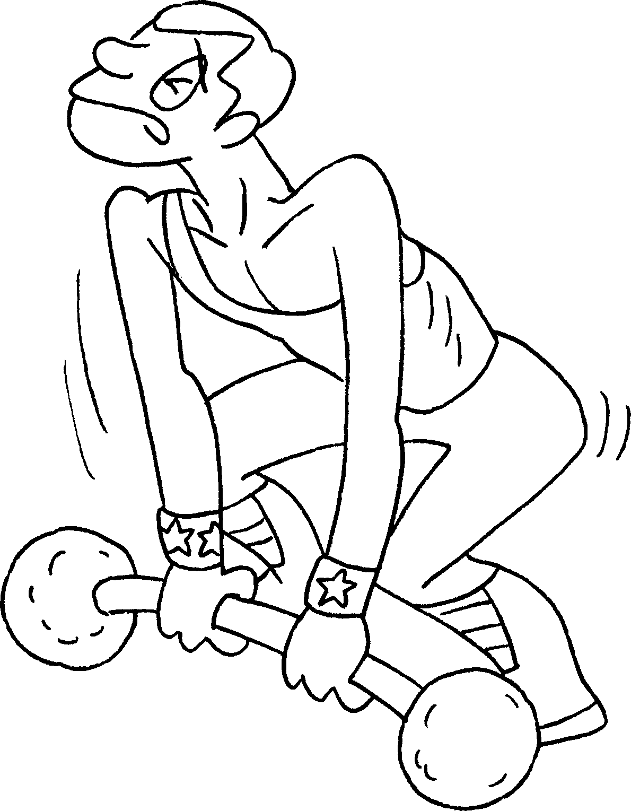  w __ __ __
7 | 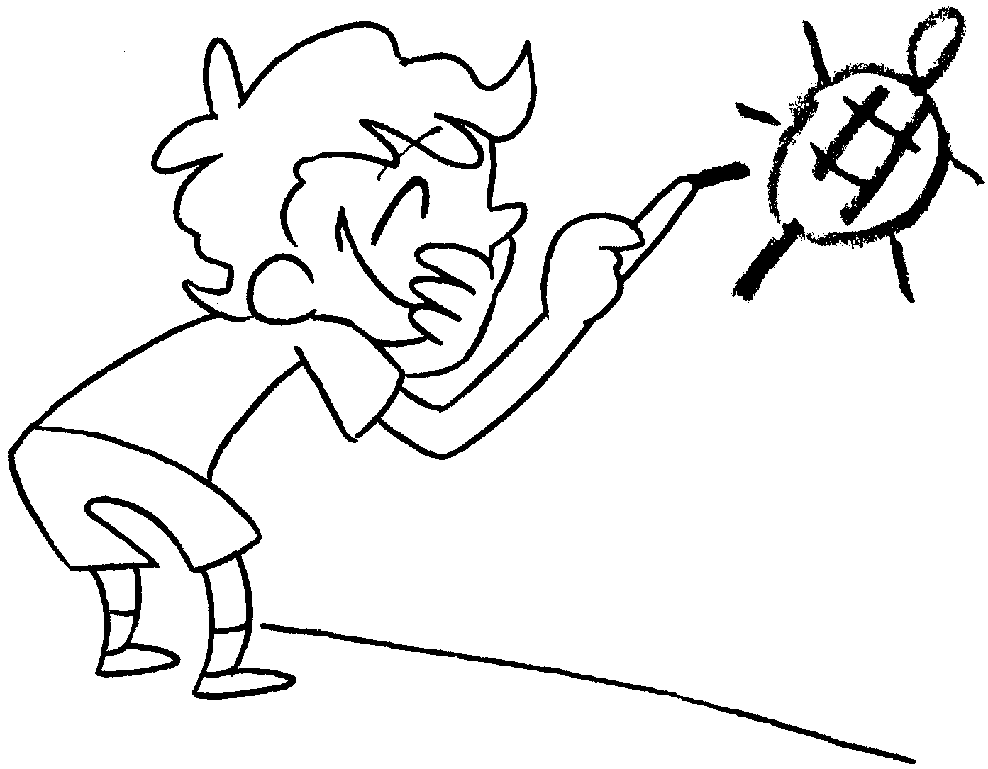  n __ __ __ __ __ __ |  | 8 |   g __ __ __


Book 3B Chapter 3 Graded Worksheets
Worksheet 1⬇⬇
- s h y 2 f r i e n d l y
3 c a r e f u l 4 c a r e l e s s
5 s t r o n g 6 w e a k
7 n a u g h t y 8 g o o d

