How can you describe the people? Write.

1 | 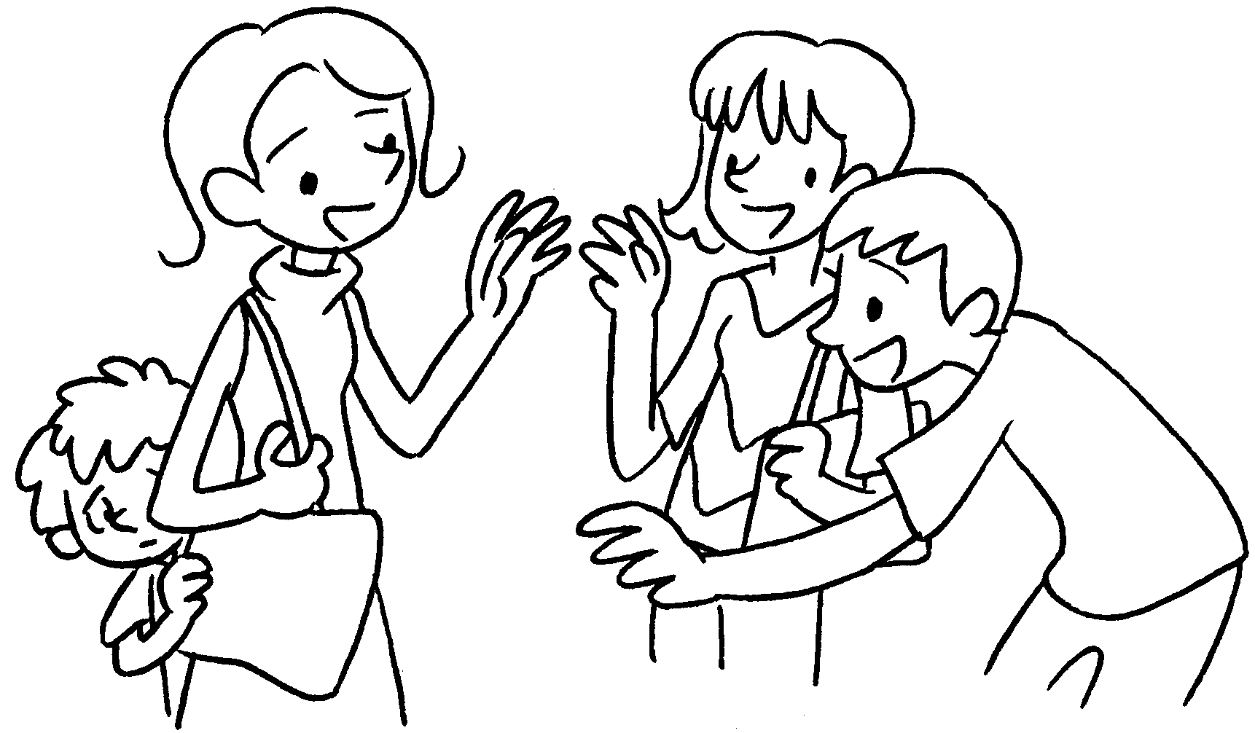  s |  | 2 | 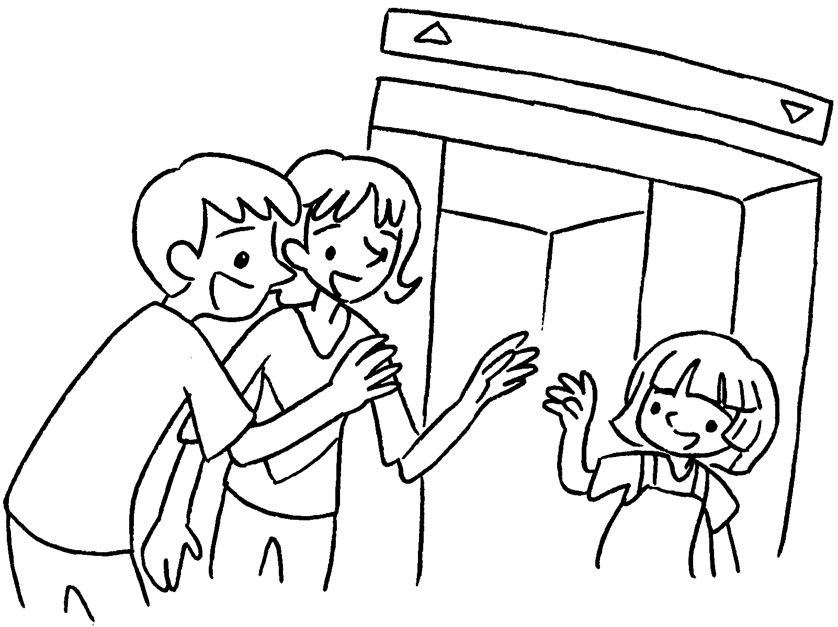  f
3 | 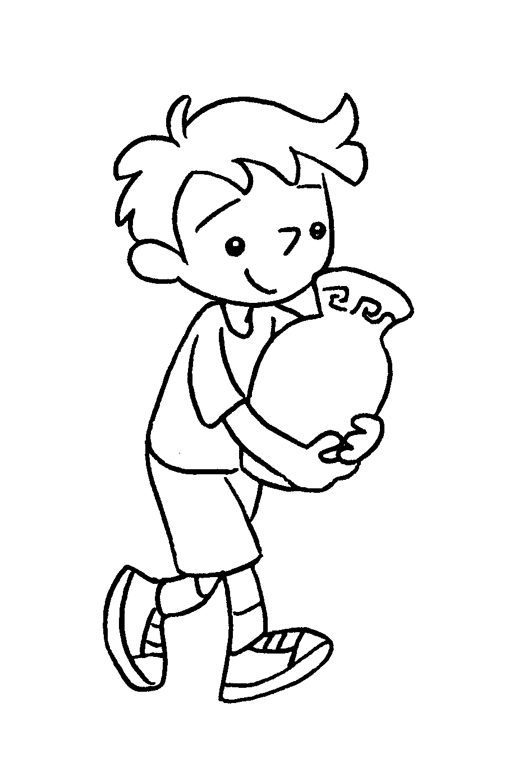  c |  | 4 | 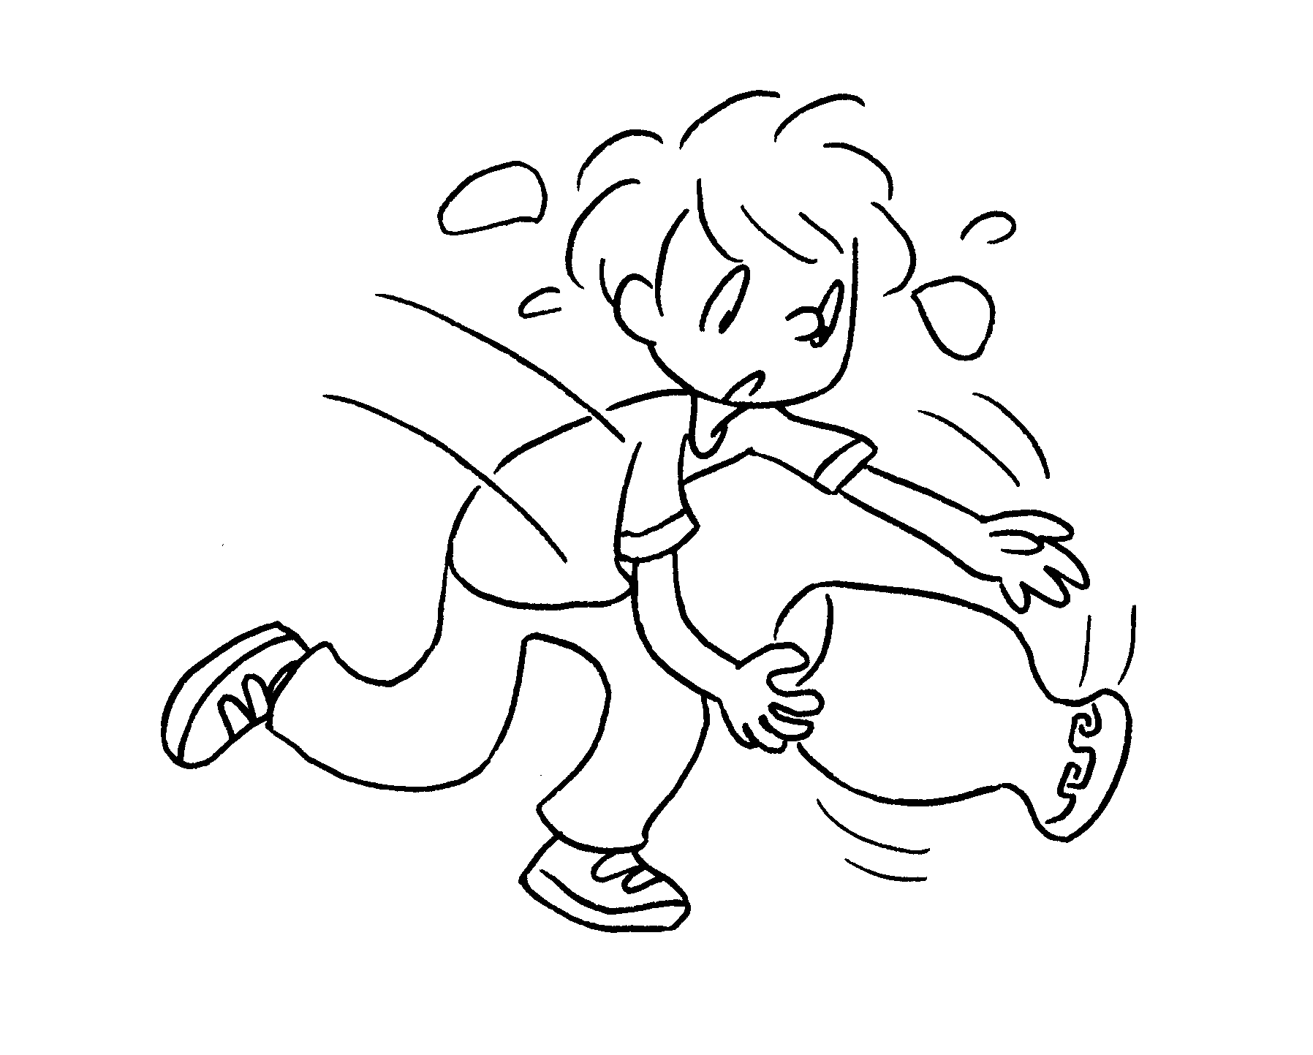  c
5 | 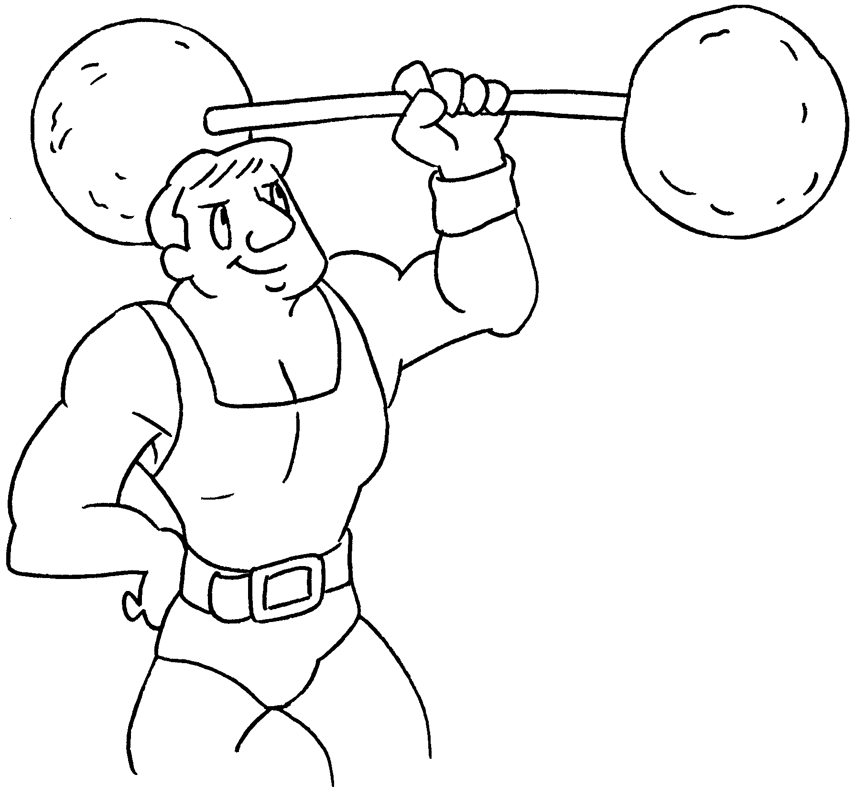  s |  | 6 | 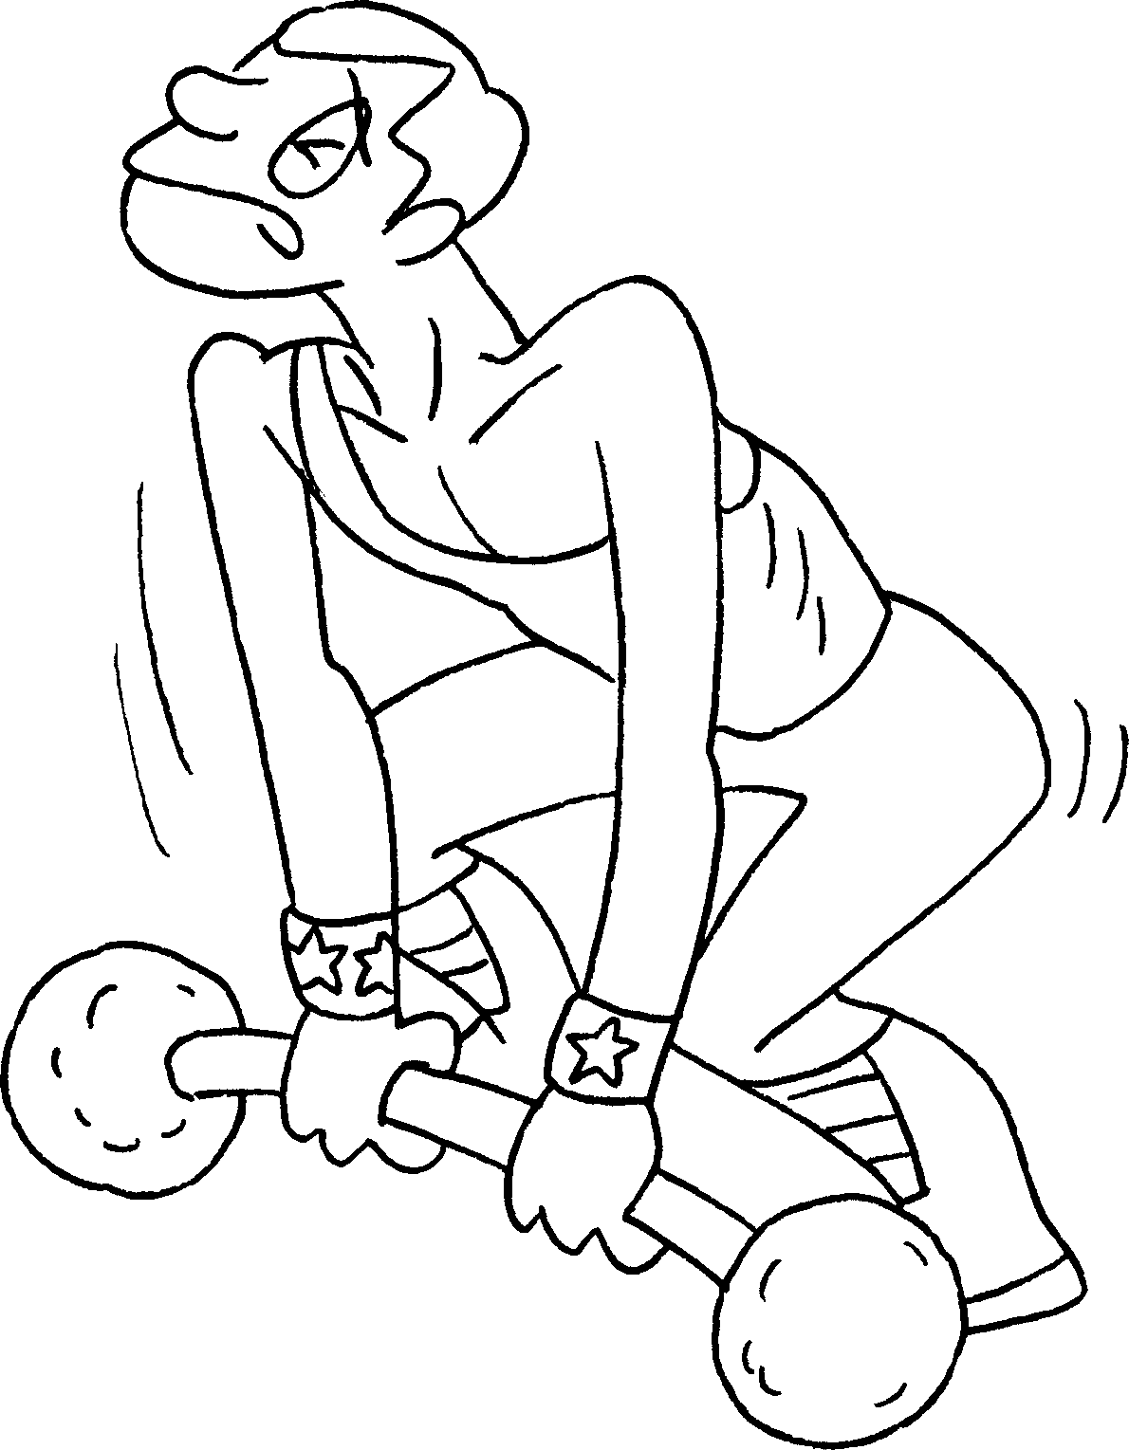  w
7 | 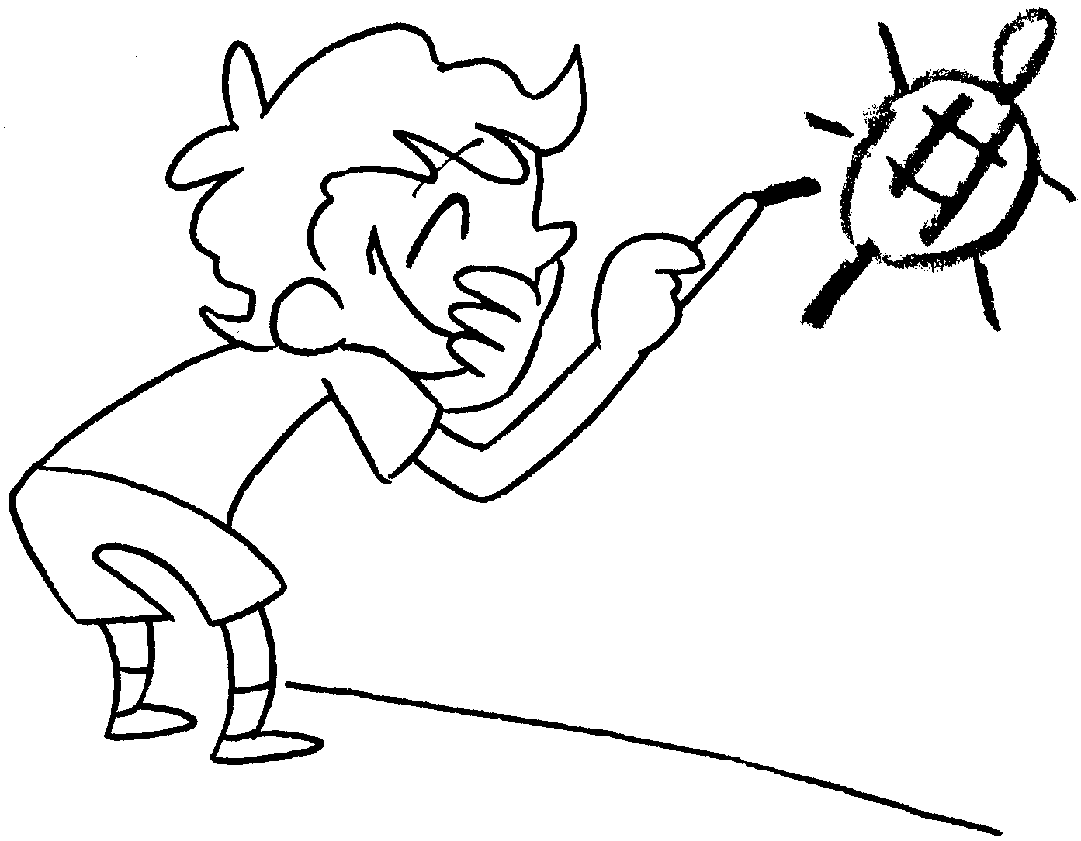  n |  | 8 |   g


Book 3B Chapter 3 Graded Worksheets
Worksheet 1⬇⬇⬇
- shy 2 friendly
3 careful 4 careless
5 strong 6 weak
7 naughty 8 good

