Choose and write.
am
is
was

1 | 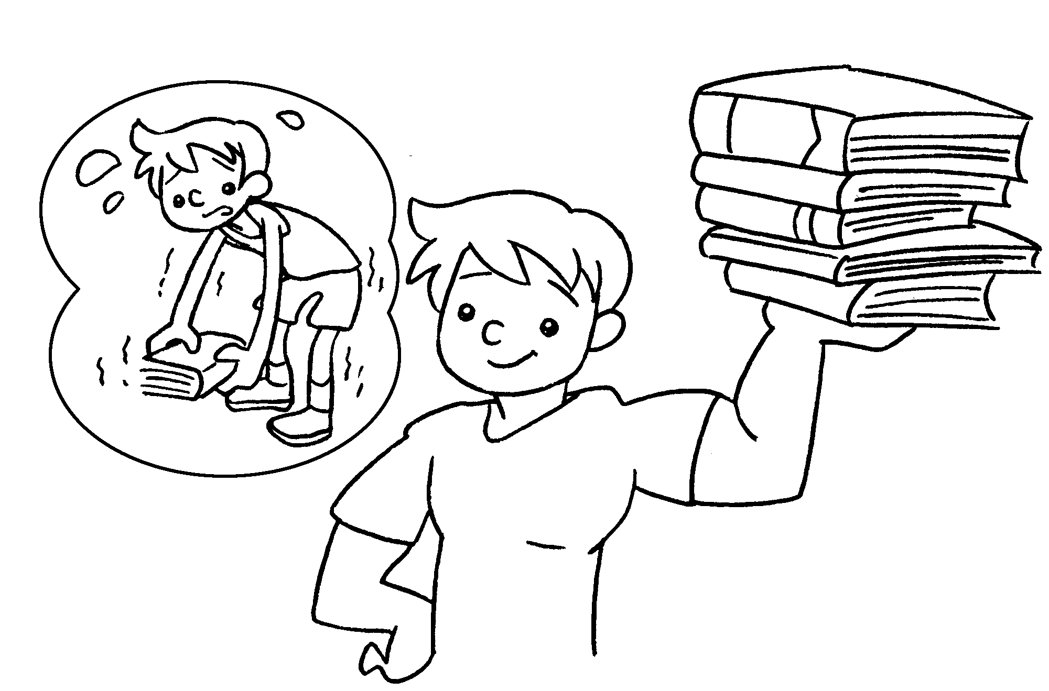 | Four years ago Eddie weak.  This year he strong.
2 | 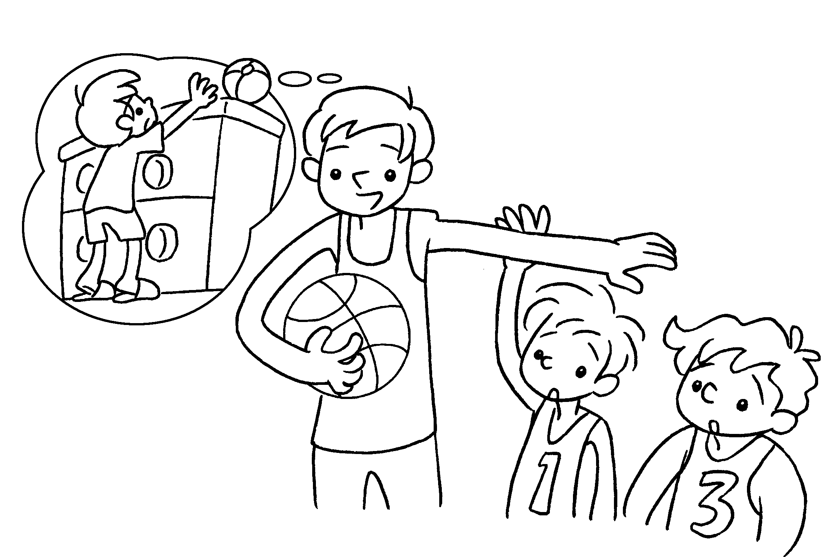 | Five years ago I short.  Now I tall.
3 | 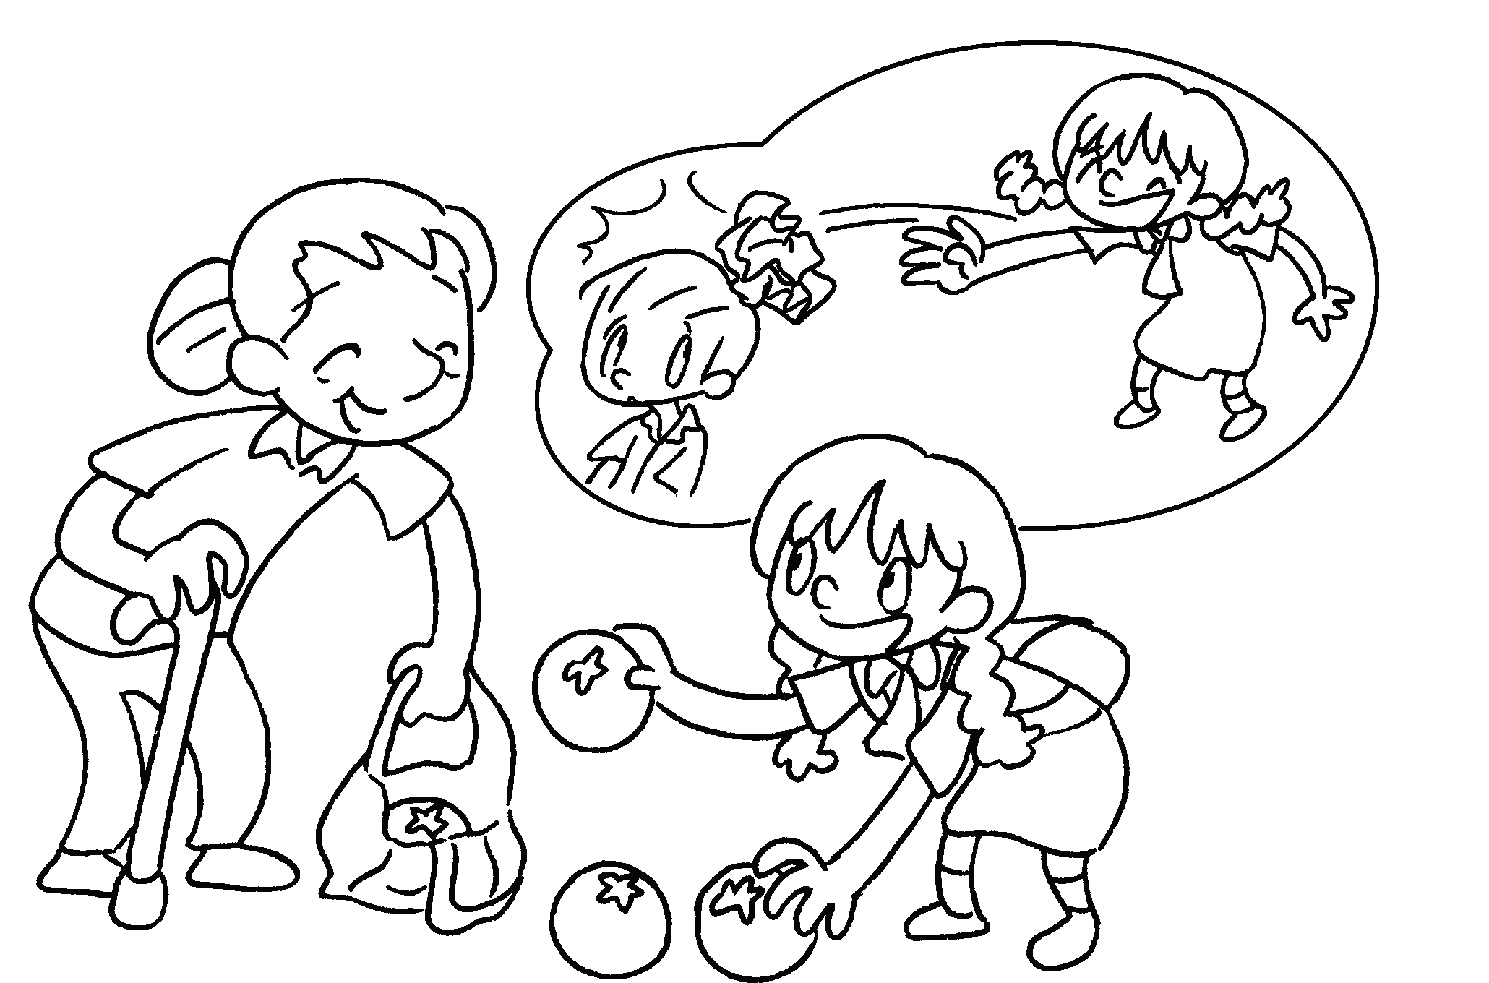 | Three years ago Lucy  naughty.  This year she good.
4 | 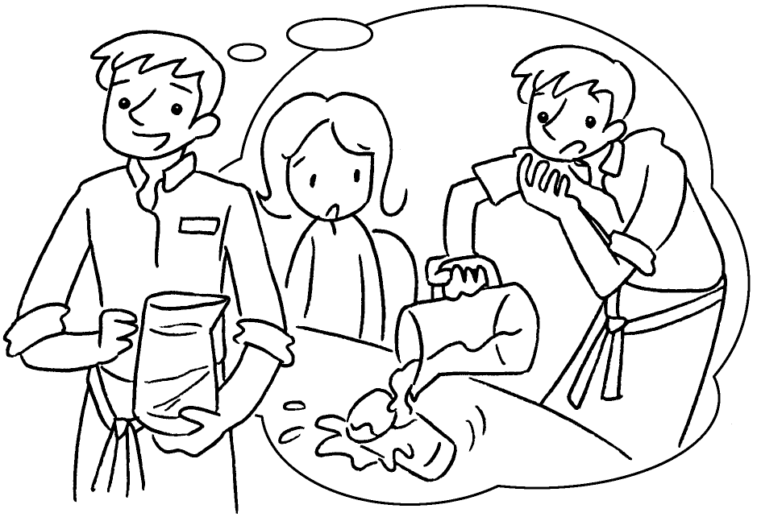 | Last year I careless.  This year I careful.
5 | 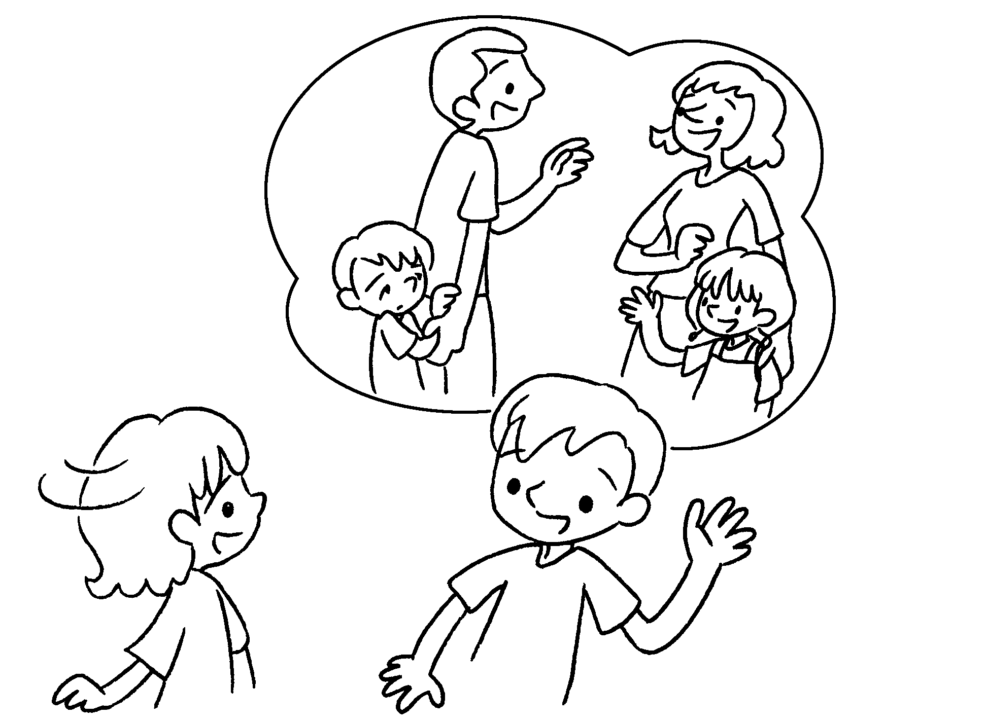 | Two years ago Alan shy.  This year he friendly.


Book 3B Chapter 3 Graded Worksheets
Worksheet 2⬇
- was
is
- was
am
- was
is
- was
am
- was
is

