Choose and write.
am
is
was

good careless shy naughty friendly careful

1 | 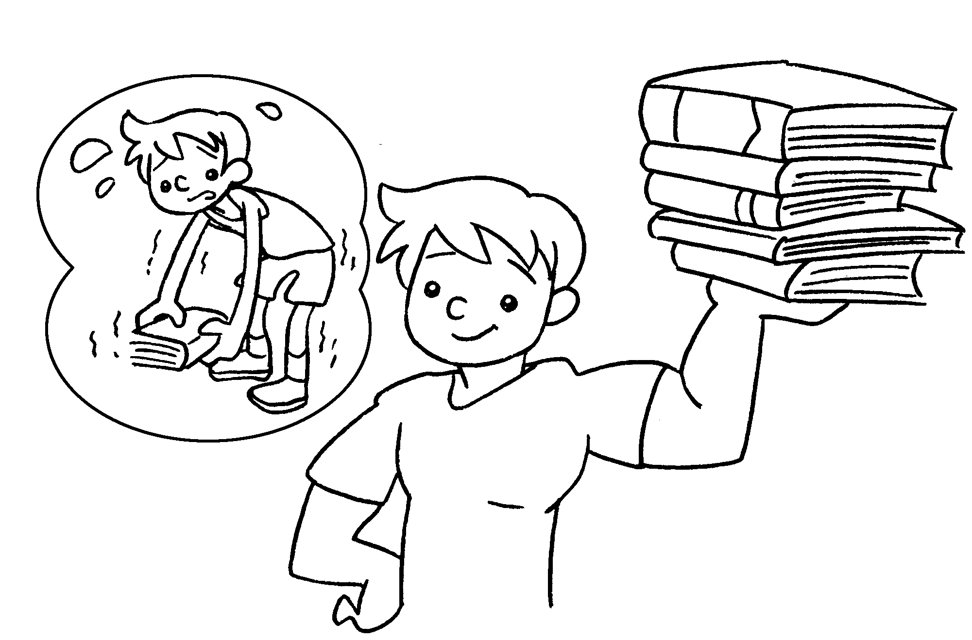 | Four years ago Eddie weak.  This year he strong.
2 | 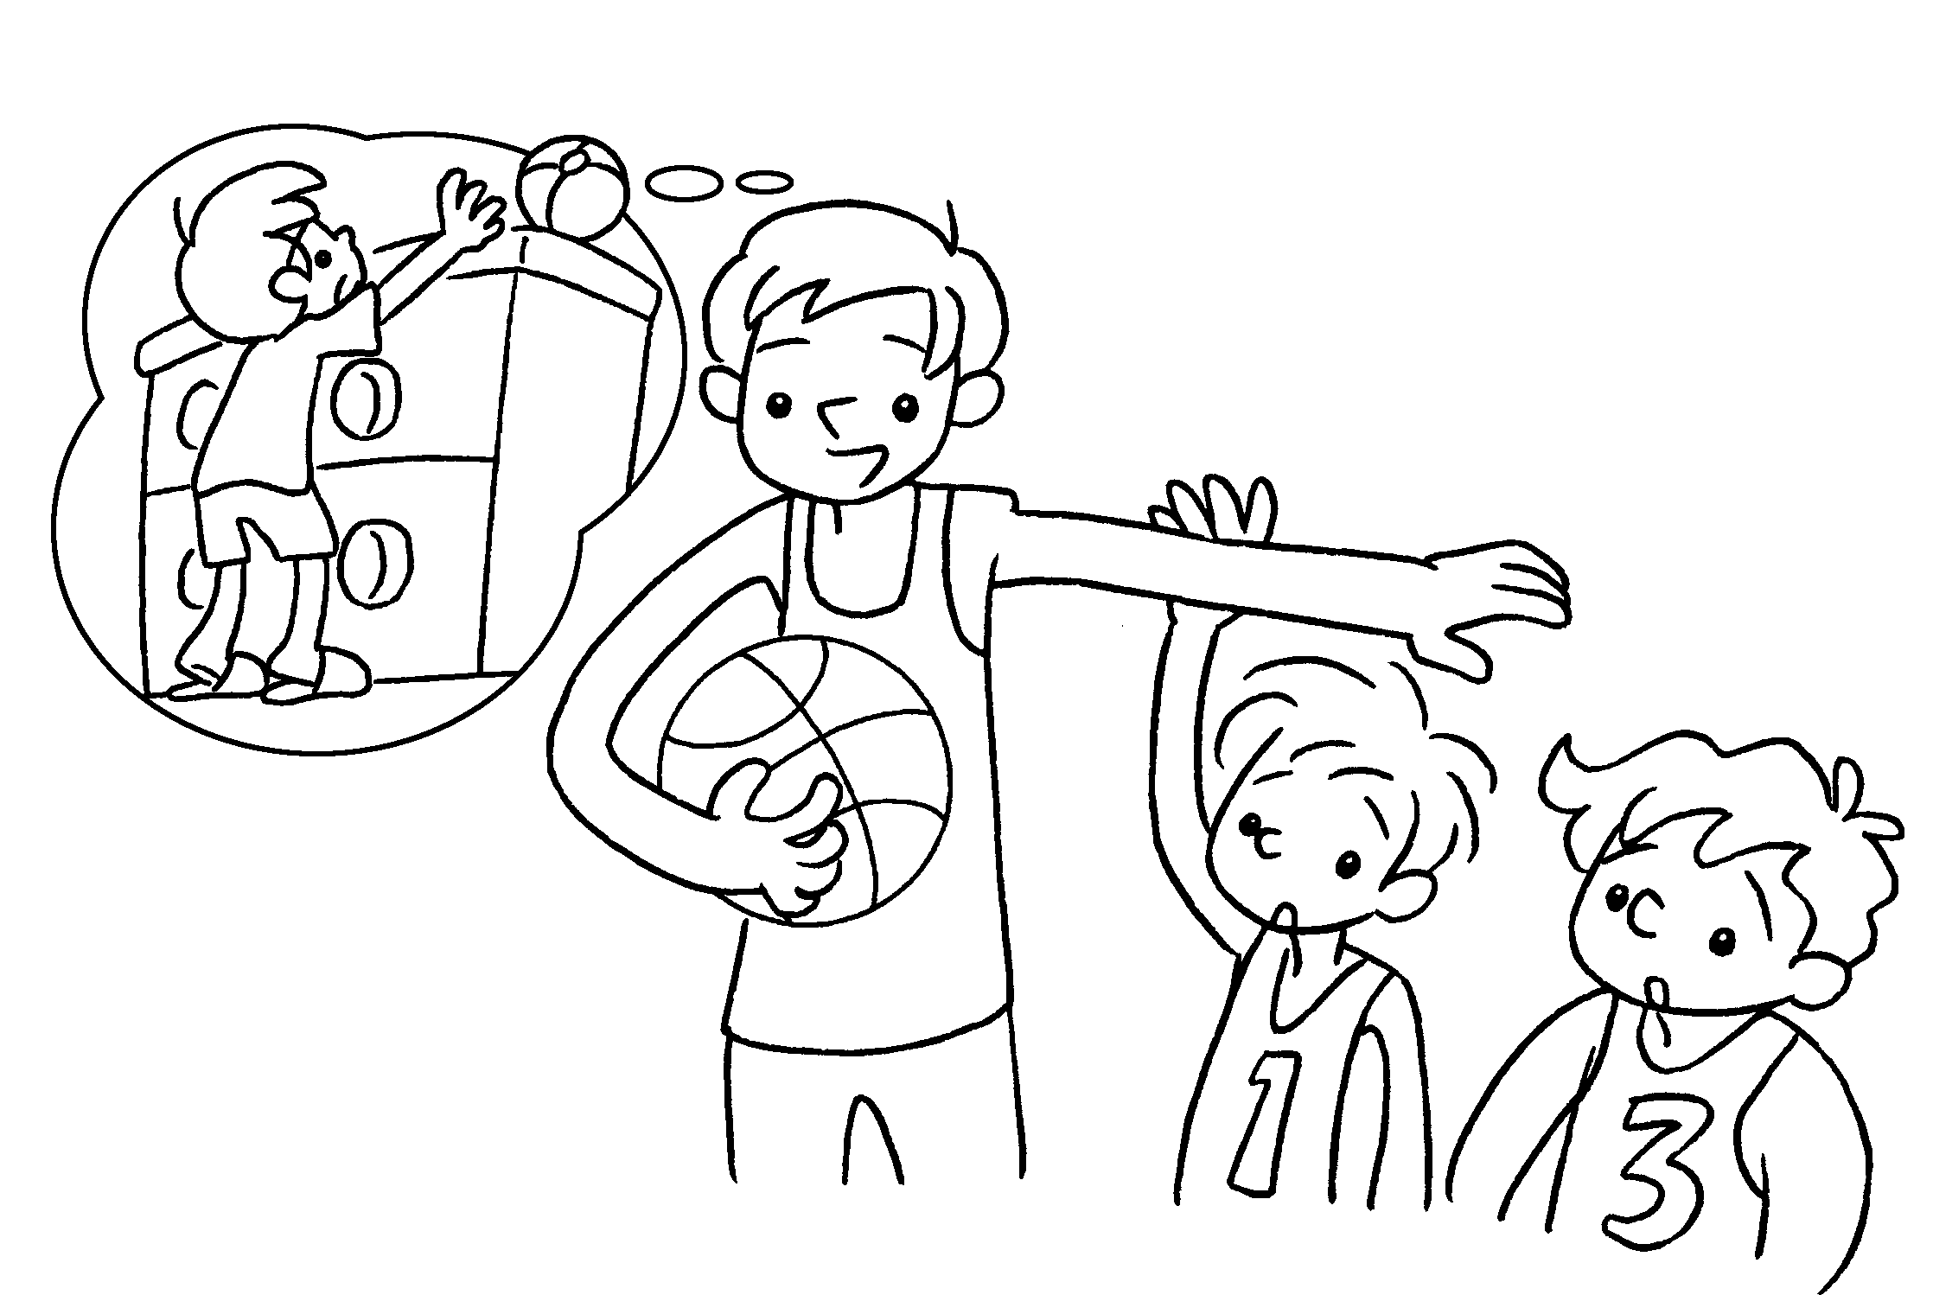 | Five years ago I short.  Now I tall.
3 | 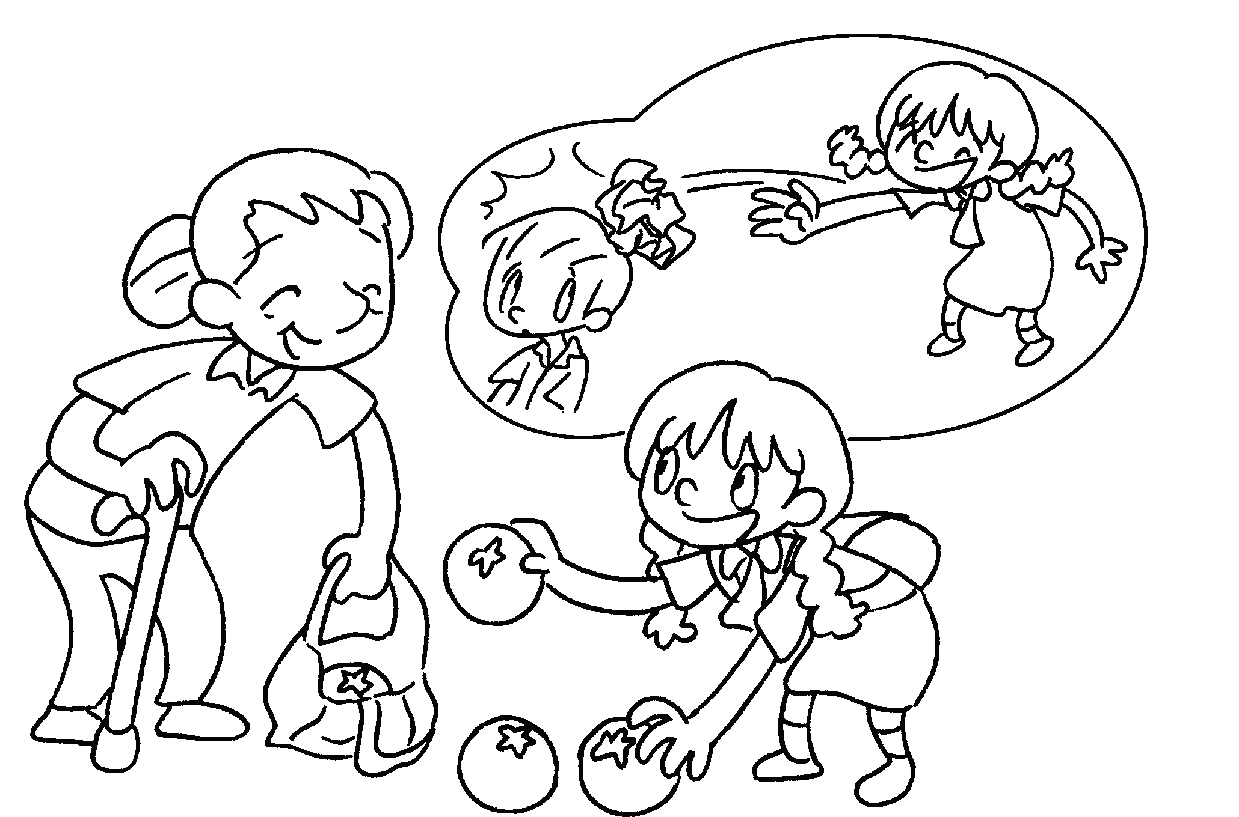 | Three years ago Lucy  .  This year she  .
4 | 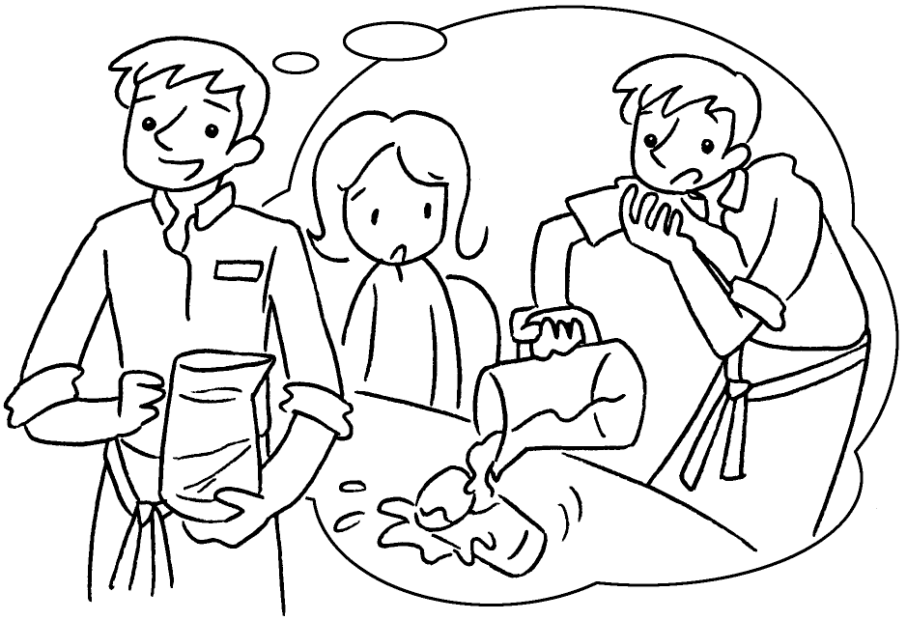 | Last year I .  This year I .
5 | 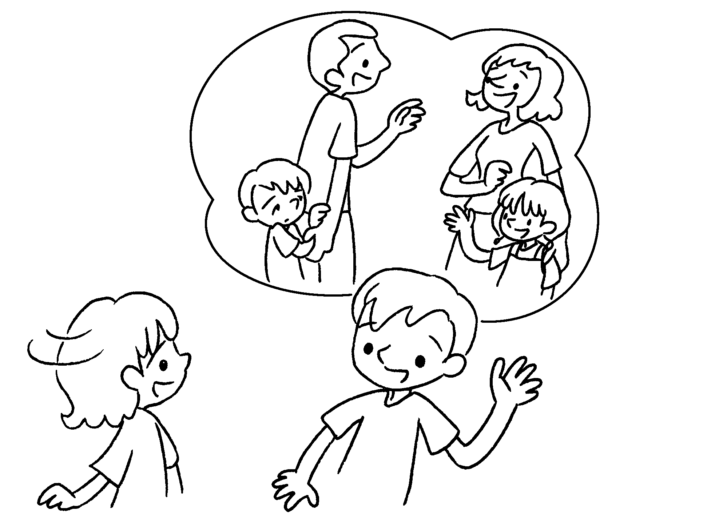 | Two years ago Alan  .  This year he .


Book 3B Chapter 3 Graded Worksheets
Worksheet 2⬇⬇
- was
is
- was
am
- was naughty
is good
- was careless
am careful
- was shy
is friendly

