Fill in the blanks.

1 | 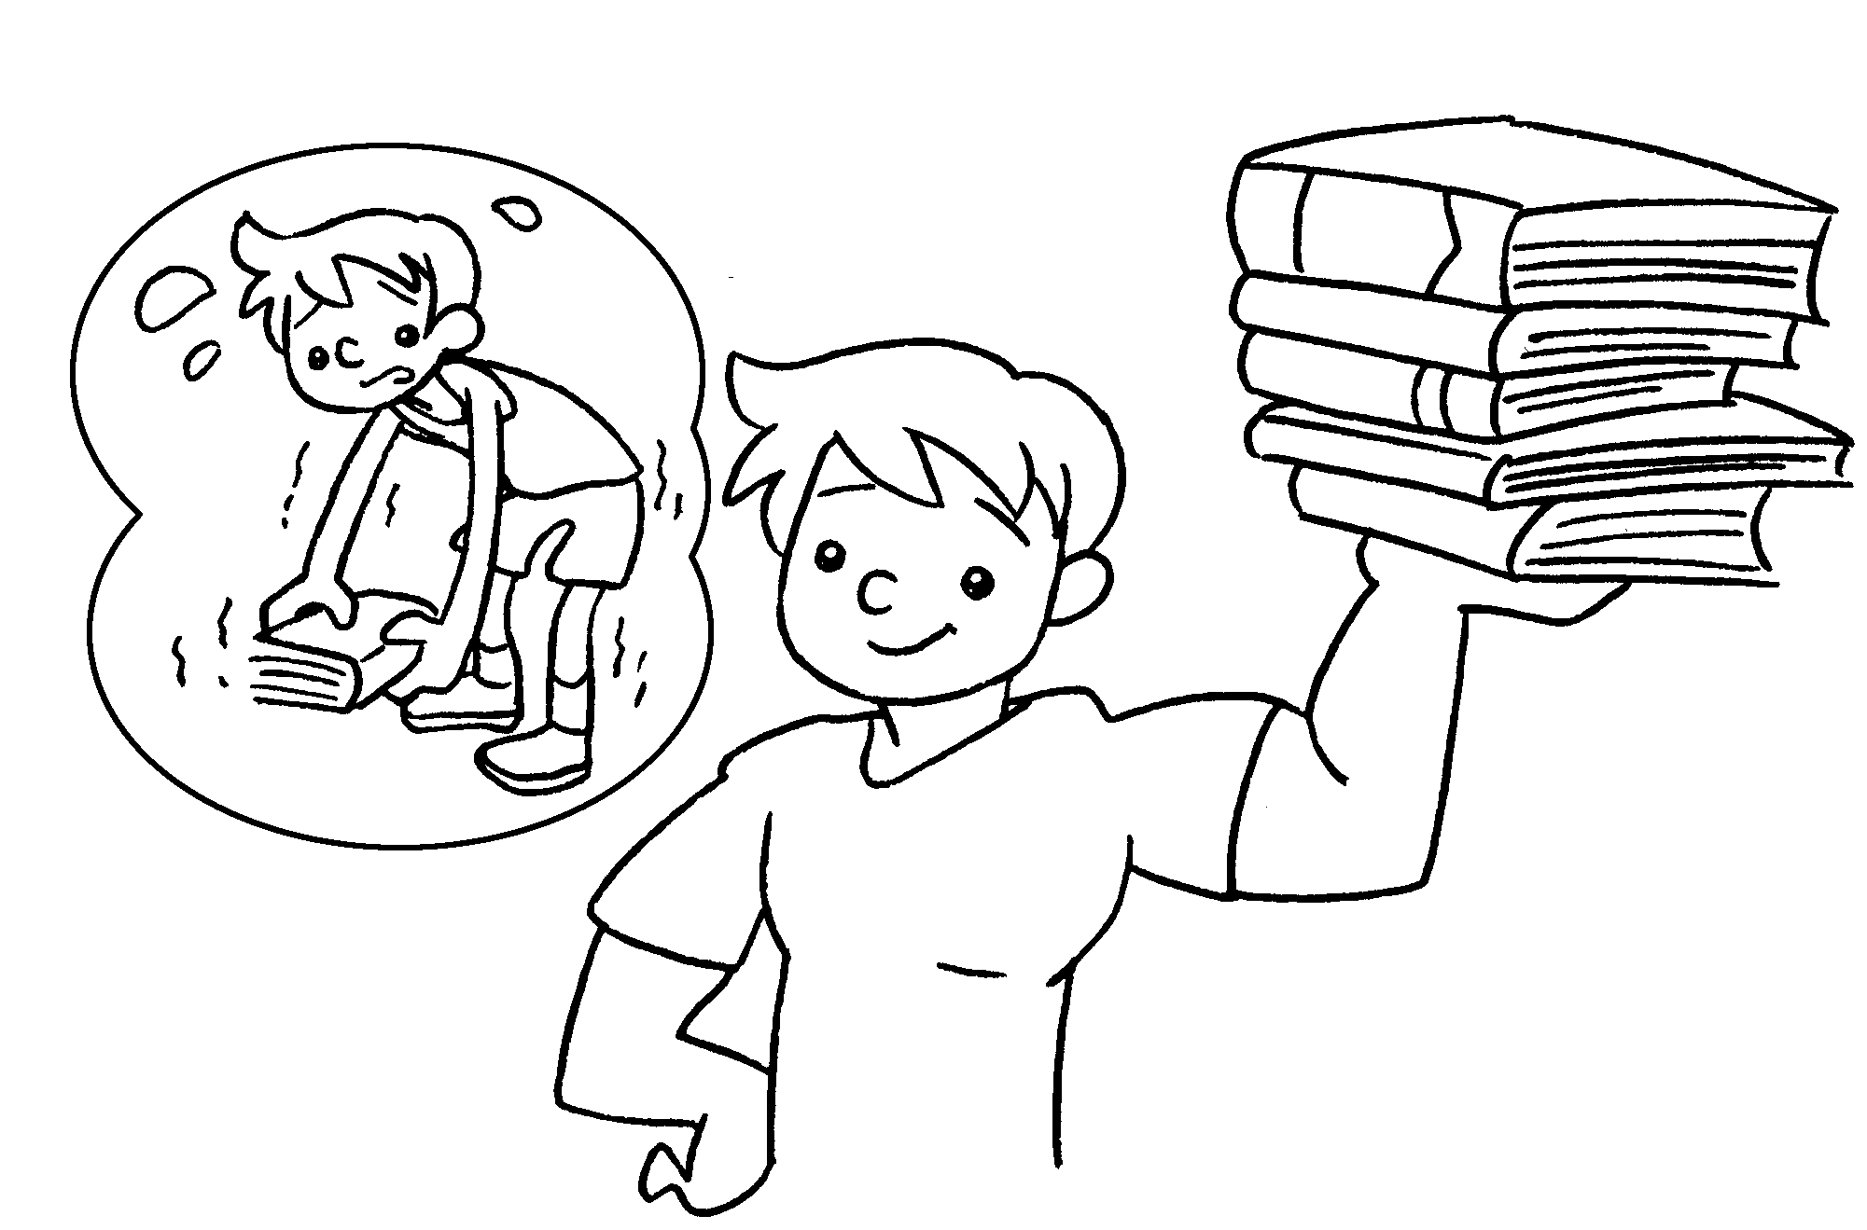 | was  Four years ago Eddie weak.  This year he s .
2 | 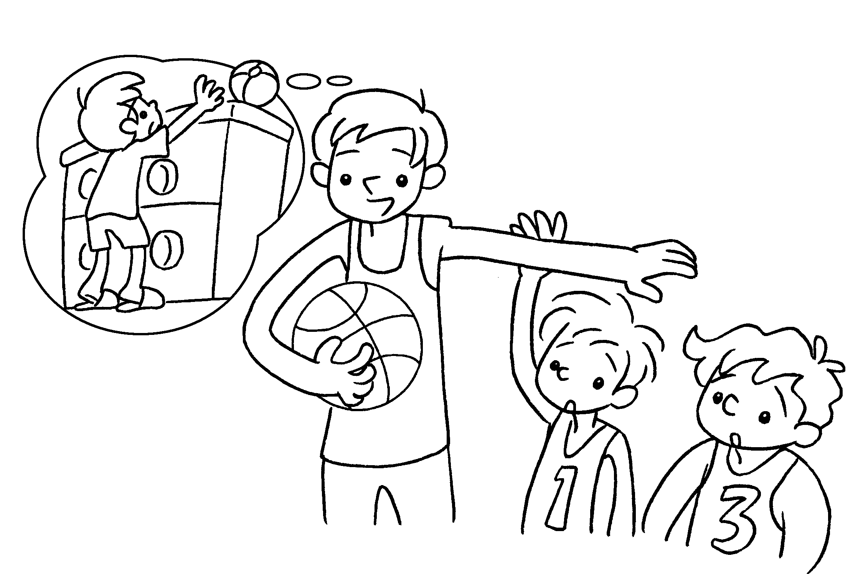 | Five years ago I  s .  Now I tall.
3 | 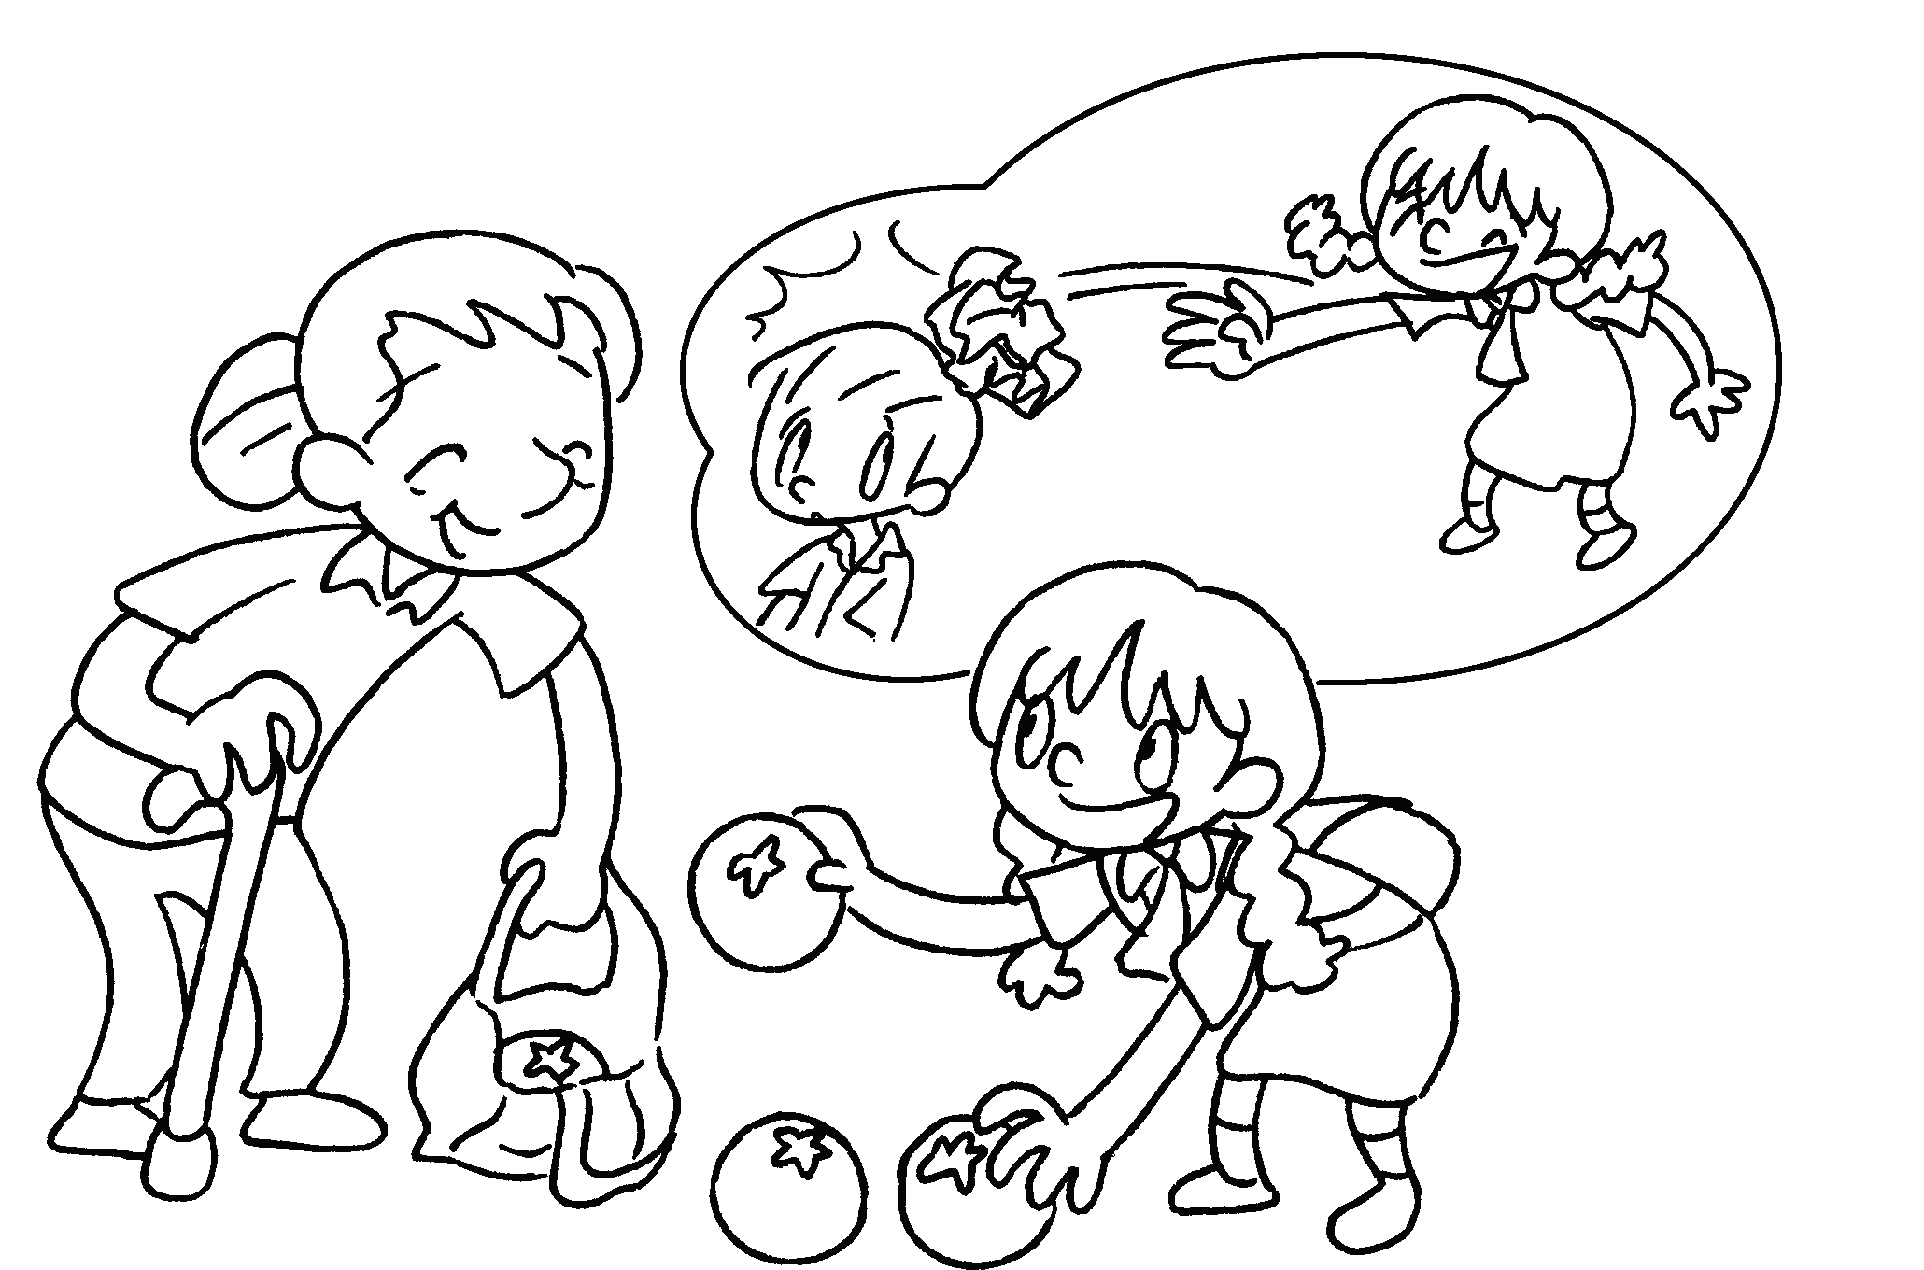 | Three years ago Lucy  n .  This year she good.
4 | 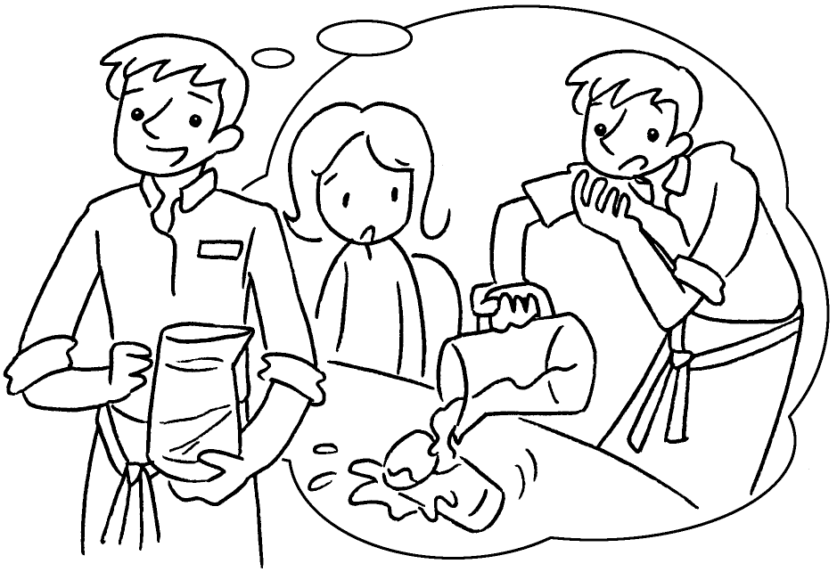 | Last year I c .  This year I c .
5 | 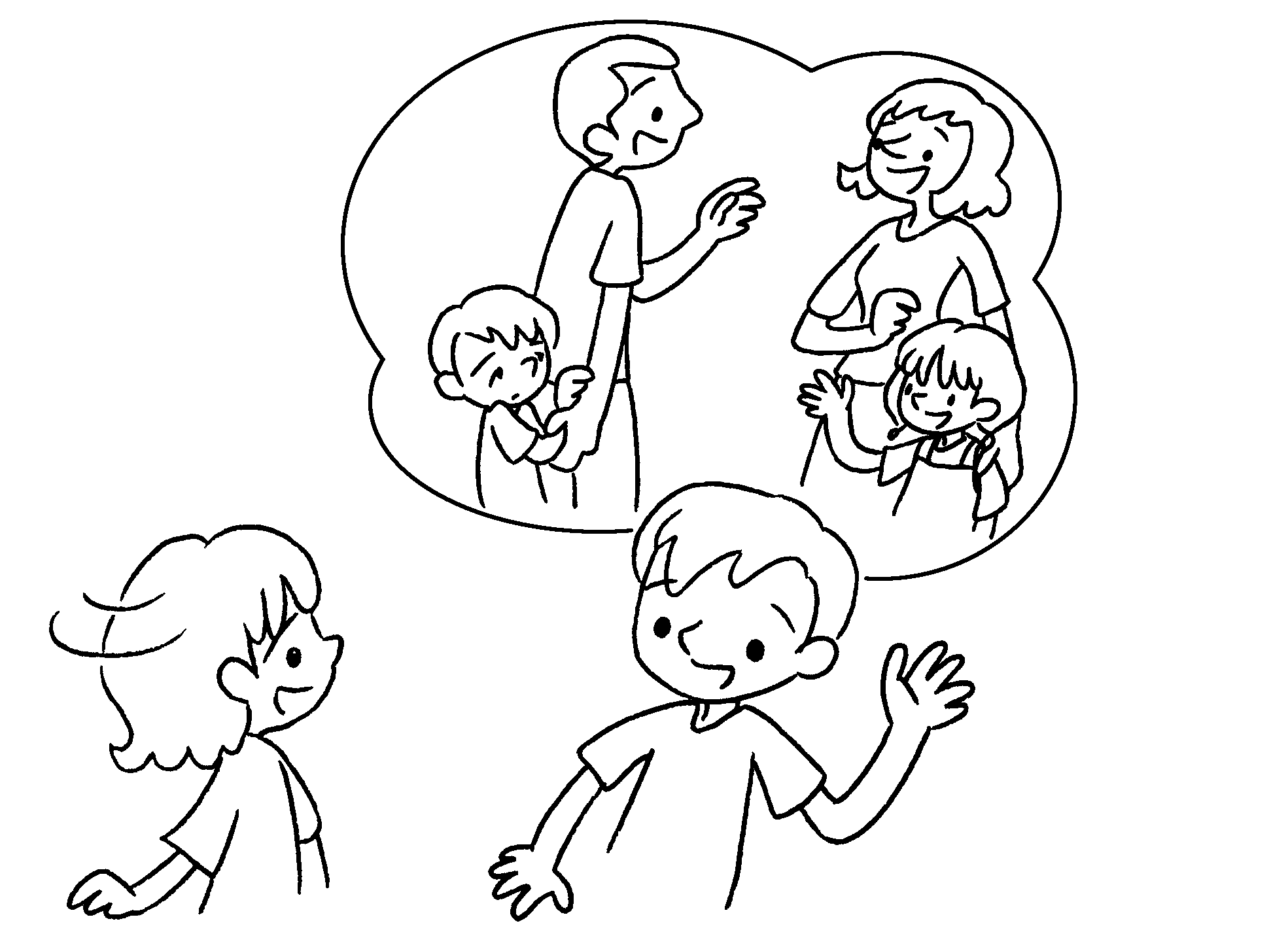 | Two years ago Alan  s .  This year he f .

Book 3B Chapter 3 Graded Worksheets
Worksheet 2⬇⬇⬇

1 is strong
2 was short
am
- was naughty
is
4 was careless
am careful
5 was shy
is friendly



