Choose and write.
are
were
1 | 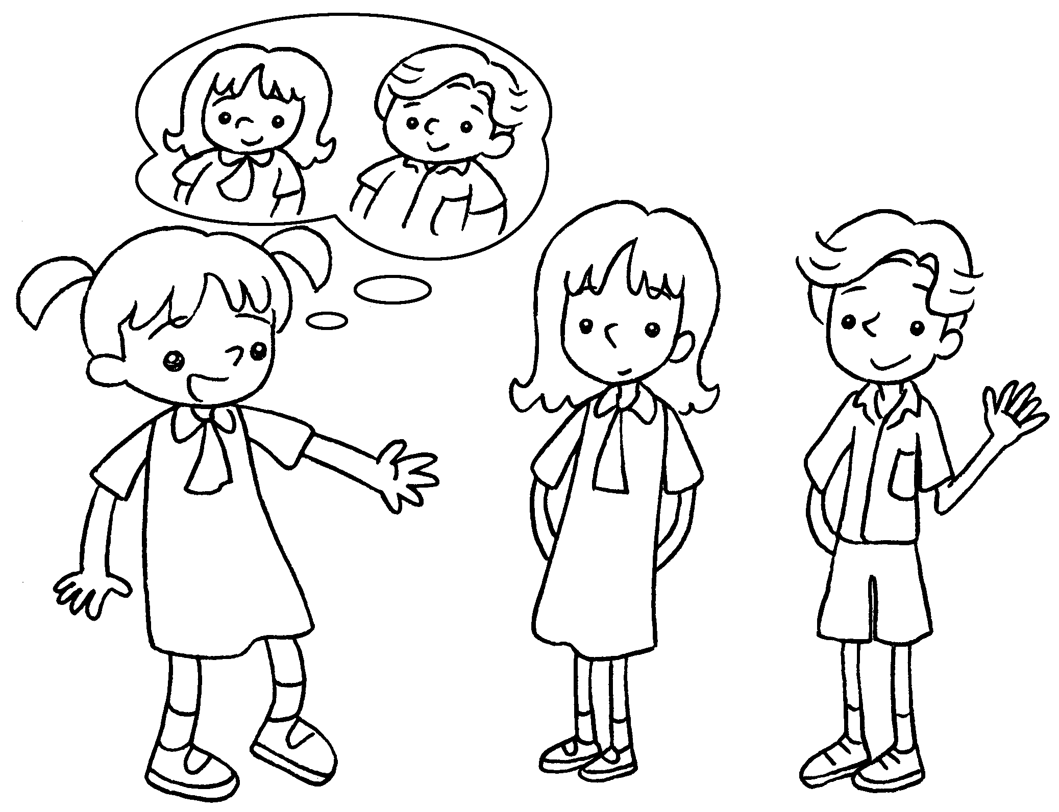 | Two years ago Annie and Sam  fat.  This year they thin.
2 | 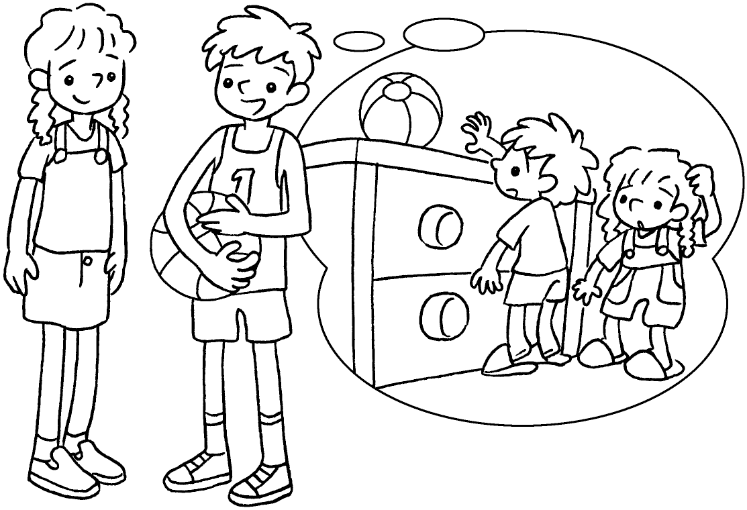 | Five years ago Kim and I short.  Now we tall.
3 | 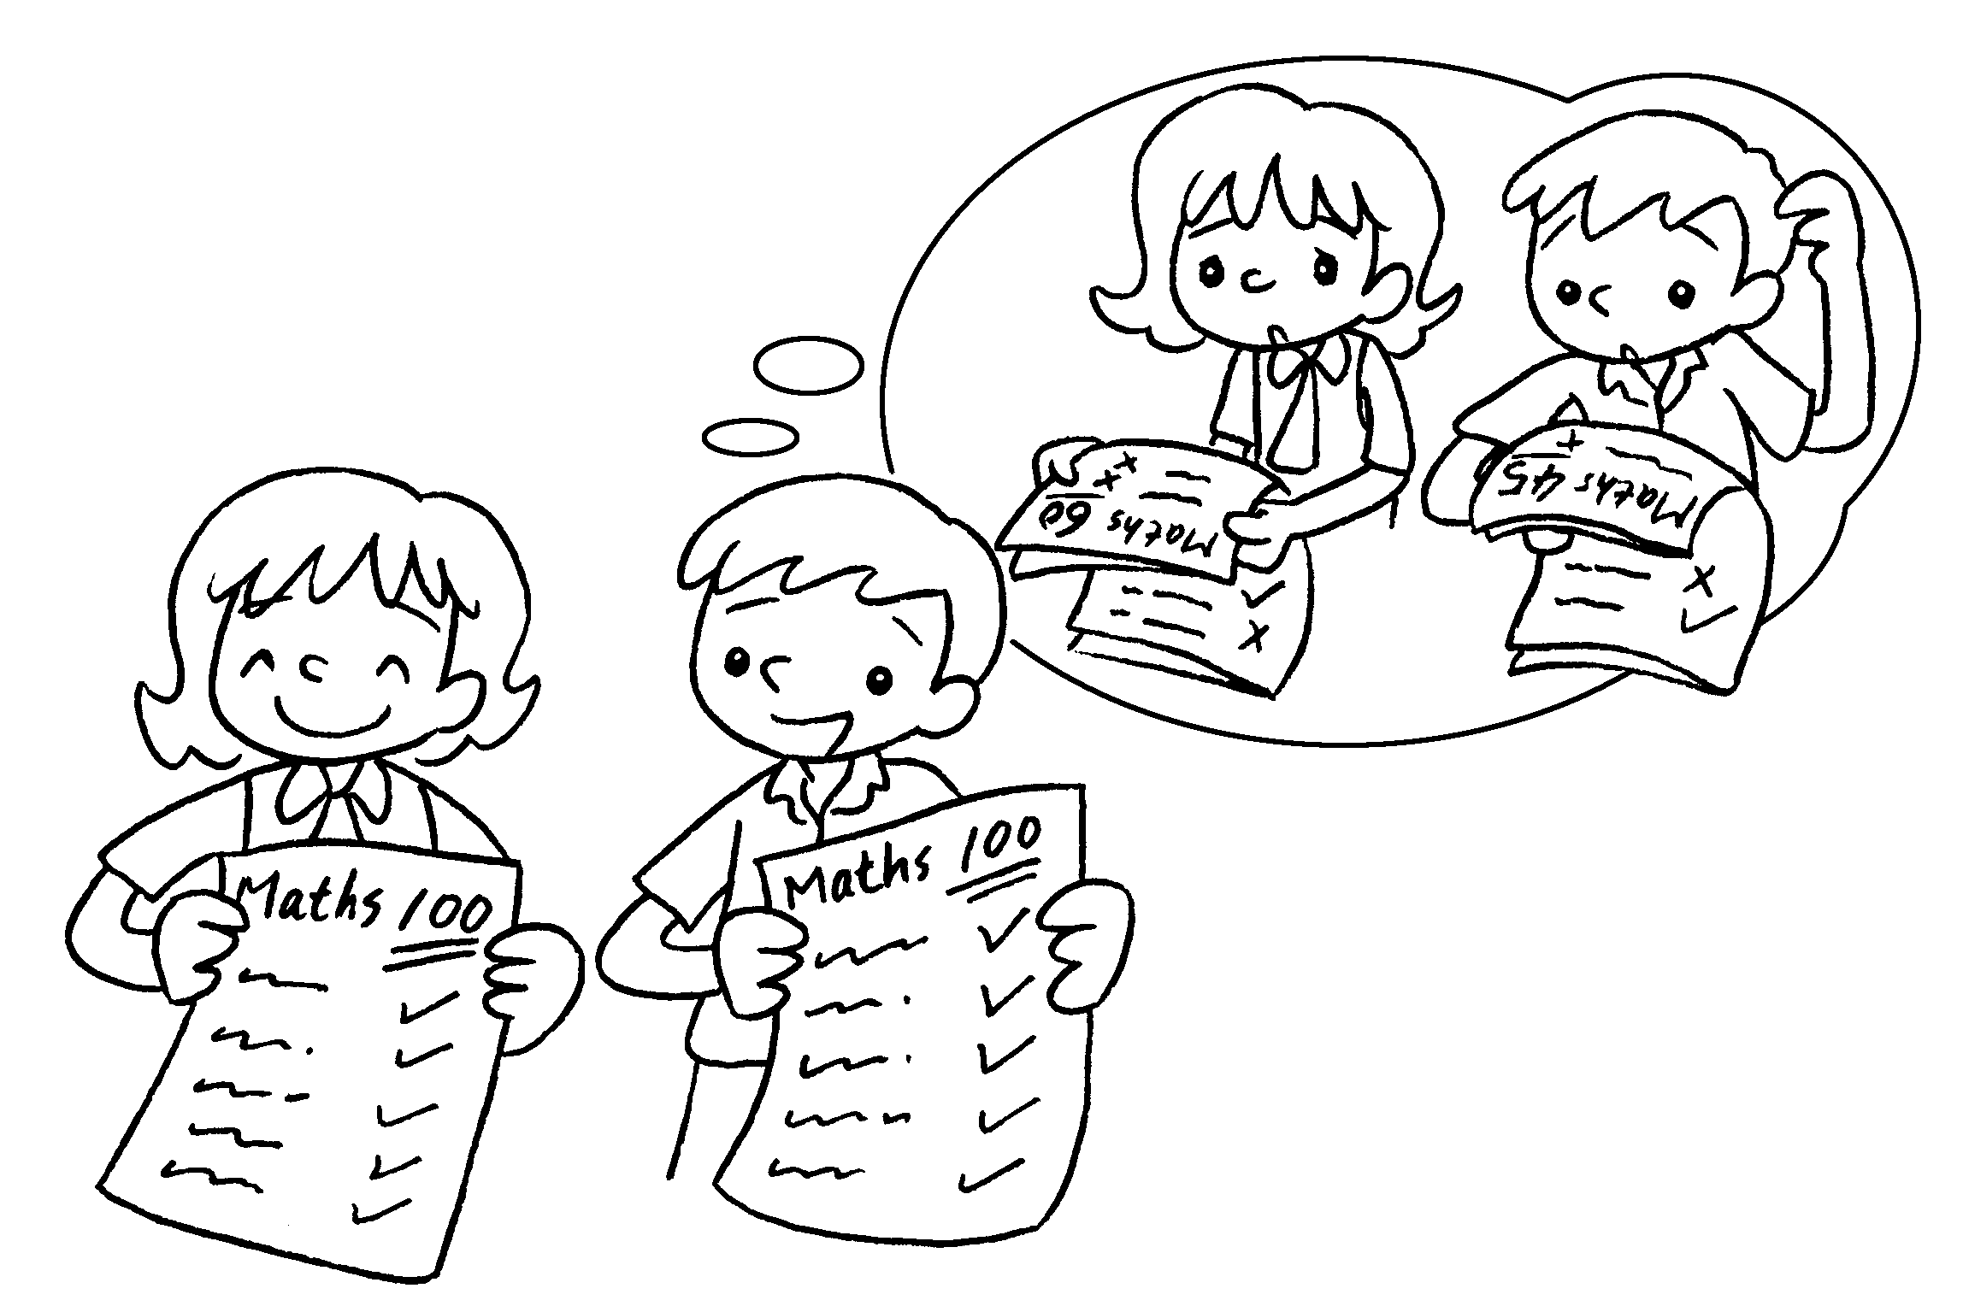 | Last year Coco and I careless.  Now we careful.
4 | 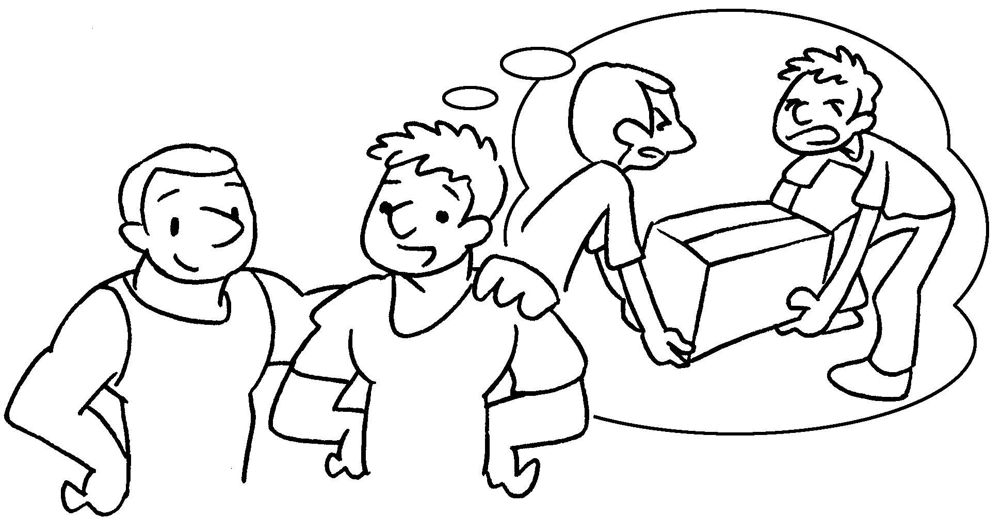 | Last year we weak.  This year we strong.
5 | 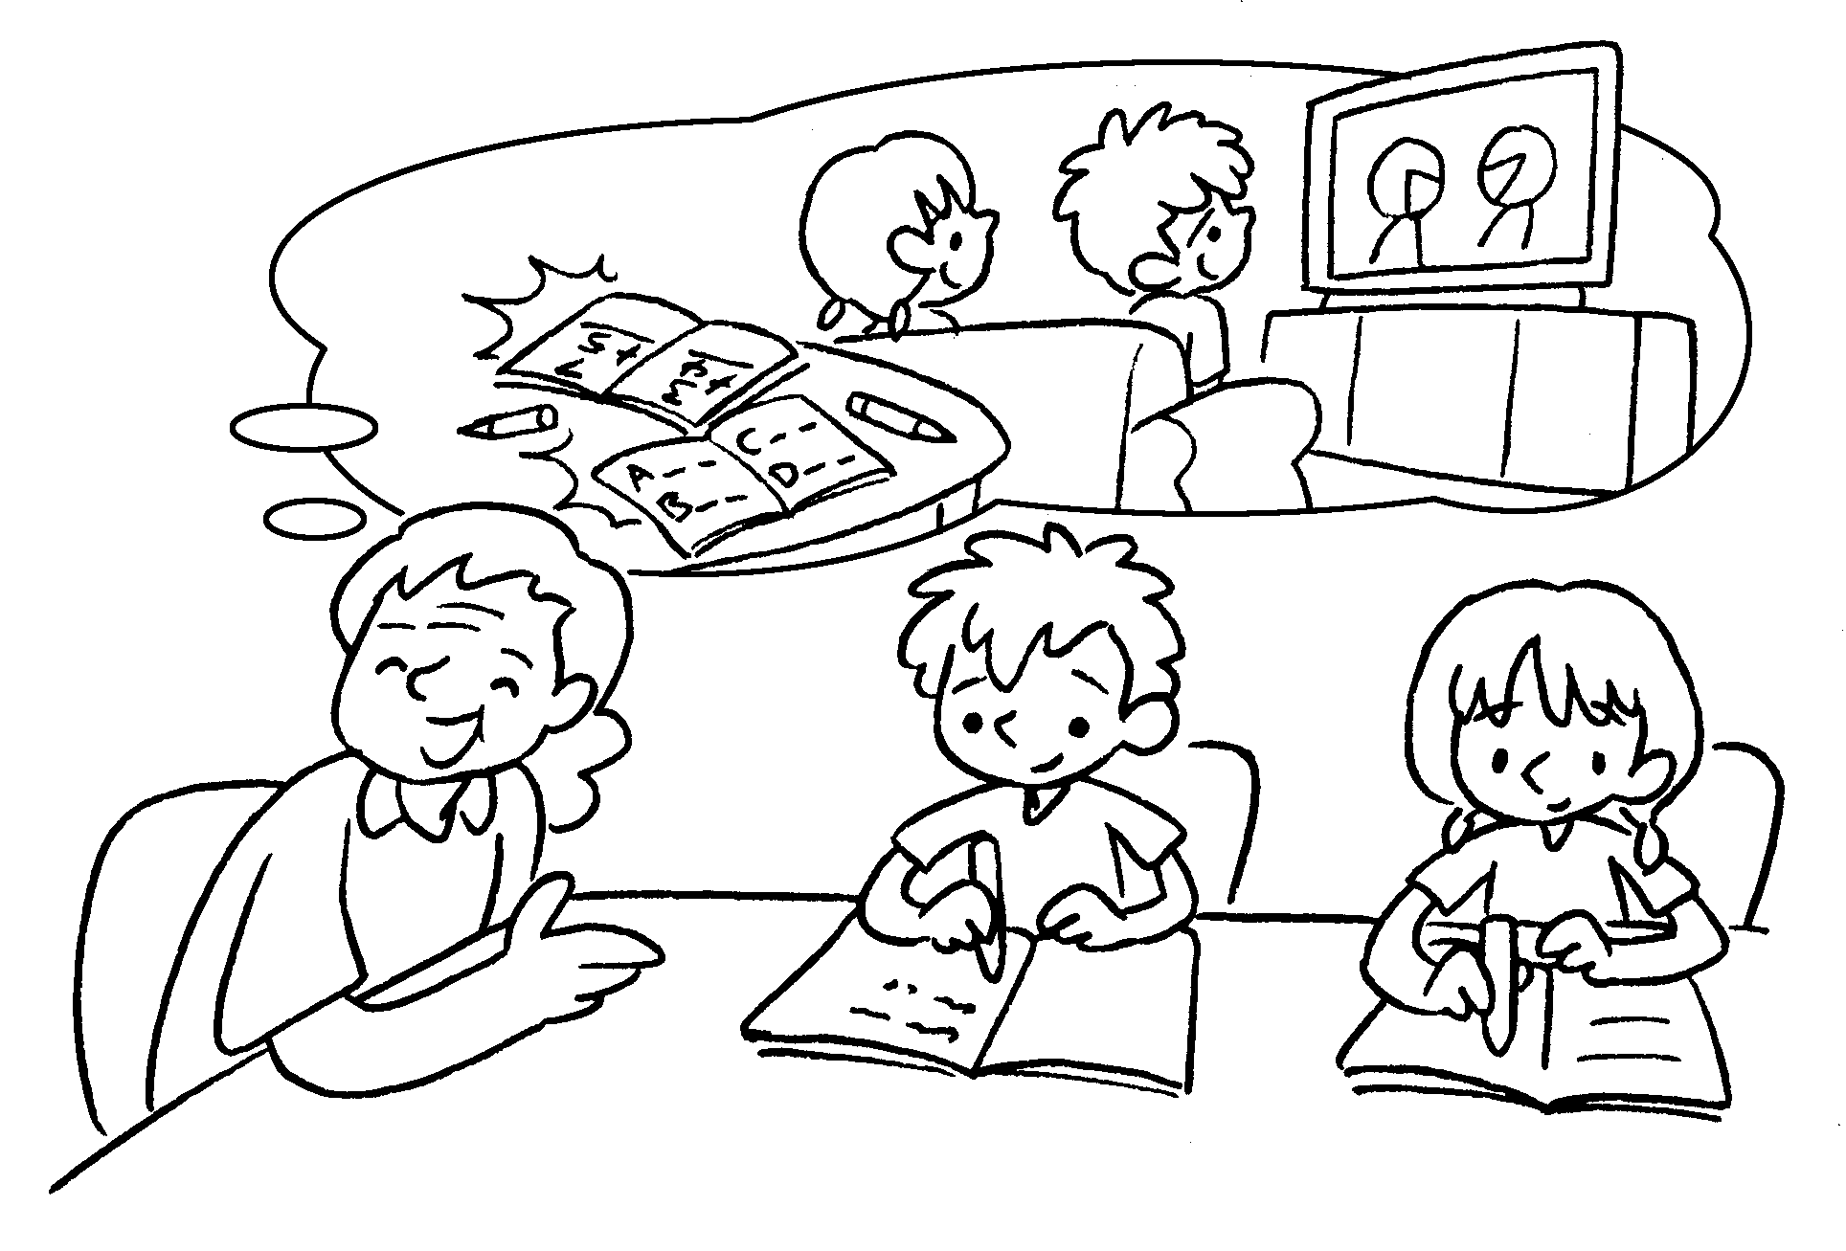 | Four years ago Bill and Betty  lazy.  Now they hard-working.


Book 3B Chapter 3 Graded Worksheets
Worksheet 3⬇
- were
are
- were
are
- were
are
- were
are
- were
are

