Fill in the blanks.

tall lazy strong careful hard-working weak

1 | 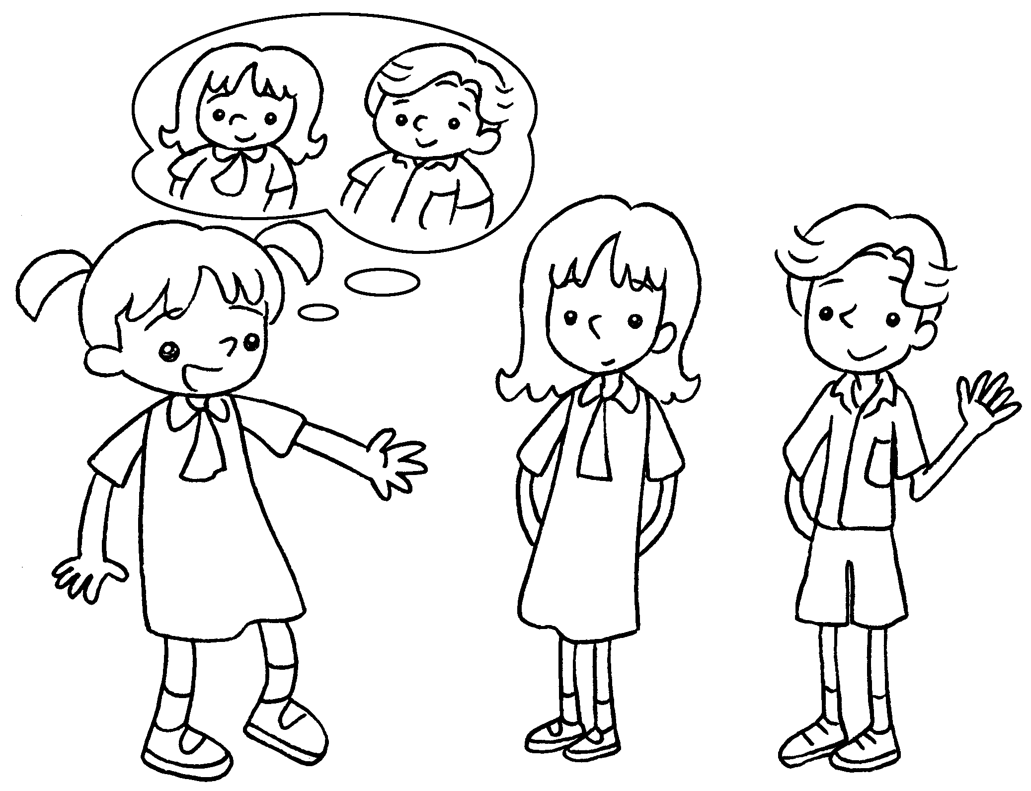 | Two years ago Annie and Sam  fat.  were  This year they thin.
2 | 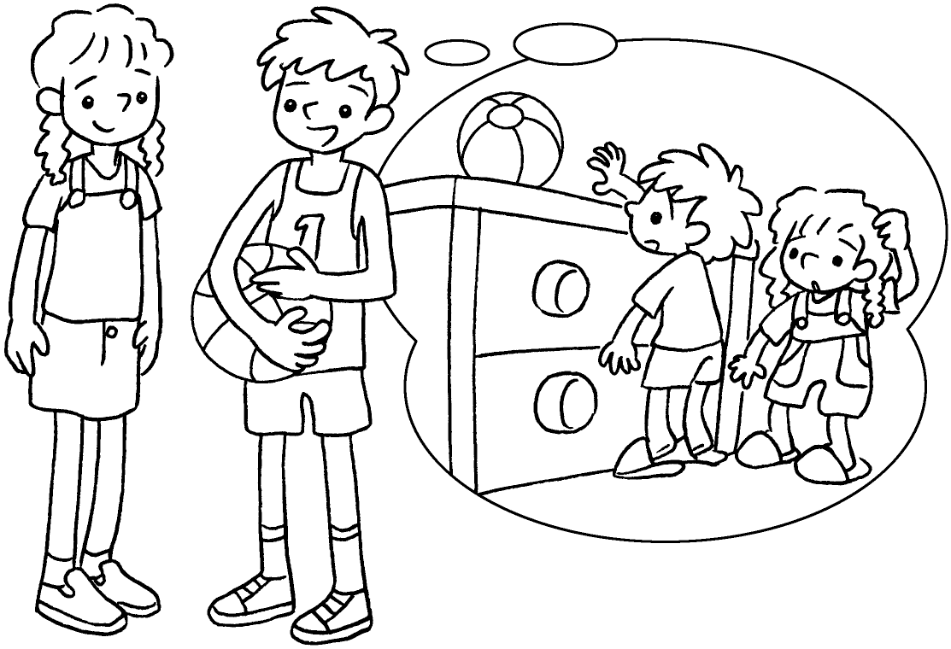 | Five years ago Kim and I  short.  Now we .
3 | 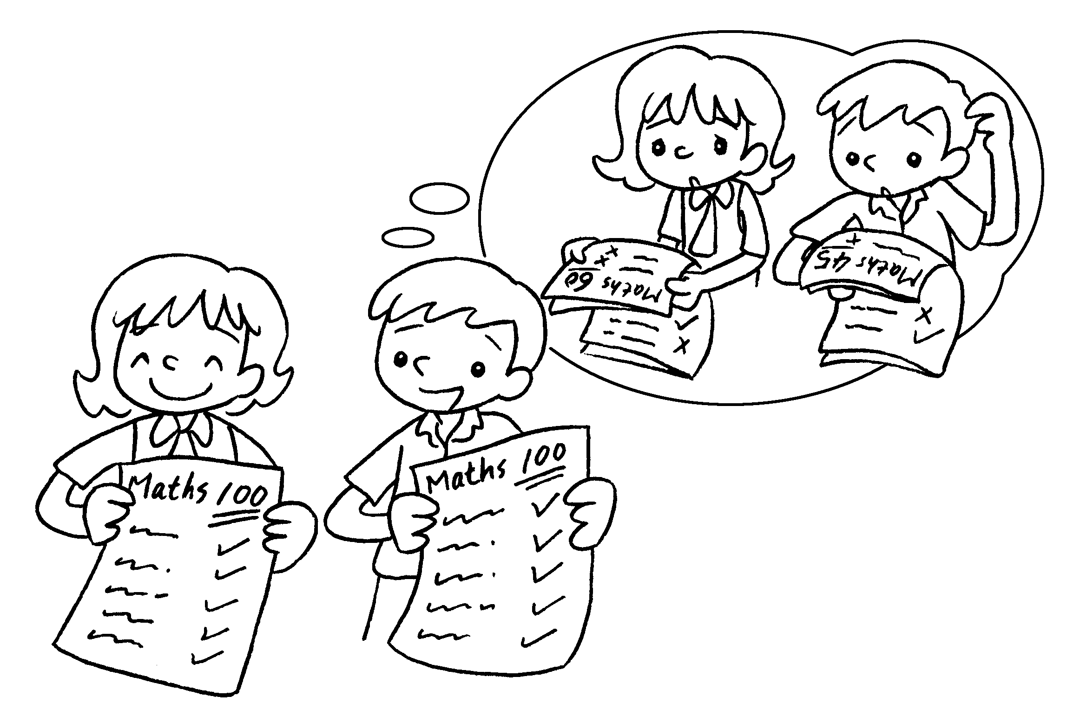 | Last year Coco and I  careless.  Now we .
4 | 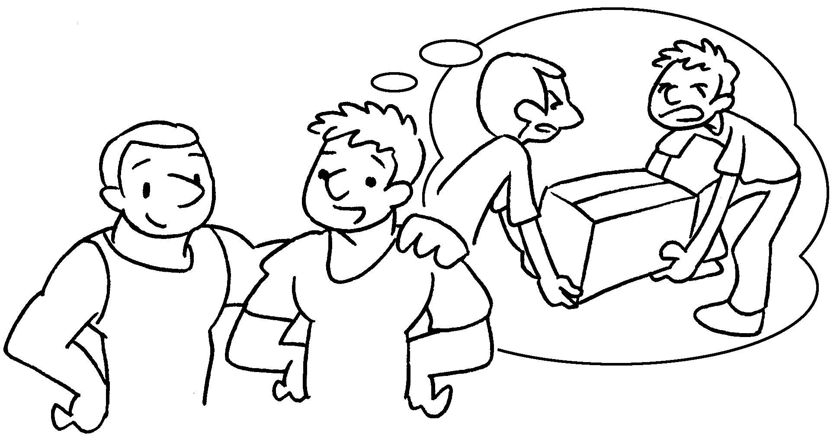 | Last year we .  This year we .
5 | 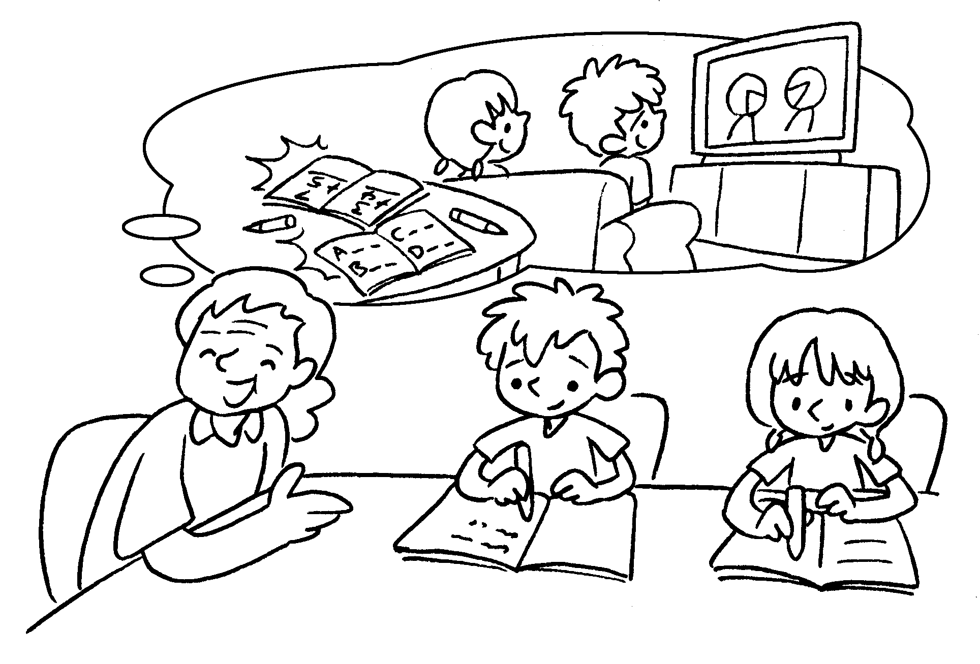 | Four years ago Bill and Betty  .  Now they  .



Book 3B Chapter 3 Graded Worksheets
Worksheet 3⬇⬇
- are
- were
are tall
- were
are careful
- were weak
are strong
- were lazy
are hard-working

