Fill in the blanks.

is / are was / were

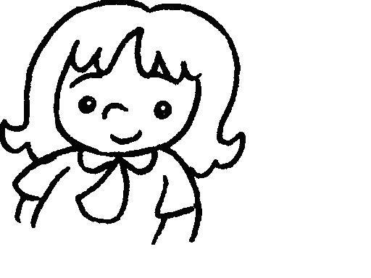
1 | 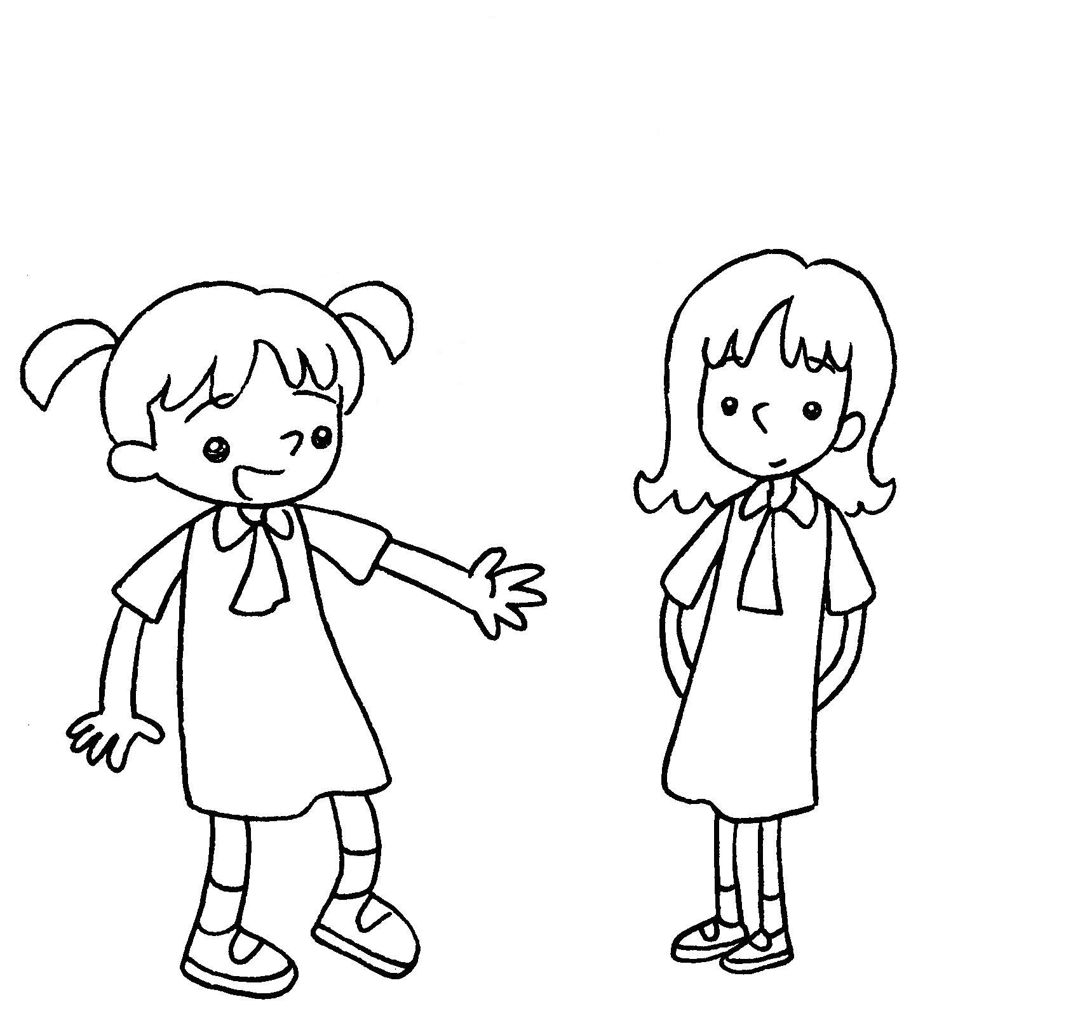 | Two years ago Annie fat.  This year she thin.
2 | 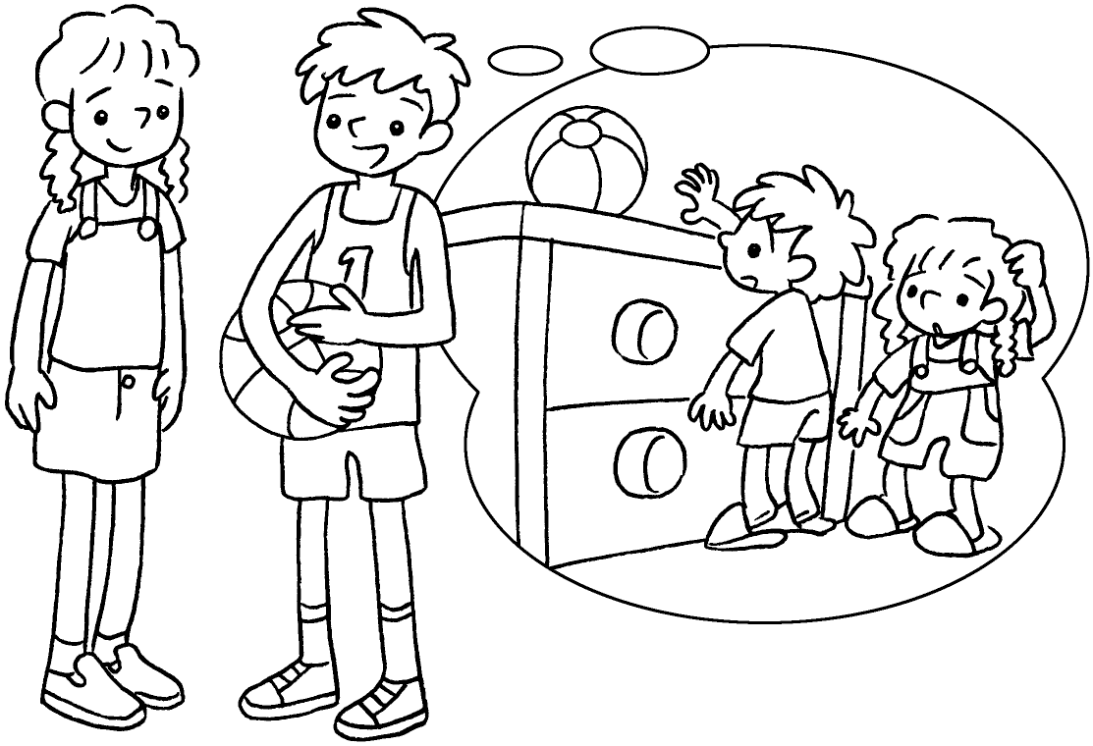 | Five years ago Kim and I  short.  Now we t .
3 | 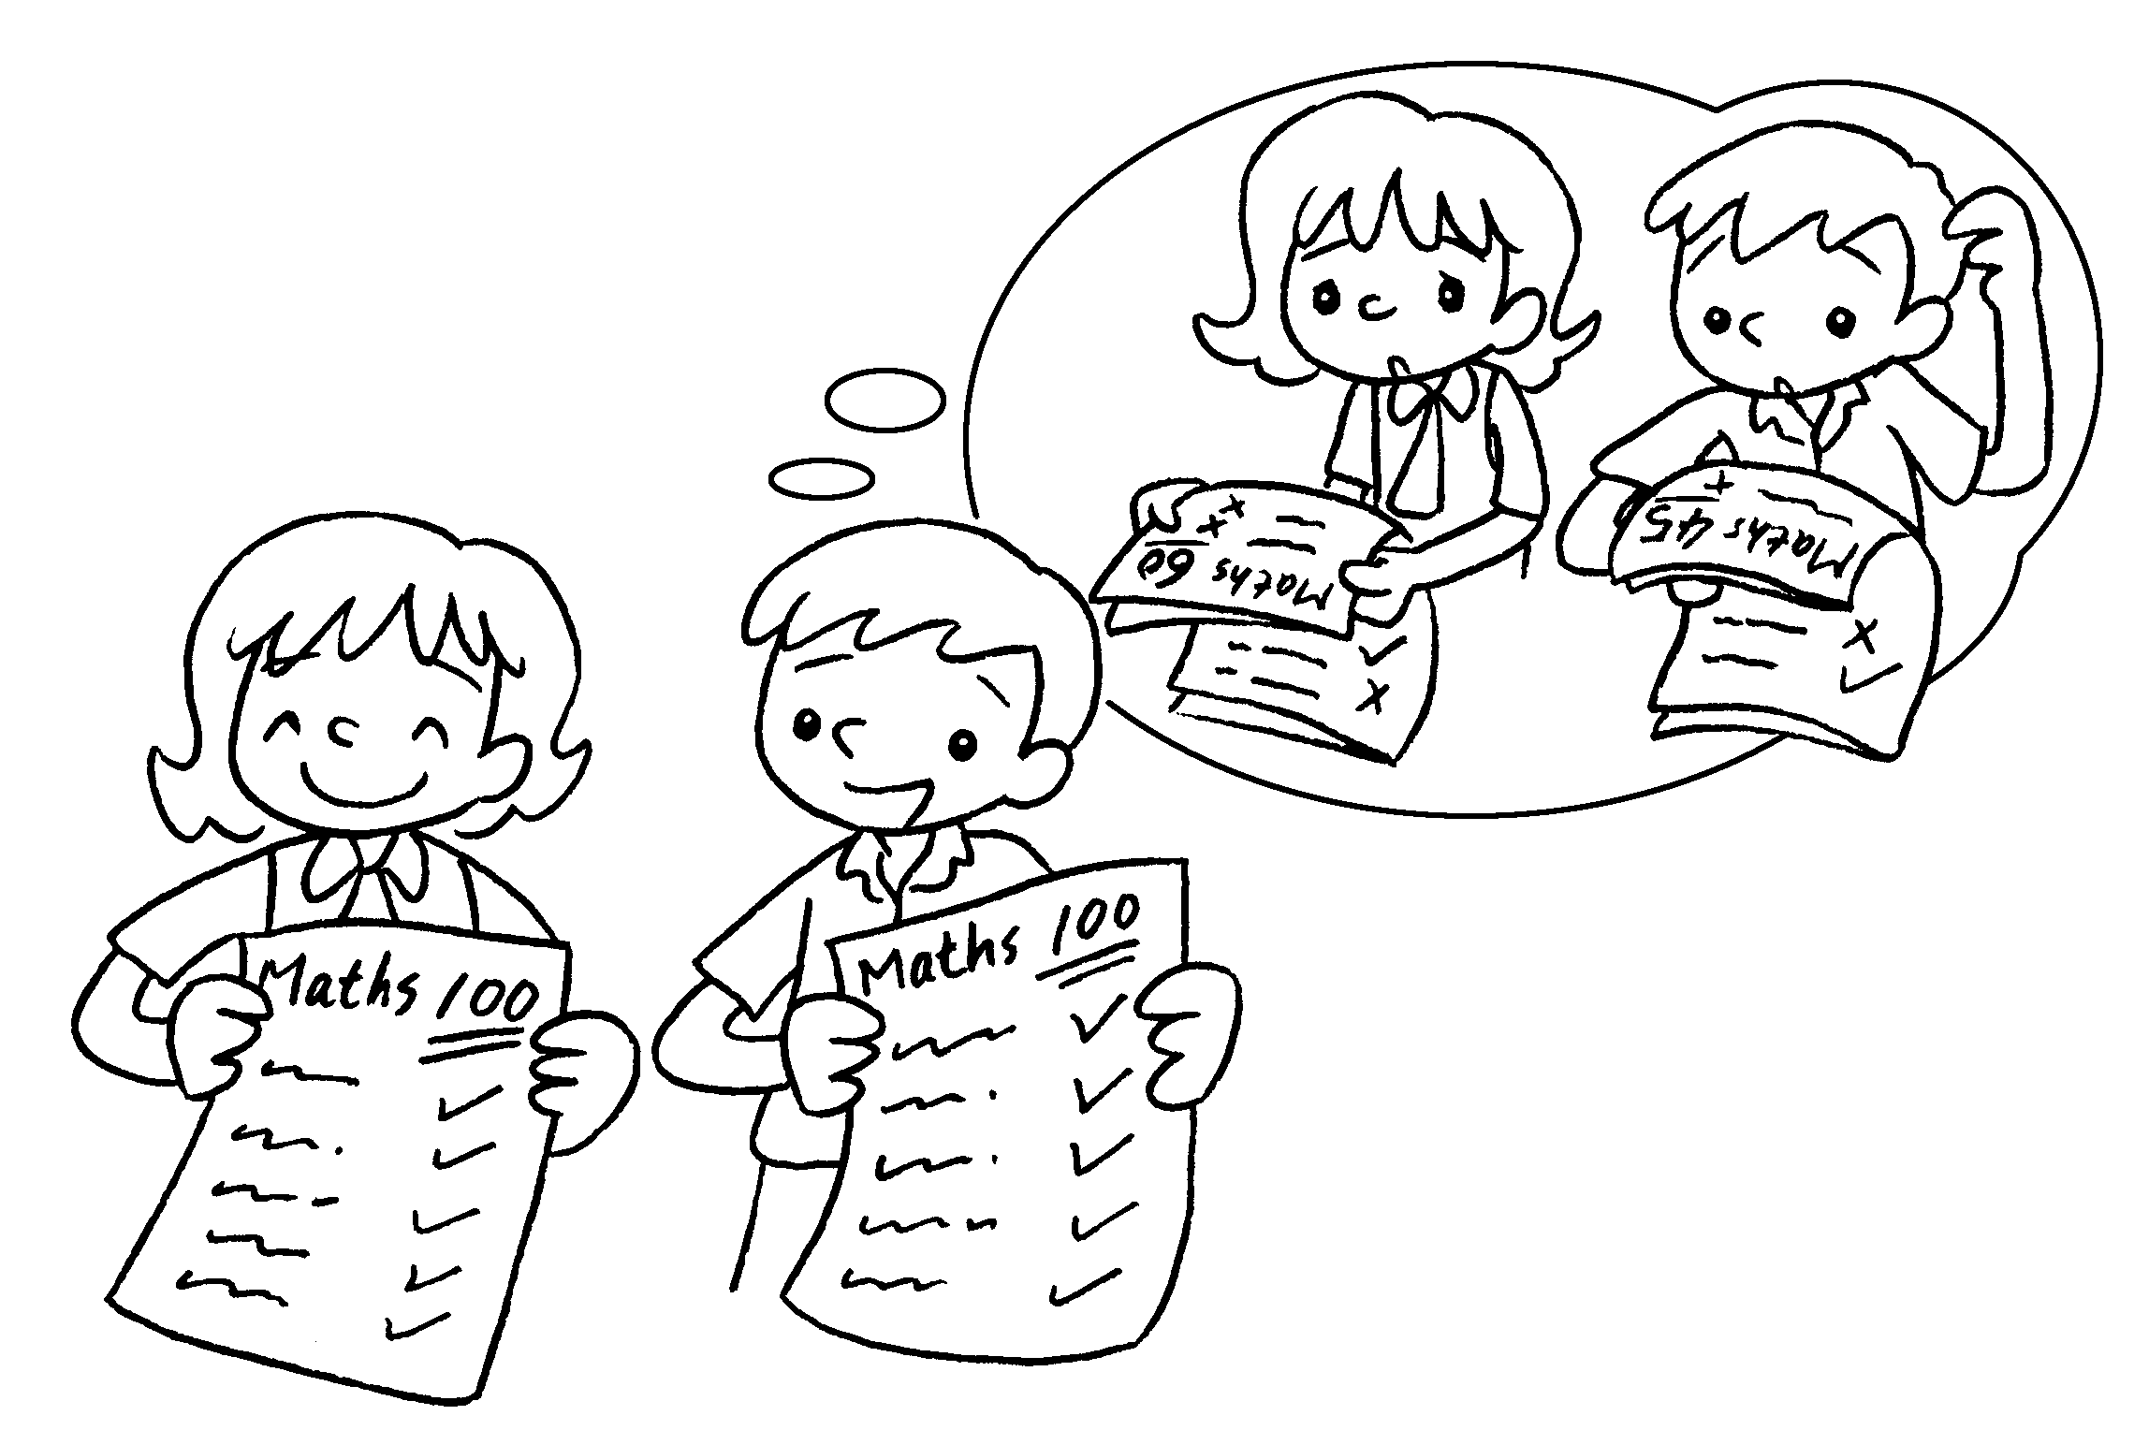 | Last year Coco and I  careless.  Now we c .
4 | 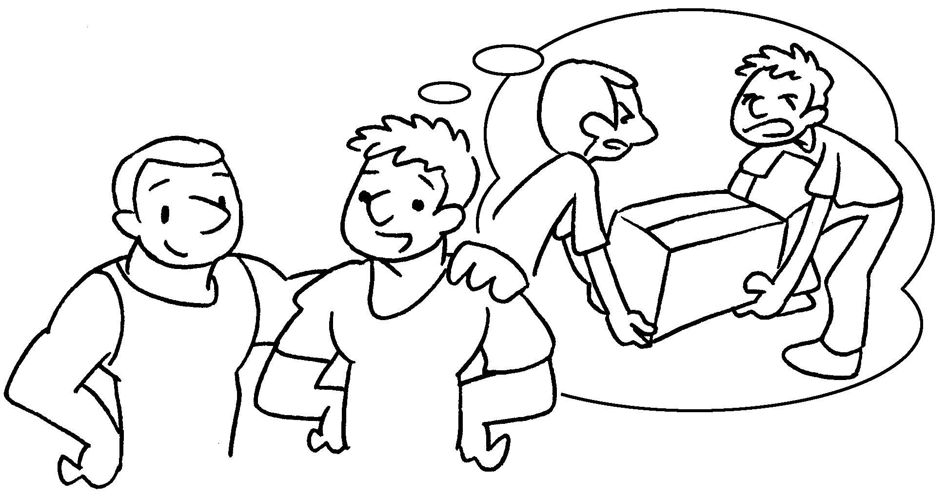 | Last year we w .  This year we s .
5 | 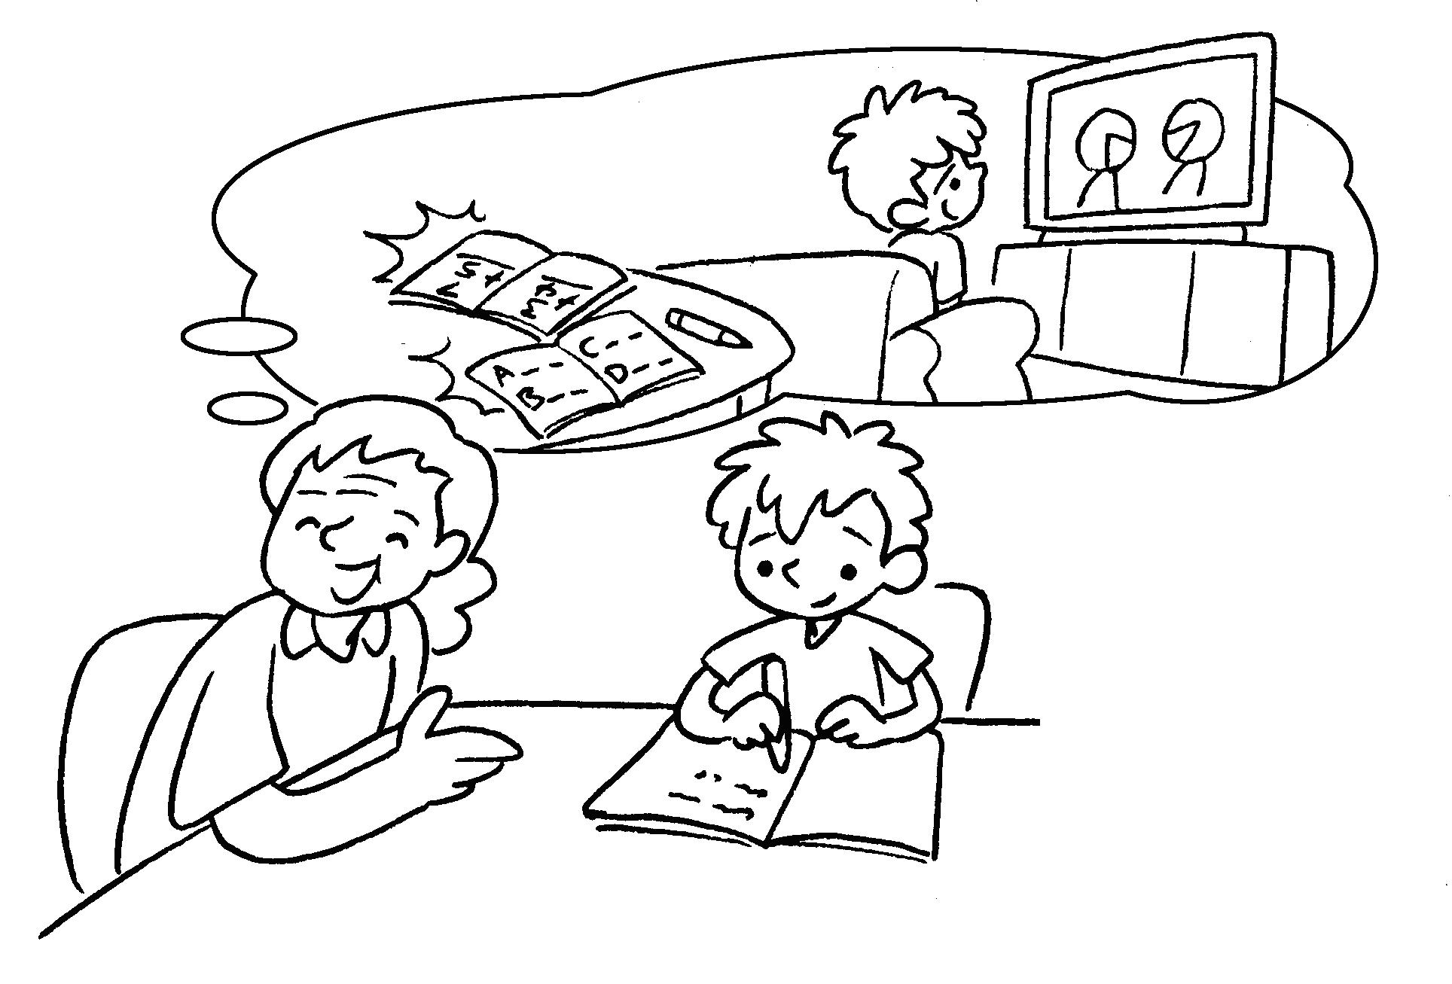 | Four years ago Bill  l .  Now he h .


Book 3B Chapter 3 Graded Worksheets
Worksheet 3⬇⬇⬇
- was
is
- were
are tall
- were
are careful
- were weak
are strong
- was lazy
is hard-working

