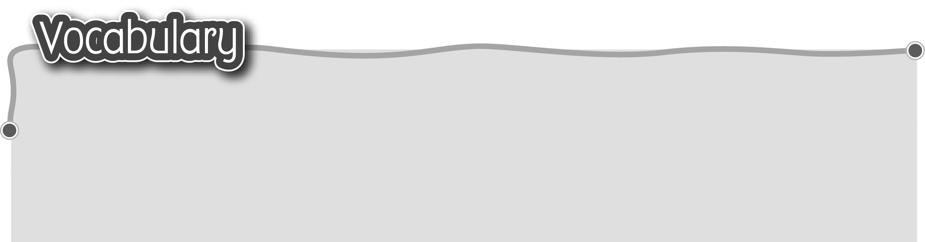
1 good* 乖 / naughty 頑皮 4 shy 害羞
The words marked with * have different meanings in other contexts. You can look up those meanings in a dictionary.

2 weak* 虛弱 / strong* 強壯 5 friendly 友善
3 careful 小心 / careless 大意

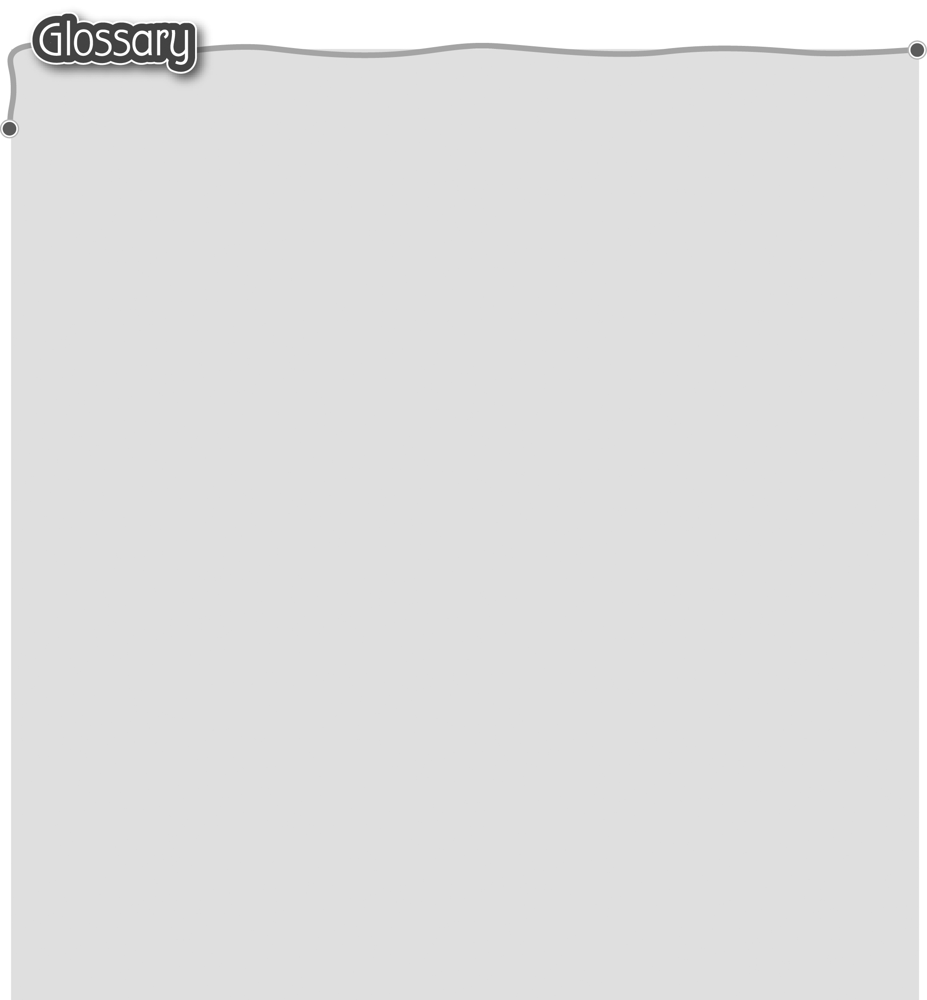
1 old* (p.20) 舊 16 height (p.23) 身高
2 explain (p.20) 解釋 17 weight (p.23) 體重
3 a few years (p.20) 幾年 18 something (p.25) 有些事情
4 ago (p.20) ……以前 19 twin* (p.25) 雙生（形容詞）
5 was / were (be) (p.20) 是 20 front cover (p.27) 封面
6 really (p.20) 真的 21 back cover (p.27) 封底
7 gram (g) (p.20) 克 22 photography (p.27) 攝影
8 kilogram (kg) (p.20) 23 publisher (p.27) 出版社/商
千克/公斤 24 contain* (p.27) 包含
9 another (p.21) 另一 25 press* (p.27) 出版社（名詞）
10 sure* (p.21) 肯定（形容詞） 26 series* (p.27) 系列
11 then* (p.21) 當時 27 in the past (p.27) 以前
12 centimetre (cm) (p.21) 28 popular (p.27) 受歡迎
厘米/公分 29 nowadays (p.27) 現時
13 fall down (p.21) 跌下來 30 yo-yo (p.27) 搖搖
14 change* (p.21) 改變（動詞） 31 board game (p.27) 棋類遊戲
15 this / last year (p.23) 32 electronic toy (p.27) 電子玩具
今年/去年

