Front covers and back covers
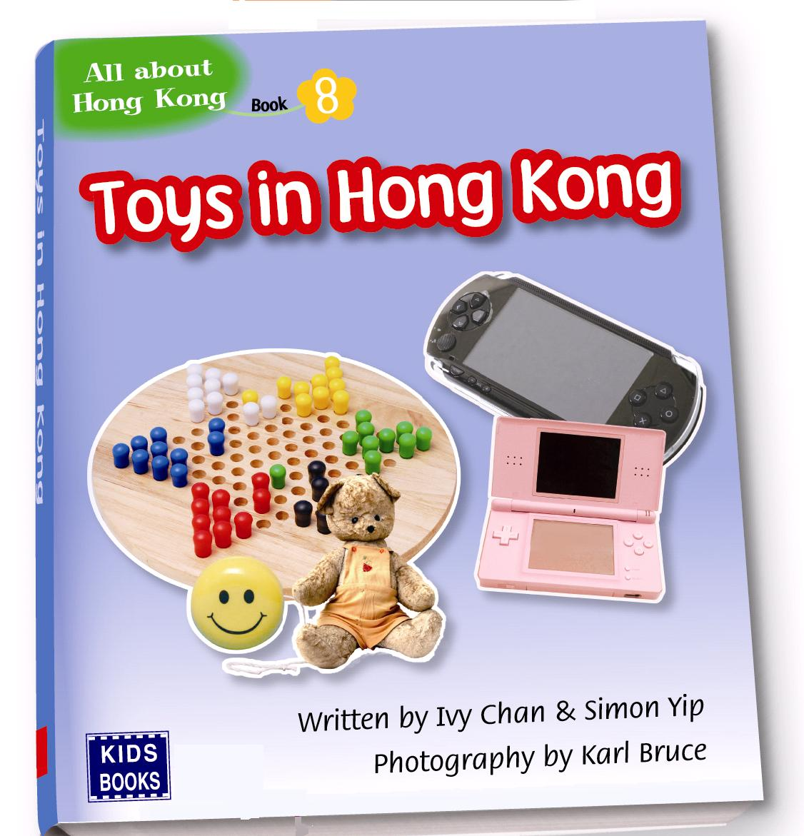
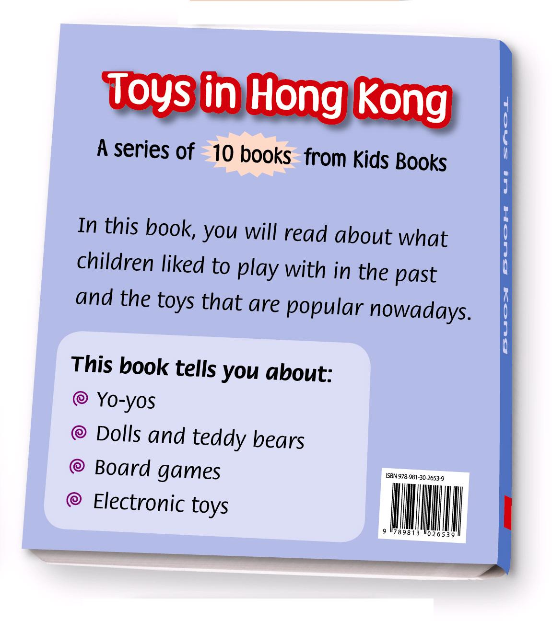

Write the answer and blacken • the circles.

1 Who took the photos for this book?

2 What CAN’T you find on the front cover?
 A. the names of the writers
 B. the name of the book
 C. the name of the publisher
 D. the names of the toys

3 The back cover tells us ___ .
 A. what toys we can read about in the book
 B. about the writer
 C. about the publisher
 D. about Hong Kong in the past and in the present

4 Which sentence is true?
 A. The title of the book is All about Hong Kong.
 B. Toys in Hong Kong is a story about teddy bears.
 C. The authors of the book are Ivy Chan and Simon Yip.
 D. The book is published by All about Hong Kong.

Answers:
1 Karl Bruce. 2 D 3 A 4 C

