Choose and write.
chat | paint | play
listen | study | watch

1 | 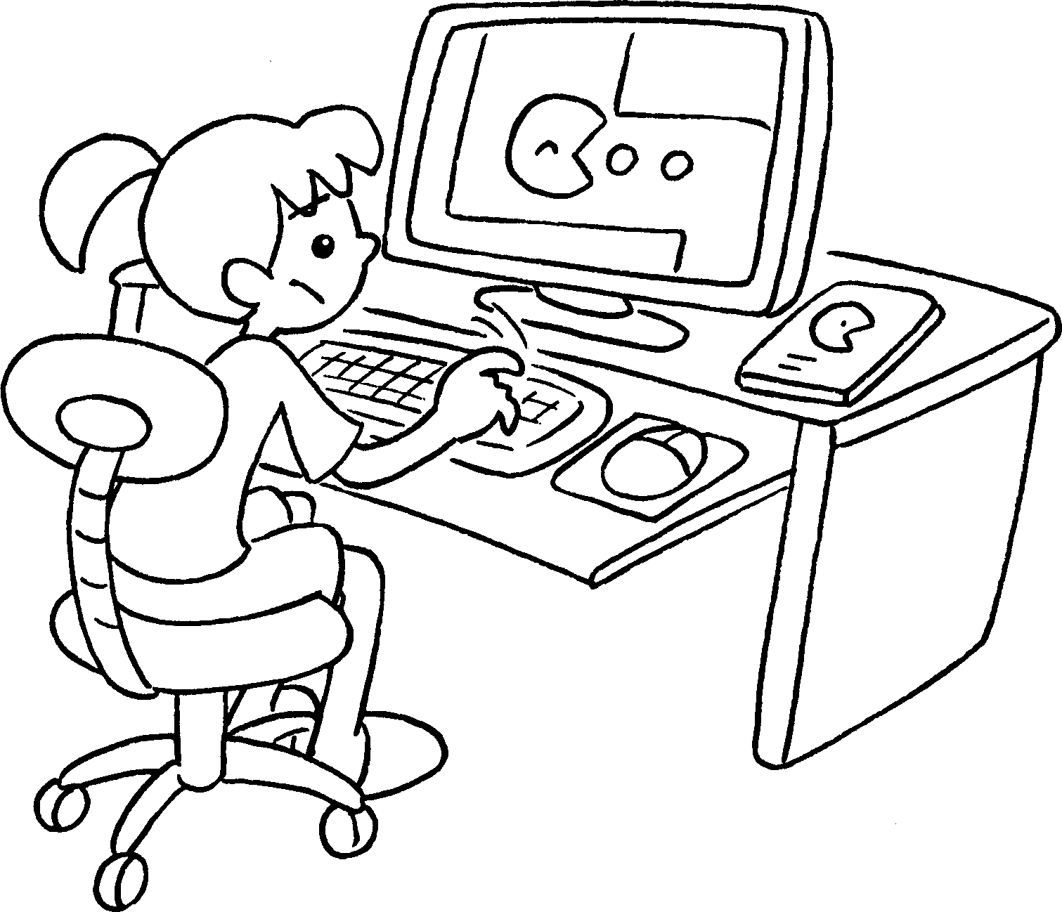 | 2 | 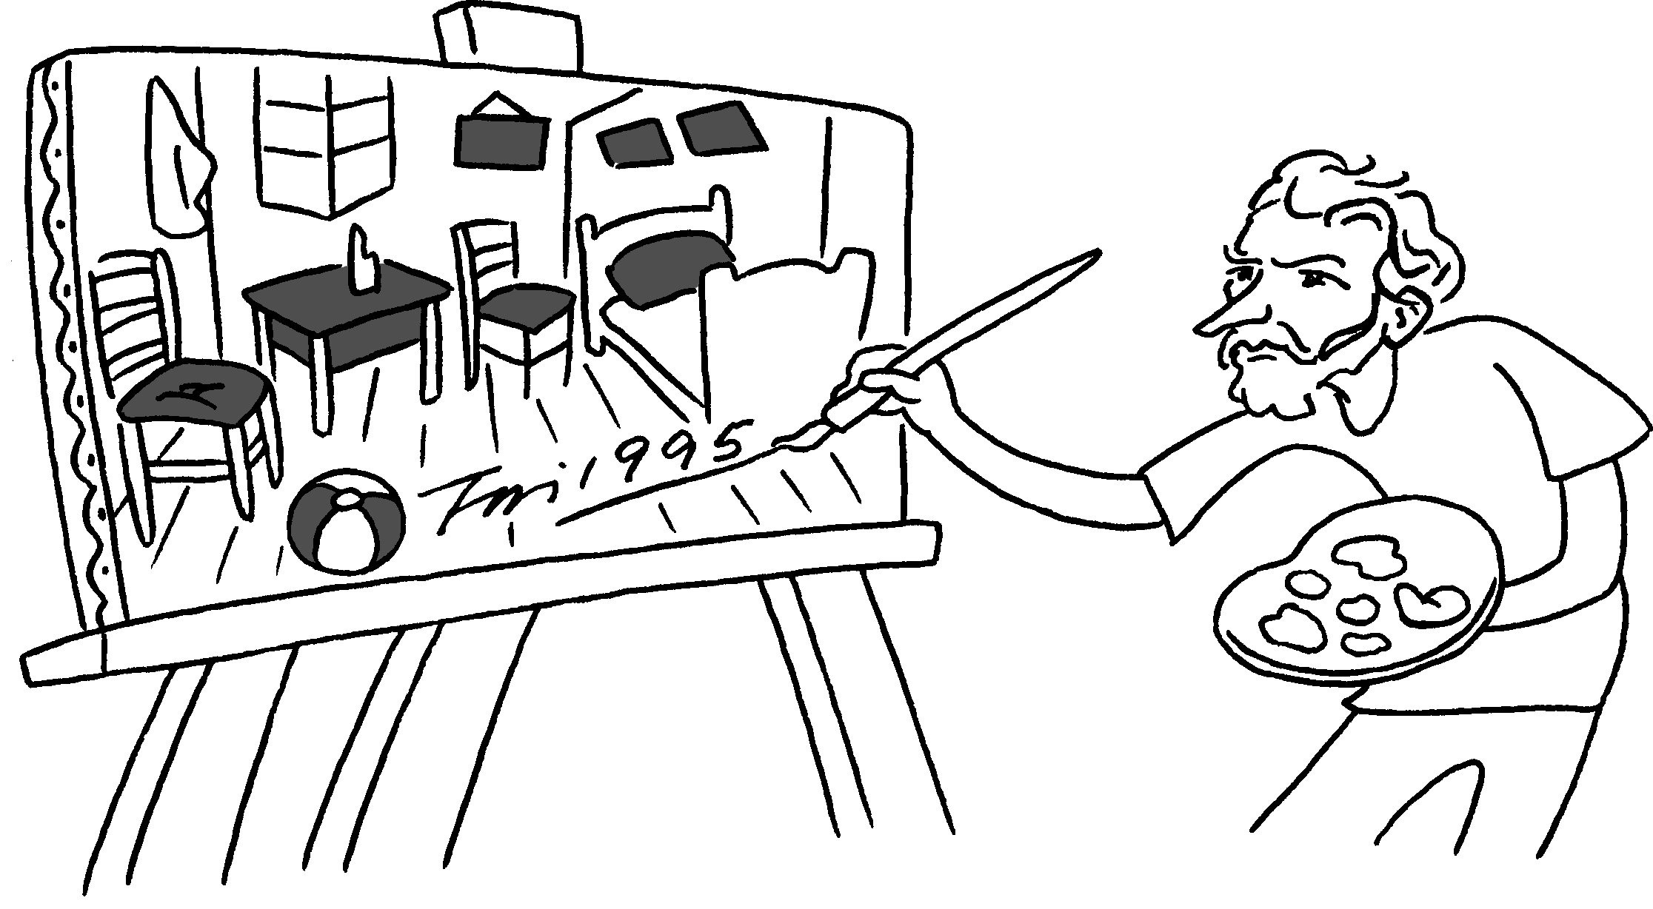
 | computer games |  | pictures
3 | 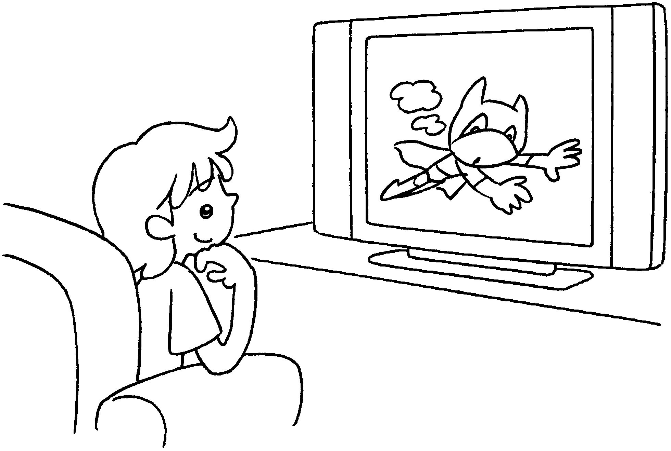 | 4 | 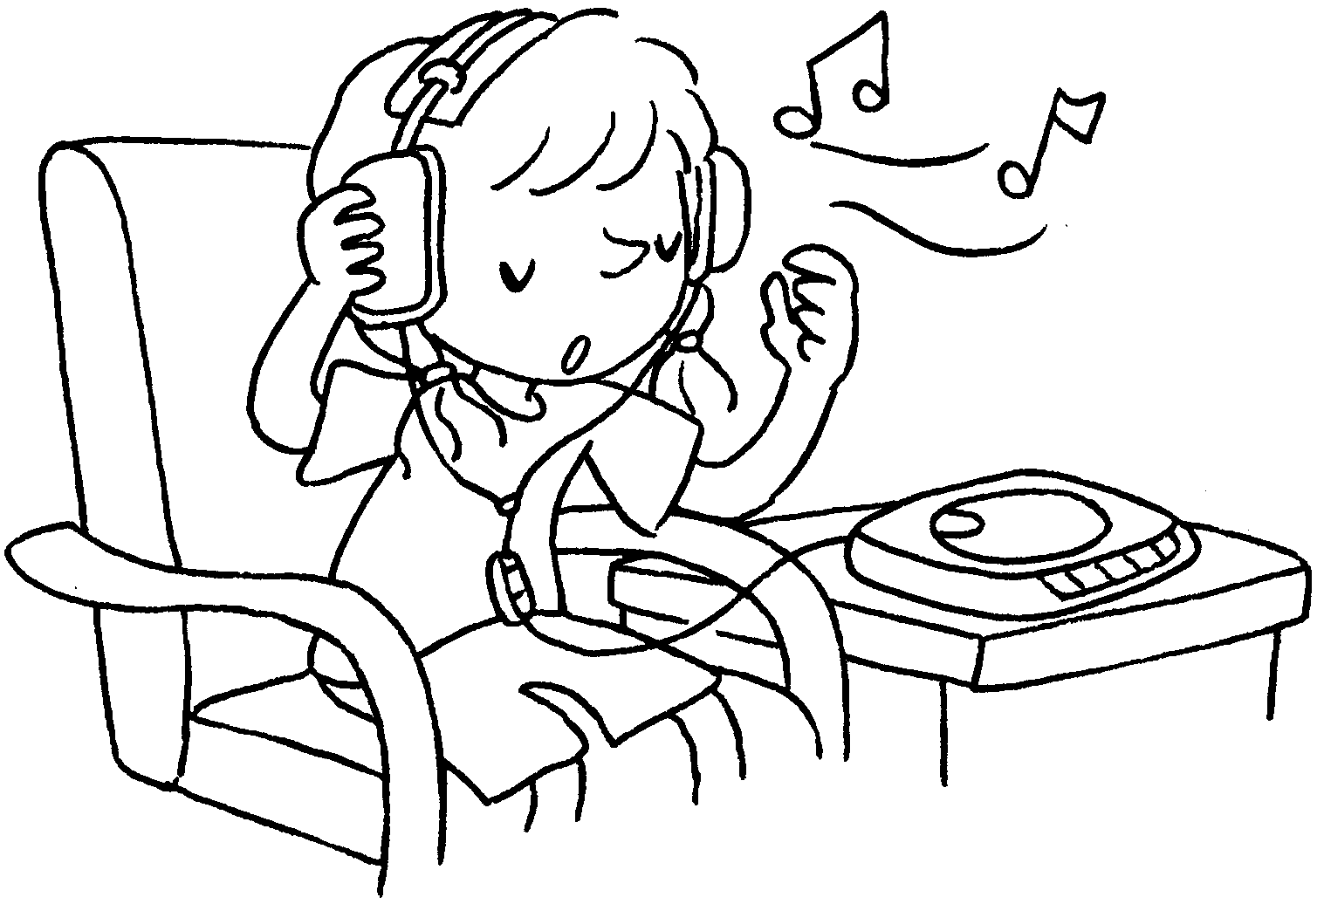
 | TV |  | to music
5 | 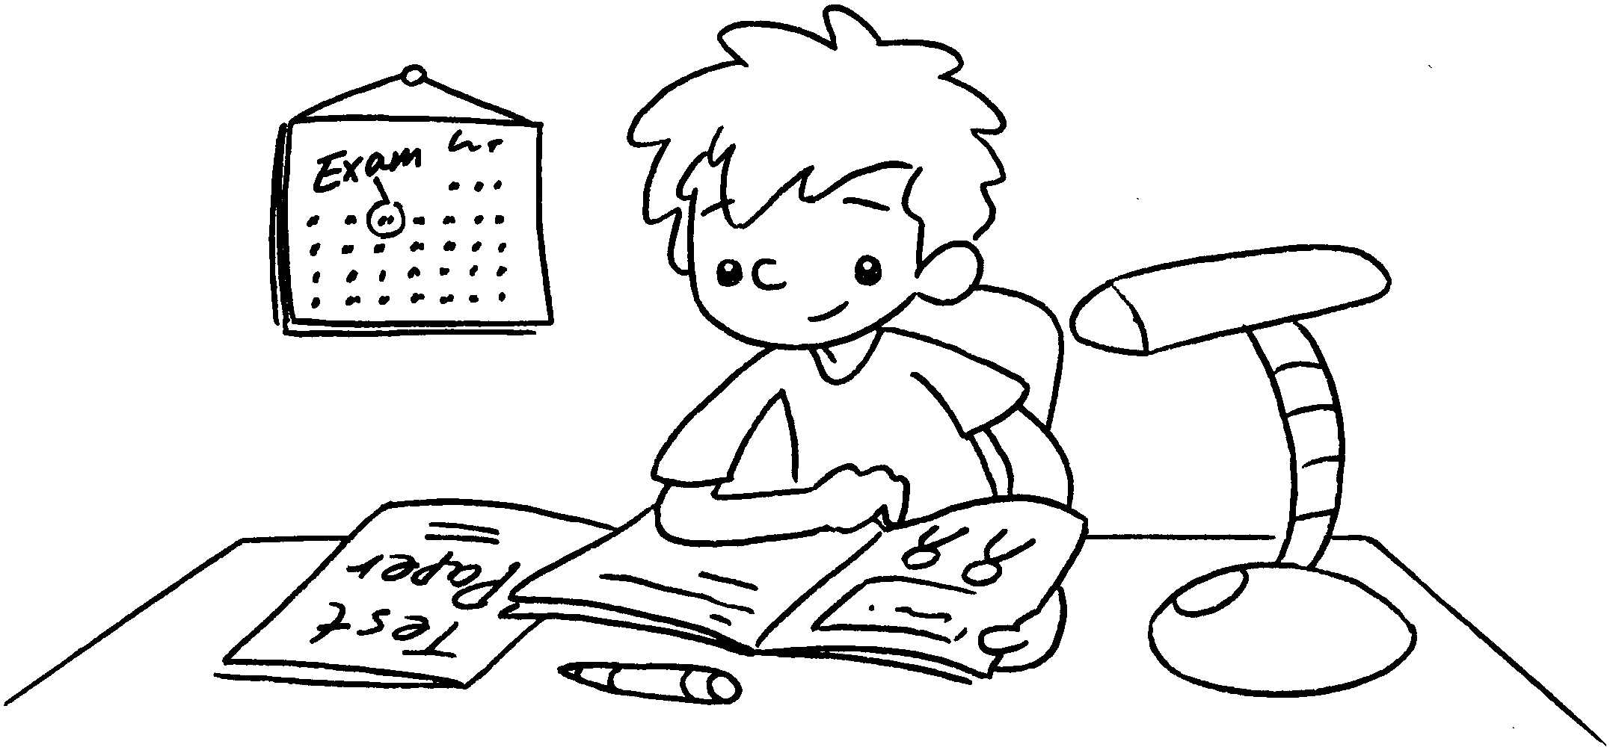 | 6 | 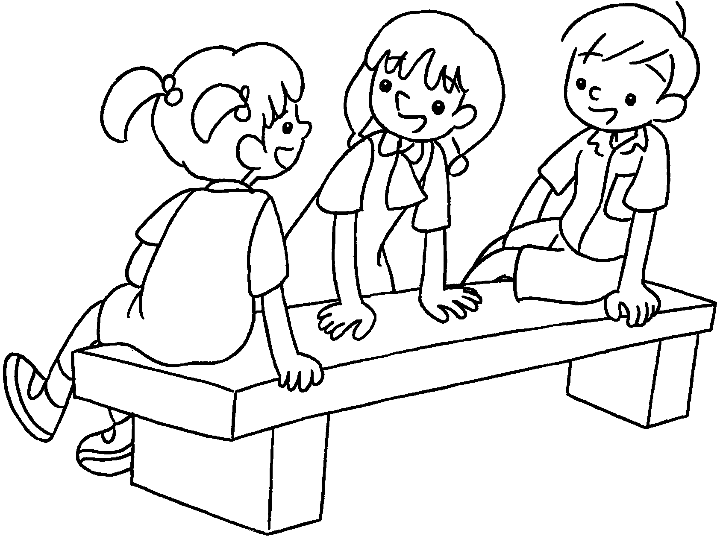
 | for the exam |  | with friends


Book 3B Chapter 4 Graded Worksheets
Worksheet 1⬇
1 play 2 paint
3 watch 4 listen
5 study 6 chat

