Fill in the missing letters.

1 | 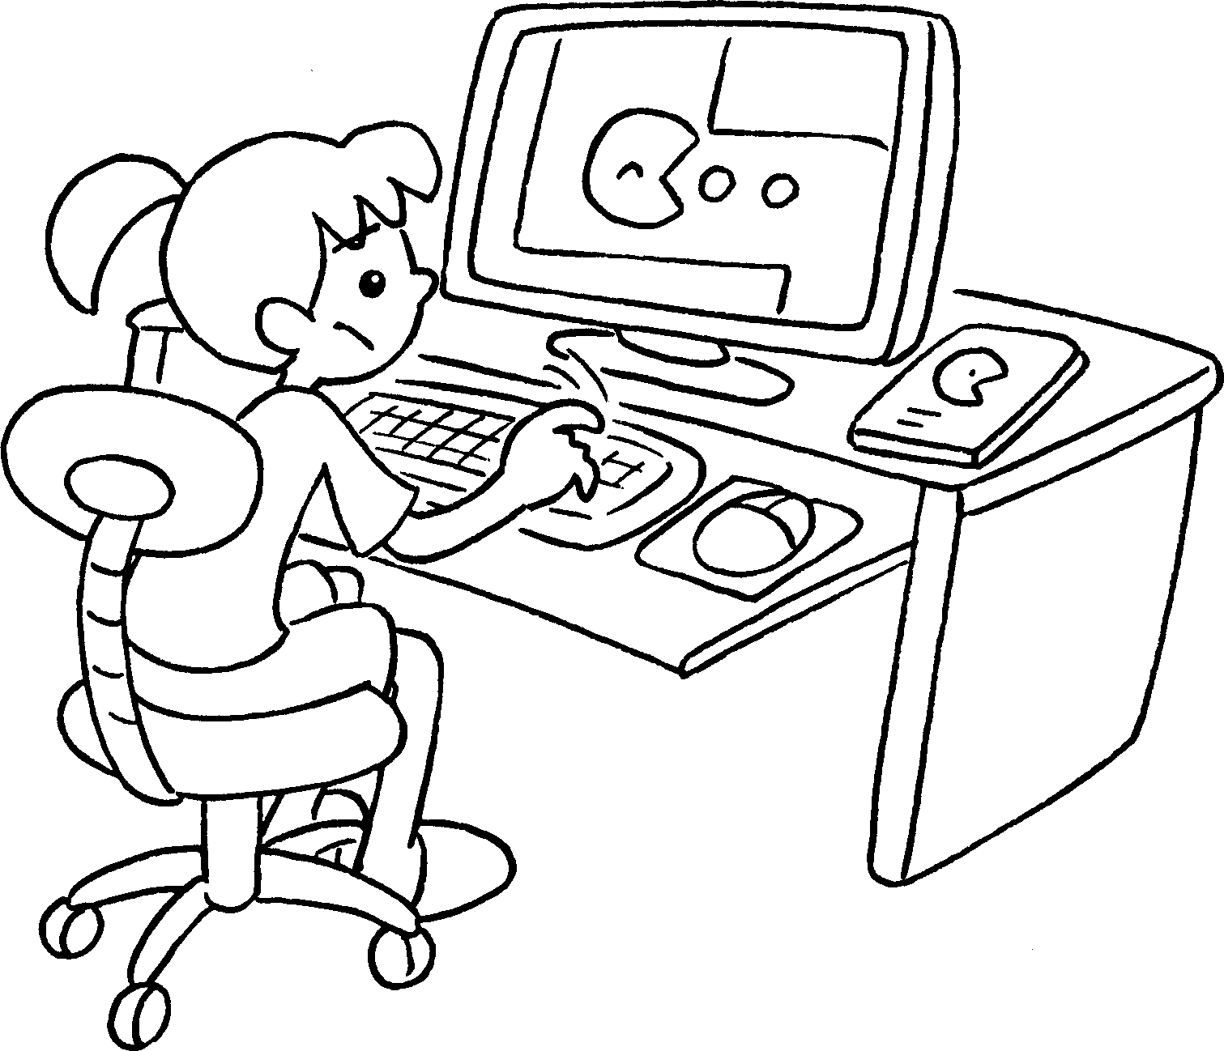 | 2 | 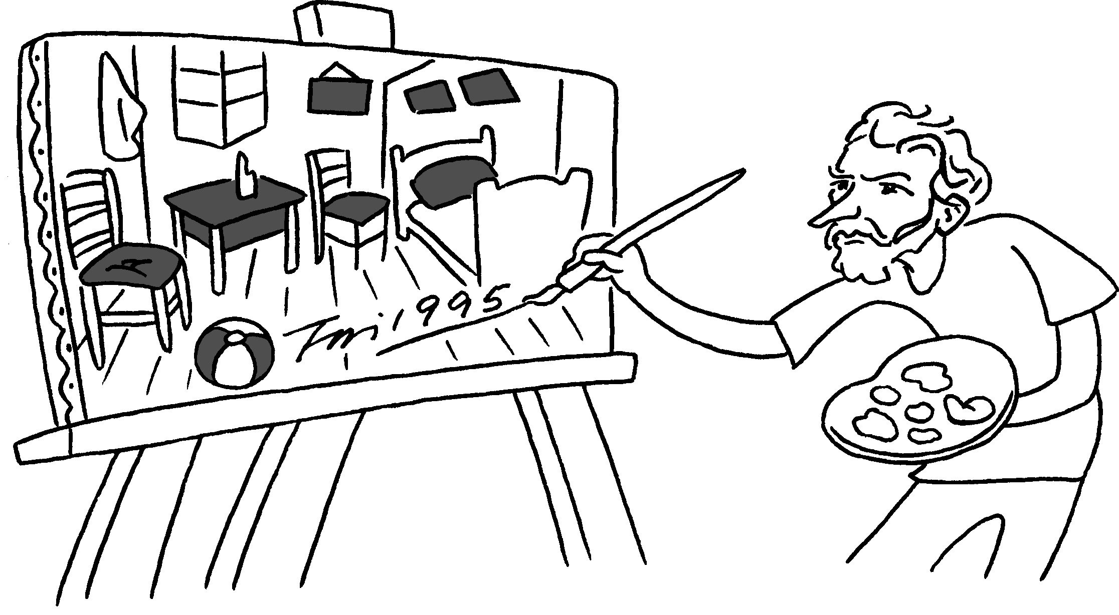
 | p __ __ __ computer games |  | p __ __ __ __ pictures
3 | 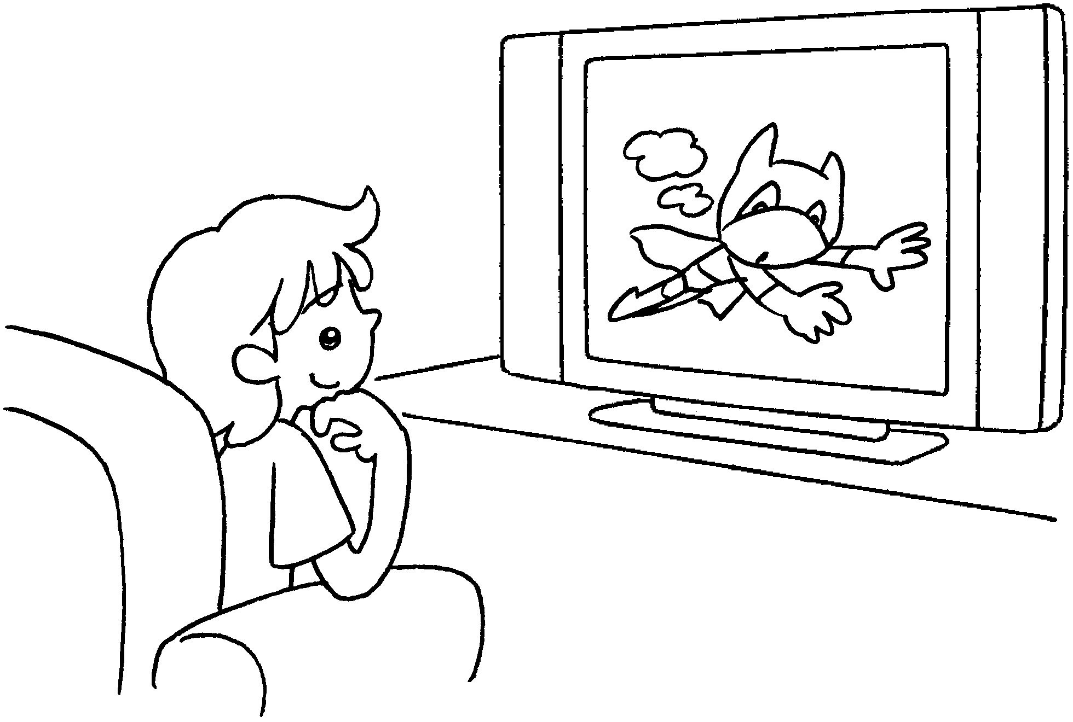 | 4 | 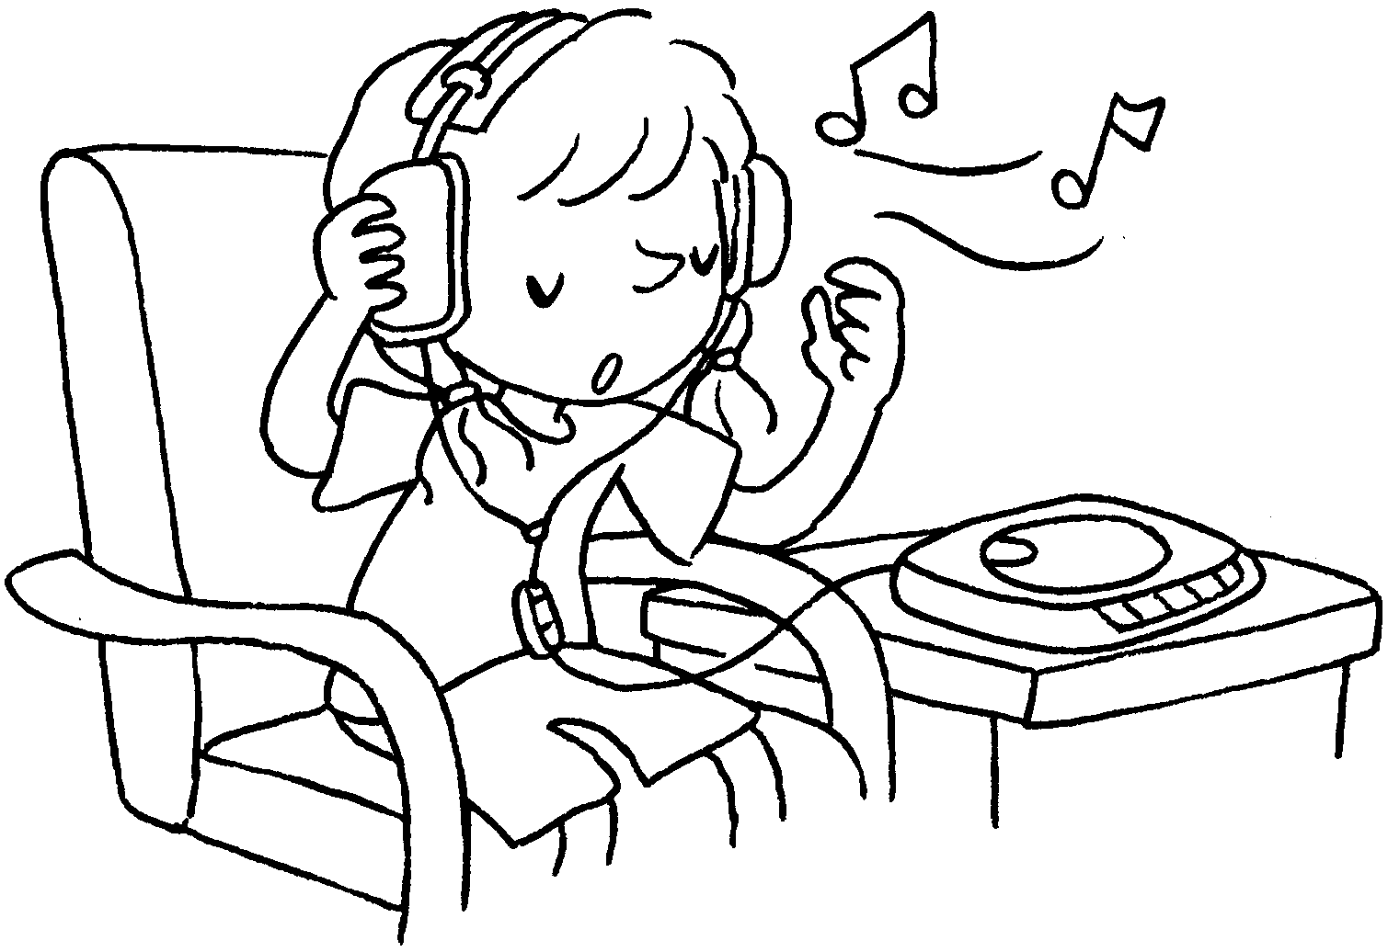
 | w __ __ __ __ TV |  | l __ __ __ __ __ to music
5 | 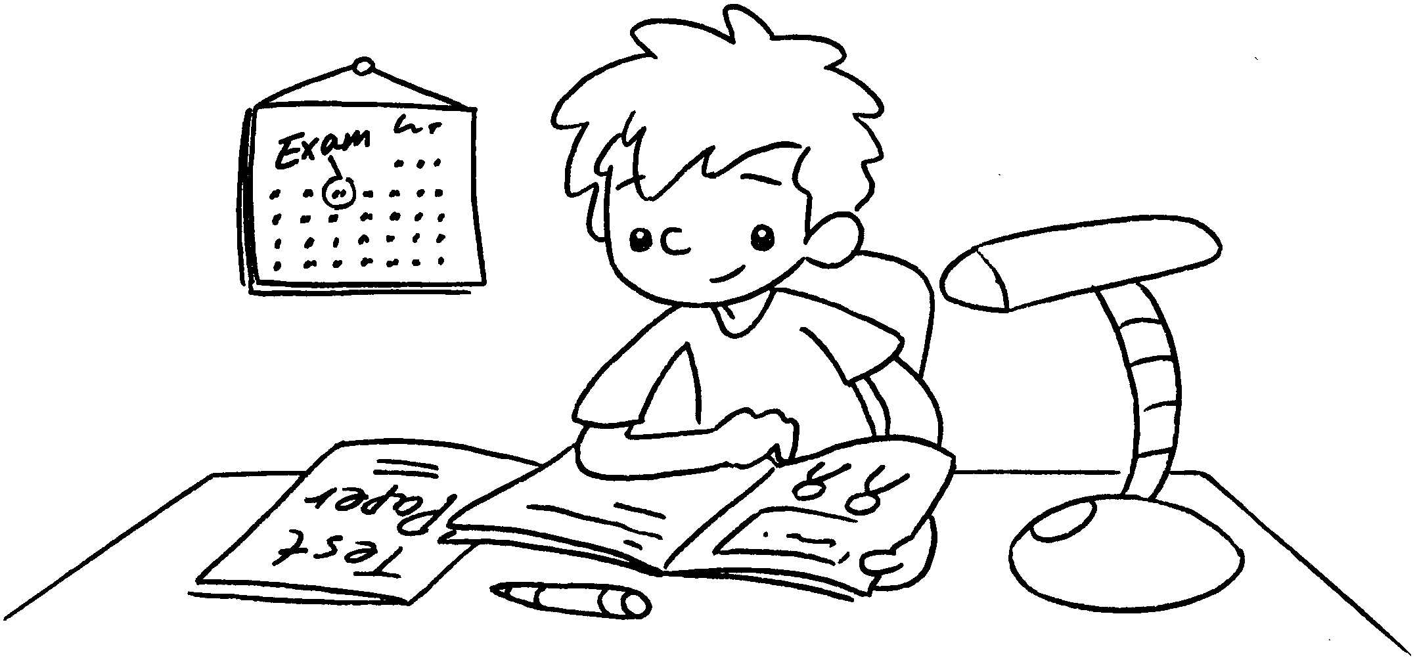 | 6 | 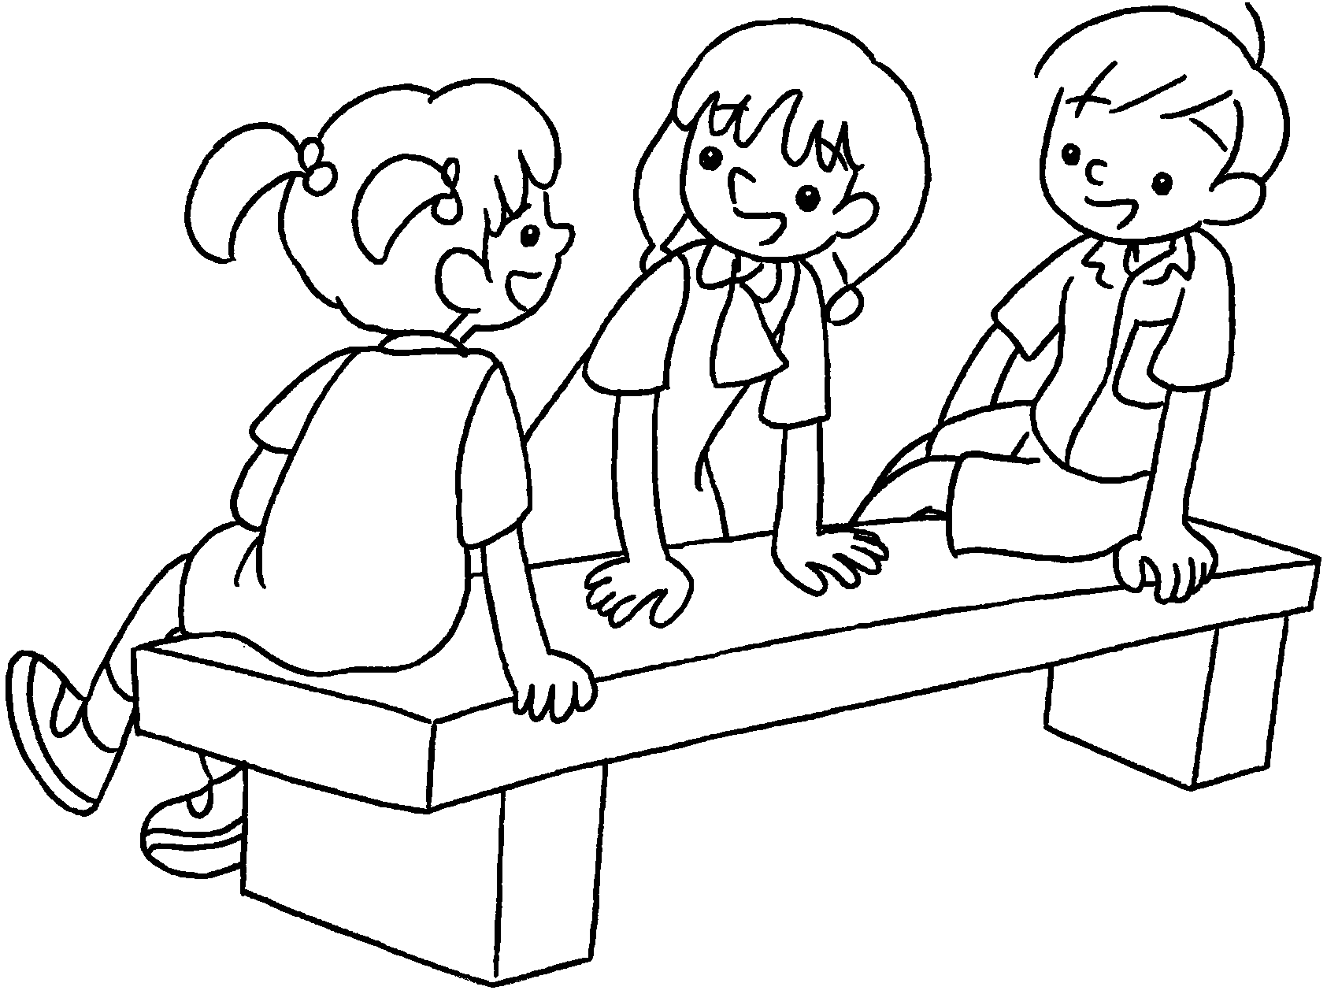
 | s __ __ __ __ for the exam |  | c __ __ __ with friends


Book 3B Chapter 4 Graded Worksheets
Worksheet 1⬇⬇
1 p l a y 2 p a i n t
3 w a t c h 4 l i s t e n
5 s t u d y 6 c h a t

