Look at the pictures and fill in the blanks.

1 | 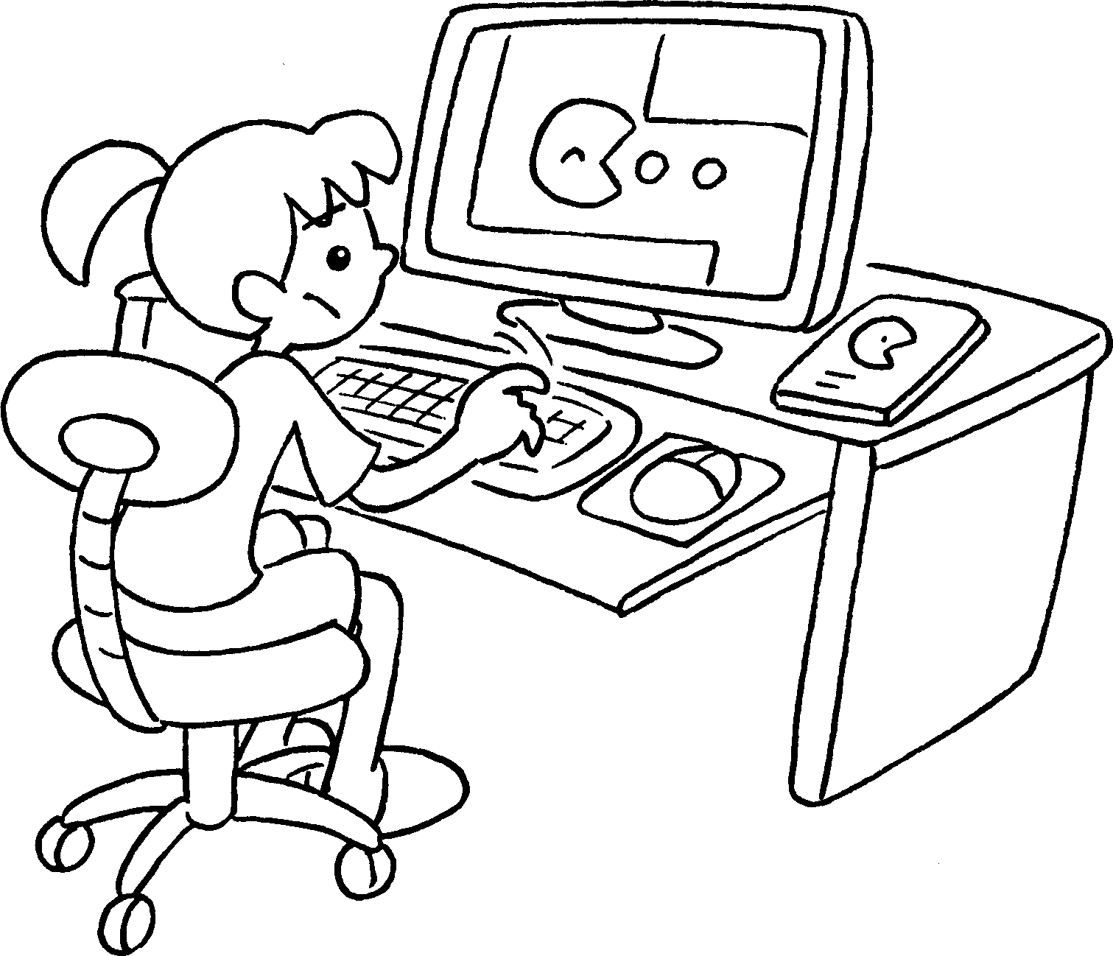 | 2 | 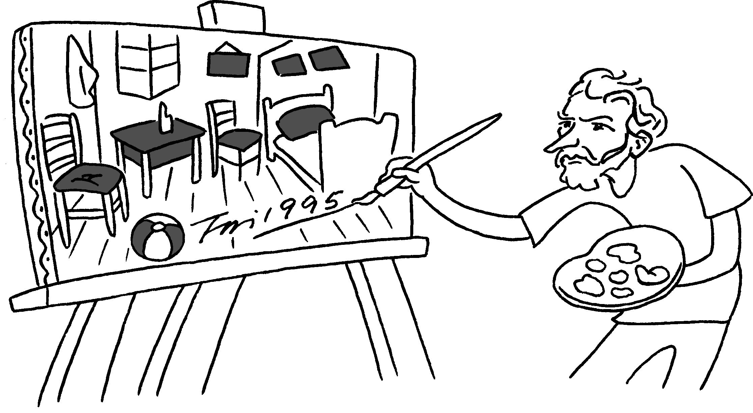
 | p computer games |  | p pictures
3 | 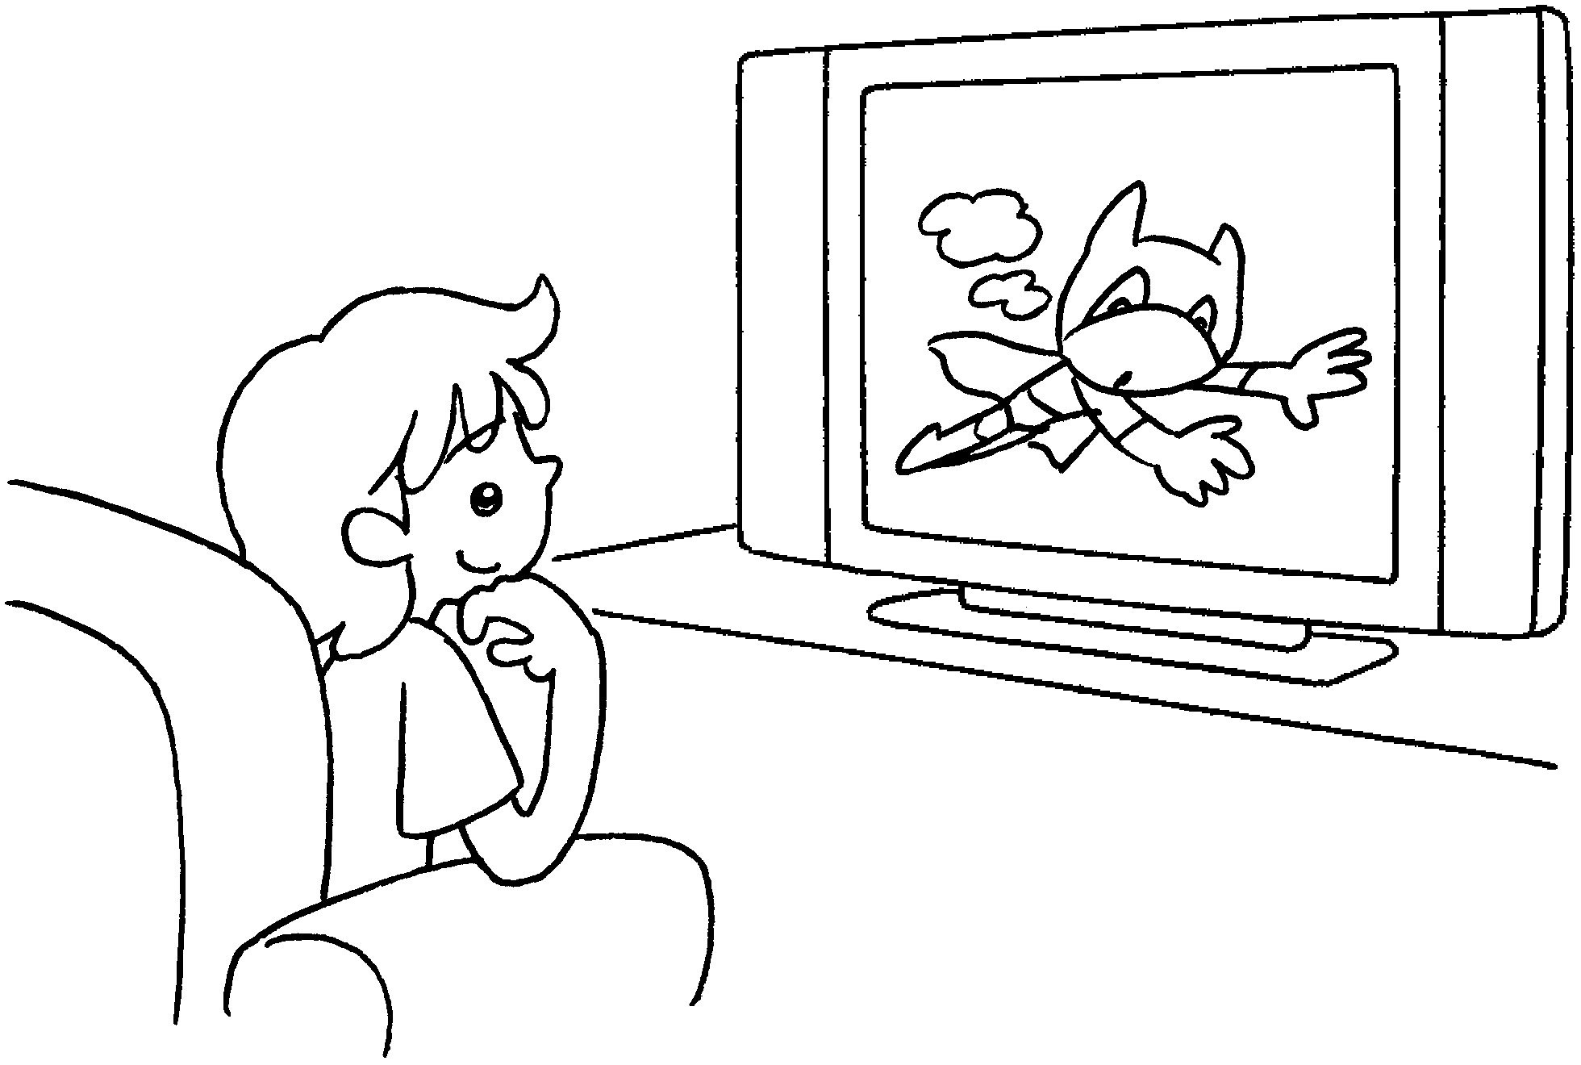 | 4 | 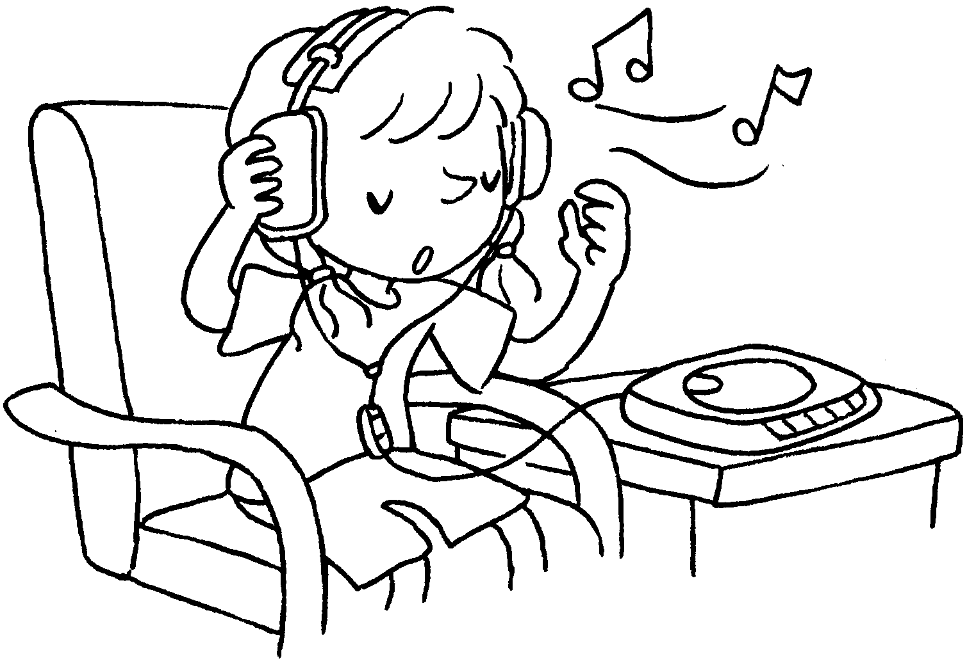
 | w TV |  | l music
5 | 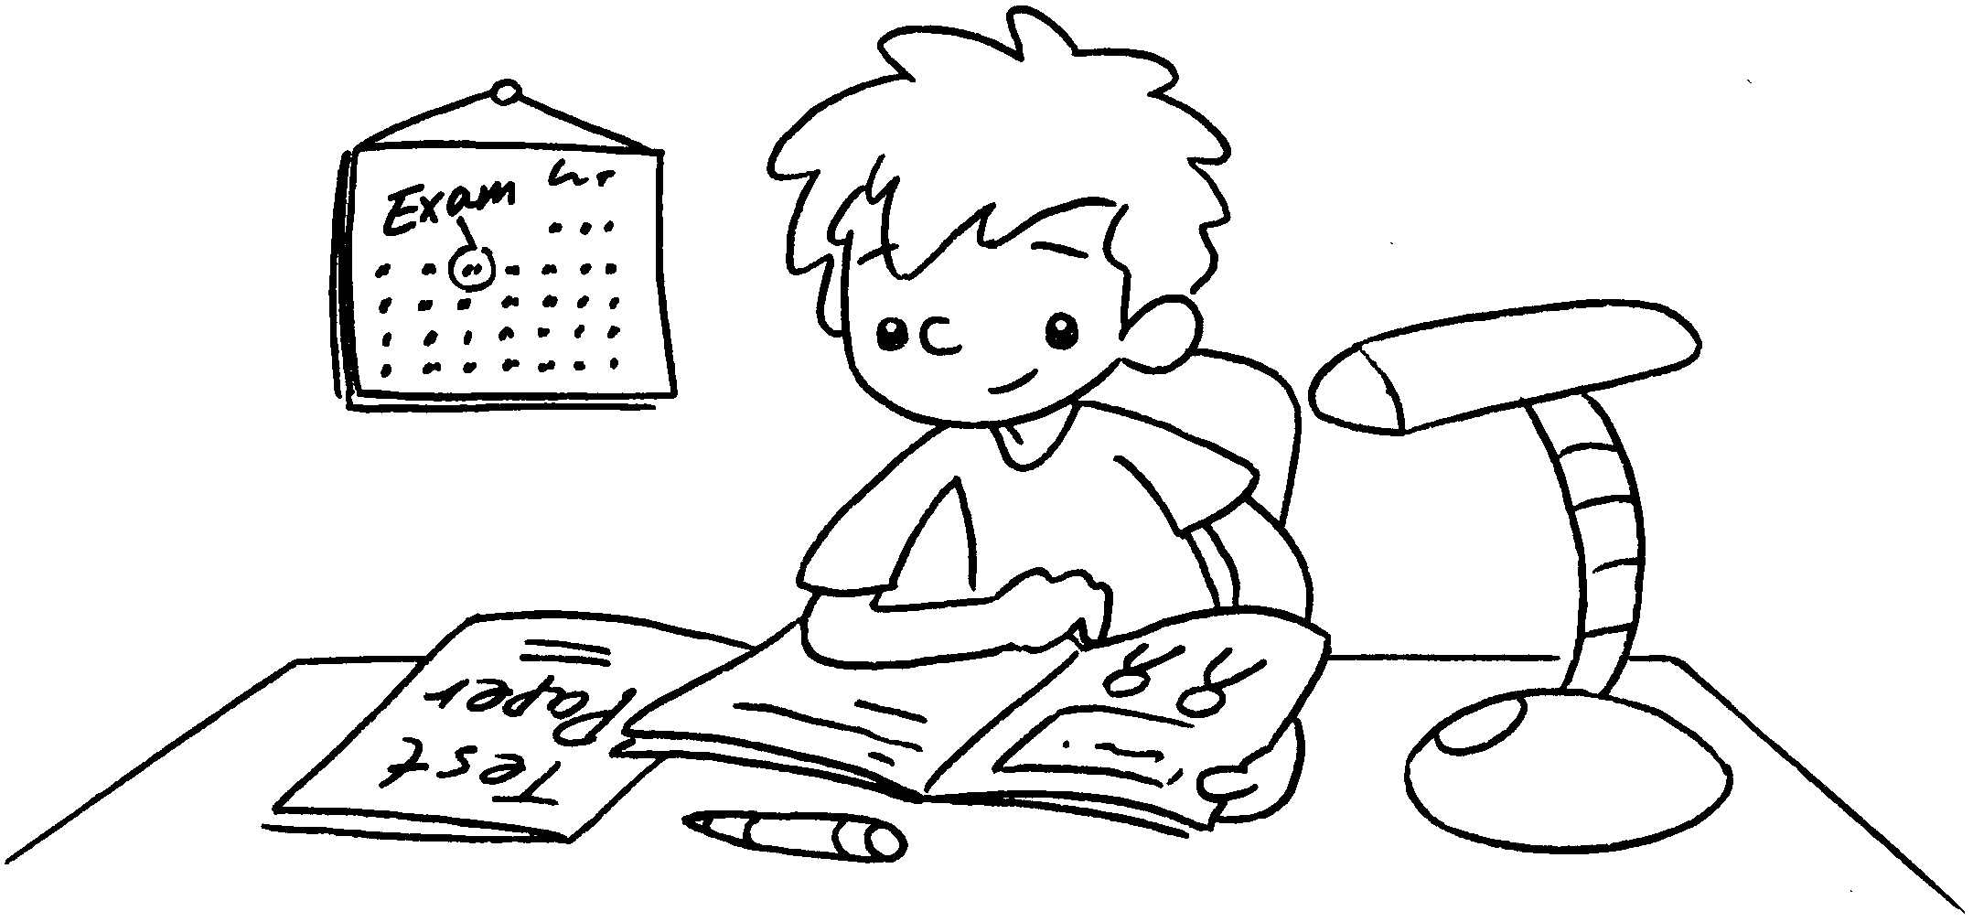 | 6 | 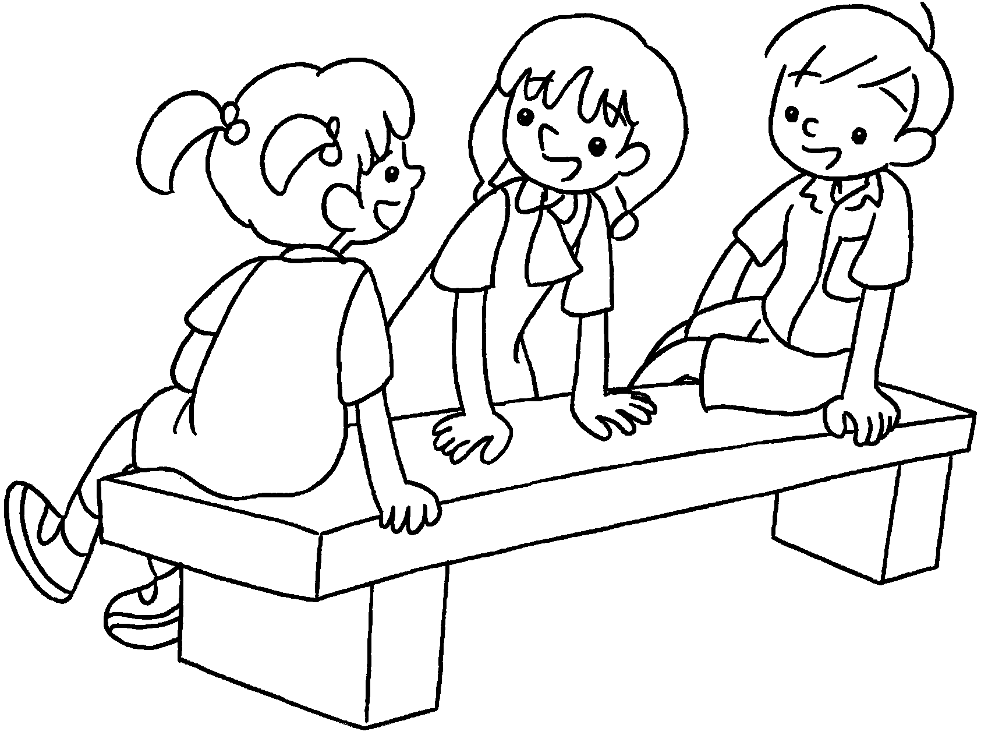
 | s the exam |  | c friends


Book 3B Chapter 4 Graded Worksheets
Worksheet 1⬇⬇⬇
1 play 2 paint
3 watch 4 listen to
5 study for 6 chat with

