Circle the correct answers.
1  A  B | 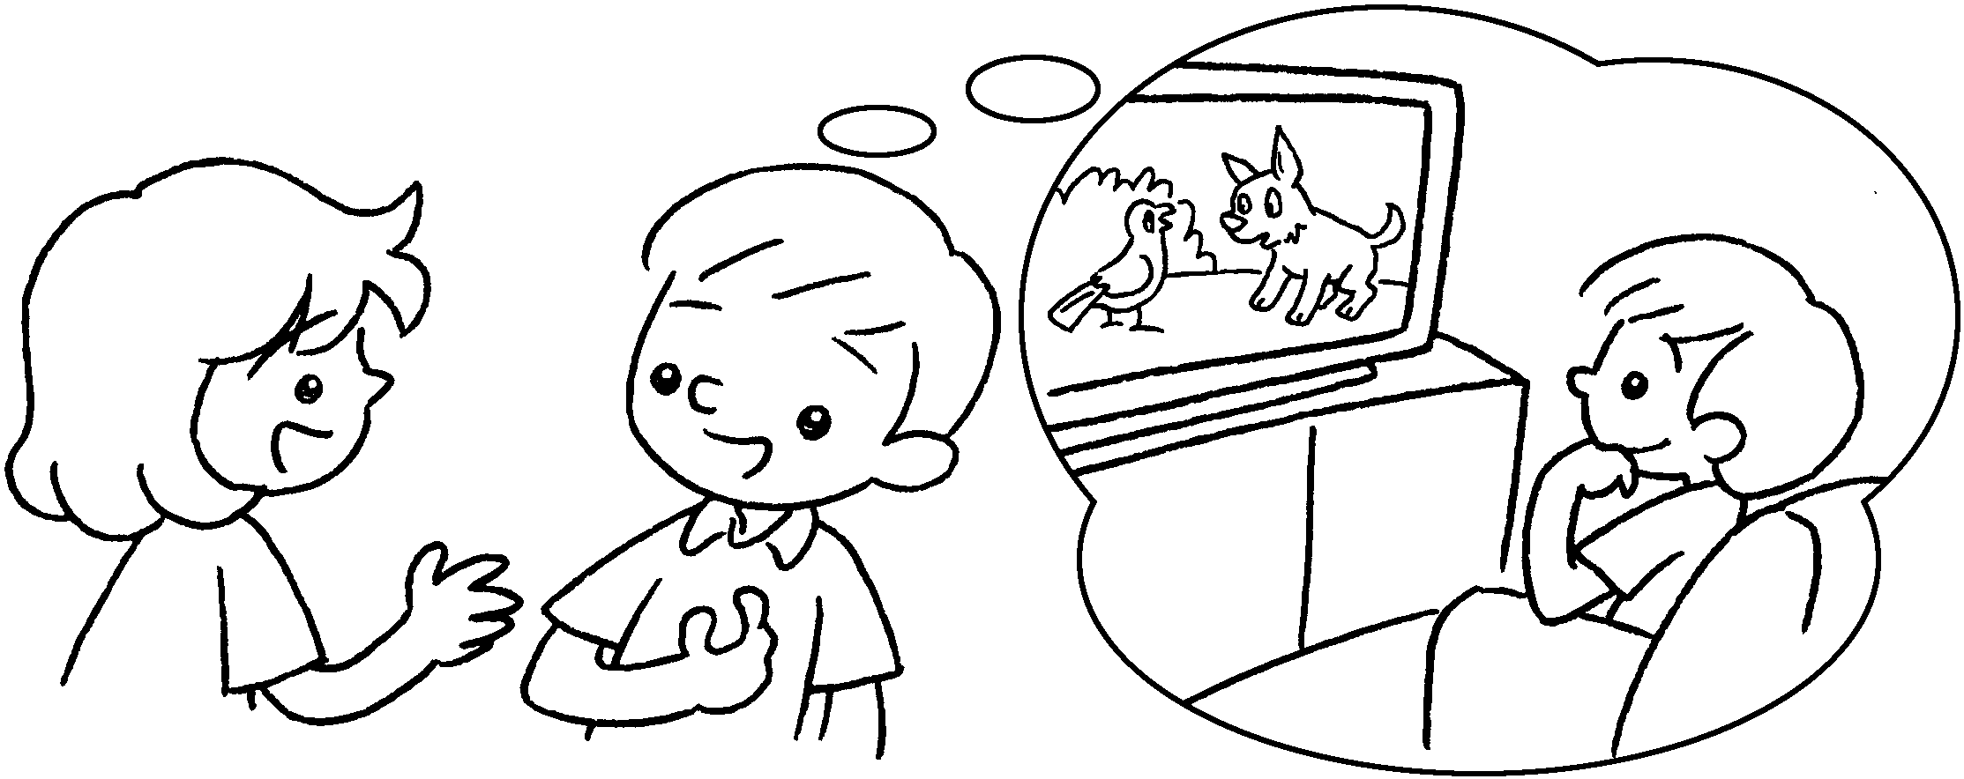 | A : What did you do at the  weekend?  B : I ( watched / watch )  cartoons.
2  A  B | 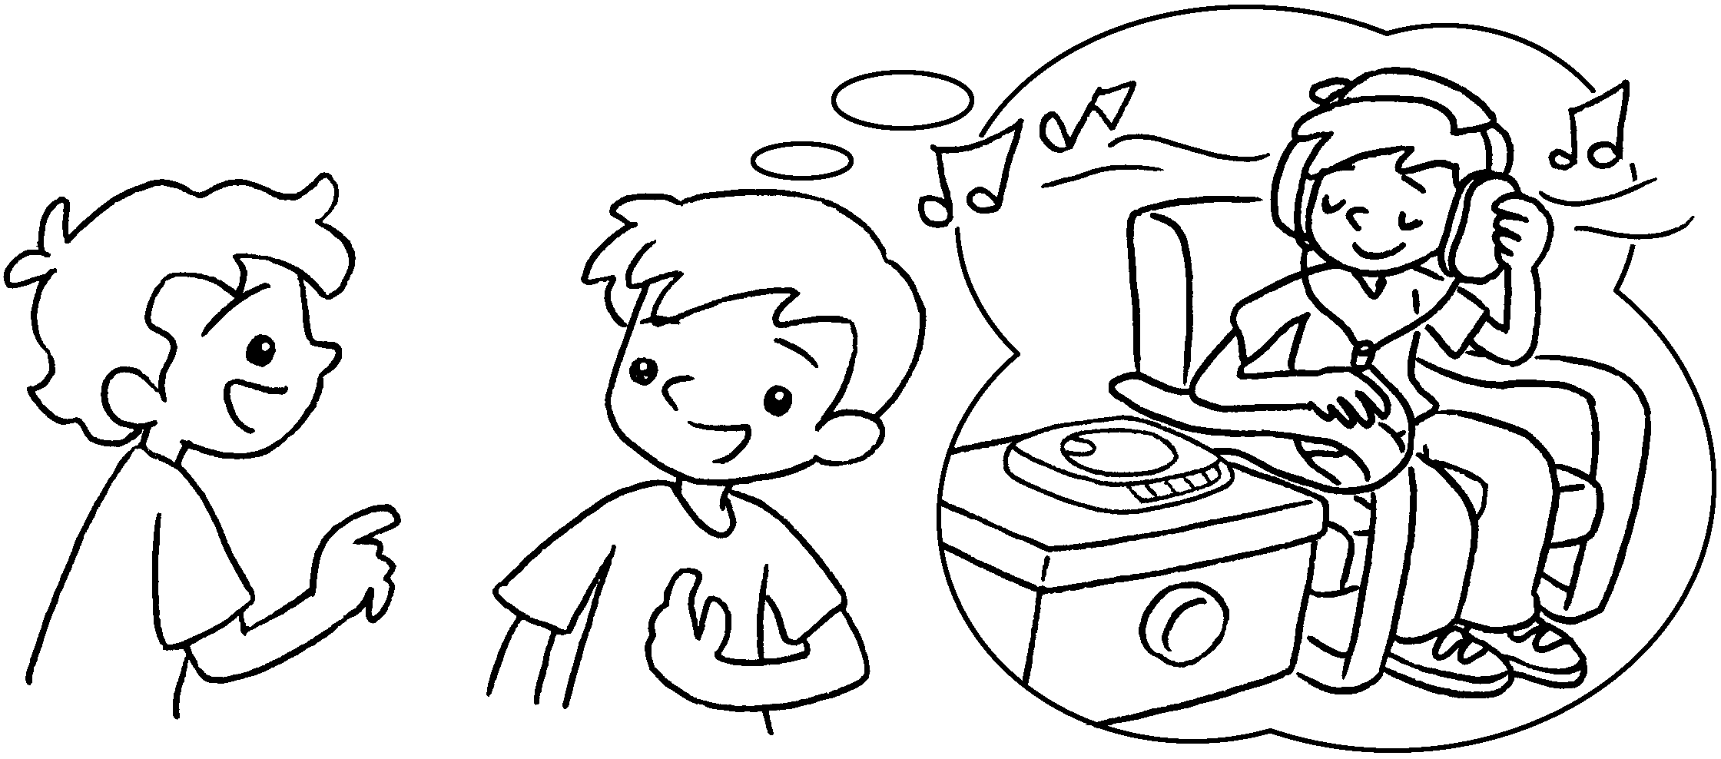 | A : What ( do / did ) you  ( did / do ) last night?  B : I listened to music.
3  A  B | 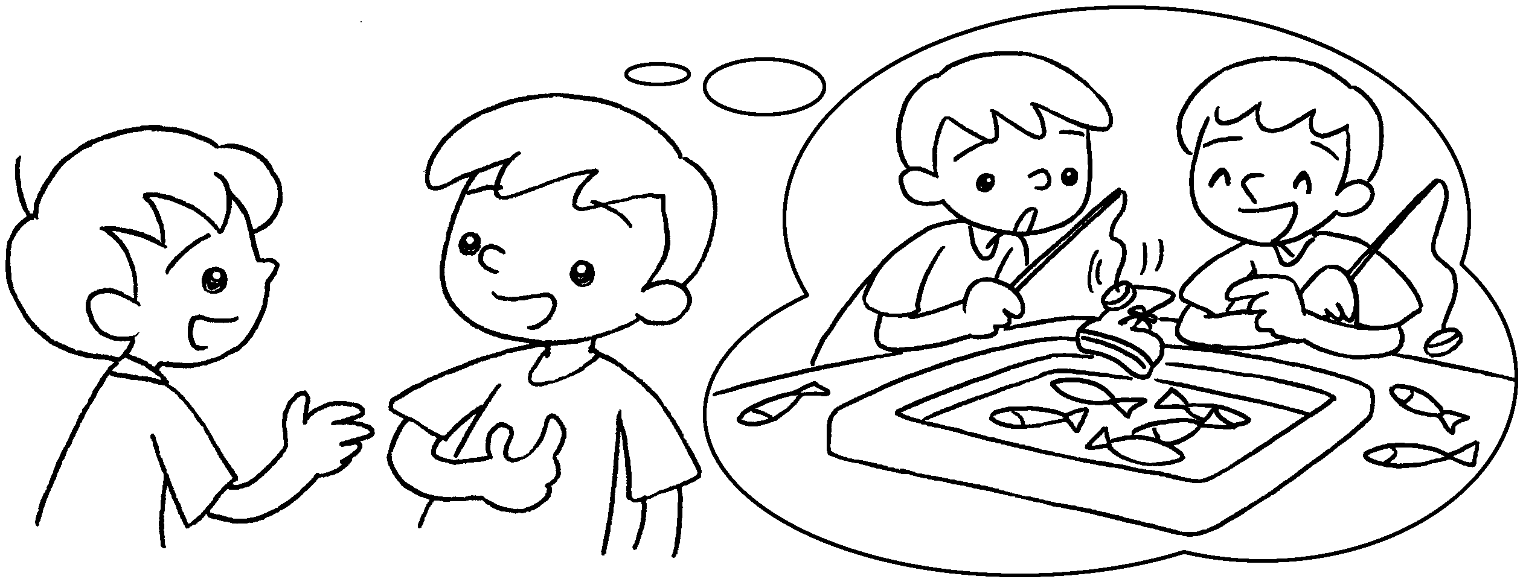 | A : What ( did / do ) you  ( did / do ) yesterday?  B : I ( played / play ) games  with my brother.
4  A  B | 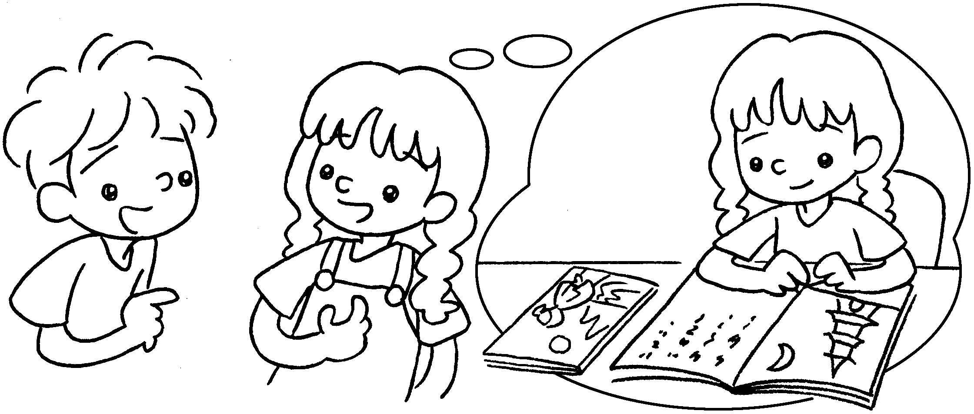 | A : What ( do / did ) you  ( did / do ) last Monday?  B : I ( study / studied ) for  the test.
5  A  B | 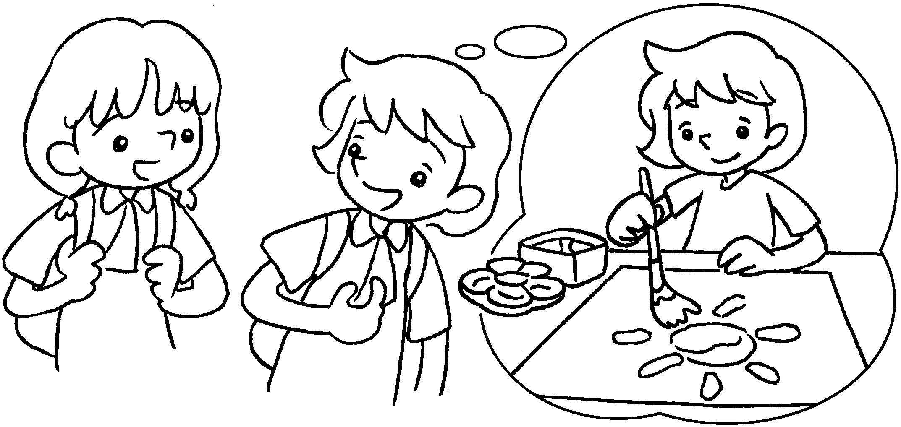 | A : What ( did / do ) you  ( do / did ) last night?  B : I ( paint / painted ) a  picture.


Book 3B Chapter 4 Graded Worksheets
Worksheet 2⬇
- ( watched / watch )
- ( do / did ) ( did / do )
3 ( did / do ) ( did / do )
( played / play )
4 ( do / did ) ( did / do )
( study / studied )
5 ( did / do ) ( do / did )
( paint / painted )

