What did the children do? Finish the questions and answers.

do listen paint play study watch

1  A  B | 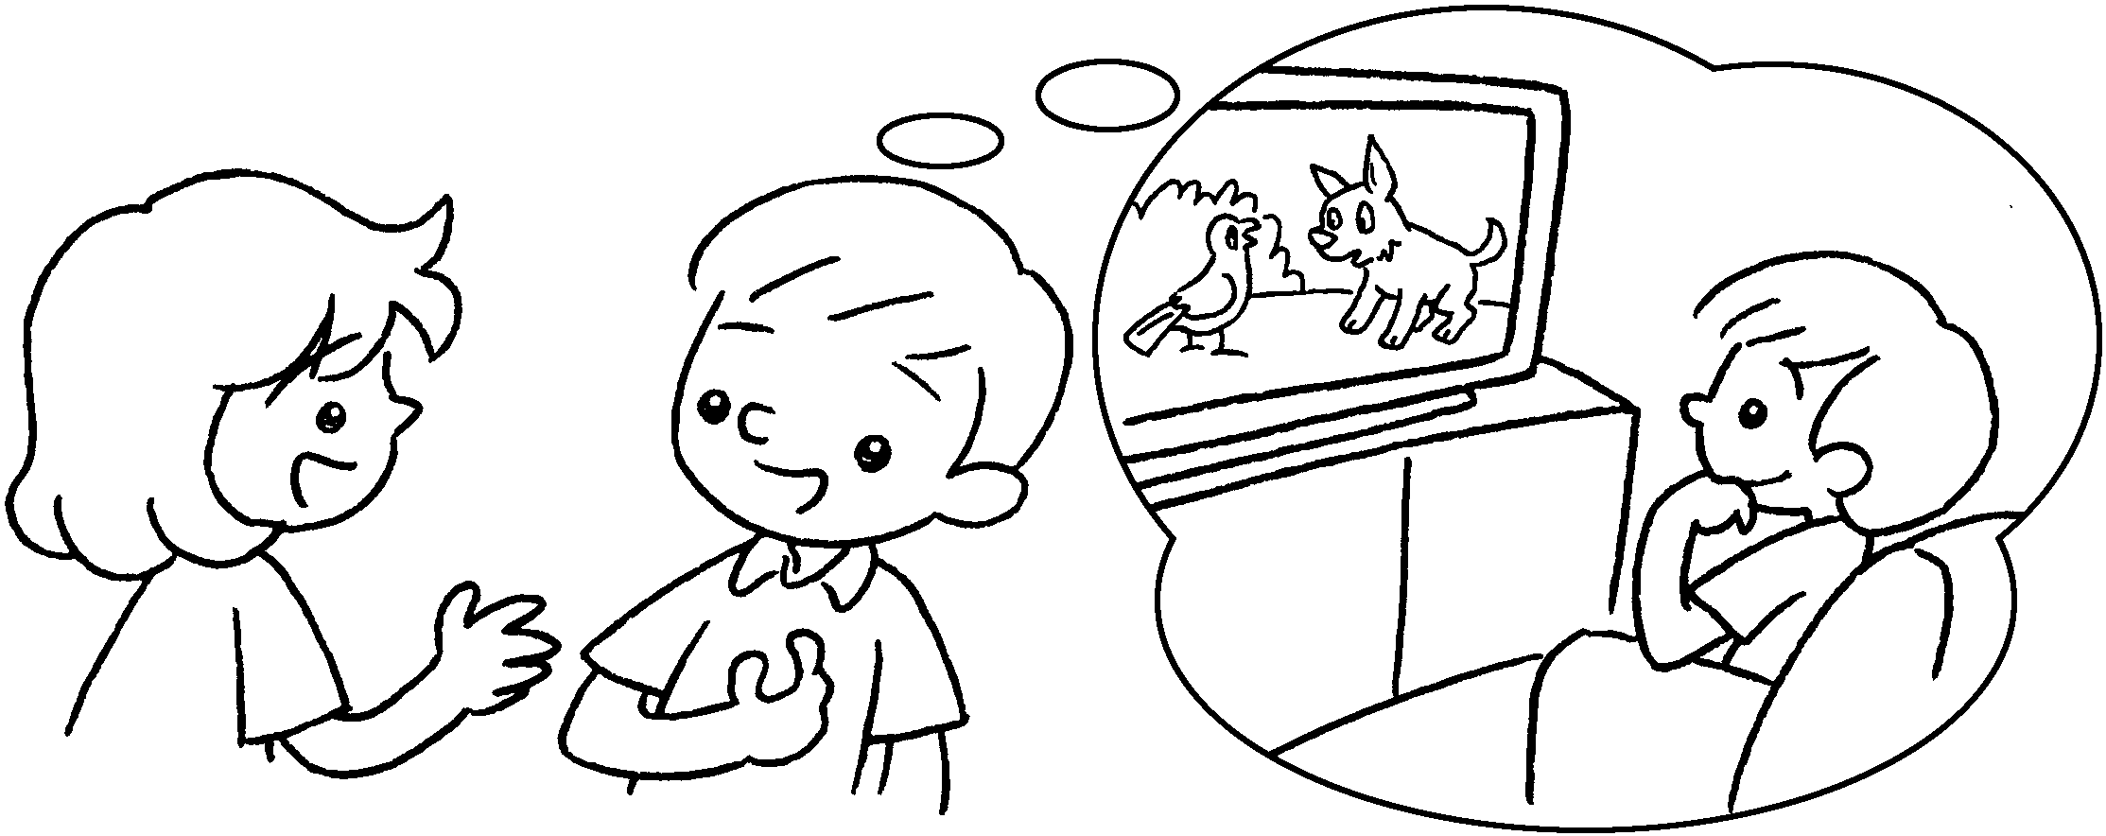 | A : What did you do at the  weekend?  B : I  cartoons.
2  A  B | 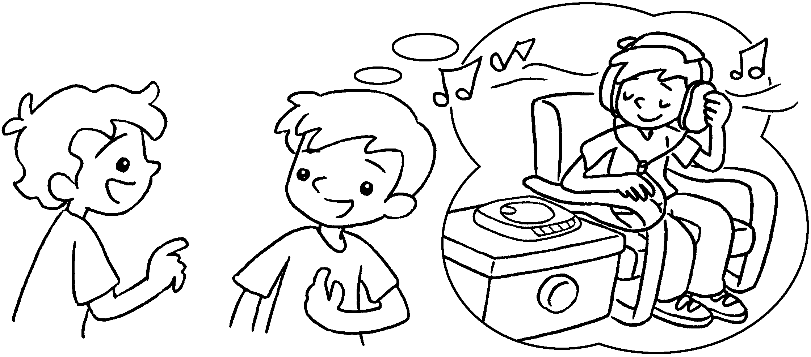 | A : What did you do last night?  B : I to music.
3  A  B | 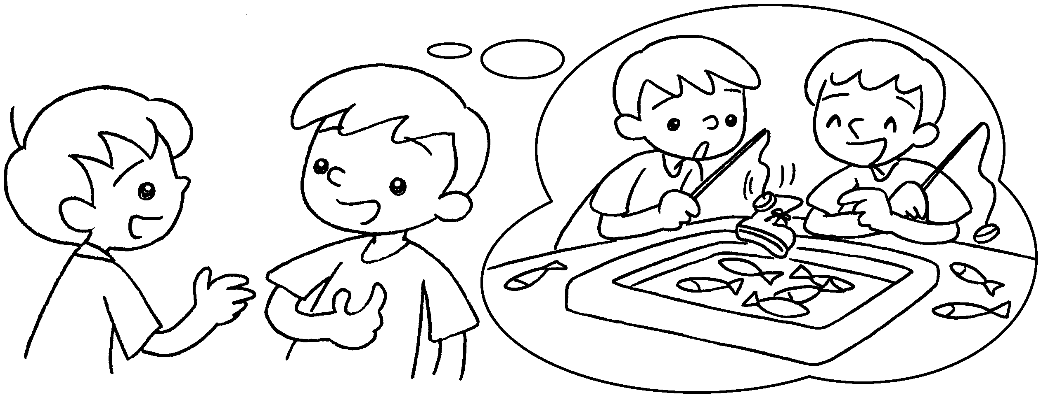 | A : What you do yesterday?  B : I games  with my brother.
4  A  B | 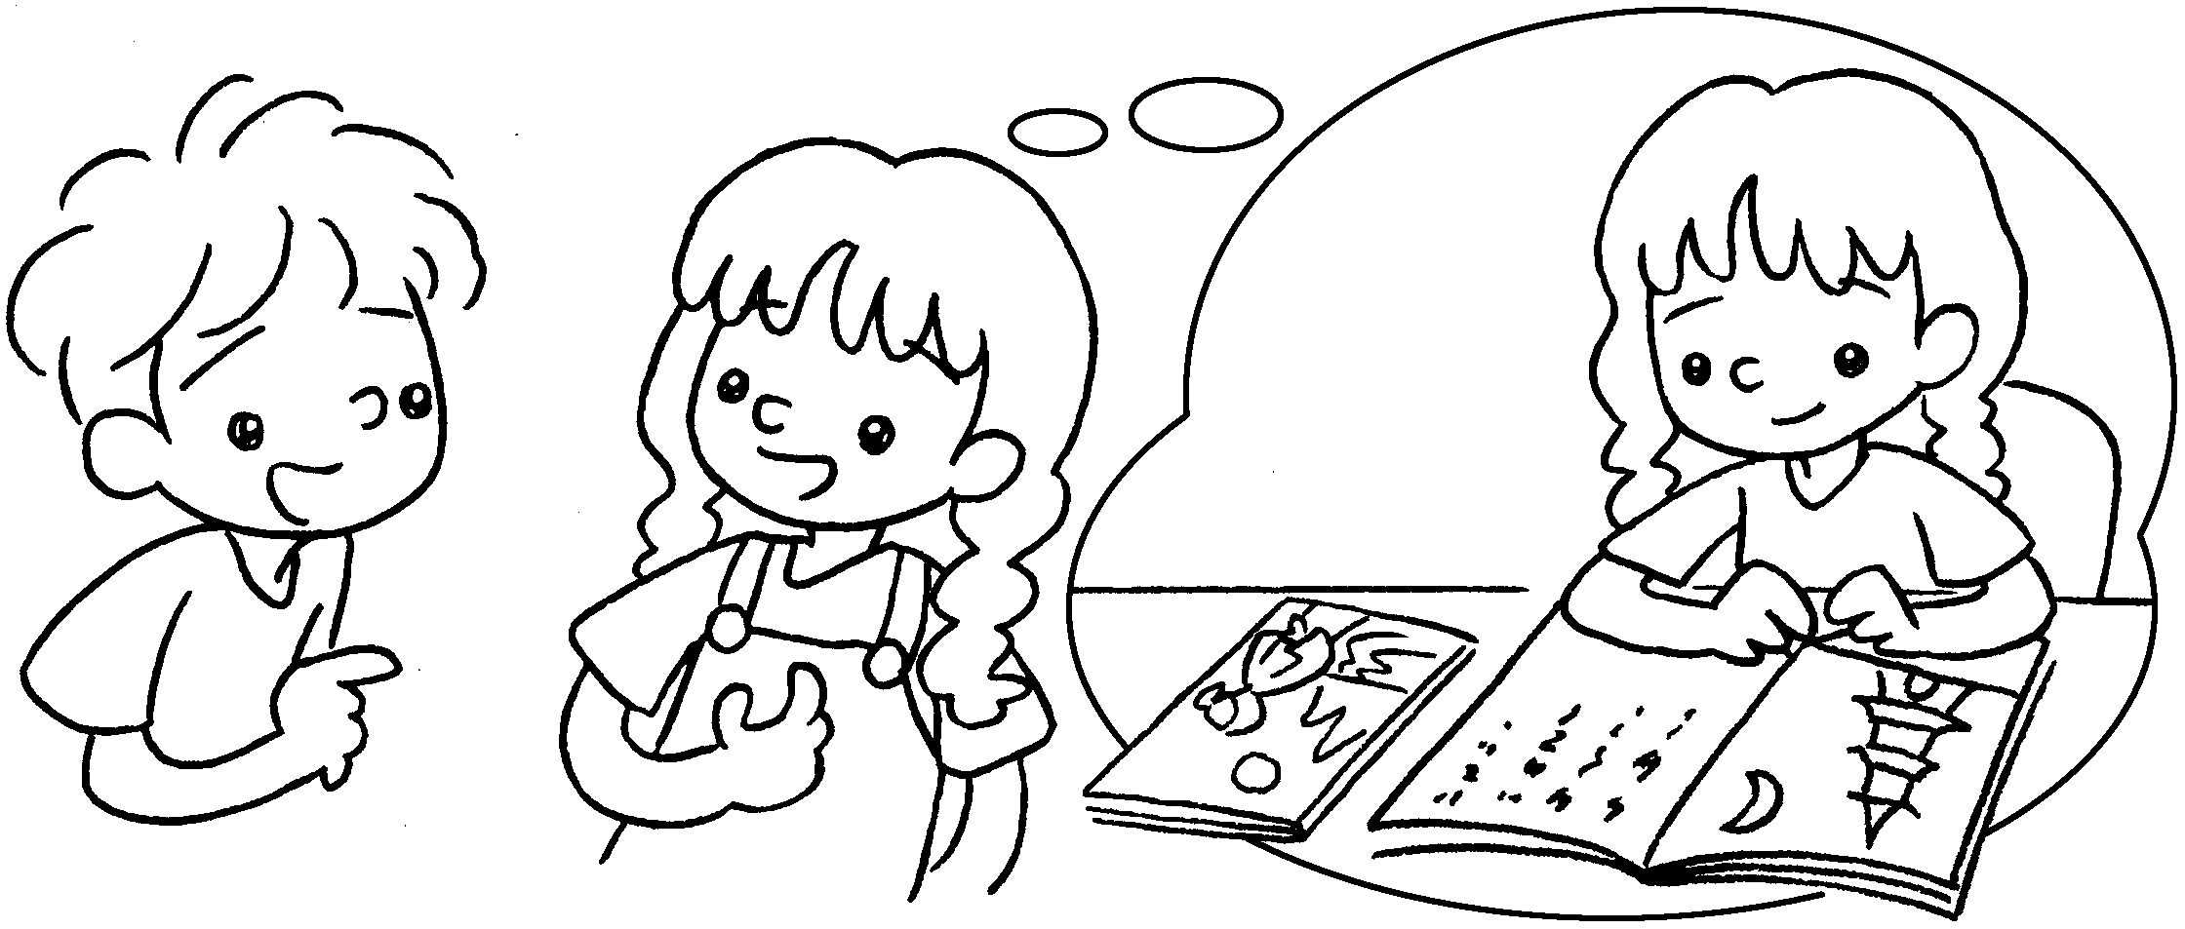 | A : What you  last Monday?  B : I for the test.
5  A  B | 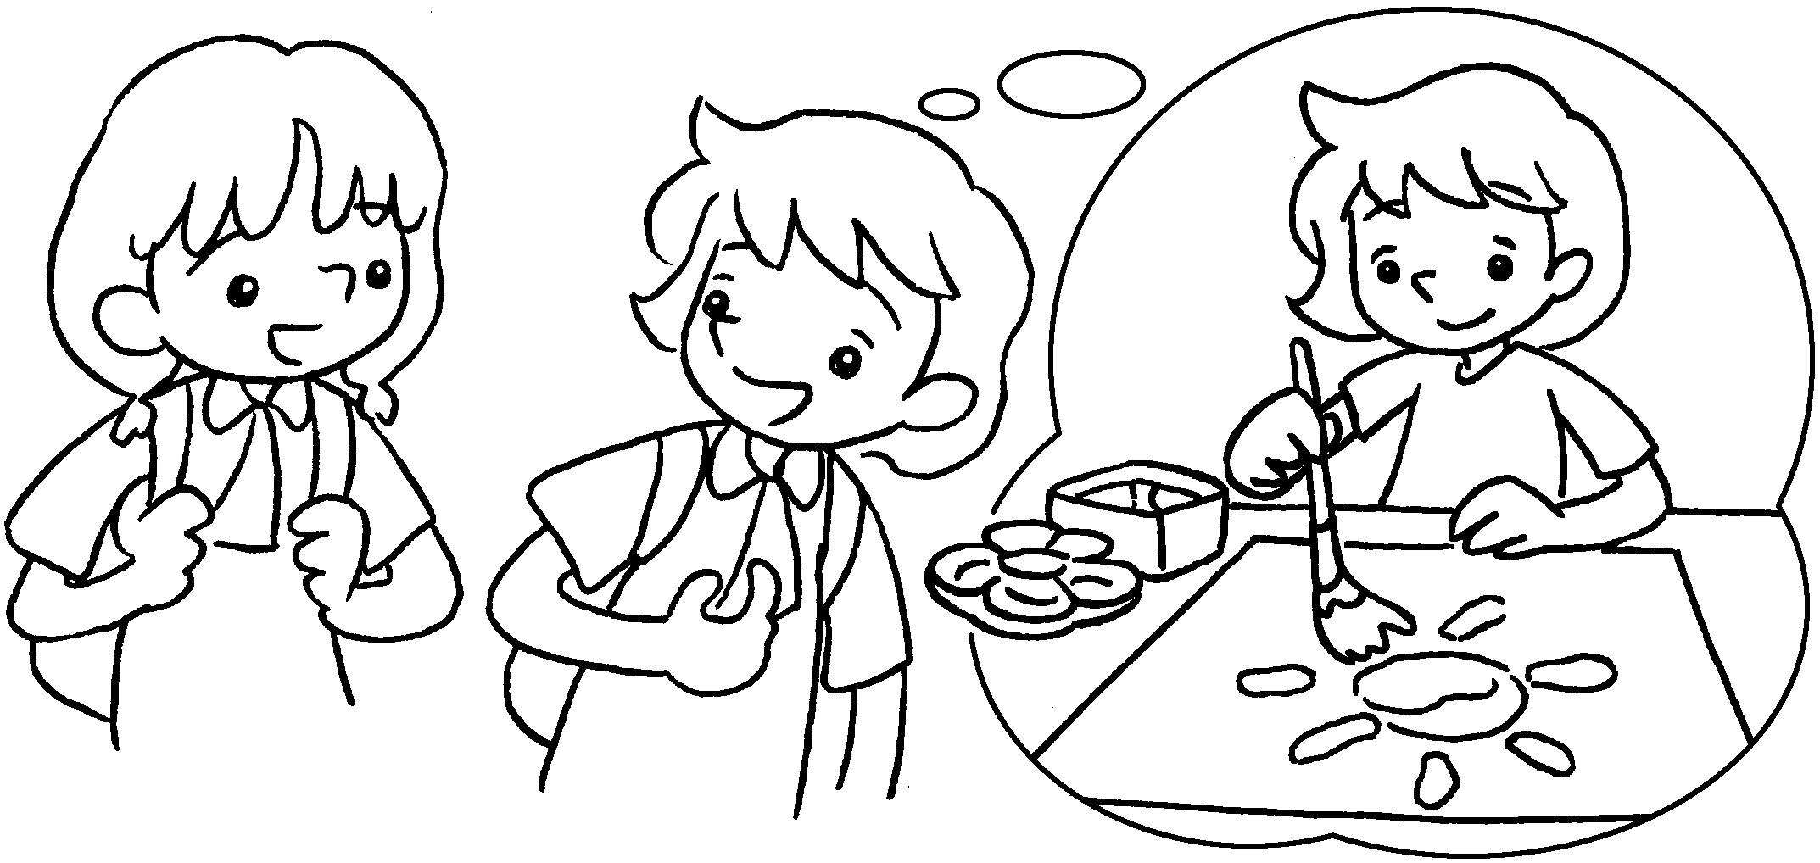 | A : What you  last night?  B : I a picture.


Book 3B Chapter 4 Graded Worksheets
Worksheet 2⬇⬇⬇
- watched
- listened
- did
played
4 did do
studied
5 did do
painted

