Fill in the blanks. Use the simple past tense.
so
didn’t

1 | 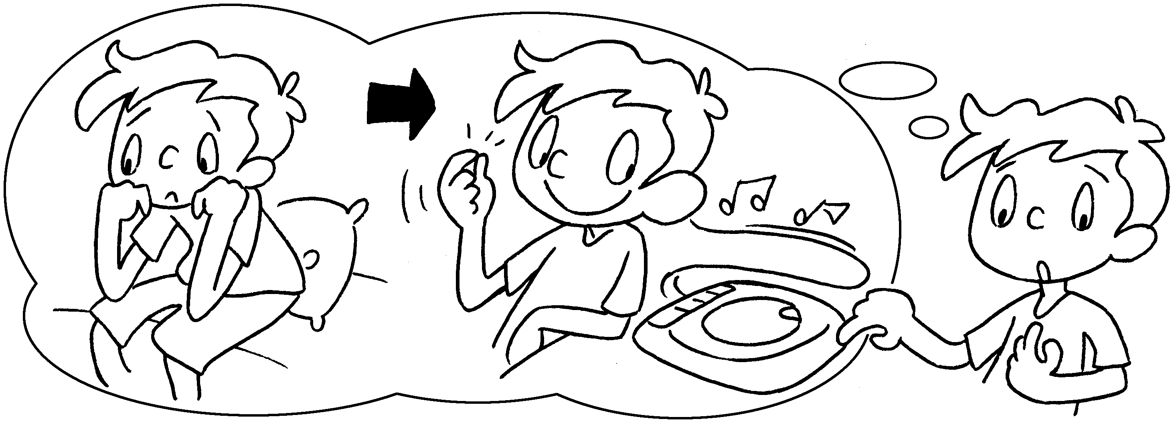 | I was bored  I ( listen ) to CDs.
2 | 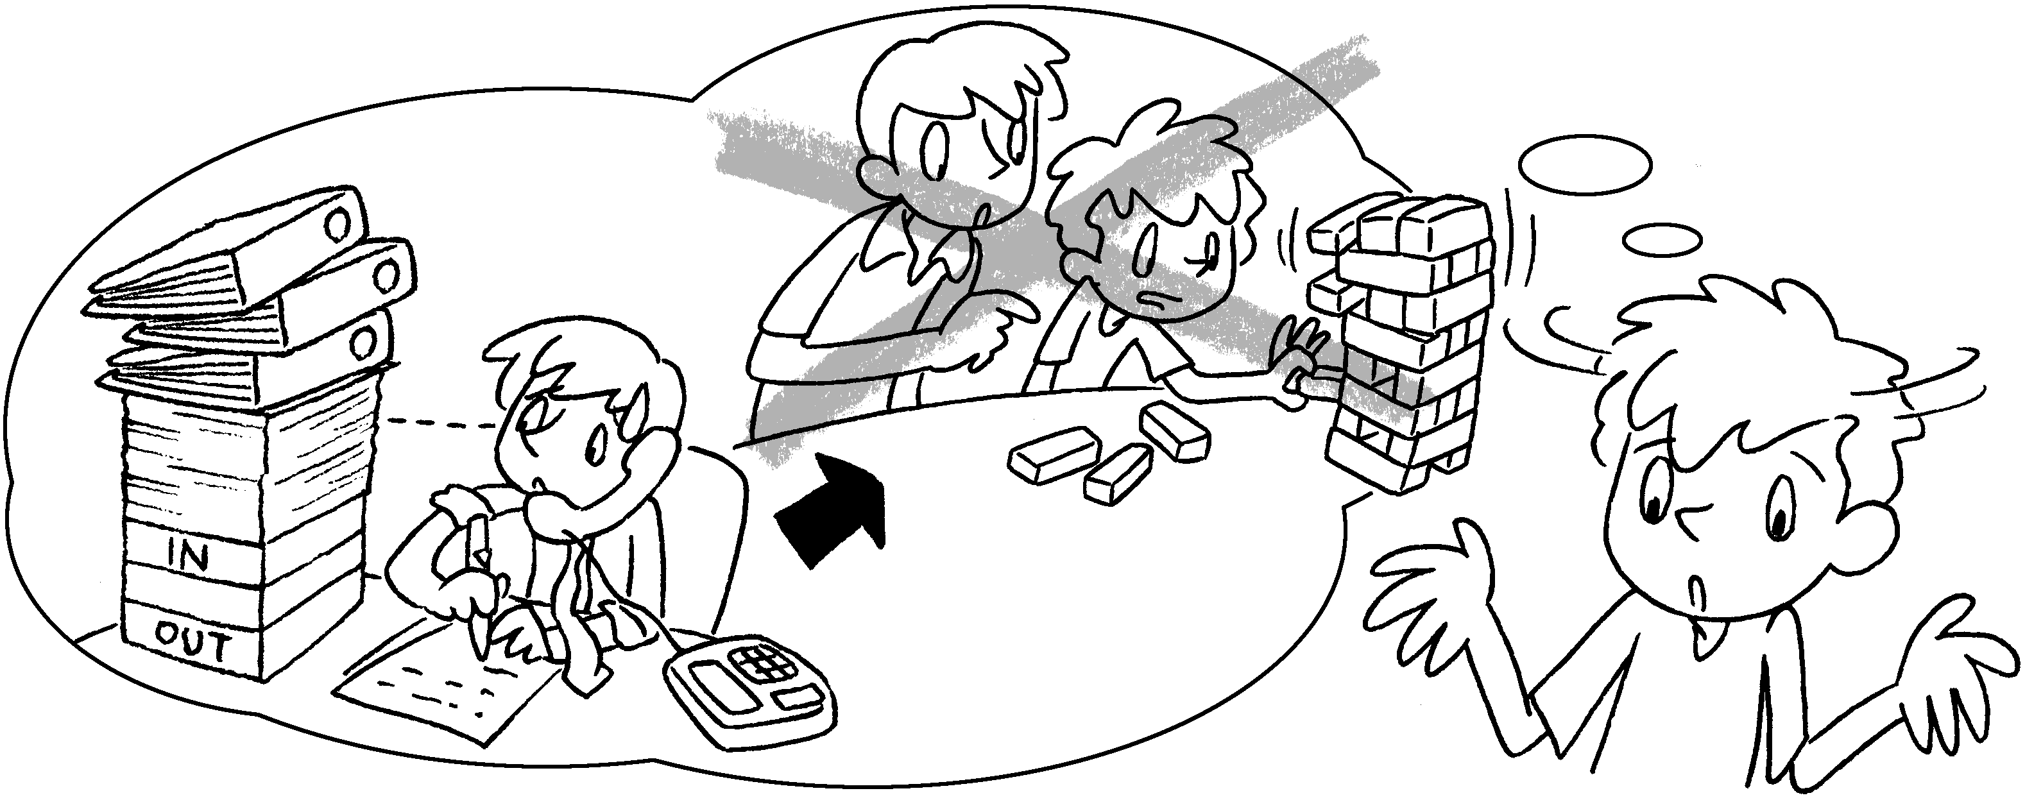 | My brother was busy so he  ( play )  with me.
3 | 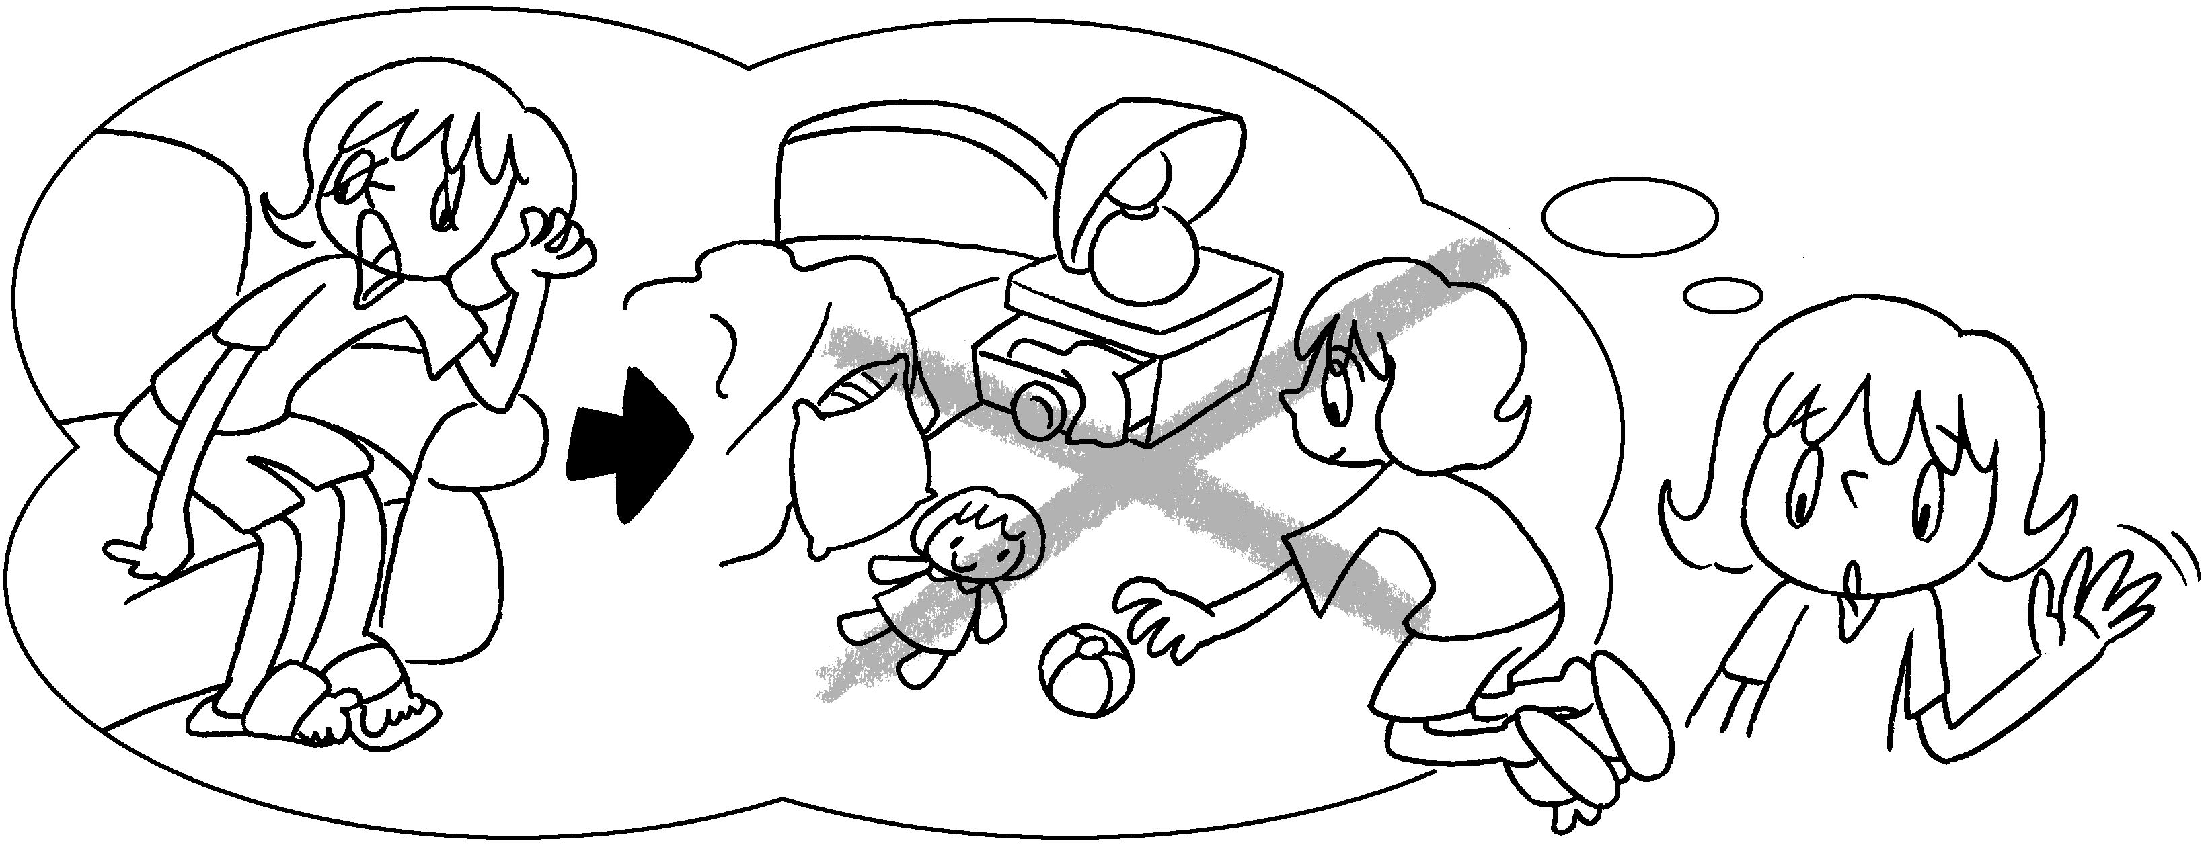 | I was tired so I  ( tidy )  my room.
4 | 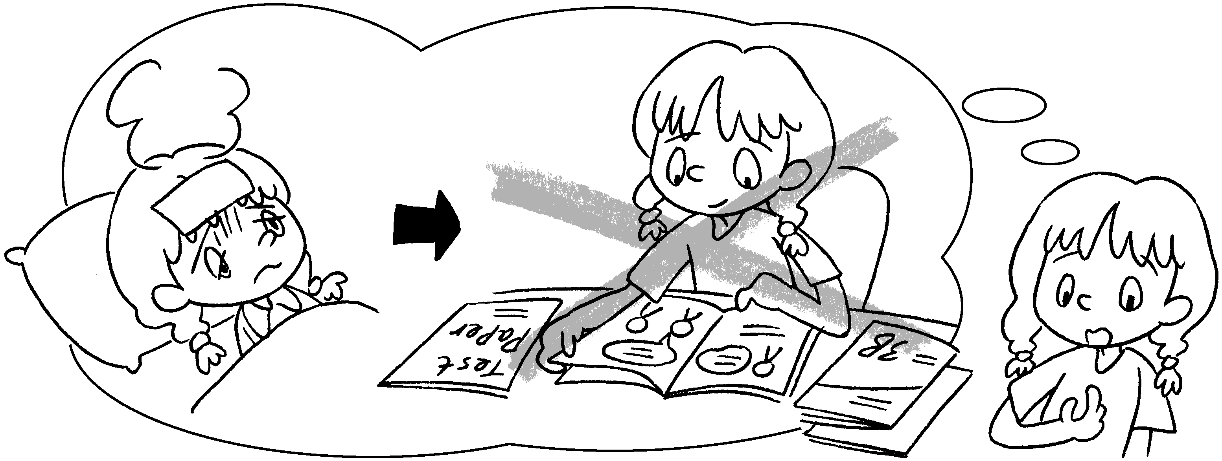 | I was sick I  ( study ) for the exam.
5 | 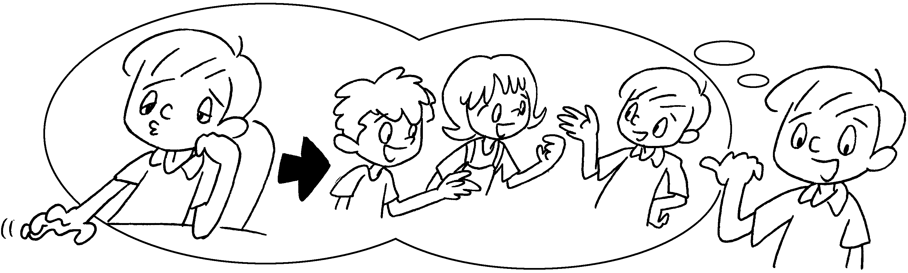 | I was bored I  ( chat ) with  my friends.


Book 3B Chapter 4 Graded Worksheets
Worksheet 3⬇
1 so listened
2 didn’t play
3 didn’t tidy
4 so didn’t study
5 so chatted

