Fill in the blanks. Use the simple past tense.
chatlisten play studytidy

1 | 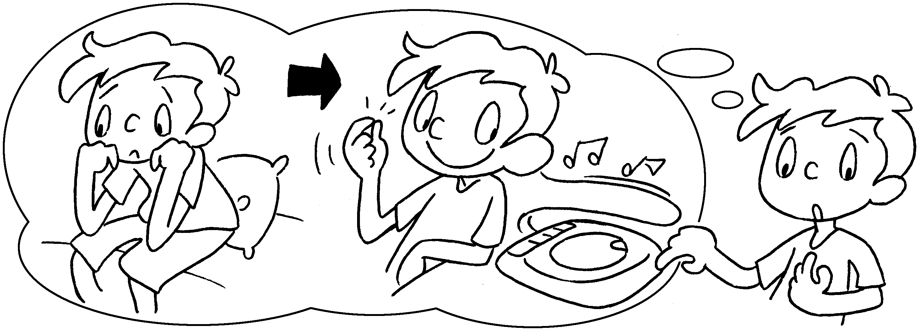 | I was bored  I to CDs.  so
2 | 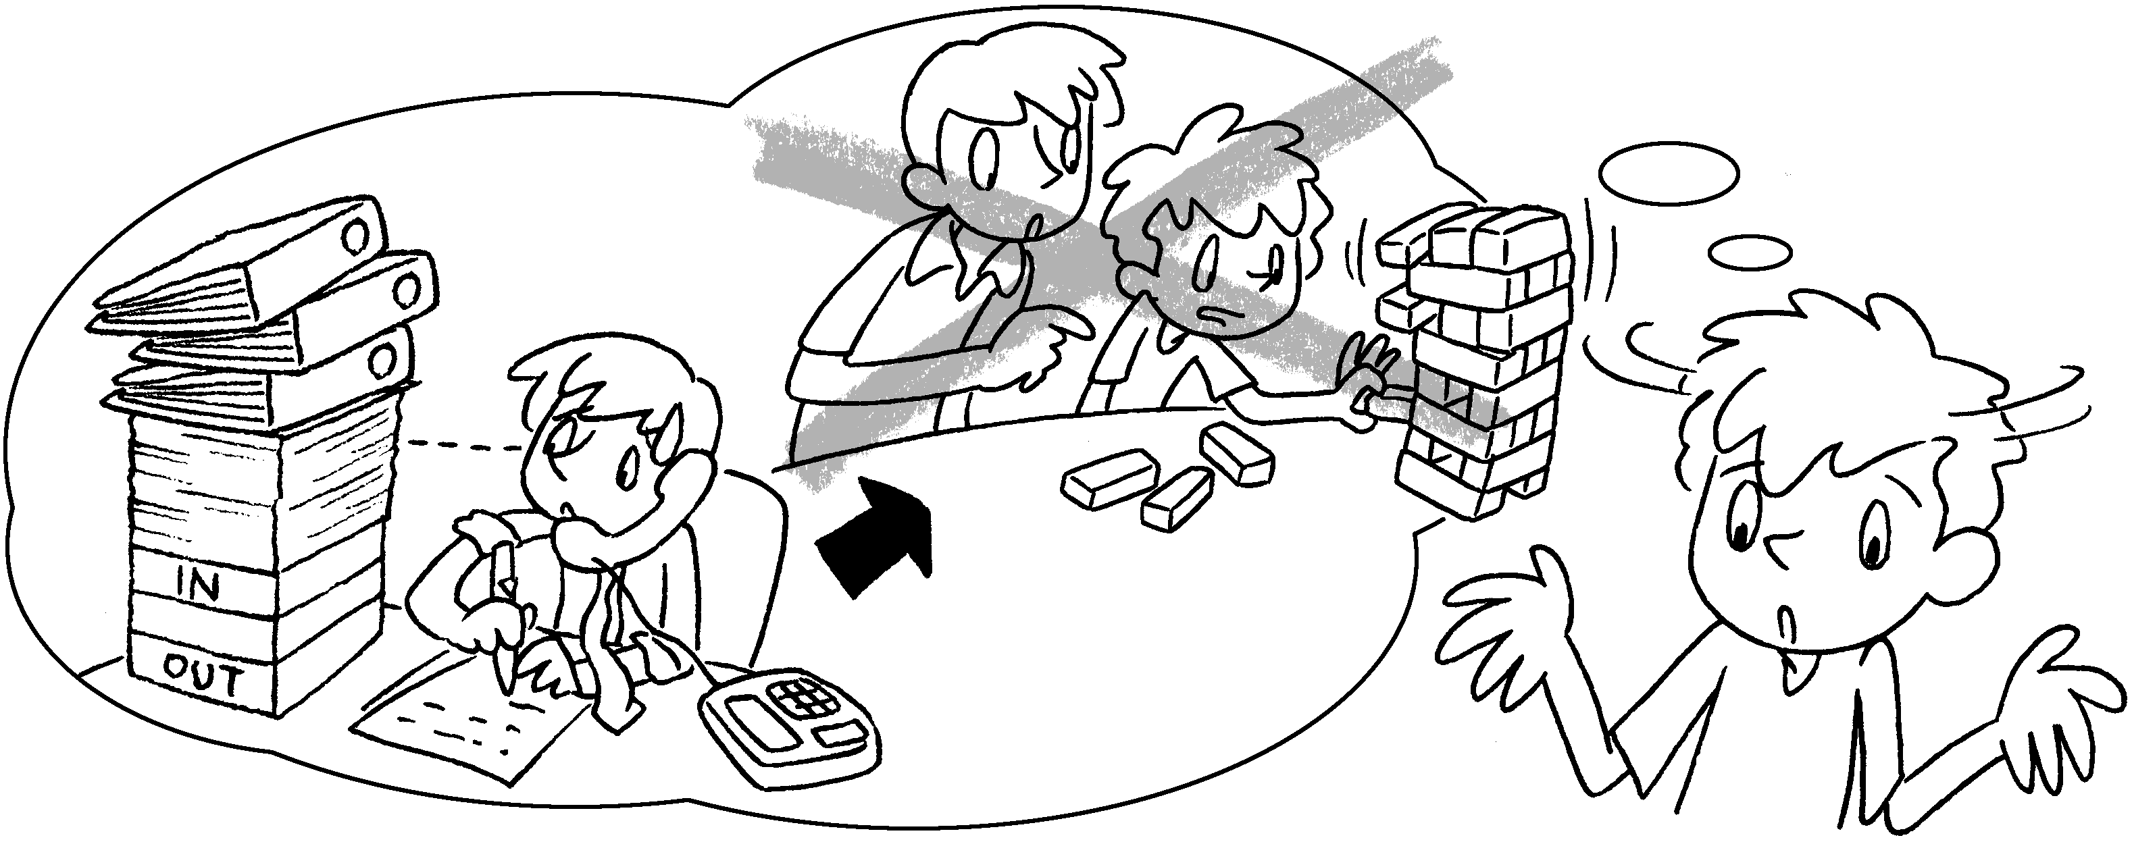 | My brother was busy so he  with me.  didn’t
3 | 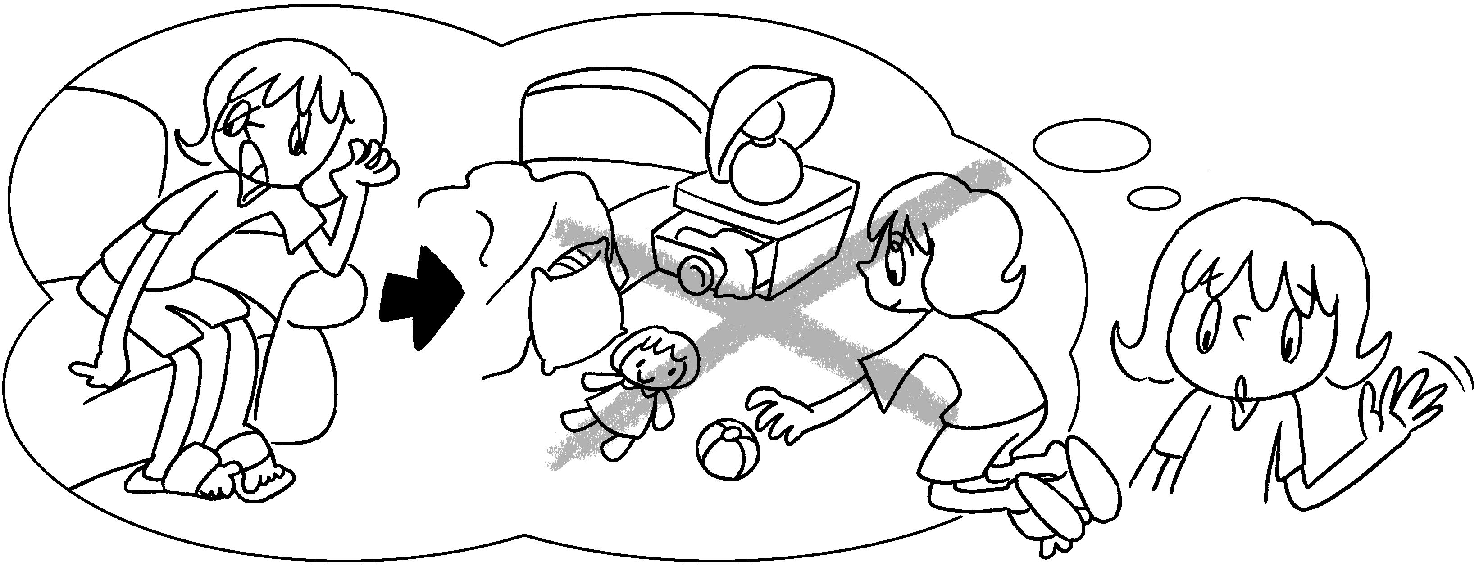 | I was tired so I  my room.
4 | 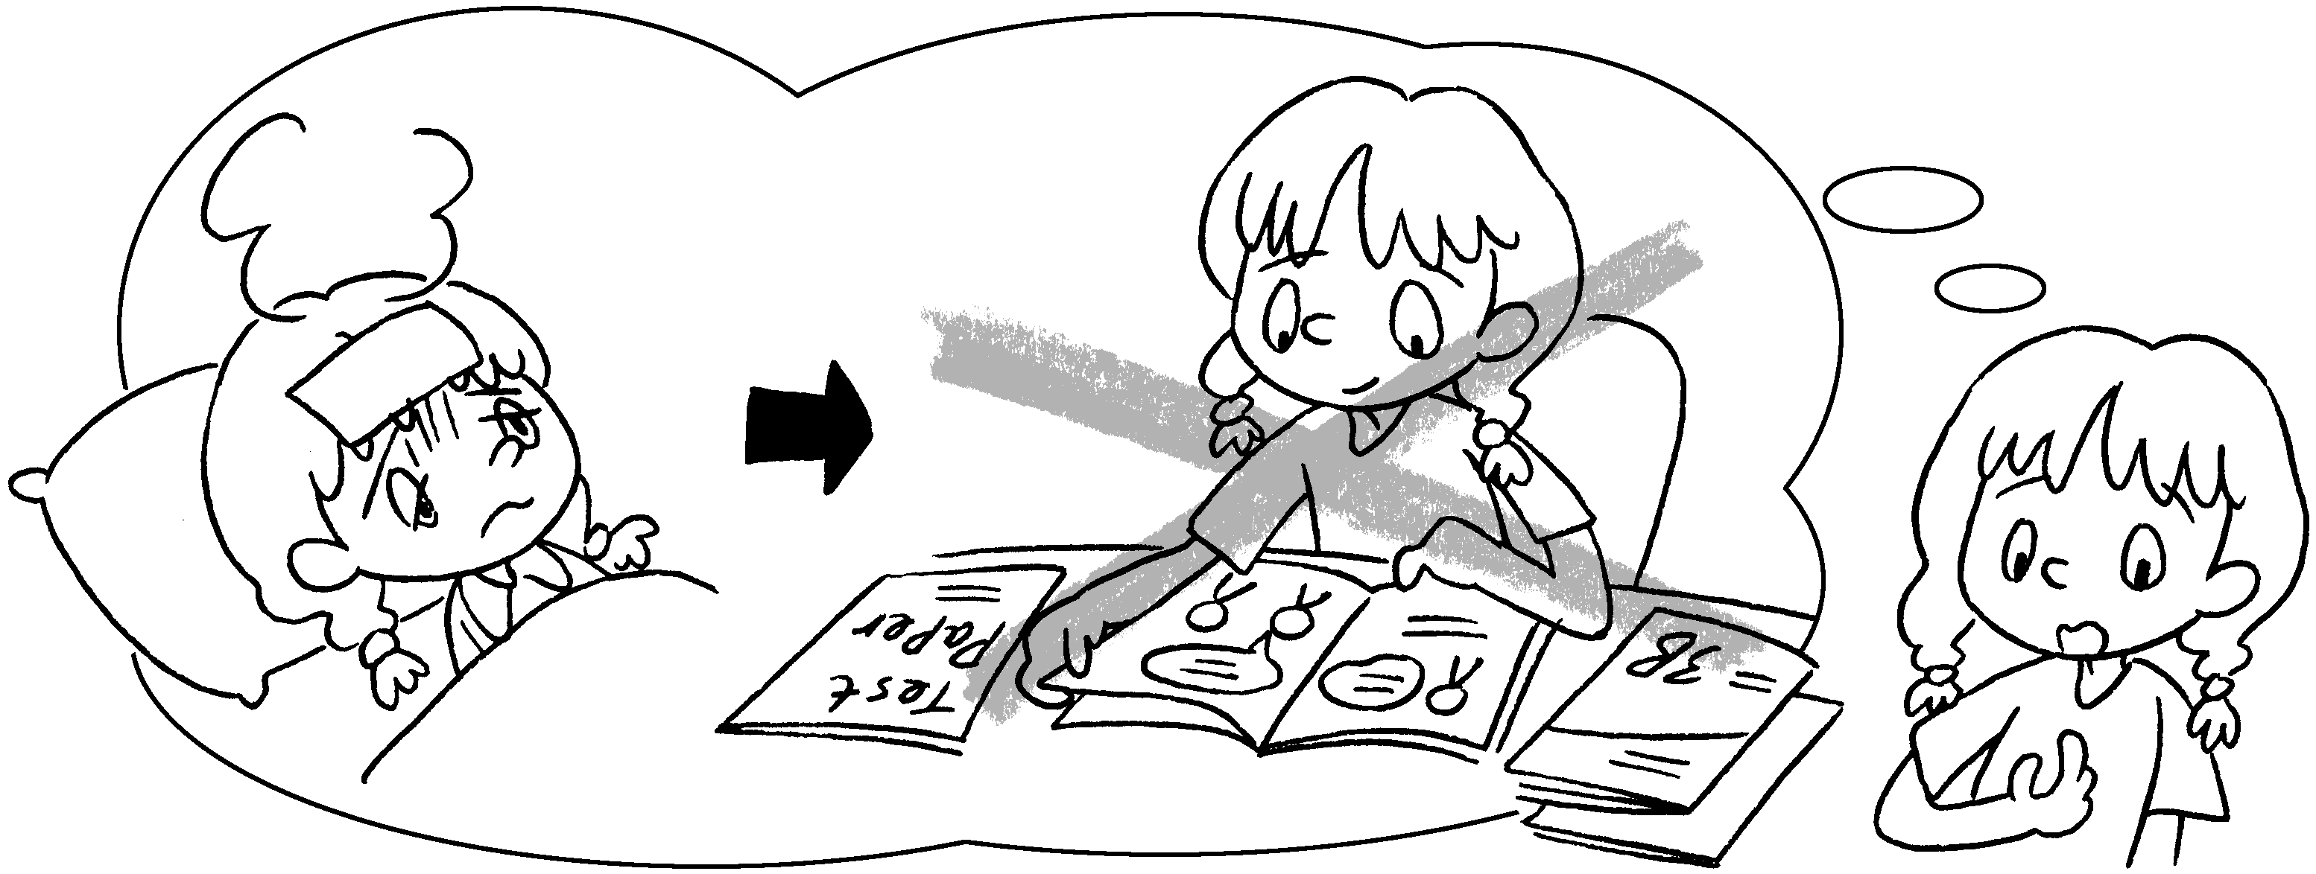 | I was sick I  for the exam.
5 | 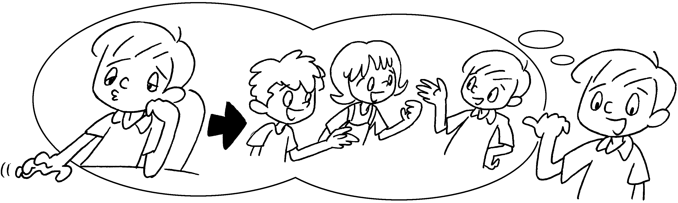 | I was bored  with my friends.


Book 3B Chapter 4 Graded Worksheets
Worksheet 3⬇⬇
- listened
- play
- didn’t tidy
- so didn’t study
- so I chatted

