Fill in the blanks. Use the simple past tense.
chatlisten play studytidy

1 | 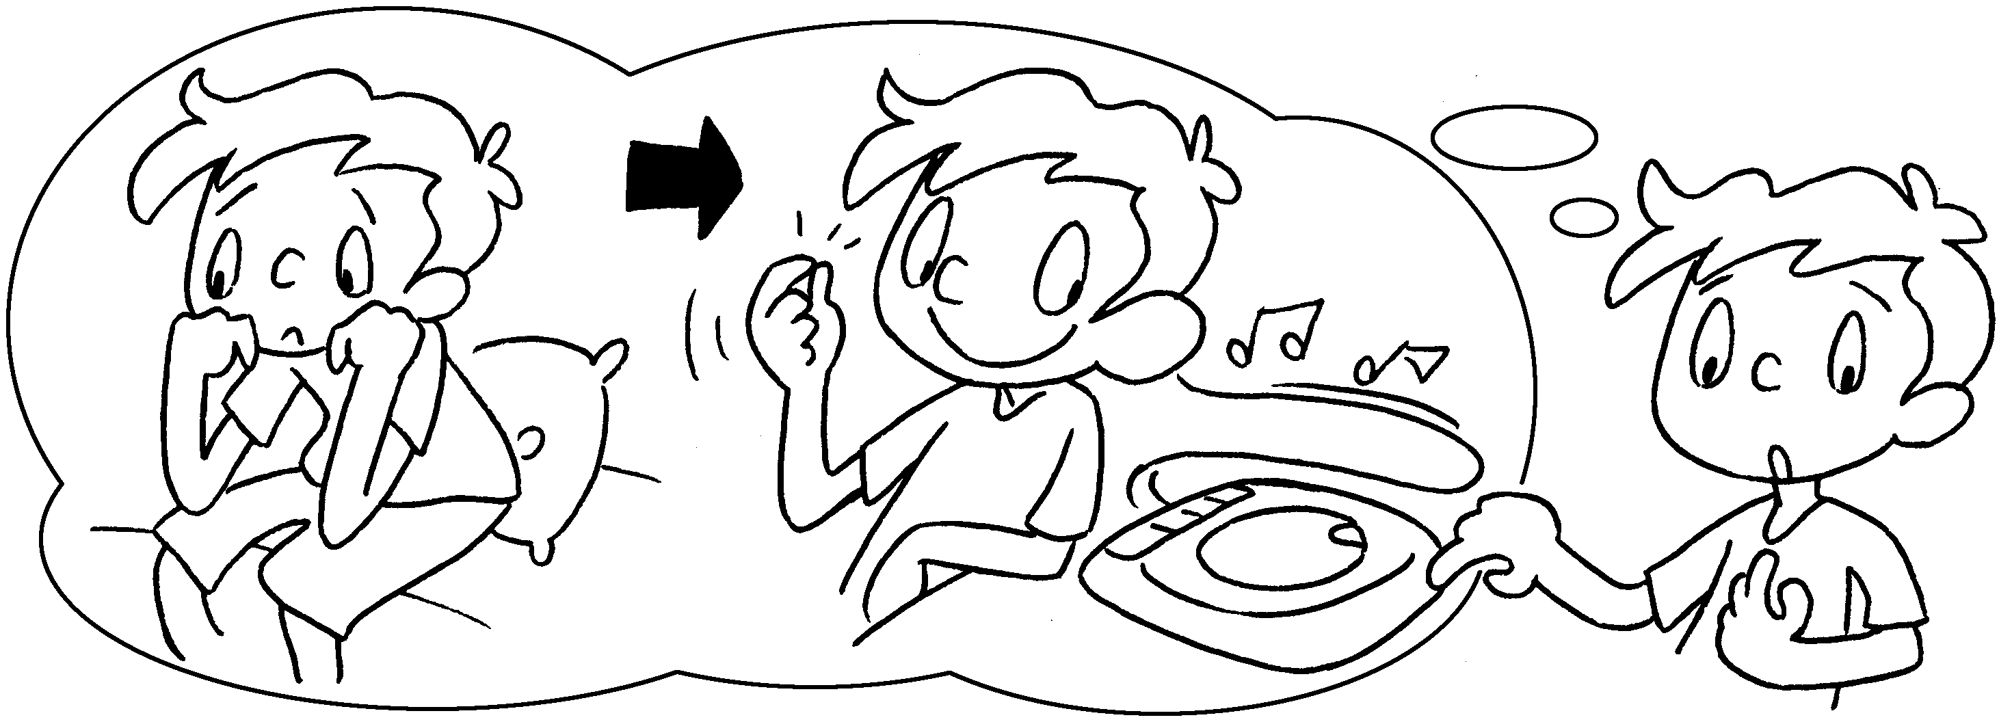 | I was bored  I to CDs.  so
2 | 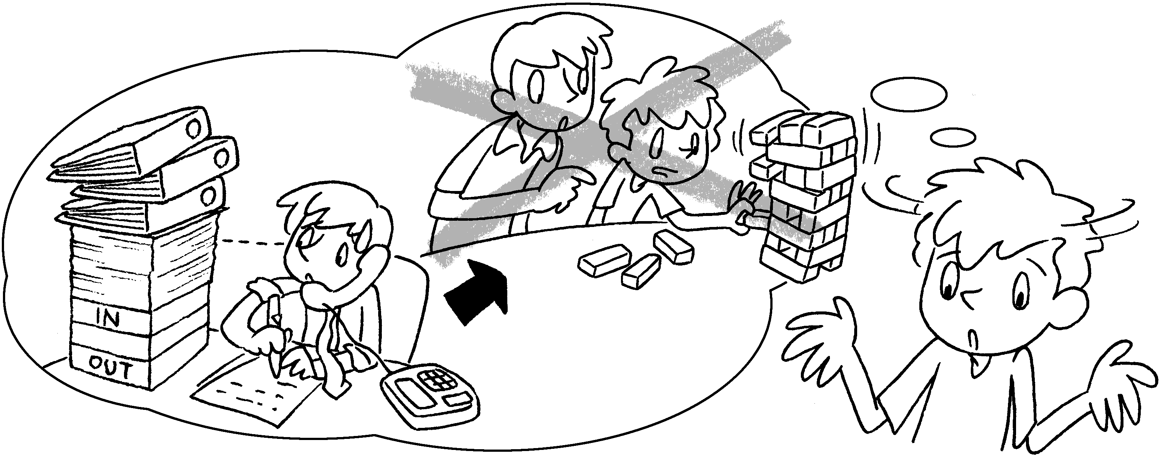 | My brother was b  so he  with me.  didn’t
3 | 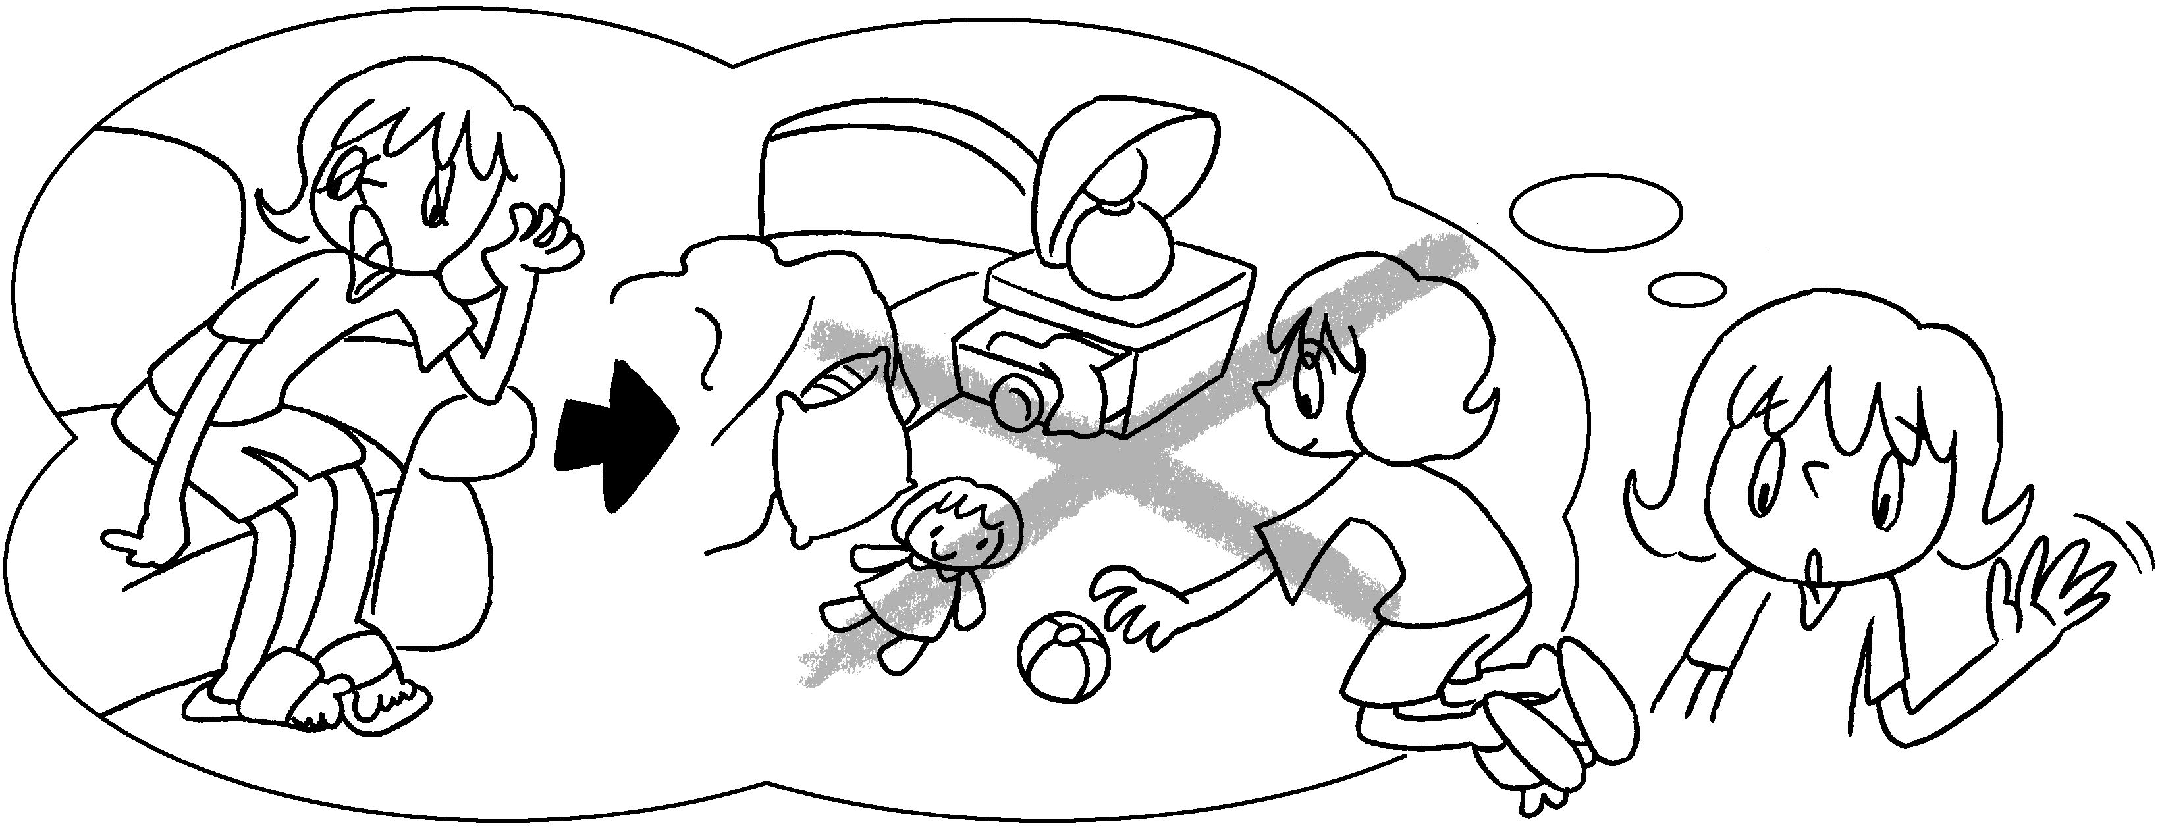 | I was t so  I my room.
4 | 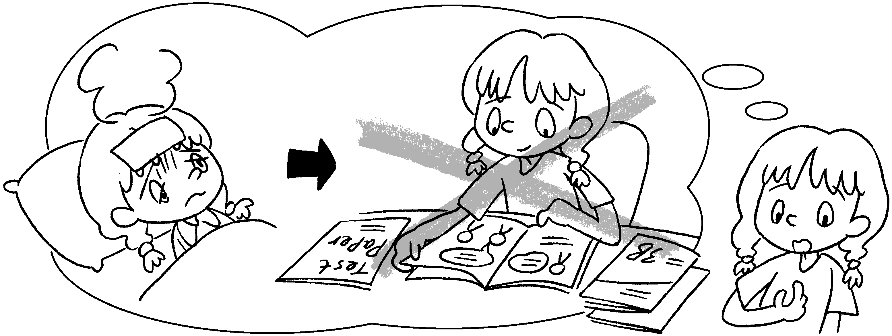 | I was  I  for the exam.
5 | 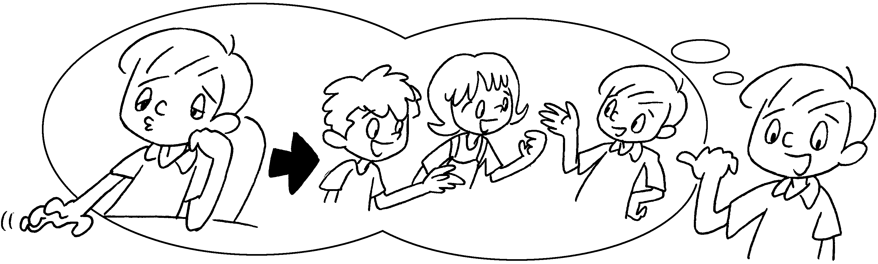 | I  with my friends.


Book 3B Chapter 4 Graded Worksheets
Worksheet 3⬇⬇⬇
- listened
- busy play
- tired didn’t tidy
- sick so didn’t study
- was bored so I chatted
(Accept any reasonable answers.)

