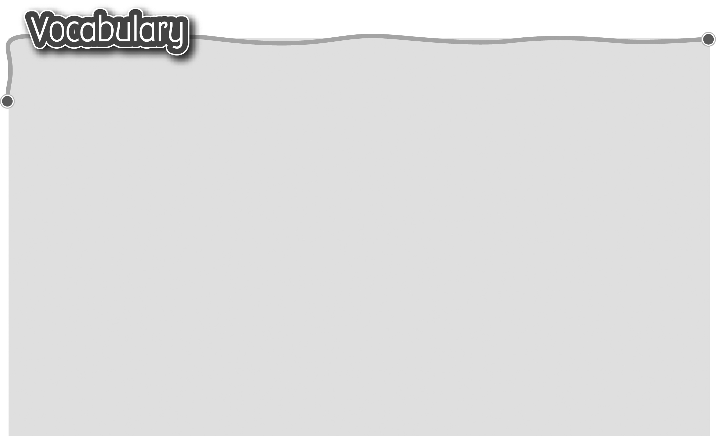
1 action* 動作 5 paint pictures 畫水彩畫/油畫
The words marked with * have different meanings in other contexts. You can look up those meanings in a dictionary.

2 listen to CDs / music 6 chat with friends 與朋友聊天
聽鐳射唱片/音樂 7 study for the exam / test
3 watch TV / cartoons 爲應付考試/測驗溫習
看電視/卡通片
4 play computer games
玩電腦遊戲

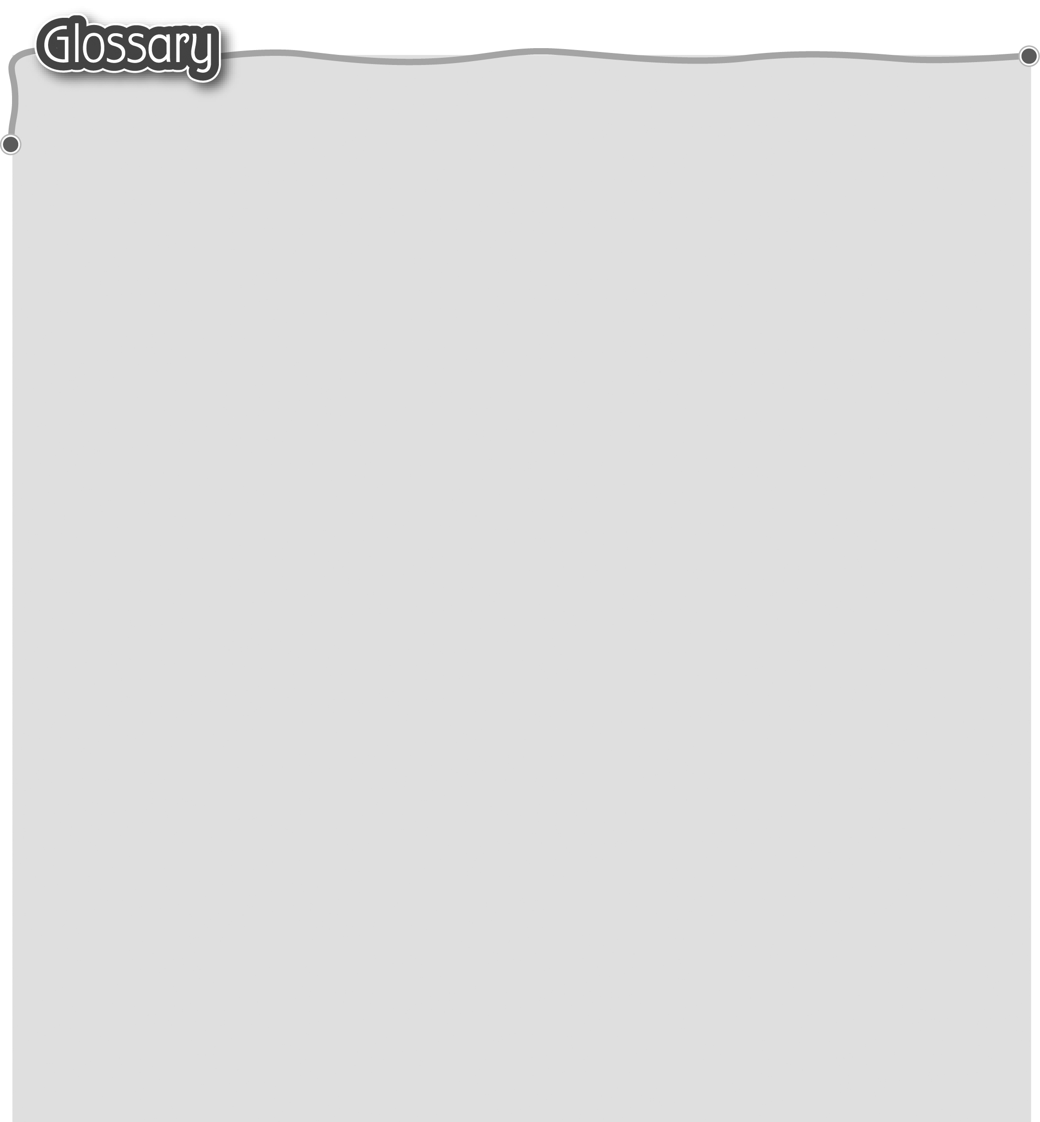
1 so* (p.28) 所以/因此 12 alright* (p.29) 沒關係/好
2 stay* (p.28) 留在…… 13 weekend (p.29) 週末
3 until (p.28) 直到 14 fantastic* (p.29) 精彩
4 skip* (p.28) 跳繩 15 yesterday (p.31) 昨天
5 jump* (p.28) 跳躍（動詞） 16 last night (p.31) 昨夜
6 got (get) up (p.28) 起床 17 clap* (p.31) 拍掌（動詞）
7 late* (p.29) 很晚（副詞） 18 after that (p.35) 然後
8 nobody (p.29) 沒有人 19 uncle (p.35) 叔叔/伯父/
9 messy (p.29) 凌亂 舅父/姨父/姑丈
10 favourite (p.29) 最喜愛 20 cousin (p.35) 堂/表兄弟姊妹
11 without* (p.29) 沒有（帶）

