Choose and write.
belt | card |  | handbag |  | key ring |  | purse
tie |  | towel |  | wallet |  | watch

1 | 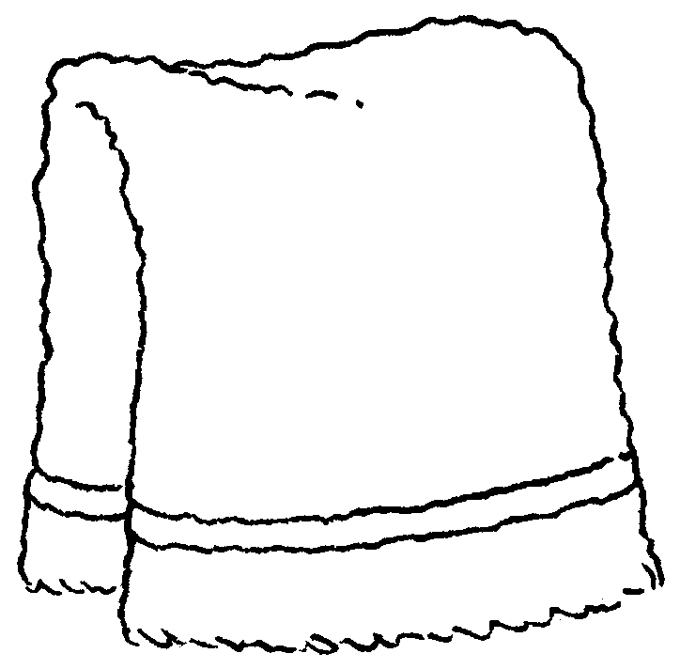 | 2 | 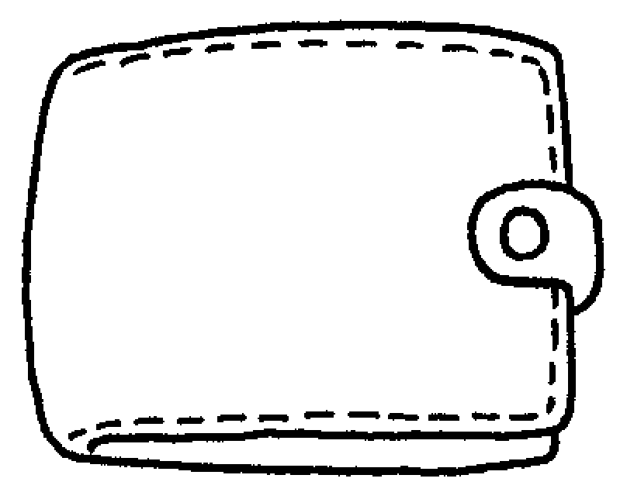 | 3 | 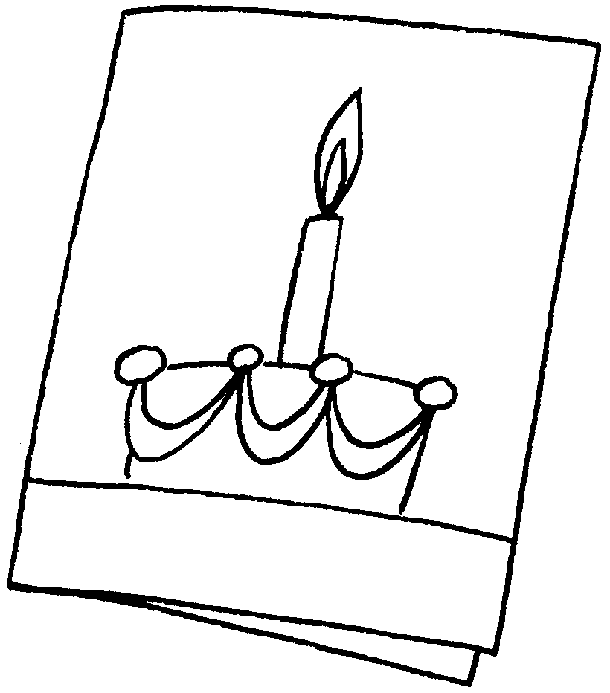
 | a |  | a |  | a
4 | 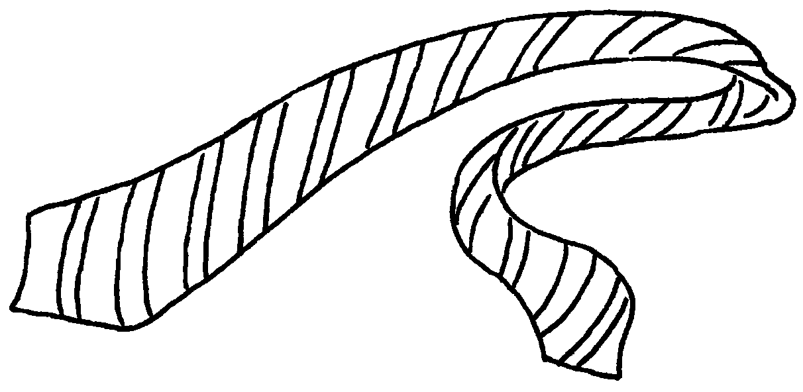 | 5 | 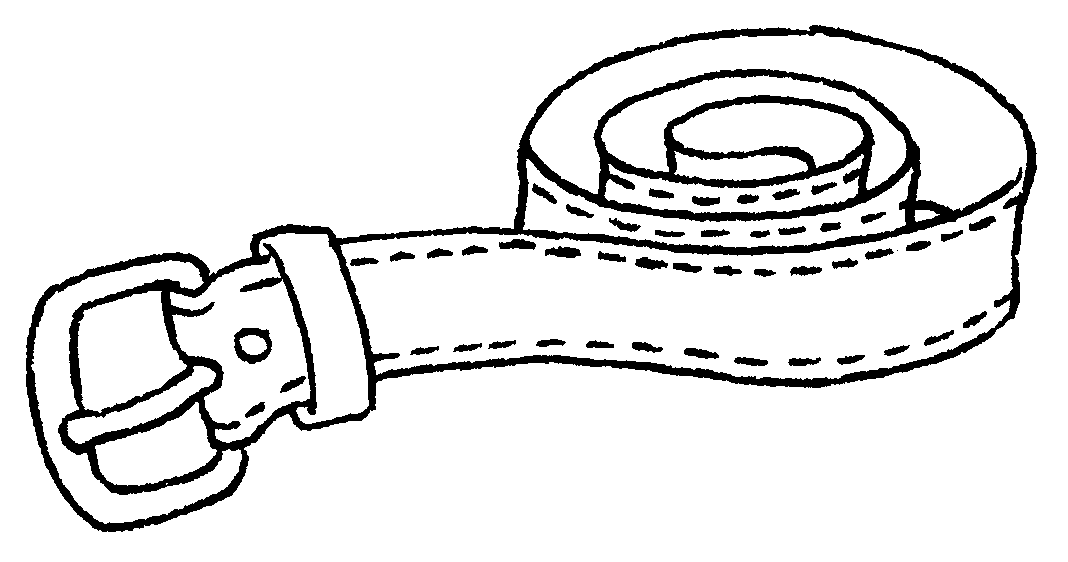 | 6 | 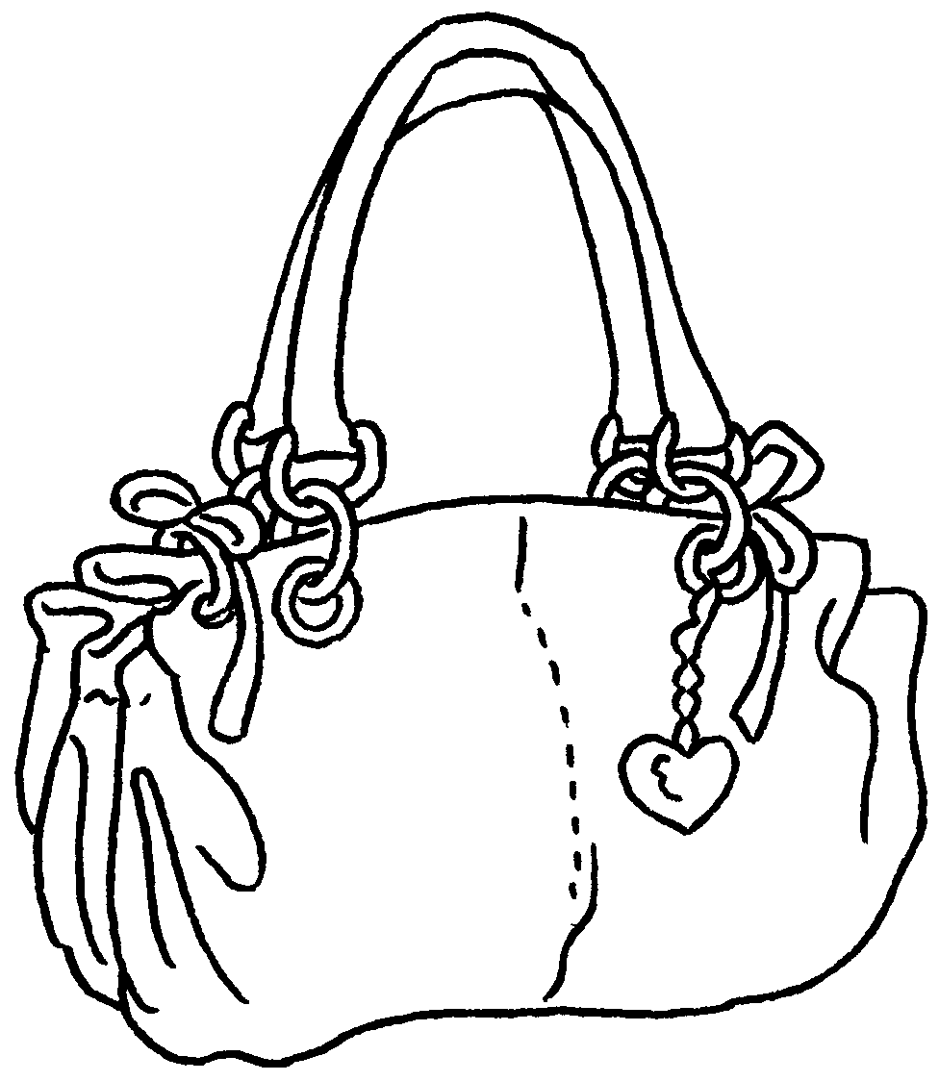
 | a |  | a |  | a
7 | 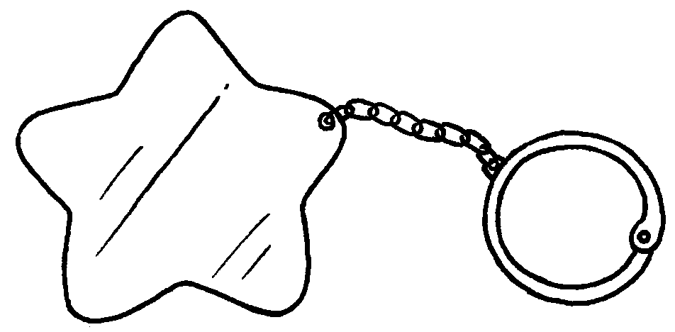 | 8 | 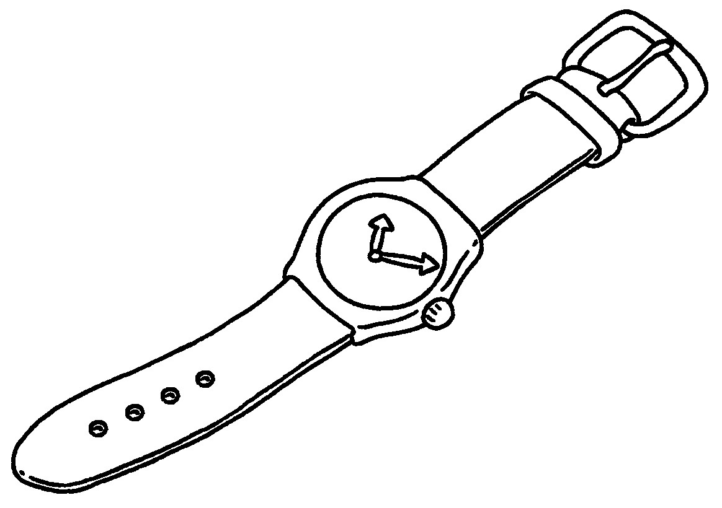 | 9 | 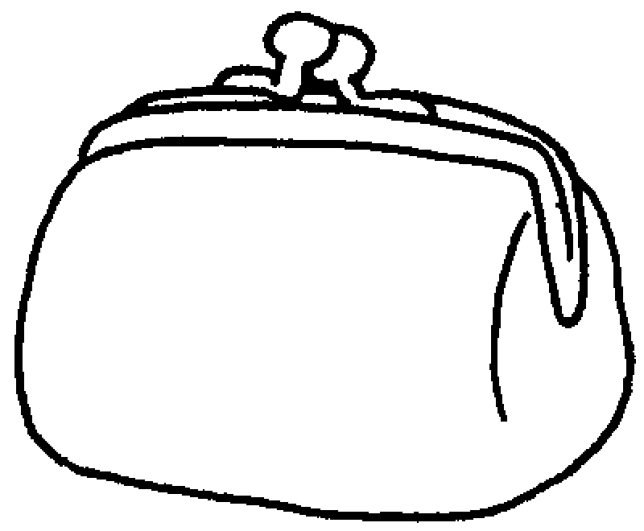
 | a |  | a |  | a


Book 3B Chapter 5 Graded Worksheets
Worksheet 1⬇
1 towel 2 wallet 3 card
4 tie 5 belt 6 handbag
7 key ring 8 watch 9 purse

