Fill in the missing letters.

1 | 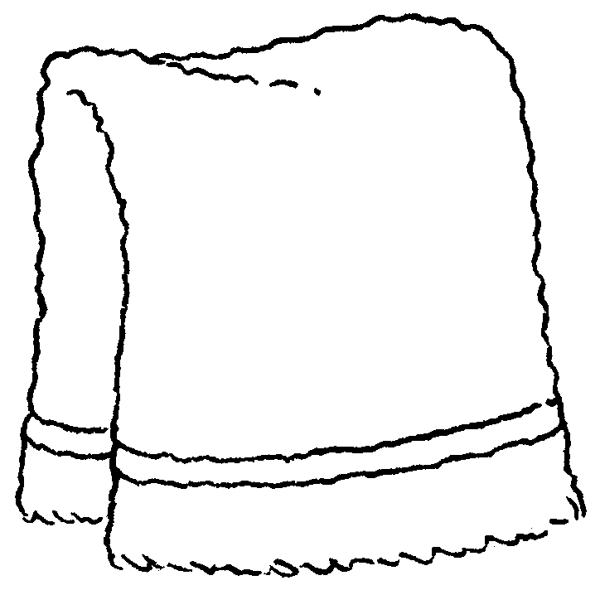 | 2 | 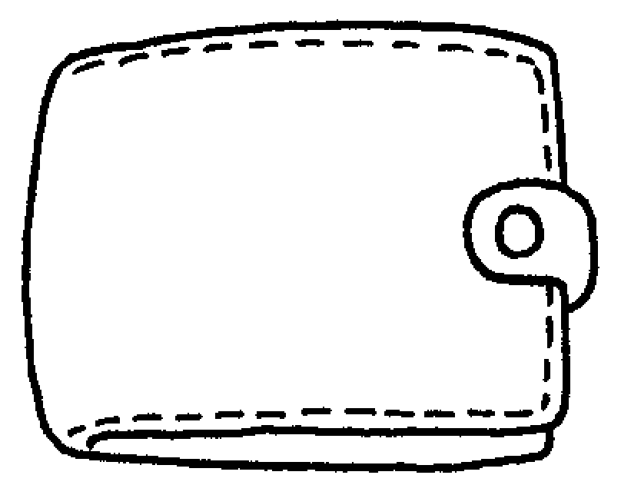 | 3 | 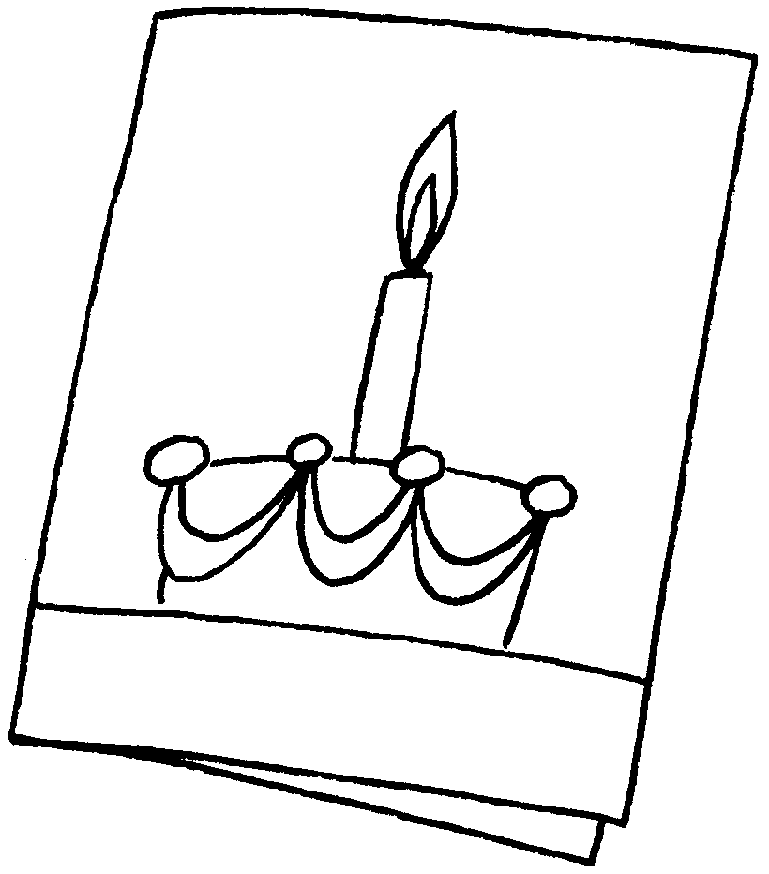
 | a t __ __ __ __ |  | a w __ __ __ __ __ |  | a c __ __ __
4 | 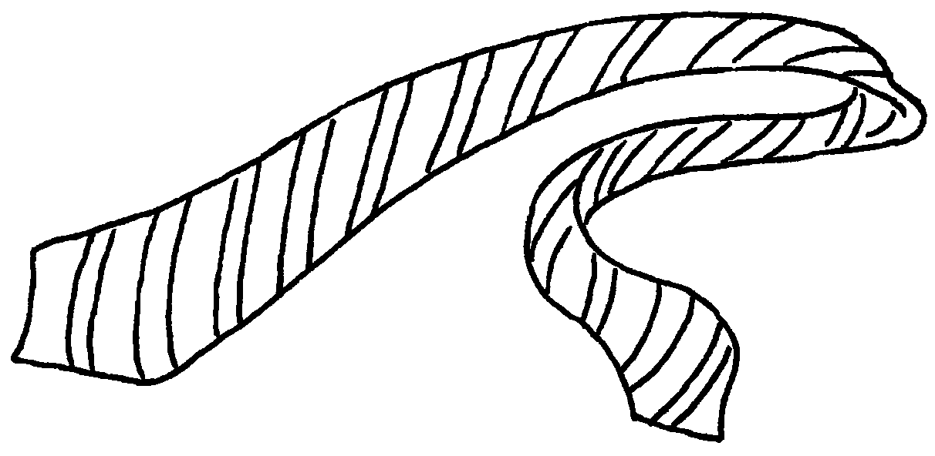 | 5 | 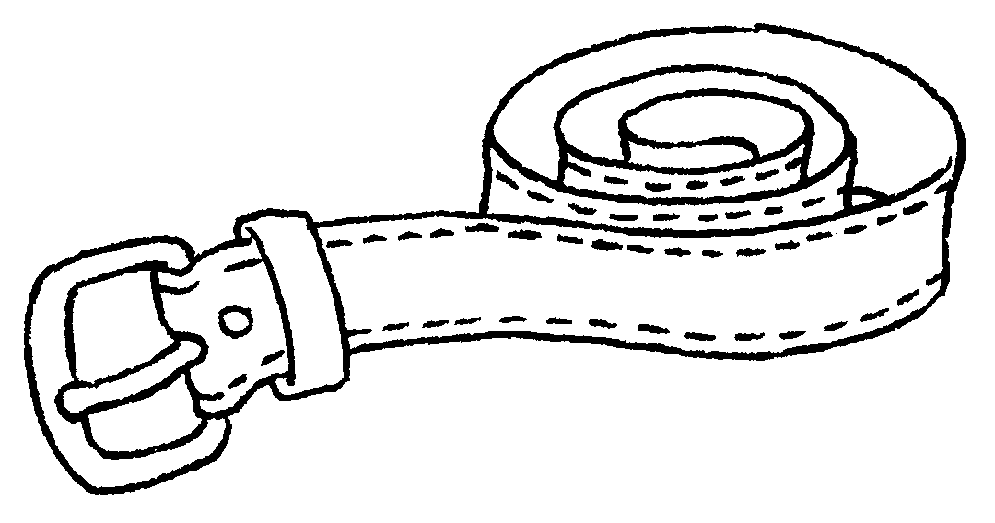 | 6 | 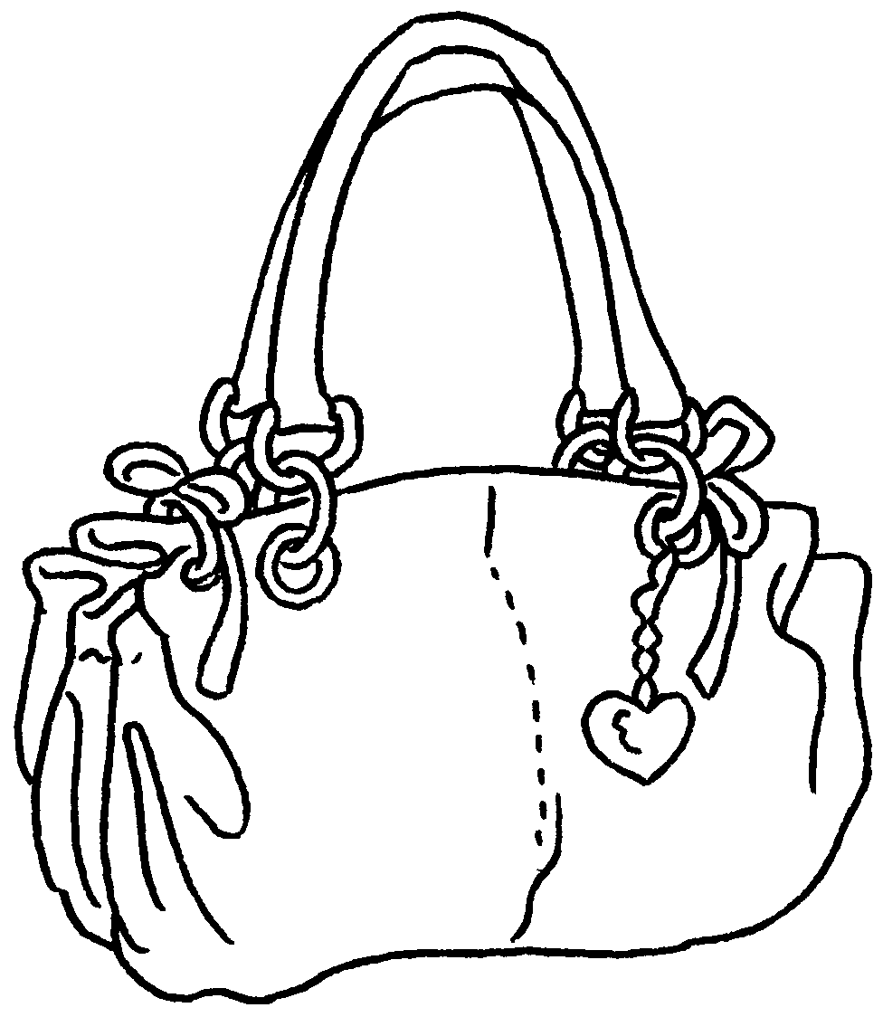
 | a t __ __ |  | a b __ __ __ | a h __ __ __ __ __ __
7 | 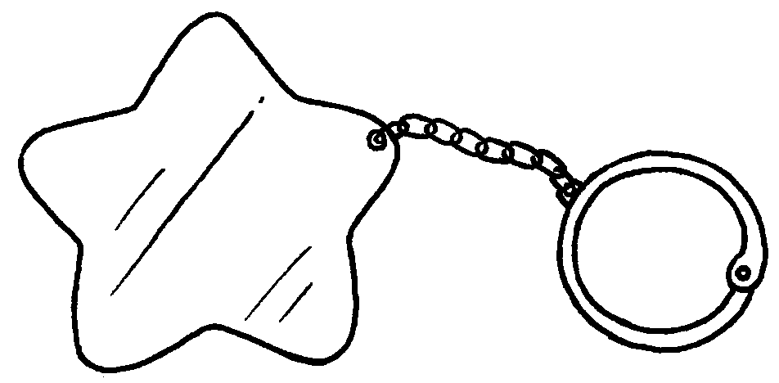 | 8 | 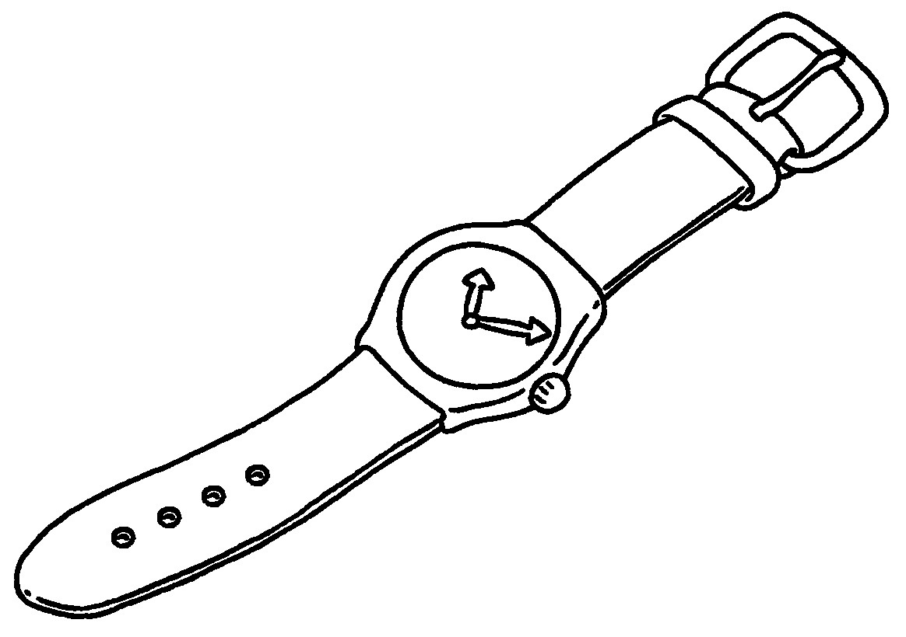 | 9 | 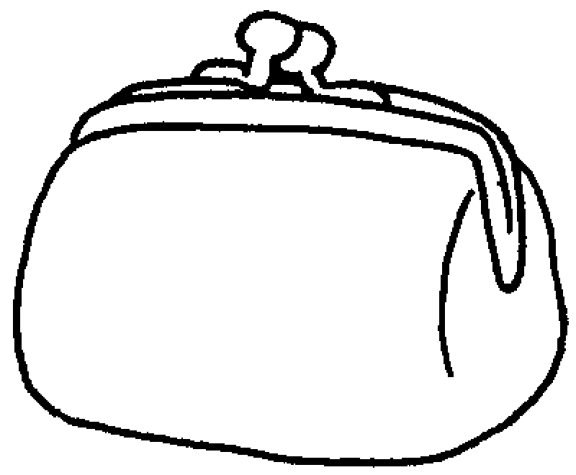
a k __ __ r __ __ __ |  |  | a w __ __ __ __ |  | a p __ __ __ __


Book 3B Chapter 5 Graded Worksheets
Worksheet 1⬇⬇
1 t o w e l 2 w a l l e t 3 c a r d
4 t i e 5 b e l t 6 h a n d b a g
7 k e y r i n g 8 w a t c h 9 p u r s e

