Circle the correct answers.

1 | 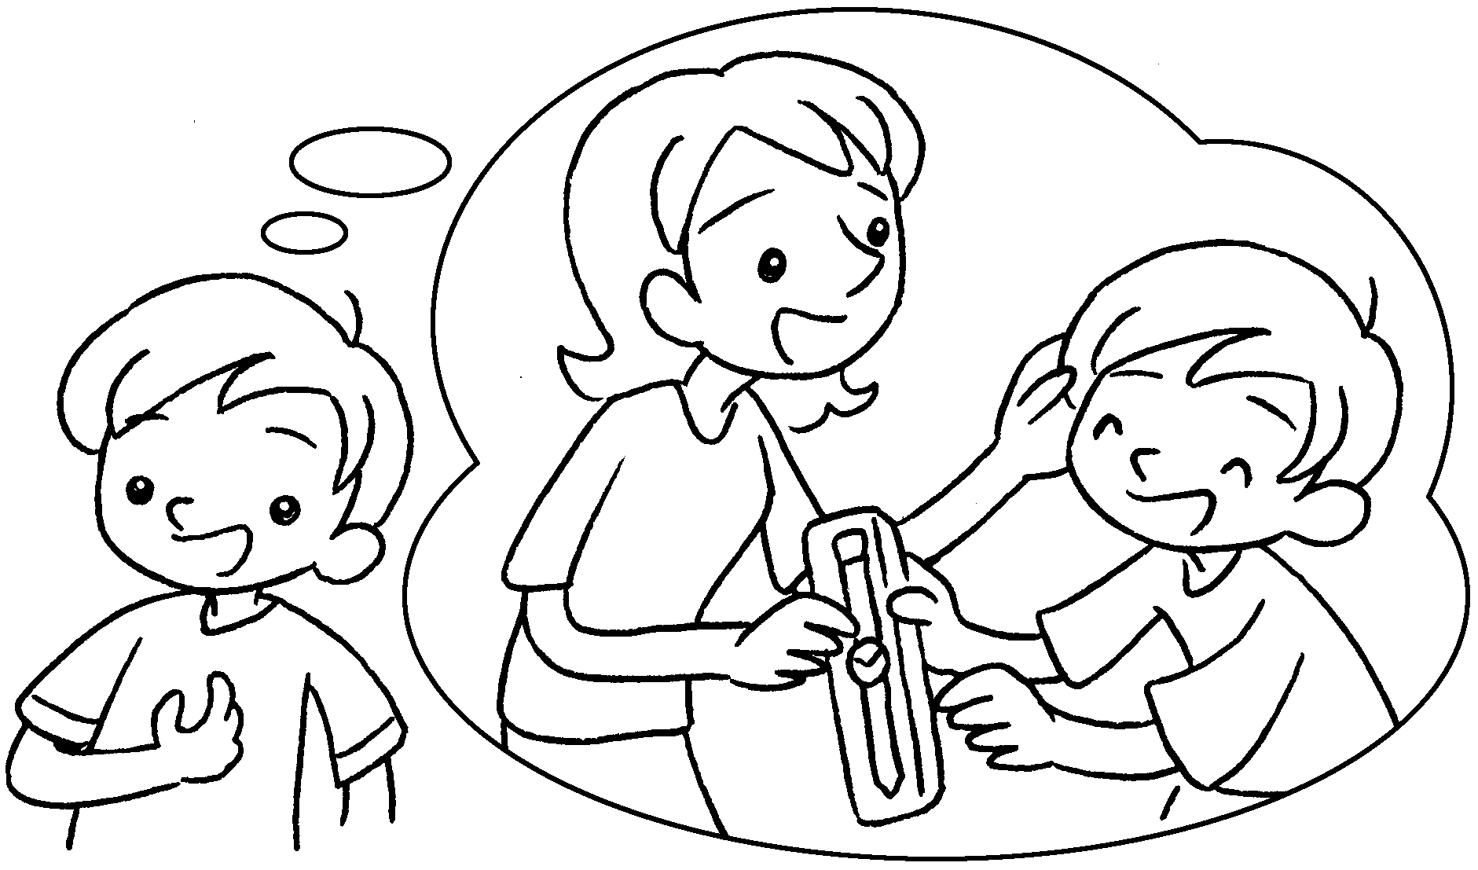 | Mum ( bought / buys ) me a new watch yesterday.
2 | 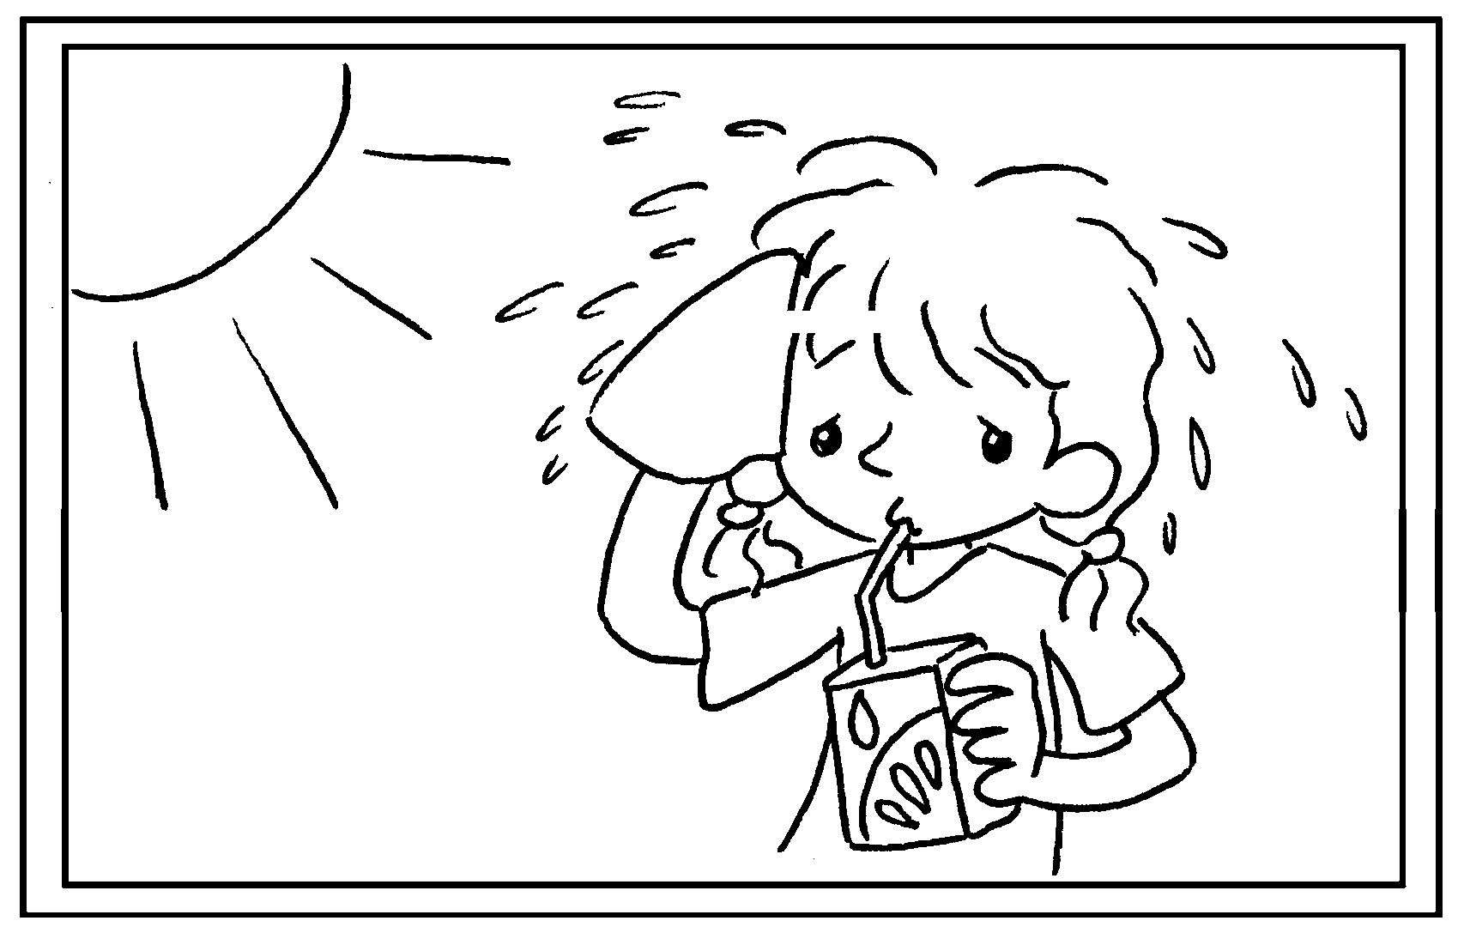 | Fion was thirsty so she ( drinks / drank )  some juice.
3 | 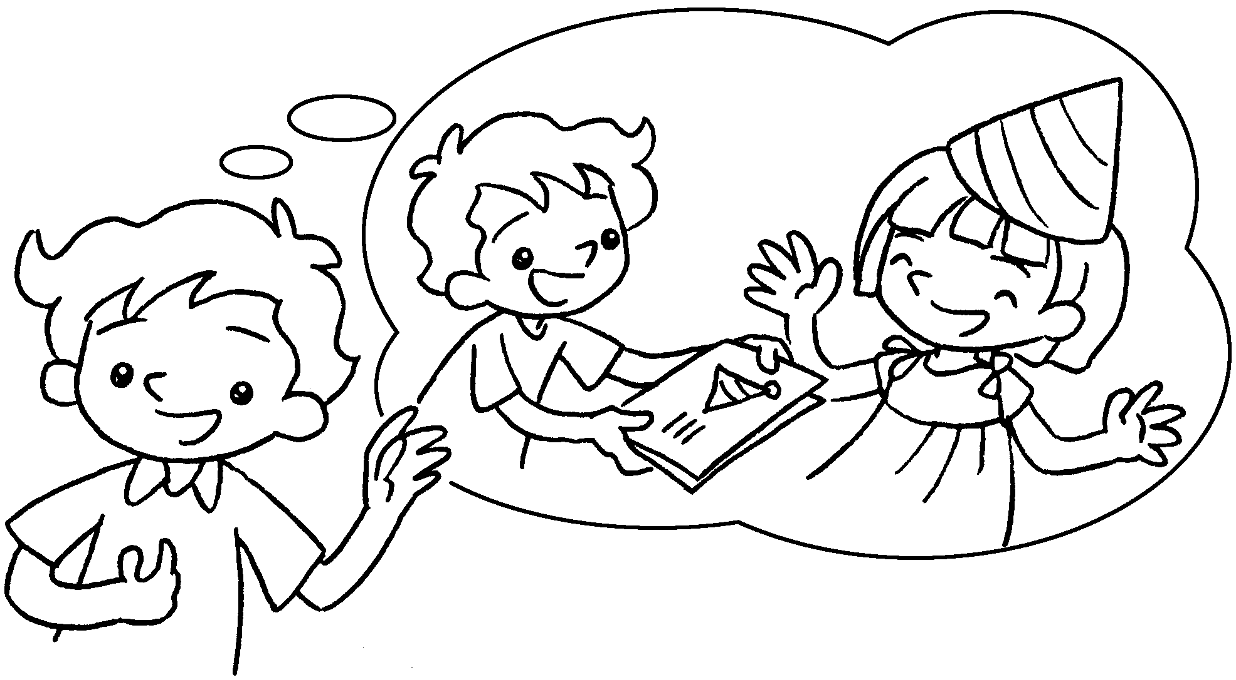 | It was Katie’s birthday last Monday  so I ( give / gave ) her a card.
4 | 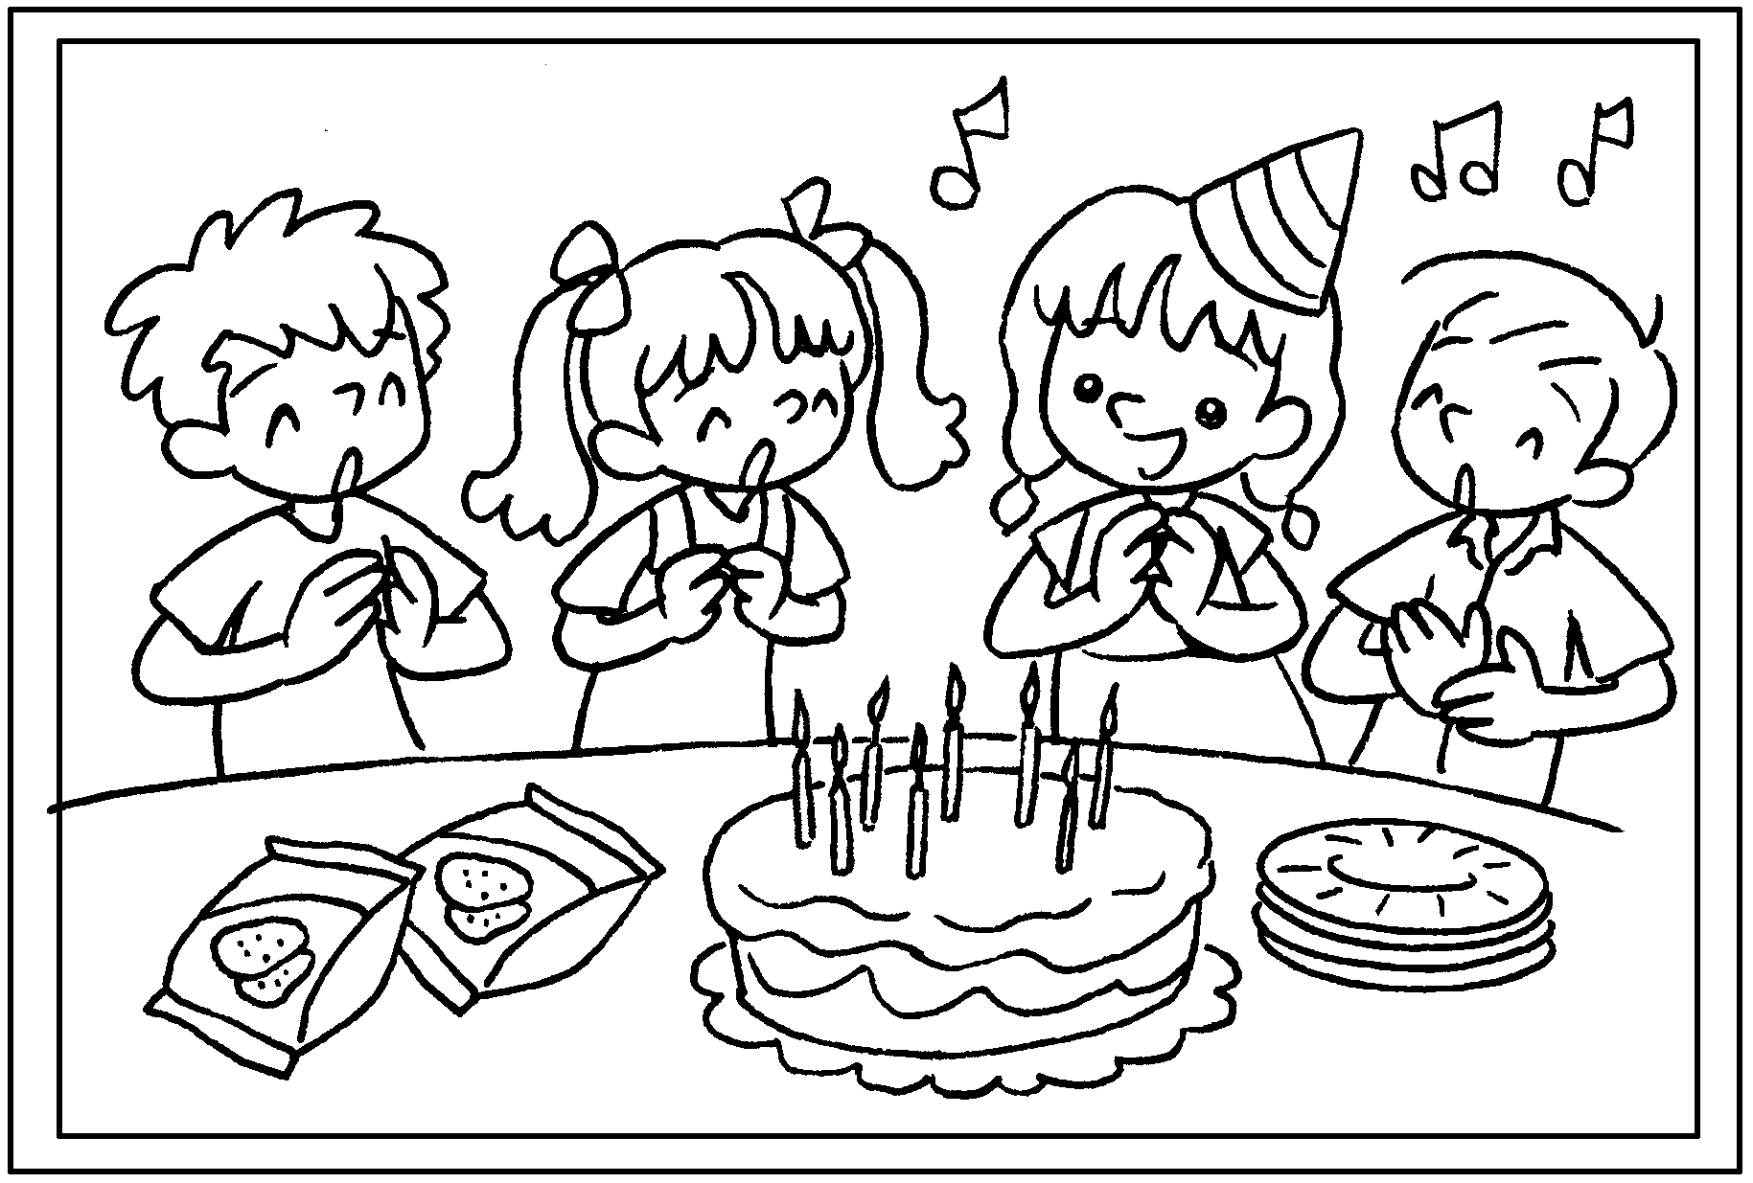 | Last Friday was Kelly’s birthday. We  ( sing / sang ) the birthday song and  ( ate / eat ) a birthday cake.
5 | 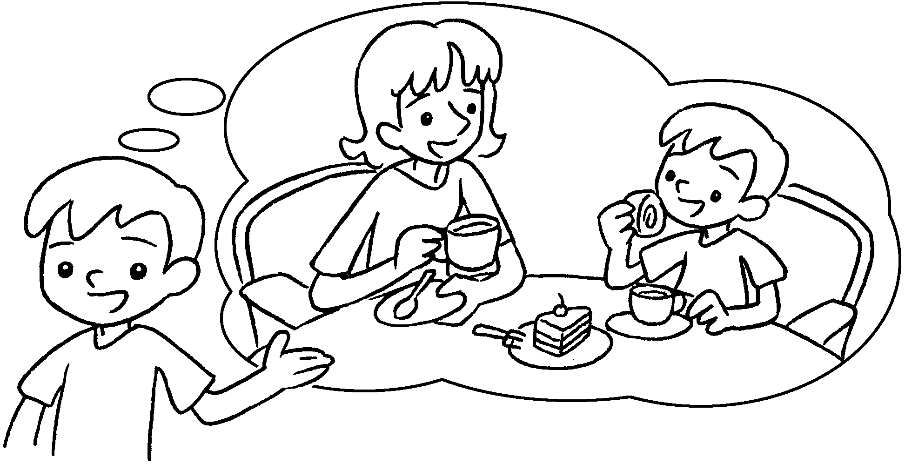 | Yesterday my mother ( took / takes ) me to a cafe and we ( have / had ) afternoon tea.



Book 3B Chapter 5 Graded Worksheets
Worksheet 2⬇
- ( bought / buys )
- ( drinks / drank )
- ( give / gave )
- ( sing / sang ) ( ate / eat )
- ( took / takes ) ( have / had )

