Fill in the blanks. Use the simple past tense.
1 | 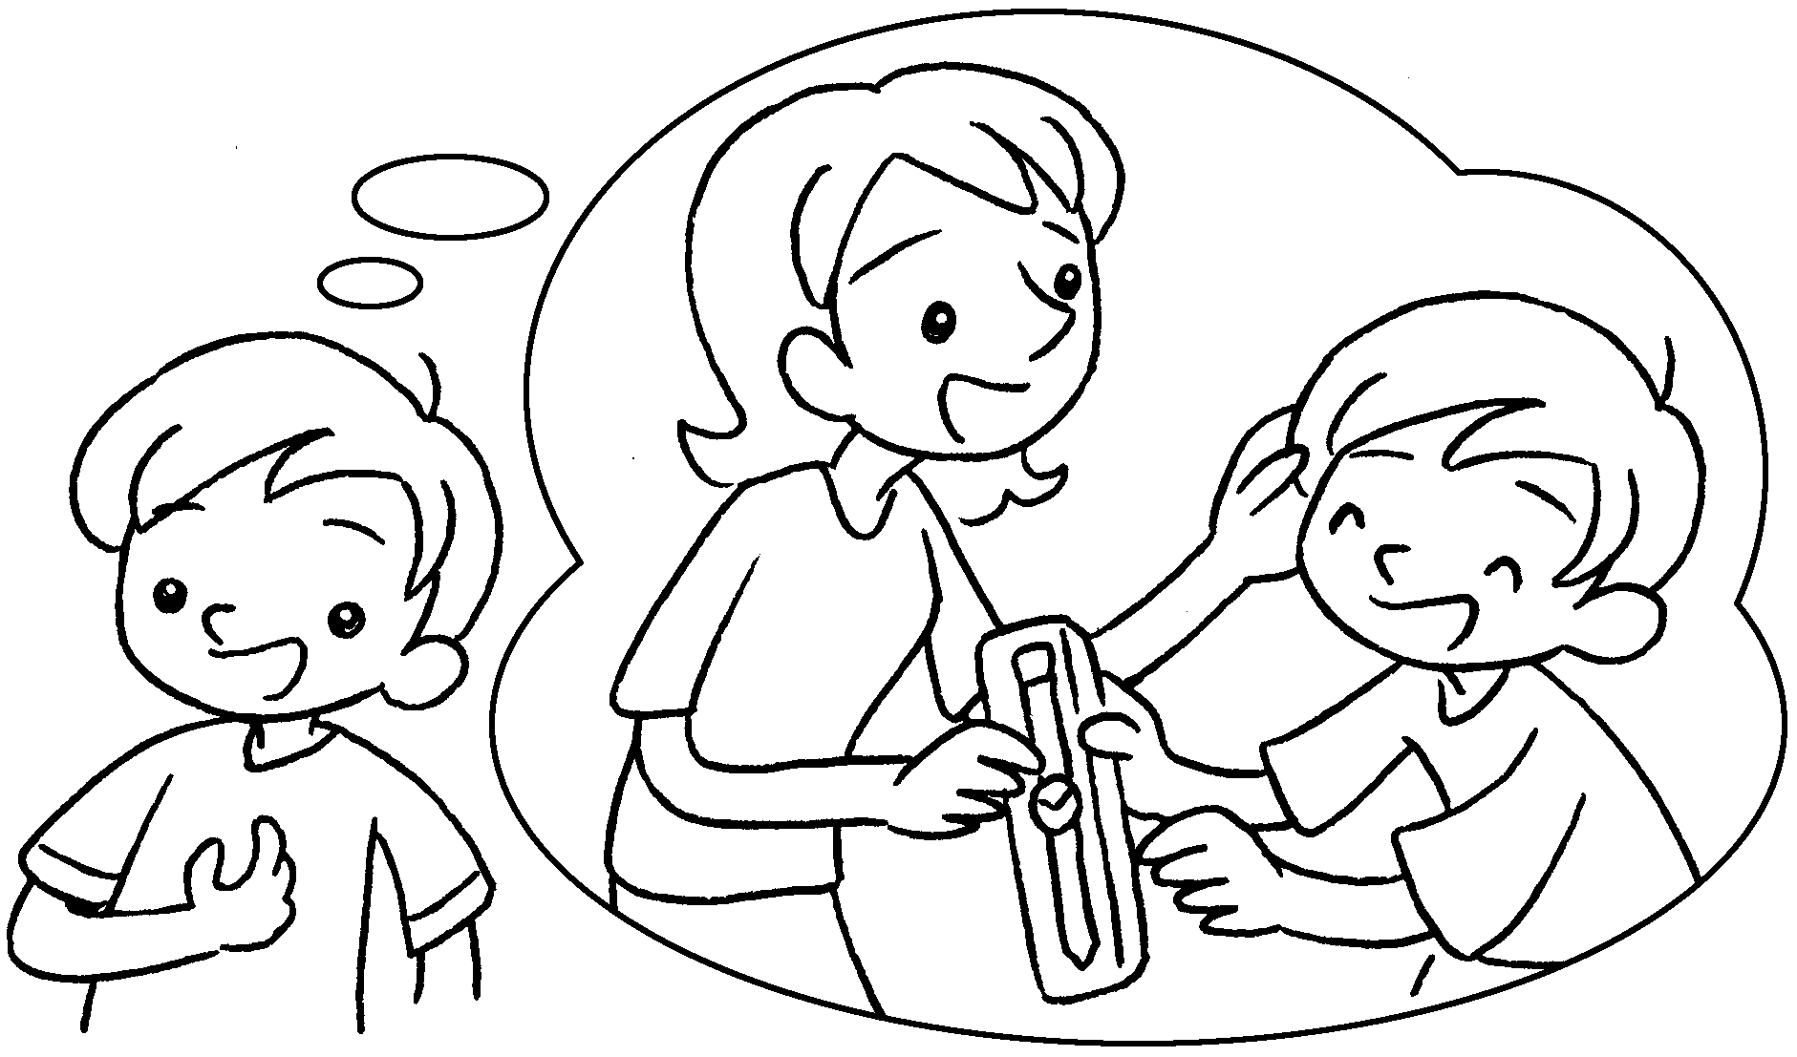 | Mum ( buy ) me a  new watch yesterday.
2 | 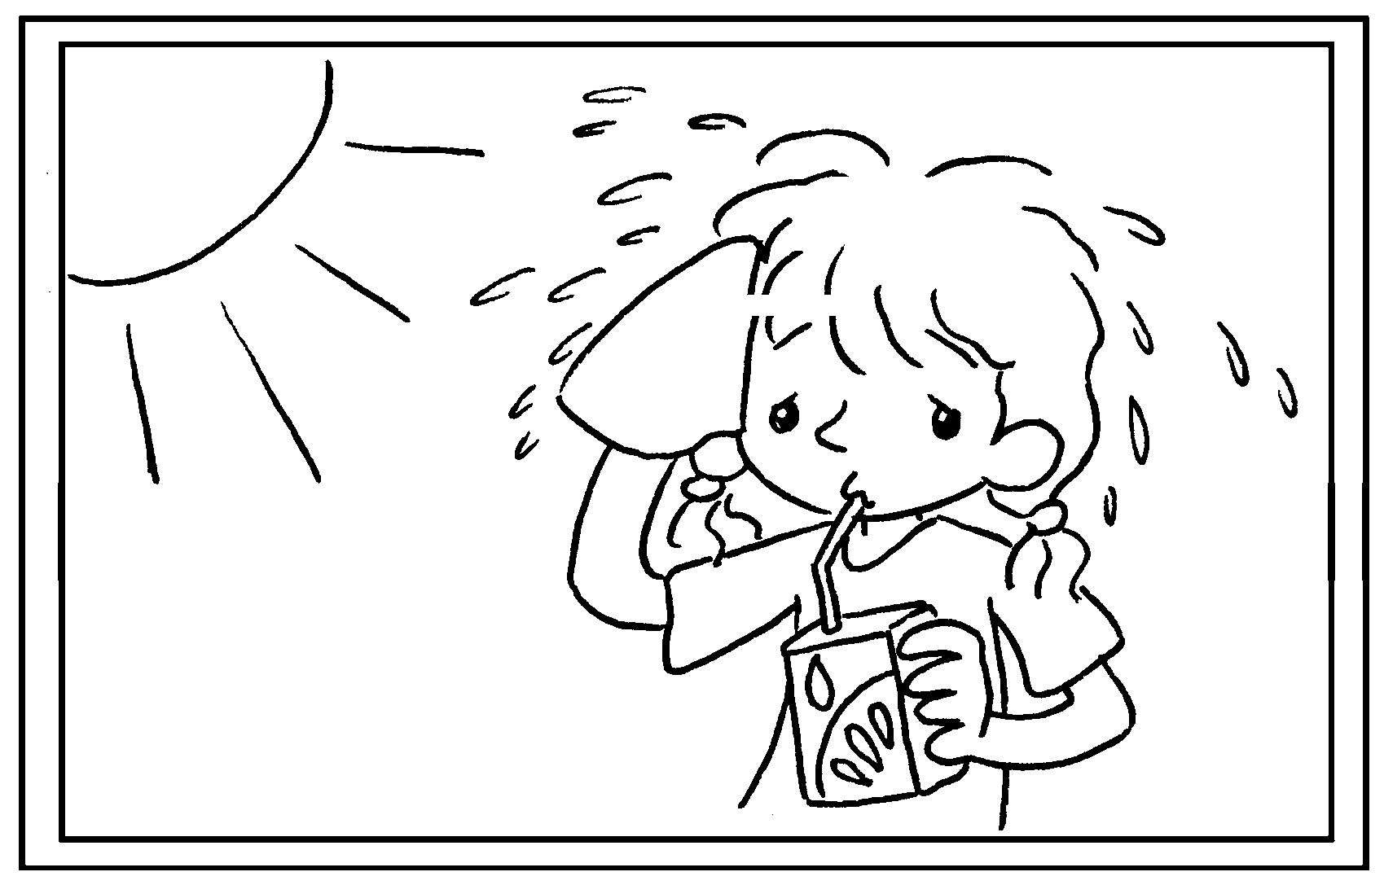 | Fion was thirsty so she  ( drink ) some juice.
3 | 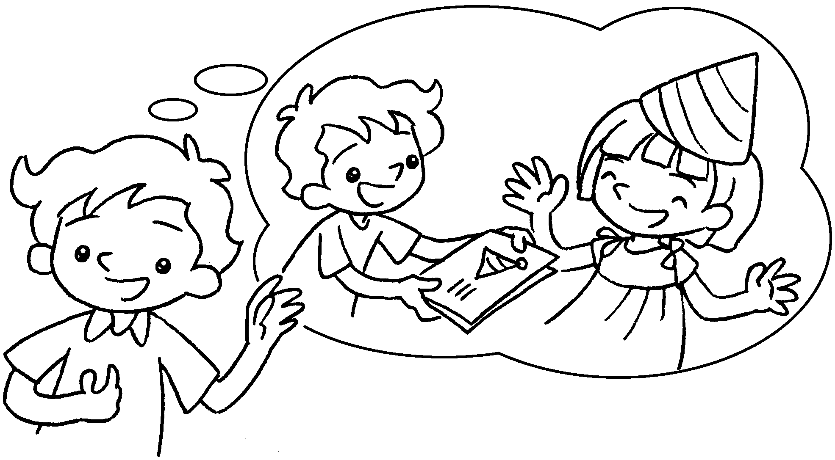 | It was Katie’s birthday last Monday  so I ( give ) her a card.
4 | 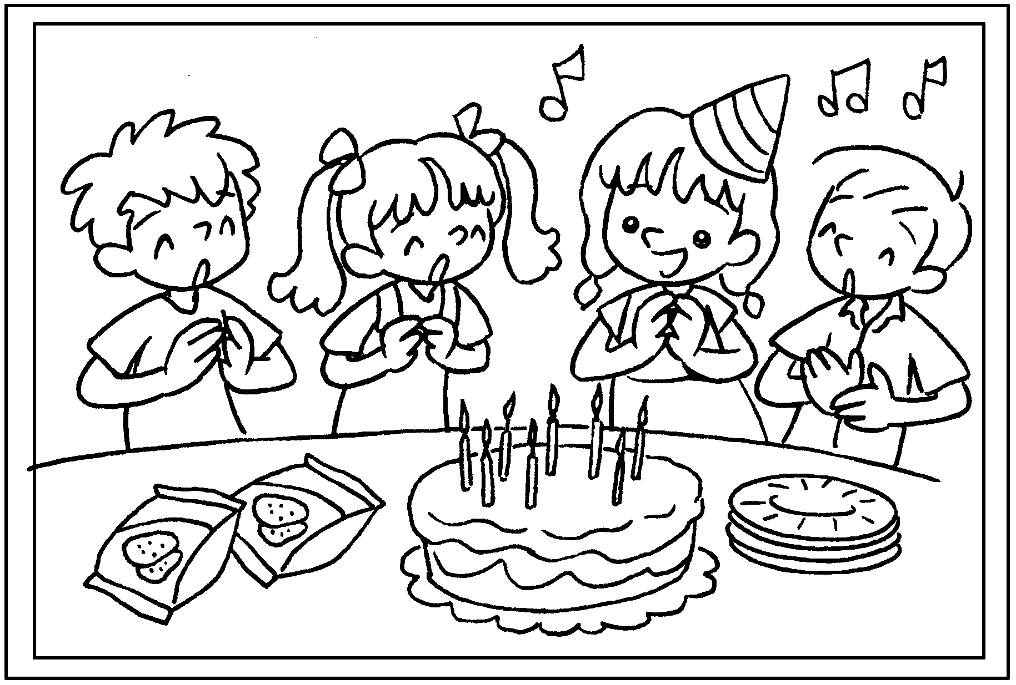 | We ( sing ) the  birthday song and  ( eat ) a birthday cake.
5 | 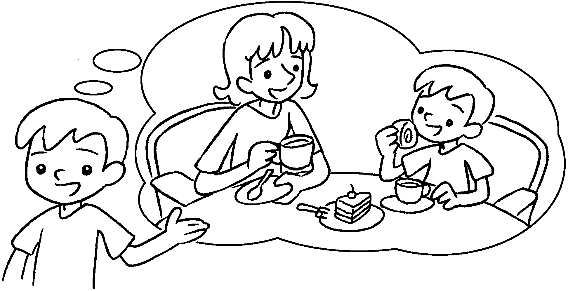 | My mother ( take ) me  to a cafe and we  ( have ) afternoon tea.


Book 3B Chapter 5 Graded Worksheets
Worksheet 2⬇⬇
- bought
- drank
- gave
- sang ate
- took had

